New Transaction to Identify COVID-19 related expenditures

Texas State University is required as a state agency to report expenditures directly related to COVID-19. To provide the reporting, campus departments need to identify documents for any COVID-19 related expenditures as early as January 20, 2020 and until further notice. In March, there were document indicators added to Marketplace, Purchase Orders and e-NPOs to help account managers identify if documents contained COVID-19 related expenditures.
If there are any documents that were COVID-19 related prior to that, and the documents have not been previously reported, please use this new form to report the expenditures. Your accurate reporting supports the Texas State reimbursement process with FEMA. Access the transaction via transaction code or portal.
SAP Portal Tile:
Step1. Log onto the SAP Portal. Go to the Texas State Homepage. Click on Faculty & Staff.
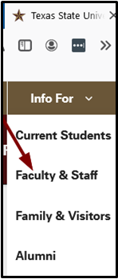
Step 2. Click on SAP Portal.
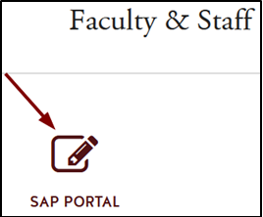

Step 3. Enter credentials to login.
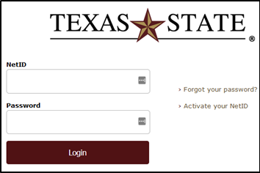

Step 4. Click on the tile: “Report Additional COVID-19 Related Documents”
in the group “COVID-19 Federal and State Reporting.” Once the tile is chosen, please follow the instructions below under “Transaction Code”.
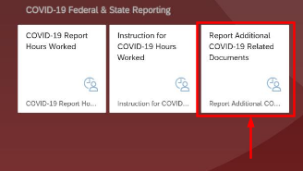

TRANSACTION CODE:
ZFI_COVID19_DOC_ID
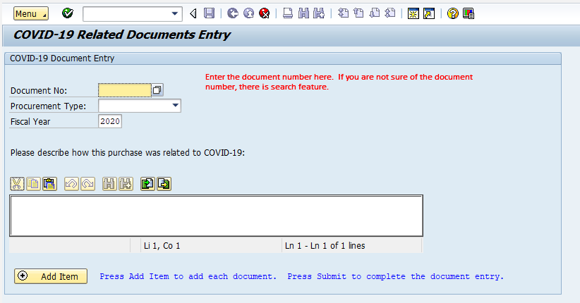
Document Number: Enter the document number identified as COVID-19 related. The form allows entry of multiple documents to be submitted, but the documents must be entered one at a time. Do not enter purchase order numbers; this form is only for invoice documents.
There is a search feature for the document number. Enter the company code of 754 and fiscal year of 2020. If you know what type of document, enter the two-character document type. The dropdown list will show the different types. The most common document types will be NP, RE and KR.
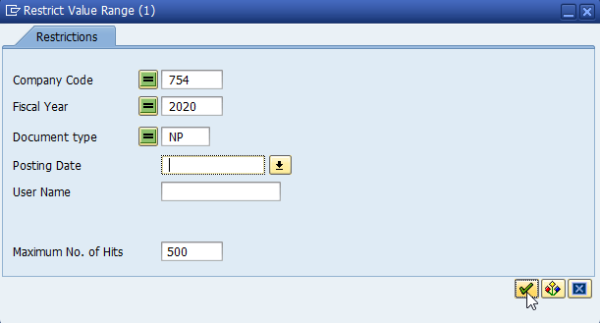
Procurement Type: This is a dropdown, select one of the choices.
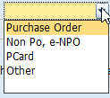
Fiscal Year: default is 2020
Text Box: Use this text box to describe how the expenditure is COVID-19 related.
Click on the ADD ITEM button to add the document to the grid below. Once all documents have been entered, click on the submit button. The user entering the documents will receive an email verifying the documents included on the request.
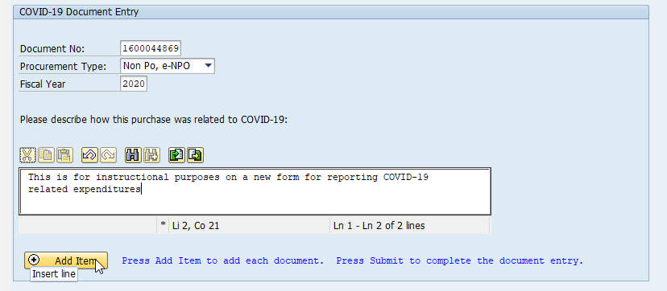
Here is the screen after the item is entered. Notice there are multiple documents added:
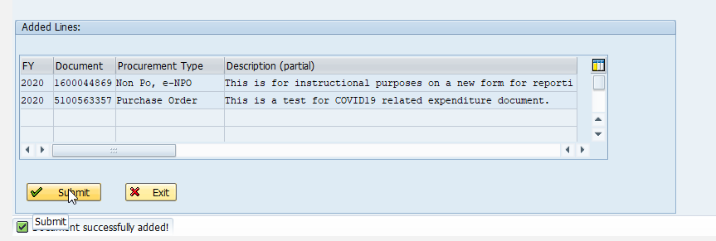
Click RETURN to go back to the main menu
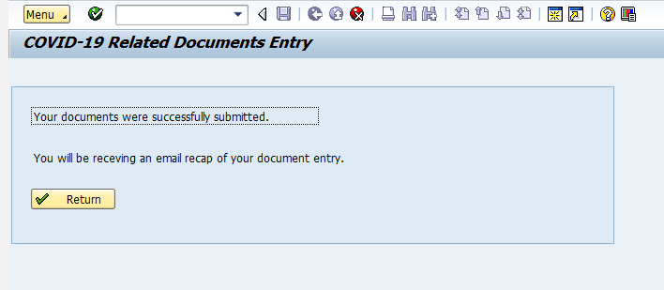
Error Messages:
- If the document has been submitted previously, an error message will appear:
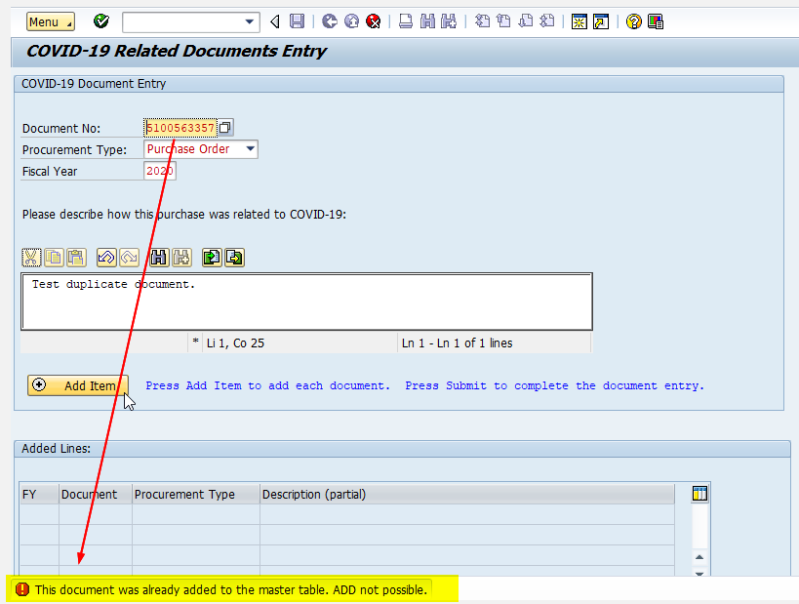
- If the document is not valid, an error message will appear:
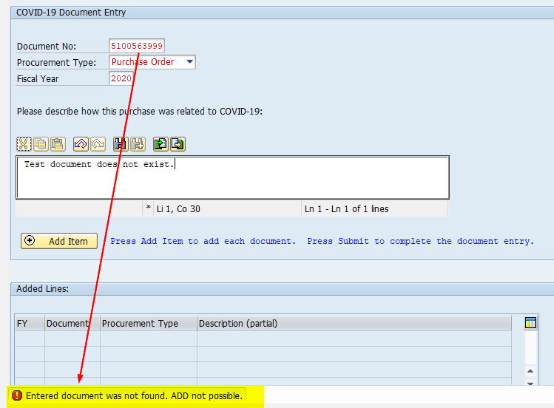

EMAILS
Here is an example of the email sent to the user after submitting the documents:
