NASA STEM Learning with Drones: Preparing Educators

Drones in Education

Drones are permeating our everyday lives from delivery services and art to scientific research. In education, drones are a creative vehicle for teaching and learning - an opportunity to teach inter-disciplinary and multi-disciplinary concepts in STEM that encompass computational thinking, technology interaction, and principles of flight. Their educational value is also compelling in the domain of workforce development, curriculum enhancement, and development of soft skills such as teamwork, critical problem solving, and communication.

Students, through multitude of experiences, have knowledge and expertise in interacting with technology. Drones can serve as a tool in student-centered classrooms to bridge the gap between out-of-class and in-class technology experiences for students and generating excitement for learning.

Preparing Educators

Drones, on the other hand, if not implemented with meaningful instruction and focus on student outcomes, will just be the next “shiny object” and an infatuation because they inherently don’t possess more functional value than similar technologies like robots that already has an established track record in education. We propose that these pitfalls can be avoided by leveraging NASA-unique contexts for using drones to achieve two-fold outcomes – learn NASA mission-related STEM and use of drone technology. As a pilot initiative, we are working on developing digital learning opportunities for educators using digital badging. Figure below shows the organization of proposed digital badges which will help educators to use drones to teach NASA-unique STEM at different depths of knowledge (based on Webb’s Depth of Knowledge framework) while learning about drone safety and careers pathways that involve drones.
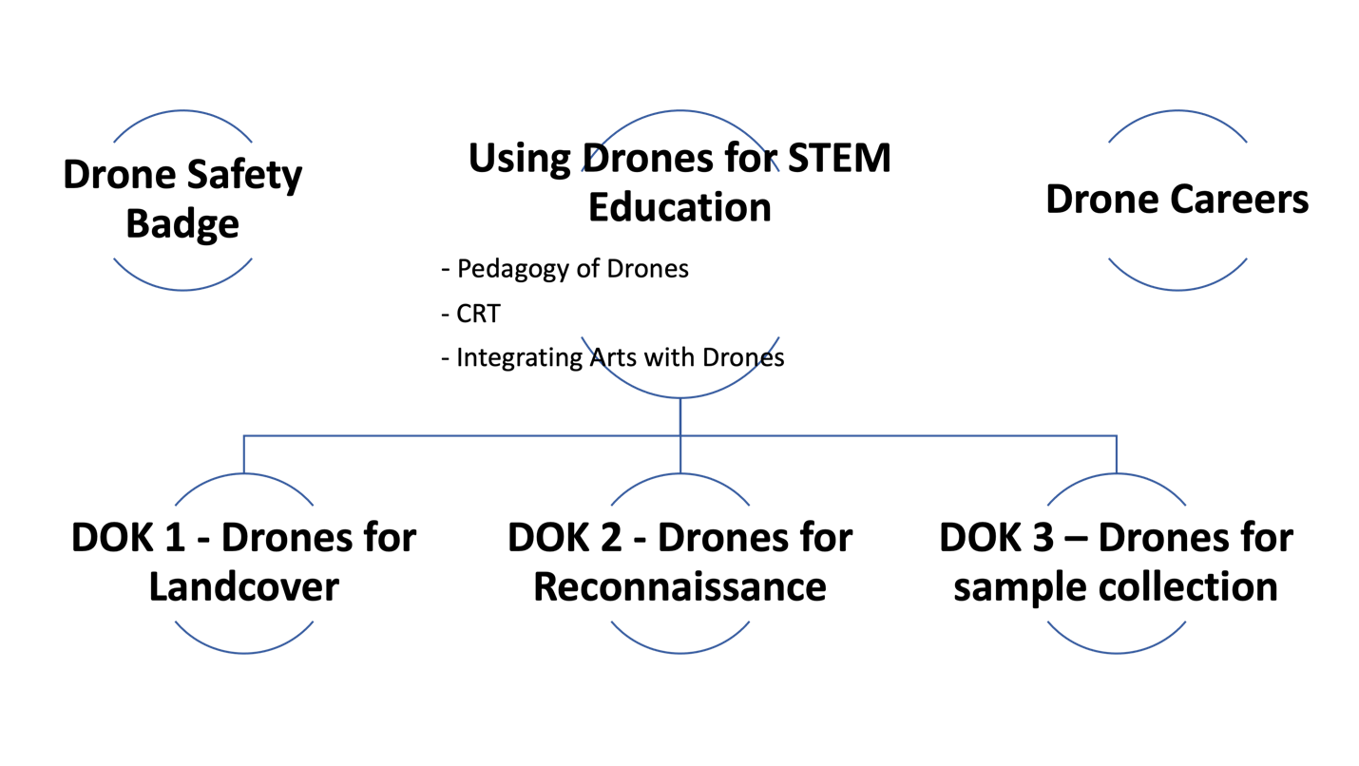

Description of Digital Badges:
- Drone Safety Badge – The objective of this badge is to inform educators about safety issues related to using drone with students in classrooms.
- Using Drones for STEM Education – This badge will cover general aspects of pedagogy of teaching using drones, strategies for implementing Culturally Responsive Teaching, and aspects of integrating Art as a part of STEM with drones. After completing this badge, educators can choose one of the tracks depending on their interest
  - DOK 1 Badge – Guidance on how to use drones to gather data about landcover in students’ communities. This badge will closely follow GLOBE’s Landcover protocol for NASA context.
  - DOK 2 Badge – At the next level, this badge will provide guidance on how to use drones to collect information on geological features of a terrain relevant to robotic exploration of either Moon or Mars.
  - DOK 3 Badge – At a higher level, the badge will provide ideas to include sample collection with drones and analysis of soil or water samples to study environmental conditions in a region.
- Drones Careers Badge – This badge will provide guidance on how to share career pathways that involve drones.

