**National Council of Teachers of Mathematics**

**Assorted Collection of Math Problems**

**April 25, 2009**

*Question 1 – 5: taken from the Australian Mathematics Competition:*

1. 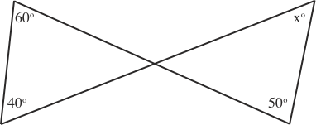The value of in the diagram is



(A) 50 (B) 100

(C) 80 (D) 40

(E) 70

2. A rectangle has its length 25 times its width. What is the ratio of its perimeter to the perimeter of the square of the same area?

(A) 13 : 5 (B) 13 : 10 (C) 5 : 1 (D) 51 : 20 (E) 51 : 10

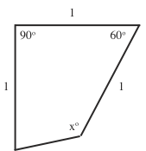3. In the diagram, the value of is



(A) 90 (B) 120

(C) 135 (D) 137.5

(E) 140

4. Natural fruit juice contains 80% water. In concentrating the juice, 75% of the water is removed. What is the percentage of water in the concentrated juice?

(A) 25 (B) 40 (C) 50 (D) 60 (E) 75

5. In the diagram, the square circumscribes the circle, is tangent to the circle and is one quarter of . What fraction of is ?



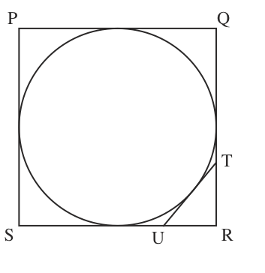 (A) (B)



(C) (D)



(E)



*Question 6 – 10: taken from the Bulgarian Mathematics Competition:*

6. In the multiplication below, different letters represent different digits and the same letters represent the same digits. Find them!

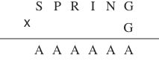

7. A hockey team played a match with six players on the rink and nine reserves. Each of the fifteen players played an equal amount of time (the replacements in the hockey are unlimited). How long did each one of the players play, if the match lasted 1 hour?

8. Two cars left city A for city B at 8AM. The distance between the cities is more than 200 km. The speed of one of the cars was 60 km/h during the first two hours and 15 km/h during the rest of the journey to B. The speed of the other car was 15 km/h during the first two hours and 60 km/h during the rest of the journey to B. At what time was the distance between the two cars 15 km?

9. Two car columns are traveling on a highway in the same direction. The cars are traveling at equal speeds of 110 km/h, and at a distance of 25 m between each other. At a certain place on the highway because of reconstruction the cars merge into one column keeping on traveling at a constant speed (possibly different) and at equal distances (possibly different from 25 m). The traveling is called “safe” if the distance between the cars is at least 7 m. The lengths of the cars are ignored (i.e., the care can be considered as points).

(a) Is it possible for the traveling in the reconstruction zone to be safe if the speed limit in the zone is 60 km/h?

(b) What is the least possible speed of the cars (correct to the nearest tens), so that the traveling in the reconstruction zone will be safe?

10. Before stealing the keys from the sleeping jailer, the prisoner has calculated that he will need at worst 21 attempts to find out which key for which cell is. How many cells are there in the jail?

*Questions 11 – 16: taken from the Texas Mathworks Qualifying Test:*

11. How many squares are visible in the diagram? Count all squares, 1x1, 2x2, 3x3, 4x4 and 5x5.

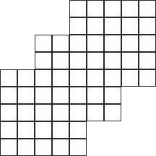

12. A frog can leap 1, 2, or 4 steps at a time in going up a stairway. How many different sequences are possible for the frog as it hops up 10 steps be avoids landing on the seventh step.

13. For numbers x, y define x ◊ y to mean xy + x + y. Hence, 1 ◊ 1 = 3 and 2 ◊ 3 = 11. Determine 1 ◊ 2 ◊ 3 ◊ 4 ◊ 5 ◊ 6.

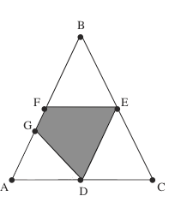14. Triangle ABC has AC = 13, BC = 15 and AB = 14. Segment CG is an altitude of the triangle and D, E, and F are the midpoints or AC, BC and AB respectively. What is the area of the quadrilateral DEFG?

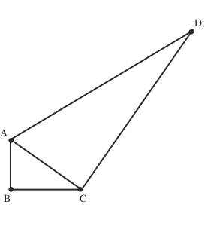15. Triangles ABC and ACD are non-overlapping right triangles with right angles at B and C respectively. If AB = 3, BC = 4 and CD = 12, what is the length of segment BD?

*Questions 16 – 20: taken from the Po Leung Kuk 11th Primary Mathematics World Contest:*

16. How many different ways are there to form a three-digit **even** number choosing the digits from 0, 1, 2, 3, 4 or 5 without repetition?

17. On a wooden rod, there are markings for three different scales. The first set of markings divides the rod into 10 equal parts; the second set of markings divides the rod into 12 equal parts; the third set of markings divides the rod into 15 equal parts. If one cuts the rod at each marking, how many pieces does one get?

18. A, B, C, D, A+C, B+C, A+D, B+D represent the eight different natural numbers 1 to 8. If A is the largest number amongst A, B, C and D, what is A?

19. The pattern below is formed by drawing semi-circles inside squares. The radii of the three types of semi-circles are 4 cm, 2 cm and 1 cm respectively. What is the total area of the shaded regions? (Take π = 3.14).



8 cm

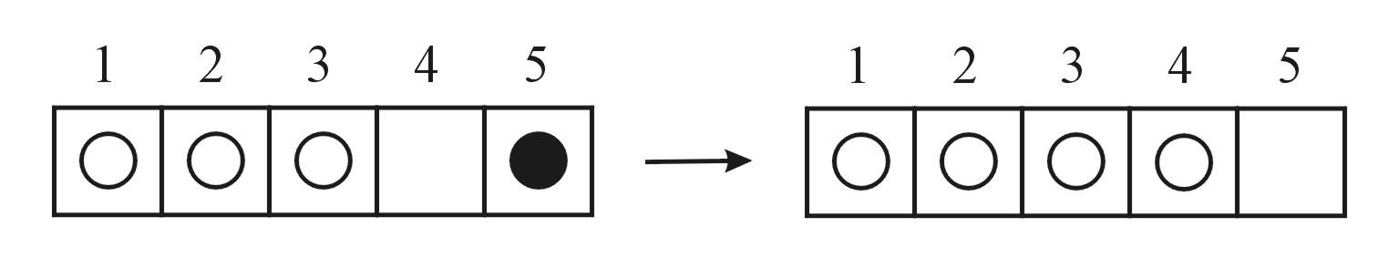20. On a 1x5 board are four counters which are white on one side and black on the other side. A counter can only change position by jumping over at least one other counter and landing on the empty space. When a counter has been jumped over, it is flipped over, but the jumping counter itself is not flipped. The configuration in the diagram below on the left must be changed to that on the right in six jumps. Record each jump by indicating the initial position of the jumping counter. Give one possible solution and its corresponding 6-digit number.

*Questions 21 – 22: taken from the American Mathematics Contest 8 (2007):*

21. The average age of 5 people in a room is 30 years. An 18-year-old person leaves the room. What is the average age of the four remaining people?

(A) 25 (B) 26 (C) 29 (D) 33 (E) 36

22. A unit hexagram is composed of a regular hexagon of side length 1 and its 6 equilateral triangular extensions, as shown in the diagram. What is the ratio of the area of the extensions to the area of the original hexagon?

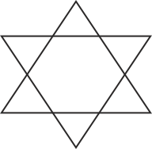 (A) 1:1

(B) 6:5

(C) 3:2

(D) 2:1

(E) 3:1

*Questions 23 – 24: taken from American Mathematics Contest 10 (2008):*

23. For each positive integer , the mean of the  terms of a sequence is . What is the 2008th term of the sequence?

(A) 2008 (B) 4015 (C) 4016 (D) 4,030,056 (E) 4,032,064

24. Bricklayer Brenda would take 9 hours to build a chimney alone, and bricklayer Brandon would take 10 hours to build it alone. When they work together, they talk a lot, and their combined output is decreased by 10 bricks per hour. Working together, they build the chimney in 5 hours. How many bricks are in the chimney?

(A) 500 (B) 900 (C) 950 (D) 1000 (E) 1900

*Questions 25 – 26: taken from American Mathematics Contest 12 (2008):*

25. A cone-shaped mountain has its base on the ocean floor and has a height of 8000 feet. The top  of the volume of the mountain is above water. What is the depth of the ocean at the base of the mountain, in feet?

(A) 4000 (B)  (C) 6000 (D) 6400 (E) 7000

26. Older television screens have an aspect ratio of 4:3. That is, the ratio of the width to the height is 4:3. The aspect ratio of many movies is not 4:3, so they are sometimes shown on a television screen by “letterboxing” – darkening strips of equal height at the top and bottom of the screen, as shown. Suppose a movie has an aspect ratio of 2:1 and is shown on an older television screen with a 27-inch diagonal. What is the height, in inches, of each darkened strip?

(A) 2 (B) 2.25 (C) 2.5

(D) 2.7 (E) 3

*Problems 27 – 31: taken from the 2008 -2009 MathCounts School Handbook:*

27. What is the ordered pair of positive integers (a, b) with b as small as possible, for which ?

28. Five cards are chosen at random from a standard deck of 52 cards. What is the probability that all five cards are the same suit? Express your answer as a common fraction.

29. The measures of the interior angles of a convex 9-gon form an arithmetic sequence and, measured in degrees, all are distinct integers. What is the measure of the largest possible angle if all the angles are obtuse?

30. A mixture is made with 45 ounces of a 10% saline solution and x ounces of a 70% saline solution. The resulting mixture is a 25% saline solution. What is the value of x, in ounces?

31. The Rockets and the Rangers are in a league where each of the teams plays 100 games. At this point in the season the Rockets have won 60% of their games, the Rangers have won 35% of their games, and both teams have the same number of games left to play. If the Rockets lose all of their remaining games while the Rangers win all of their remaining games, the teams will end the season with the same number of wins. How many games do the Rockets have left to play?

*Questions 32 – 33: taken from a Family Math Night Program*

32. Triangle ABC has area of 165. AD:DB = 1:2 and BE:EC = 2:3. Find the area of the quadrilateral BDFE.

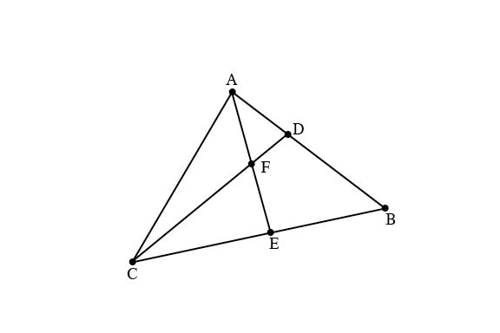

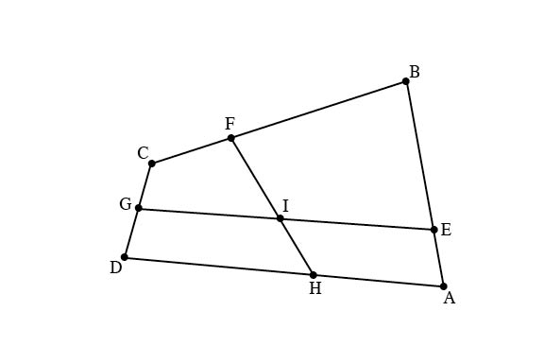33. In the following figure, G is the midpoint of CD and I is the midpoint of GE.

BE:EA = 4:1 and CF:FB = 2:5. Find DH:HA.

**Answer Key**

1. A

2. A

3. C

4. C

5. A

6. S = 1, P = 4, R = 2, I = 8, N = 5, G = 7 and A = 9.

7. Each player played 24 minutes.

8. The distance between the two cars was 15 km at 8:20AM, 11:40AM and 0:20PM

9. (a) Traveling will not be safe, (b) The least possible speed of the cars in the reconstruction zone, to the nearest tens, is 70 km/h.

10. There are 7 cells in the jail.

11. 137 squares

12. 76

13. 5039

14. 27

15. or



16. 52

17. 28

18. 6

19. 38.88

20. 152415

21. D

22. A

23. B

24. B

25. A

26. D

27. (5, 7)

**Answer Key (page 2)**

28. 

29. 176o

30. x = 15 ounces

31. 20 games