**How to Modify the Layout on FBL1N Type Boxes (Checkmarks)**

Log into SAP GUI.

Two screen shots are shown as to where to enter the T-Code as users have the option to select different view displays.

Enter transaction SU3 in the Menu bar. Hit the “Enter” key on the keyboard.

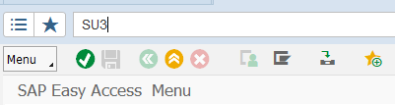

OR:

Enter transaction SU3 in the Menu bar. Hit the “Enter” key on the keyboard.

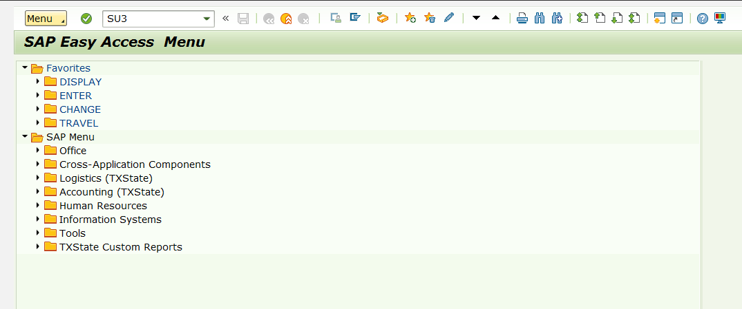

Click on Parameters

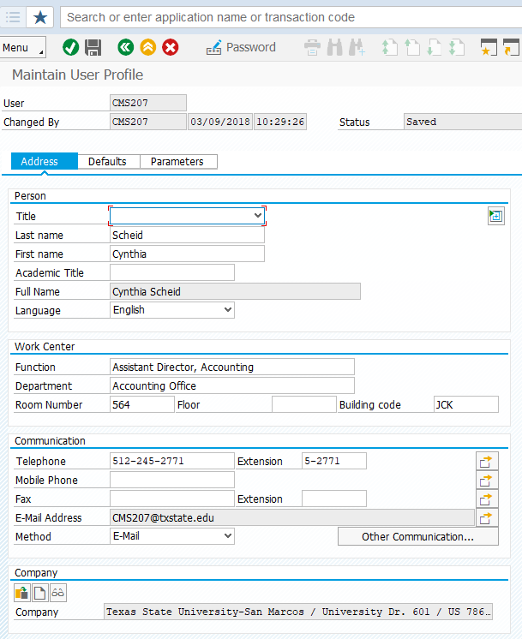

Scroll to the bottom of the list. 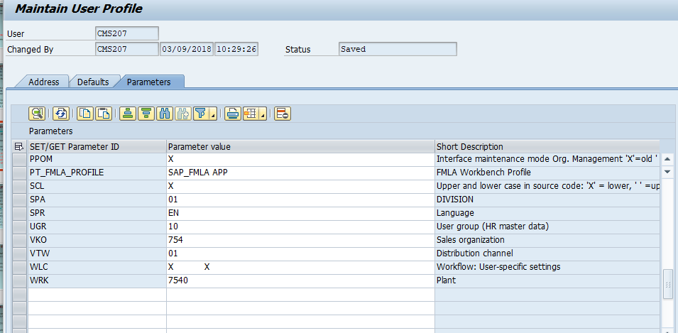

In the first blank column on the left type in FIT_X_AP. In the second column type XXXXX.  
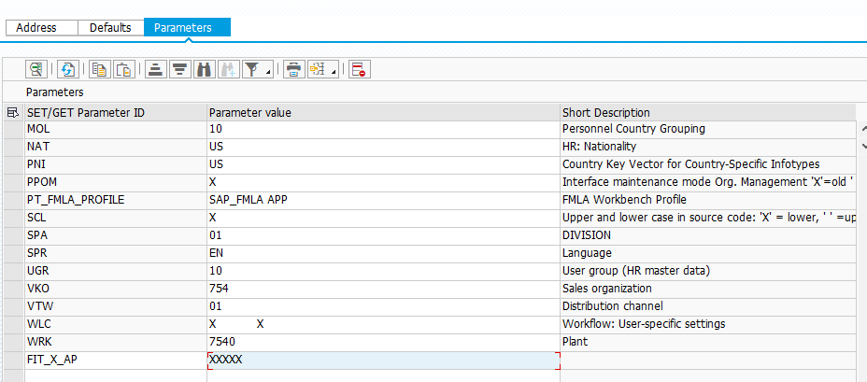

Select the SAVE icon at the top.

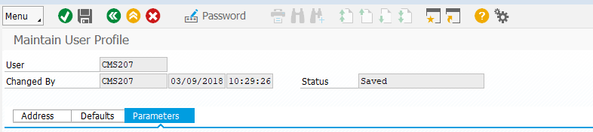

Select the EXIT icon.



Go to FBL1N and you should see all the of the Type boxes checked. 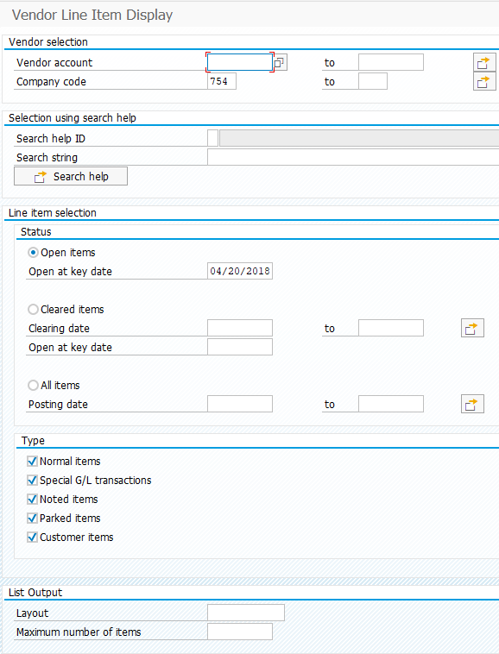

You will not have to check these boxes each time you want to view vendor payment information.