The following instructions will provide procedures for the following:
- How to look up vendor payment history. Pg. 1, 2
- Has the invoice been paid? Checking invoice status. Pg. 3
- What is the invoice number? Pg. 3
- How was the payment made to the vendor? Pg. 3
- What is the check number for the vendor payment? Pg. 4 – 7
- Vendor Payment Block. Pg. 8

How to look up the vendor payment history.
Log into SAP (GUI version). Enter transaction code: FBL1N.
The Vendor Line Item Display screen will appear.

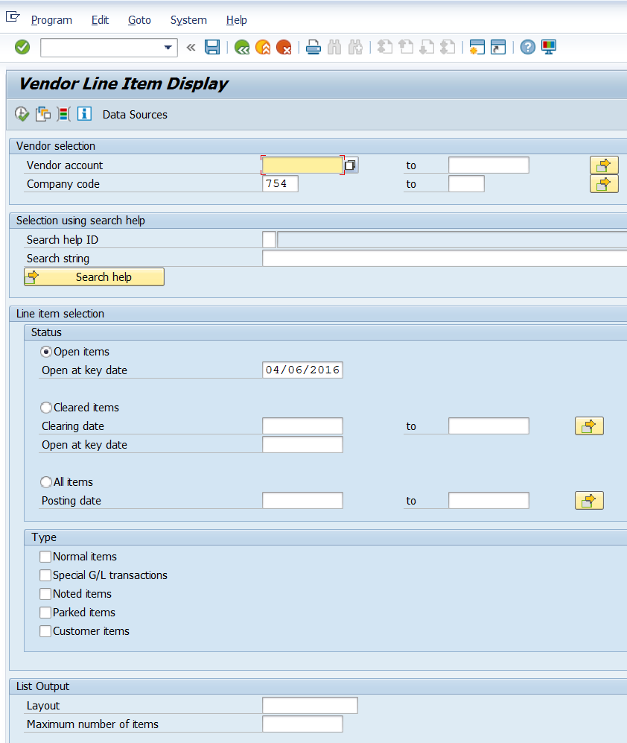

Enter the vendor number in the field located next to “Vendor account”.
Select the radio button for “All items Posting date” located in the “Line item selection section Status”.
In the spaces located next to Posting date, enter a date range to narrow the search history or leave these date fields blank to search for all items.
In the “Type” section the “Normal items” box will be checked as the default. Check the remaining boxes next to “Special G/L transactions”, “Noted items”, “Parked items”, and “Customer items”.
Click the execute icon in the upper left hand section of the screen to view the vendor payment history.
Instructions for how to default your settings in SAP to automatically check all the necessary boxes are available via the “How to Modify the Layout on FBL1N So Checkmarks Remain” document on the Accounts Payable View Vendor Invoice & Payment Activity webpage.

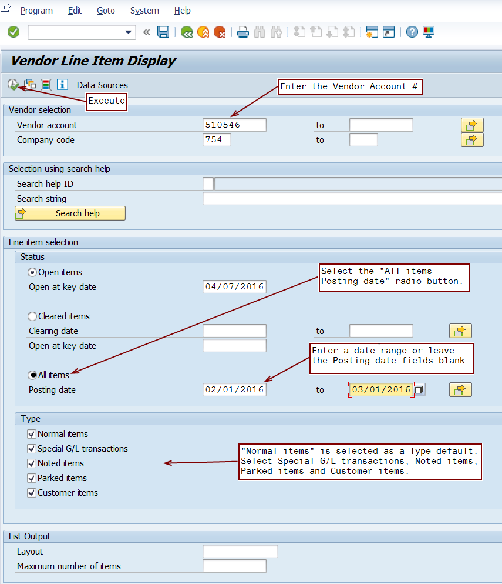

Has the invoice been paid? Checking invoice status.
Cleared/opened items can be determined by viewing the ST (Status) in the first column.
The Green is for paid invoices; the Yellow is for documents that have been entered – not yet posted; the Red is for documents that have been posted – not yet paid.
The Payment Clearing line will have “ZP” as a Type (Document type) indicating an invoice has been paid.

What is the invoice number?
The Inv # / Ref # column contains the vendor invoice number.

How was the payment made to the vendor?
PM (Payment Method) indicates how the payment was made to the vendor. The payment methods are as follows: A = American Express; C = check; D = direct deposit; U = USAS State funds; W = WEX; T = Wire; (Note: Grainger, vendor #3215 also may have G but this payment method is used for this vendor only).

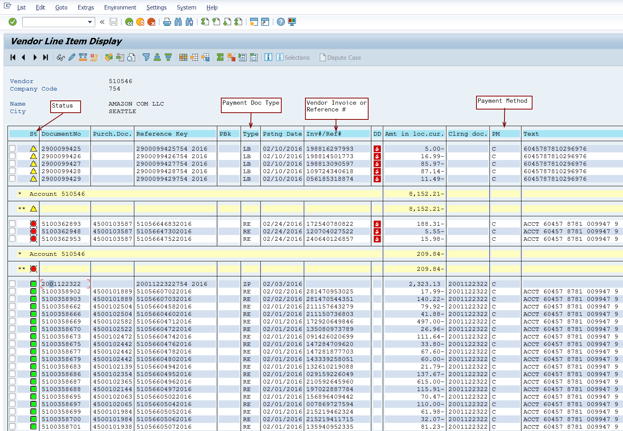
$2,323.13 was paid by check on 02/03/2016 for the 19 invoices listed below the payment.
Payment posting document type

What is the check number for the vendor payment?
On the Vendor Line Item Display screen, you can view the check detail if the document was paid by check.
The Pstng (Posting) Date on the Payment Clearing line (ZP in the Type column) is the clearing date, and payment date of the document.
To “Display Check Information” place your curser 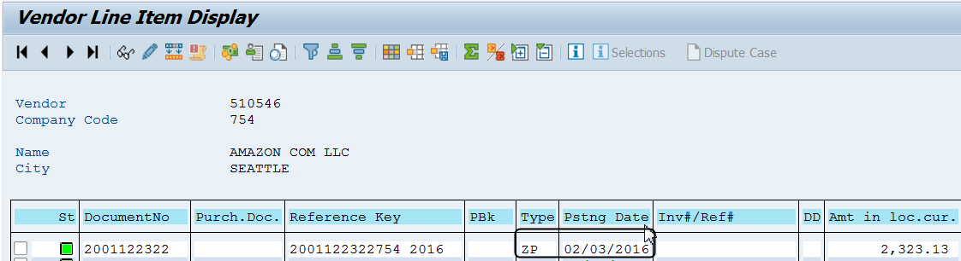
You can “Display Check Information by placing your curser on the row for the payment that you want to review and hold down Ctrl + Shift + F or select the “Display Check Information” icon shown below.
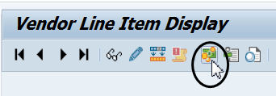
The “Display Check Information” screen will appear.
Located in the Check information section is the Check number, Payment date, Amount of the payment, and the Check encashment date (date the payment cleared the Texas State bank account).

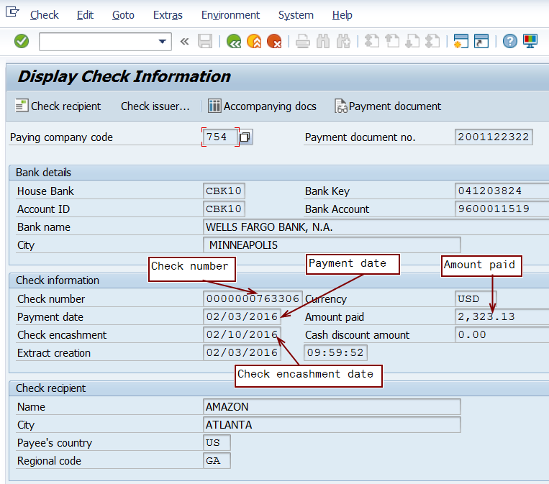

It the display check information icon is not available, double click on the DocumentNo to see the check information detail on the “Display Document: Line Item” screen.
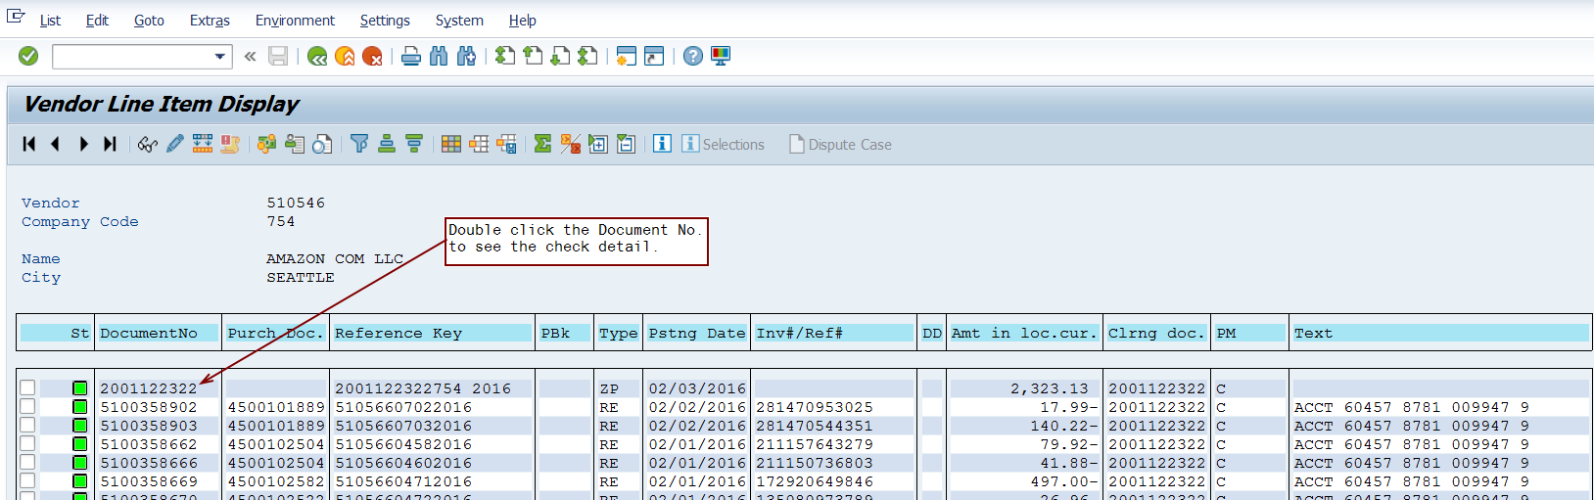

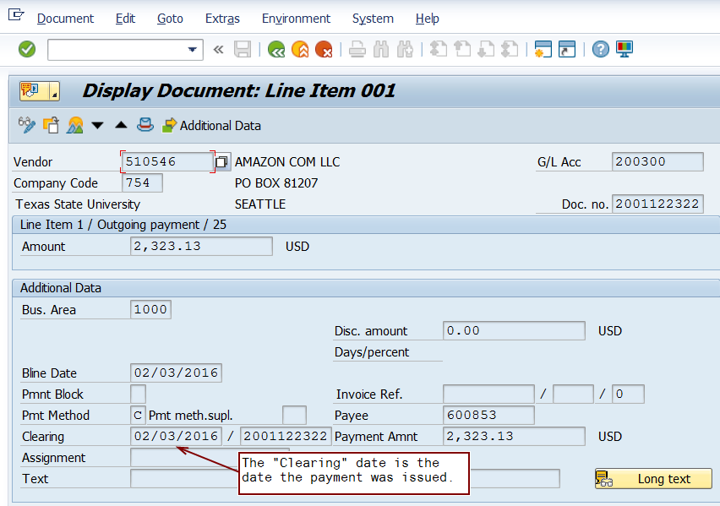

Next click the icon located on the top upper left side of your screen to display the tool bar if it is not already visible.
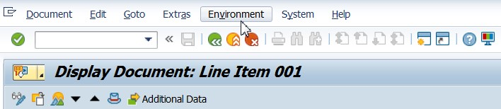
Next click “Environment”.
Click on Icon to display the tool bar.

Click “Check Information”
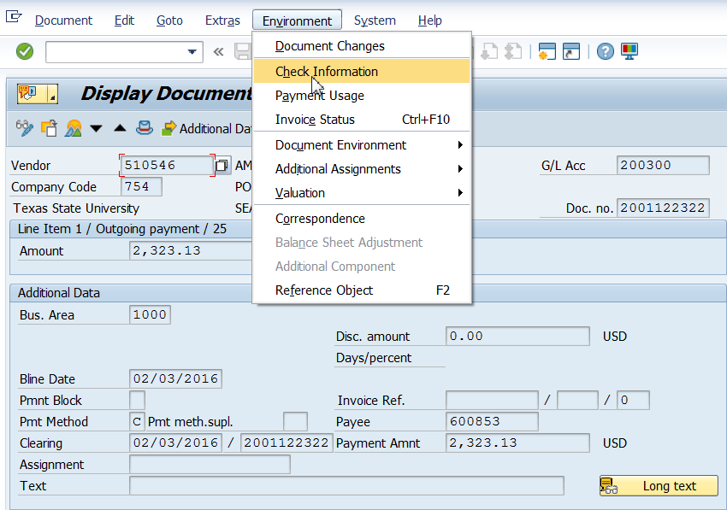

The “Display Check Information” screen will appear.
Located in the check information section is the Check number, Payment date, Amount of the payment, and the Check encashment date (date the payment cleared the Texas State bank account).

Vendor Payment Block
Whenever an H is in the payment block field, as seen below, a manual block was applied. The Accounts Payable office will release the payment when the department has sent requested information.

Whenever an “R” is in the payment block field, a GR (Good Receipt) should be completed in SAP for payment to be released.

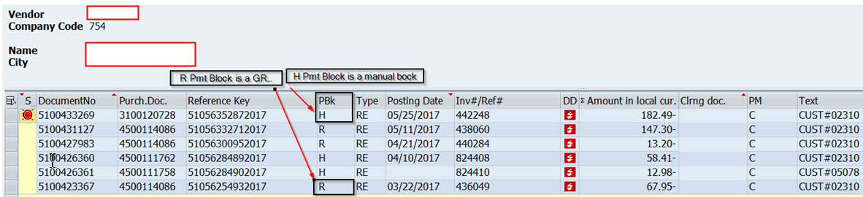

The payment may not be released even when the charge is on the Budget To Actual Report. When a payment has been posted (red status), it is ready to pay unless there is a payment block (PBk). Look at the "Vendor Line Item Display" (FBL1N) to check the payment status.

