Searching for HUBs
- Search the Commodity Book for the service(s) to fulfill your procurement or subcontracting needs. The search will result in a list sorted by Class Code and a Description of the service.
The class code is 3 digits followed by a hyphen and two digits. The last two digits are the Item Code. The Item Code helps narrow down the search from the Class Code. Scroll through the list and find the appropriate Class & Item Code for your needs.
Website: https://mycpa.cpa.state.tx.us/commbook/indexSearch
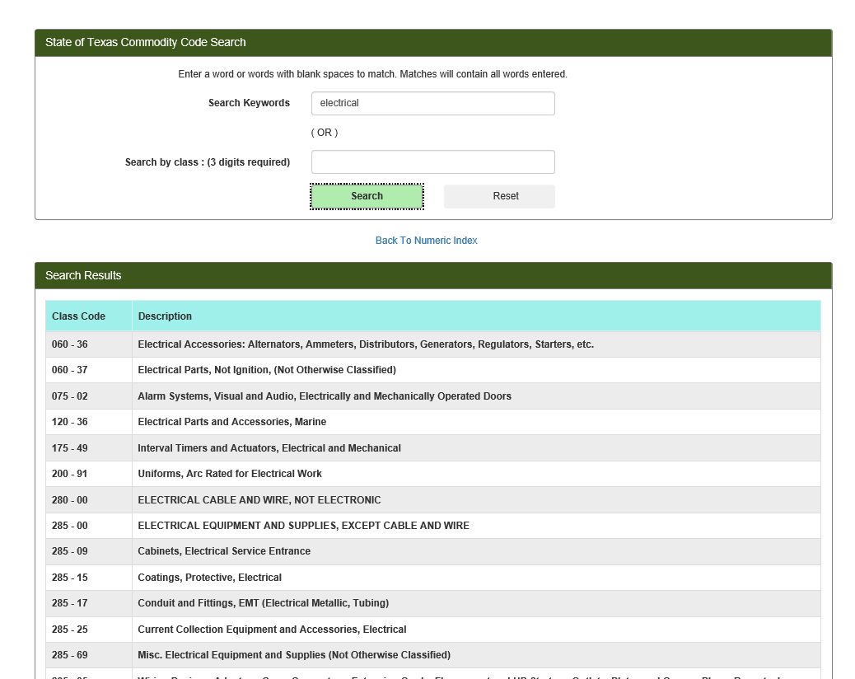
- You will then search the Centralized Master Bidders List – HUB Directory Search (CMBL) for a list of HUBs and/or Non-HUBs using the appropriate class code found from the Commodity Book.
Website: https://mycpa.cpa.state.tx.us/tpasscmblsearch/tpasscmblsearch.do?
Select a radial button for the type of vendor you would like to search e.g. HUBs Only, All Vendors (HUBs & Non-HUBS), etc.
Click the drop-down arrow next to the Multiple Vendor Search row and insert the Class Code in the NIGP column and the Item Code (if needed) in the Item Column. Texas State University can be found in in Highway District 14, but it is helpful to broaden the search by using Highway Districts 14 & 15 as San Marcos is in the middle of San Antonio and Austin.

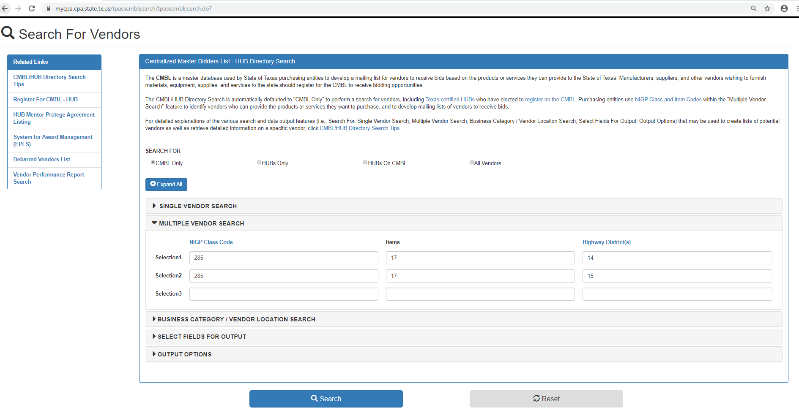
- Click Search. This will pull up a list of HUBs that you may solicit to for your procurement or subcontracting needs. If you chose the radial option of “All Vendors” please make sure that the HUB status is Active. Keep a copy of your solicitation to submit with your HUB Subcontracting Plan or your requisition.
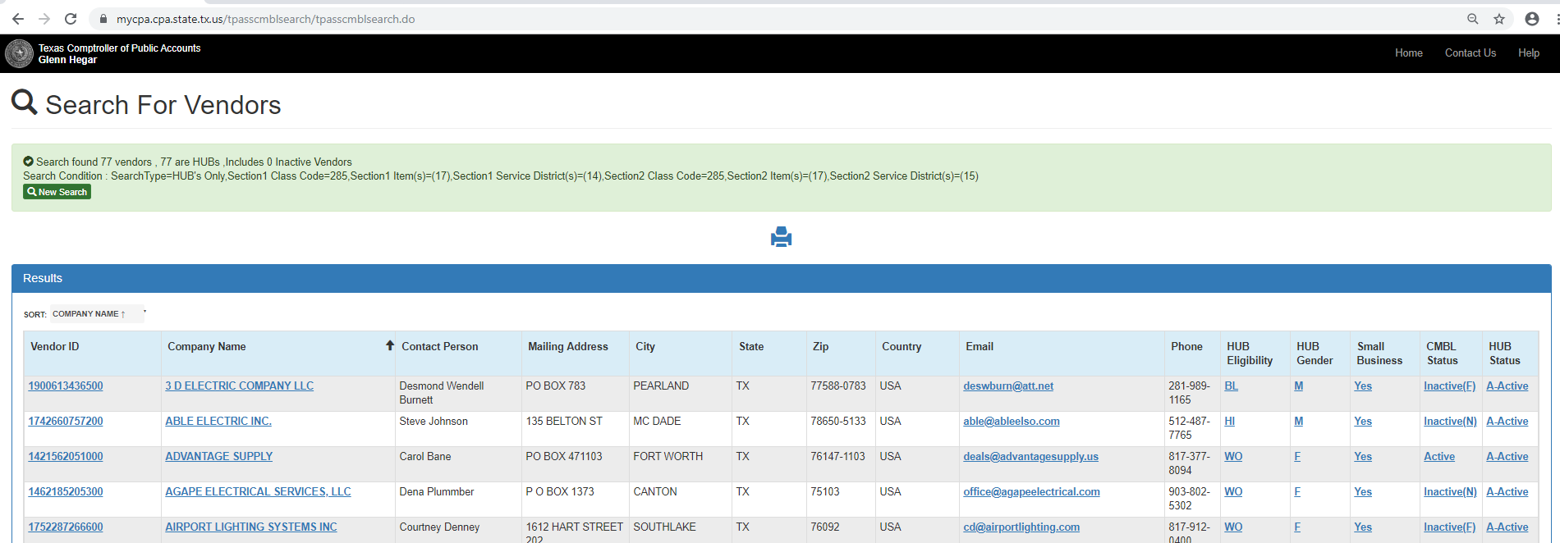

Highway Districts Map:
https://comptroller.texas.gov/purchasing/contracts/regions.php

