RETREIVING THE EXECUTED CONTRACT

When you are notified that the contract is fully executed, it will include the contract number. This is what you will use to search for your contract.

- Login to the SAP Portal at https://authentic.txstate.edu/idp/profile/SAML2/Redirect/SSO?execution=e1s1

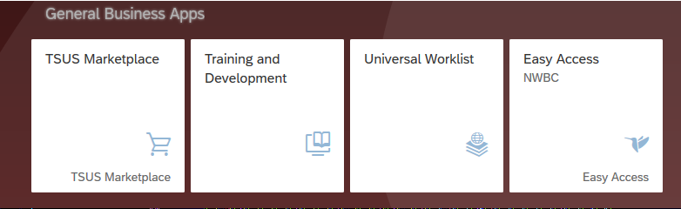
- Click on TSUS Marketplace icon under the “General Business Apps”

- On left side menu bar, click the Contracts icon. Enter the contract number from the email in the search field. Click on the magnifying glass.
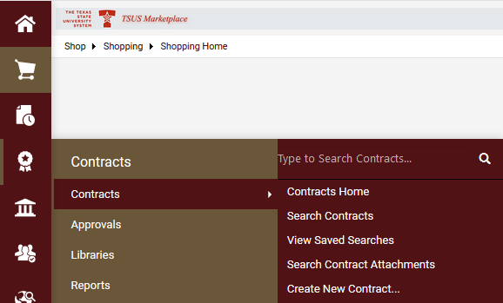
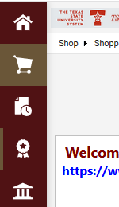

- Click on the contract number.

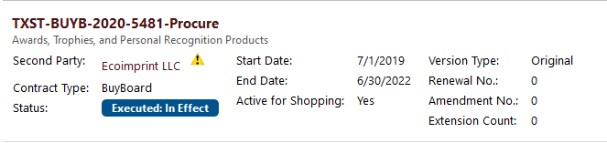

- On the contract details page, click on the “Attachments” options on the left-hand menu bar.

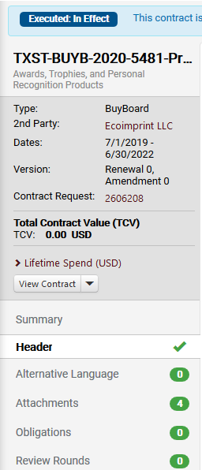

- On the attachments, click on the “Fully Executed Contract” option under the “Attachments” heading. This will bring up the fully executed contract.

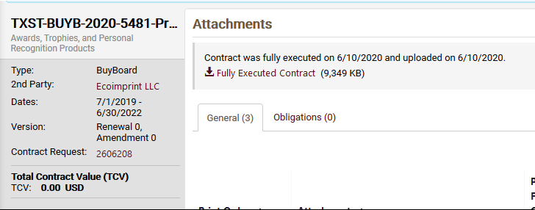

Should you have any questions, please contact purchasing at 512-245-2521 or email contracts@txstate.edu.

