San Antonio College
Summer Undergraduate Research Program

Final Research Report

SolGo ARV: Electrical System

Julio Banda, Dominic Ochoa, Yeojin Park & Kevin Castano

December 16th​, 2015​

Contents

ABSTRACT 2

INTRODUCTION & BACKGROUND 3

PROJECT TIMELINE 4

ALTERNATIVES CONSIDERED 6

PROPOSED DESIGN 11

EQUIPMENT LIST 15

FUTURE TESTING 17

DISCUSSION & CONCLUSIONS 18

SOLGO ARV: ELECTRICAL PARTICIPANTS 22

ACKNOWLEDGMENTS 23

REFERENCES 24

APPENDICES 25

Abstract

The SolGo ARV (Solar Go Alternative Resources Vehicle) Electric, was a SAC Undergraduate Research Program (SURP) project for summer, 2015. Prior SURP projects in 2011 and 2012 measured the increase in solar panel efficiency when panels were cooled in various ways using air or water. In addition, Team Heavy, a SURP participant during the summer of 2013 researched, designed, and tested the electrical components necessary for a solar powered vehicle to work properly. The Sol GO ARV is the culmination of these two previous projects; a fully functional solar electric vehicle for use by the
San Antonio College Mathematics, Engineering and Science Achievement (MESA) Center to promote
Science, Technology, Engineering, and Mathematics (STEM) at different events on and off campus.
The project consisted of two teams of four undergraduate students, the mechanical team and the electrical team. The mechanical team focused mainly on modification of a surplus gas­powered utility cart in order for it to accommodate an electric motor and two solar photovoltaic (PV) panels. The electrical team focused on the design of the electrical subsystems which include the motor system, the solar array system, and the accessory electronics.
The project encountered different obstacles throughout the duration of the summer. These obstacles included delays in obtaining equipment, difficulties in team members learning new concepts, problems in communications between the two teams, and challenges with interfacing the electrical equipment with the mechanical equipment. Despite these obstacles and schedule delays they caused, the car was ultimately finished and made fully functional. However, time did not permit performance testing of the solar­electric vehicle, such as determining the time required to charge the batteries using solar power and the duration the vehicle will run on a single charge. It is hoped that a SURP team will accomplish this in the near future. The SOLGO ARV is now able to be displayed at STEM­related events across the SAC campus and the community.

Introduction

Since the first gasoline­powered automobile was invented in Germany in the late nineteenth century, the consumption of gasoline and petrol has grown exponentially. Subsequently, air pollution, from gas emissions of those fuels, has also been increasing.
Alternative energy sources, such as solar power, offer an environmentally friendly option in place of fossil fuels. These alternative energy sources help reduce the amount of harmful pollutants and greenhouse gases emitted by the burning of gasoline and other fossil fuels in vehicles. They are also part of a solution for the inevitable fossil fuel shortages in the future. Finally, alternative energy sources might reduce the cost of fuel for vehicles as they are renewable sources and always available. To use alternative energy sources in place of fossil fuels is to look for a better future of the environment.

Background

Previous SAC Undergraduate Research Program (SURP) participants have provided advantageous information and resources, which we can incorporate into our own project. Prior SURP teams have used photovoltaic (PV) panels in their projects to find ways to improve their maximum efficiency and Team Heavy’s (previous SURP participant in 2013) research demonstrated the performance of a battery powering an electric motor running at different speeds when either connected or disconnected from a PV panel. This information was useful to our SURP project since we would have some background data on how to make the battery packs the most efficient. In addition, we used the previously purchased PV panels for our use and it allowed us to use our funds towards the purchase of other vital components.
SolGo ARV consisted of two teams, the electrical team and the mechanical team. The electrical team dealt with all the electrical devices and how they were going to function together. The mechanical team worked to modify a donated, inoperable gas engine powered utility cart (see Figure 1, below) such that it could accommodate an electric motor for driving the wheels and two solar panels mounted on the roof. We collaborated with each other by attempting to figure out how we would mount the electrical elements onto the frame of the vehicle. This was being carried out with measurements, safety, and accessibility in mind.
Requirements for the SolGo ARV were to accommodate seating for two people, have the ability to maneuver in reverse, provide storage compartments for common school handouts, personal items, and include appropriate safety items (lights, brakes, horn, seat belts).
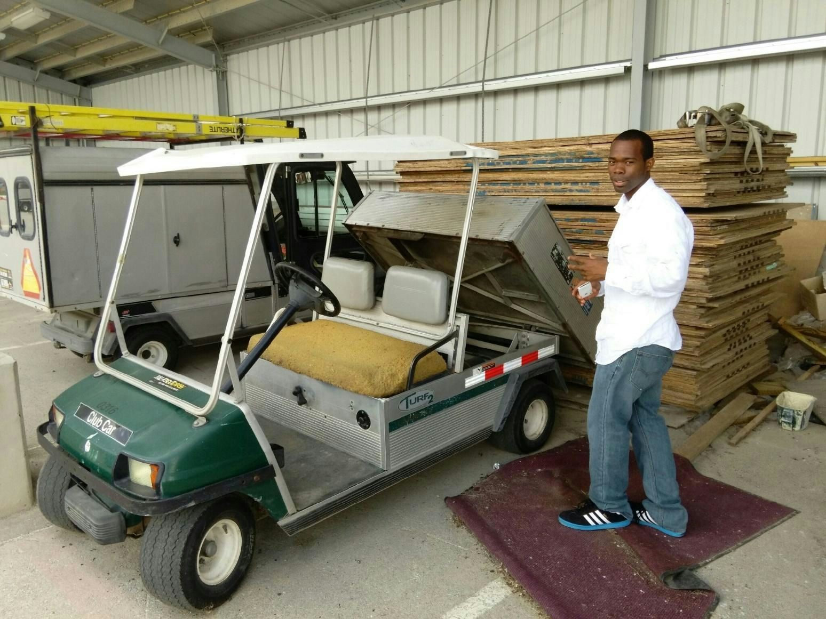
Figure 1 Surplus Gas­Powered Utility Cart

Initial Projected Project Timeline (also, see fig 2, pg. 6)

Week One​ (6/8​6/15):
- Initial Project Meetings (6/8)
- Part List Assembled and Finalized (6/8​6/14)

Week Two​ (6/15​6/22):
- Concept Familiarization (6/15​6/22)
- Preliminary/Abstract Design (6/15​6/22)

Week Three (6/22​ 6/29):​
- Library Workshop (6/24)
- Finalize Design (6/22​6/29)

Week Four​ (6/29​7/6)
- Off frame Assembly (6/29​7/2)

Week Five​ (7/6​7/13):
- Digital Storytelling Workshop (7/7)
- Analyze Test Phase 1 Data (7/9​7/11)
- Complete Project Design Document (7/13)

Week Six​ (7/13​7/20):
- Parts Ordered (7/13)

Week Seven​ (7/20​7/27)
- Parts Received (7/21)

Week Eight​ (7/27​8/3)
- Begin On Frame Assembly (7/27)

Week Nine​ (8/38/10)​
- Test Phase (8/3)
- Analyze Test Phase Data (8/4) ● Finish Final Report (8/5~)

Week Ten​ (8/10​8/17)
- Customer Delivery and Acceptance (8/10)
- Finish Final Report (~8/17) ● Finish PowerPoint (~8/17)

August
Digital Storytelling Video (8/17​8/21)
September
Presentation during STEM Week (9/8)

Figure 2. Project Gantt Chart

Alternatives Considered

There are 5 major components to a solar­electric vehicle.
- Photovoltaic Panels ­ Converts sunlight into electrical energy (Also called solar panels or solar modules)
- Charge Controller ­ Regulates voltage and current applied to the batteries produced by PV array.
- Battery Pack ­ Storage source for power being produced by PV array
- Motor Controller ­ Regulates how the motor will run through the controlling of current and voltage.
- Motor ­ Converts electrical energy into mechanical energy

Motor
Because we were continuing the work of the Team Heavy ​Electrical Subsystem for Solar Panel
Electric Cart​ report, we used their suggestion for motor and motor controller which is the ME0909 and
AXE4834 respectively. The ME0909 motor had fit our specifications perfectly. We used a Club Car Turf 2 utility cart as our frame. The original motor for the Turf 2 is a 3.7 horsepower shunt wound motor. The ME0909 can reach up to 4 horsepower continuously at 48VDC (see Appendix C).

Photovoltaic Panels
We will be reusing the solar panels from previous SURP projects which are Yingli YL235P­29B’s (see Appendix F). That leaves our team with batteries and a charge controller to consider.

Batteries
The main limitation of a purely solar powered vehicle is that the amount of electricity is dictated
by the availability of sunlight. If the sun is shaded, or if it is in the evening time, the car will not be able to run. The way we got around this problem was by using a battery pack to store the energy produced by the solar panels, when sunlight ​is ​available, for later utilization. We had three options as for which type of battery to use.
- Lithium Iron Phosphate (LiFePO​4)​
- Lithium Polymer (LiPo)
- Absorbed Glass Mat (AGM)

Lithium Iron Phosphate batteries

Lithium Iron Phosphate batteries (LiFePO​4)​ are a type of lithium ion battery. They are efficient and very safe. One of the biggest advantages is the fact that they have a constant discharge voltage. That means that if the battery is rated for 3.2V, it will stay close to that voltage as it discharges. This is important as the motor will be able to operate at an optimum torque throughout a discharge cycle of the battery.
The LiFePO​2 battery is a chemically stable battery. Regardless if the battery is charged or​ depleted, the bonds between the Fe­P­O ions remain strong. Oxygen (O​2)​ molecules are unlikely to disassociate and ‘leak’ out, reducing the risk of ignition in the case of mishandling.
The biggest drawback lies in the charging. Because no standard charge controllers offer charge profiles for any lithium based battery, we would be required to buy an expensive programmable charge controller.

Lithium Polymer
Lithium polymer (LiPo) batteries are another type of lithium ion battery. The polymer denomination comes from the soft and lightweight polymer encasing. This type of battery is typically used in cellphones and laptops.
As with all lithium ion based batteries, LiPo batteries are susceptible to overcharge, overheating, and electrolyte leakage. When a battery is overheated or overcharged, the liquid based electrolyte undergoes vaporization. Because the battery has a soft case it will expand and possibly explode. In order to use LiPo batteries safely, the solar electric car would need to have a battery regulation system which we would purchase or make ourselves. That requires either time or money that could be better spent elsewhere.
LiPo batteries also require specific charge stages just like LiFePO​4 so the same drawbacks in​
that regard apply to LiPo as well.
Deep Cycle Absorbed Glass Mat
Absorbed glass mat (AGM) batteries are a special type of sealed lead acid battery. The acid
electrolyte is absorbed by fiberglass making the battery spill­proof. This kind of configuration also allows for greater resistance to vibration and shock as the mats and metal plates are tightly packed within the battery.
The biggest advantage to AGMs is that they are very safe. In addition to resistance to vibration and being spill­proof, AGM batteries are ​recombinant​ batteries which means that any released O​2 and H​ ​+ ions recombine within the cell itself so there are no concerns with fumes even when used in high temperature environments. This also means that we don’t have to equalize the electrolyte levels periodically, which is typical for standard flooded lead acid batteries. AGMs require less maintenance all around.
When it comes to charging AGM batteries with solar panels, AGM batteries are the most favorable. Sealed lead acid batteries (AGM included) are the industry standard for off­grid solar electric energy storage. This means we would not need a custom programmable charge controller, but can use a lower cost standard off­the­shelf unit.

Conclusion
With a good life cycle, safe chemical configuration, and easy interface with solar charging, our team selected the absorbed glass mat (AGM) battery for our vehicle. The model of battery we chose was the Power Patrol 1155 12­volt battery. We had 4 in series, producing a 48V battery pack. The reason is that 48V is the optimum voltage rating for our electric motor.

Charge Controller
When charging a battery bank by means of photovoltaic panels it is important to include a charge controller to regulate the panel voltage and current provided to the batteries. The reason is that if the panels were directly connected to batteries, the varying voltage and current could damage the battery cells by overcharging or undercharging. When it comes to selecting a controller we have two types to choose from.
- Maximum Power Point Tracking (MPPT)
- Pulse Width Modulation (PWM)

Maximum Power Point Tracker (MPPT)
A MPPT, is a type of DC­DC converter that optimizes the voltage coming out of the solar panels to match the voltage of the battery pack. The way it works is quite simple. The controller takes the DC input from the panel and converts it to a high frequency AC (up to 80 kHz).
The AC is then rectified back to DC, at the battery pack voltage, optimizing the charge going to the battery pack. Here is a table of popular models of MPPTs (fig. 3 below).

Company | Model | Price
Outback | FLEXmax 80 | $554.00
Midnite | Classic Lite 150 | $540.00
Morningstar | Tristar 60 | $499.00
*​Prices taken from Wholesale Solar

Figure 3 MPPT Charge Controllers​

Pulse Width Modulation (PWM)
There is a second method of solar charging called PWM. ​Instead of a steady output from the
charge controller, it sends out a series of short charging pulses to the battery ­ essentially working as a very rapid "on­off" switch. The controller constantly checks the charge of the battery to determine the frequency and wavelength of the pulses in a fully charged battery with no load, it may just "tick" every few seconds and send a short charging pulse to the battery. In a discharged battery, the pulses would be very long and almost continuous. The controller constantly checks the state of charge the battery between pulses and adjusts itself each time. Here is a table of popular PWM models (fig. 4 below).

Company | Model | Price
Schneider Electric | Xantrex C­40 | $110.00
Morningstar | Prostar PS­15M | $190.00
*​Prices taken from Wholesale Solar

Figure 4 PWM Charge controllers

Conclusion
With consideration to simplicity and price, our team selected pulse width modulation as our charge controller method. The model we selected was the Prostar PS­15M charge controller from Morningstar as it proved to be the most cost effective (See Appendix D).

Proposed Design

Following the suggestions of Team Heavy as well as our analysis detailed previously, the electrical configuration for the SolGo ARV is as follows:
- One 48V, 4 horsepower permanent magnet motor
- One 48V, 300A motor controller
- Four 12V, 35Ah AGM batteries
- Two 235W Polycrystalline solar panels
- One 48V, 15A PWM charge controller

Operation

The operation of the solar electric car works as follows (see fig 5, pg. 14). The 48V battery pack

(IV) is charged by two solar panels (I) which are being regulated by the ​Prostar ​​PWM charge controller (X). The battery output goes to the main contactor (V). The contactor is an electromechanical relay that is controlled by a toggle switch, ideally placed in the driver’s compartment. When the switch is flipped on, the solenoid in the relay is energized and connects the high voltage contacts (48v) completing the circuit from the batteries to the motor controller (III). Once the motor controller is powered, the driver will control the speed of the motor with a 0​5k​Ω potentiometer (pot) integrated in a foot pedal throttle.​ ​ The motor controller receives the signal from the pot and as the resistance increases, the motor speed increases.
To reverse the motor, we used a reversing contactor (VII) which conceptually works very similar to the main contactor. Instead of it being switched on or off, the reversing contactor has two states: forward or reverse. Each state has its own solenoid which are each powered by a Single Pole Double Throw (SPDT) switch. When the switch is flipped, the opposite solenoid is then energized, safely reversing the polarity of the motor and thus the direction it spins.
For protection we placed a 250A ceramic fuse (XI) on the positive side of the battery bank. If for any reason the system current exceeds 250A, the fuse will blow and the power will be cut off from the contactor and the motor controller.
Another protective component we implemented is the precharge resistor. Our motor controller
has a bank of capacitors that is connected to its inputs. An uncharged capacitor’s resistance is so little, that when a voltage is applied to it, it will appear to short circuit. This means that when a contactor without a precharge resistor closes, there will be a large voltage difference and sudden high current (known as “inrush current”) across the contactor. This can result in the damage or, in extreme cases, welding of the relay contacts. To prevent this, we connected a precharge resistor in parallel with the main contactor. This allows for low current charging of the capacitor bank prior to the closing of the contactor. When the capacitors are charged, their resistance increases, therefore decreasing the inrush current and allowing for the safe closing of the main contactor.
The last component for protection is the coil suppression diode. When the solenoids in each of
the contactors are shut off, they will try to resist the sudden drop in current by using their own stored magnetic field to produce a high voltage spike. To prevent voltage spike arcing, a diode is placed parallel with each solenoid. The diode then allows the solenoid to draw current from itself and dissipate voltage through losses (resistance) in the coil wires. (see Appendix E)
Finally, to measure data, we used a Grin Technologies ​Cycle Analyst​​. The Cycle Analyst works as a standard ammeter and shunt configuration. It measures the voltage drop across a shunt that is placed on the negative side of the battery bank. The Cycle Analyst then translates the voltage measured to the amount of current running through it. On top of measuring current, the Cycle Analyst will also measure net amp hours. This allows the driver to know how much energy they have drawn from the battery and how much of the 35Ah capacity remains.

Component Layout
The layout of the major electrical components is as follows. The motor controller, main contactor, reversing contactor, main fuse, cycle analyst shunt, and charge controller were mounted on a board of acrylic that was then mounted on the car frame behind the driver’s seat (Fig. 8, pg. 20). The batteries themselves were mounted underneath the driver’s seat and reinforced by angle aluminum and diamond plate provided by the mechanical team. Our two solar panels were mounted on supports and act as a roof for the car. These panels were stacked on top of each other when the car is driving. When the car has stopped and is ready to charge, the top panel that is mounted on a sliding rack will slide out and allowed us to utilize both panels for charging (Fig 9, pg. 21).

Figure 5 Wiring Diagram

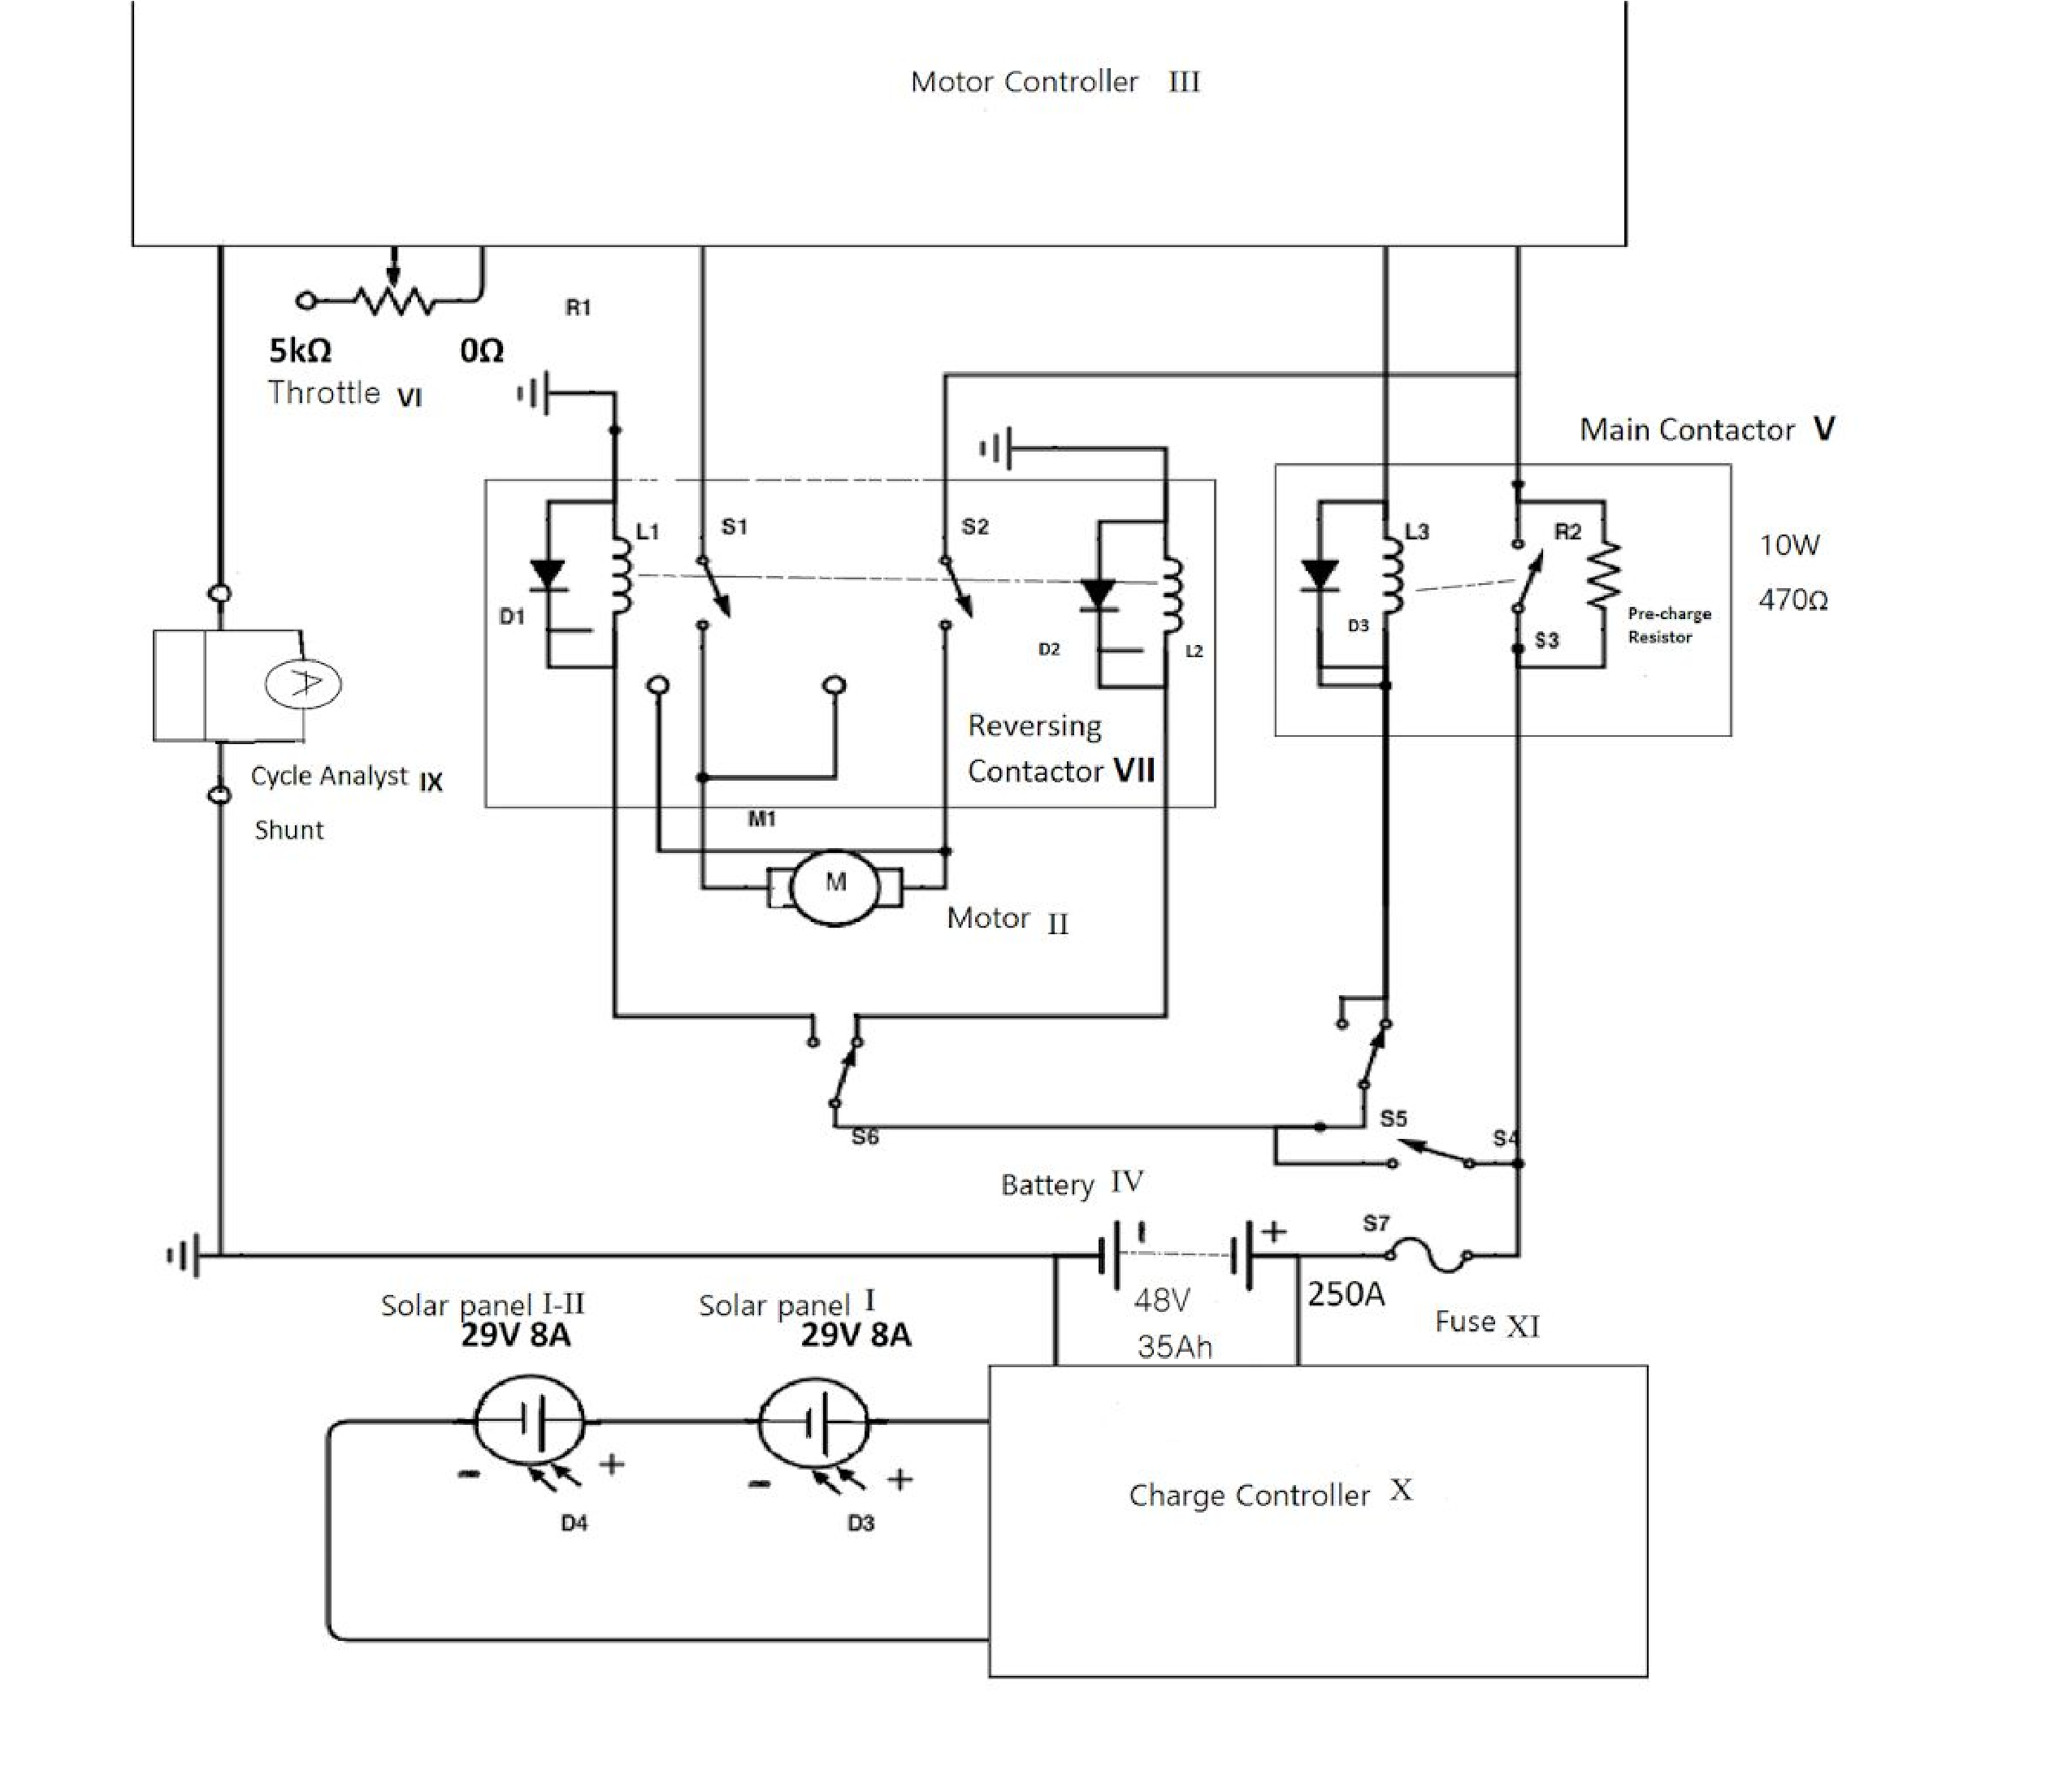

Equipment List

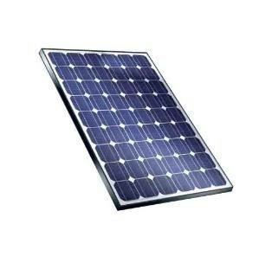​ 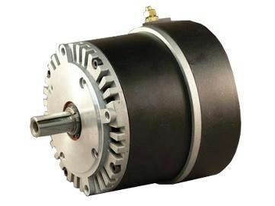​ ​ 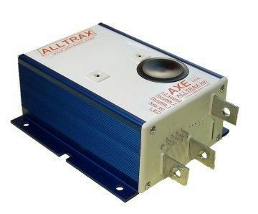
1) Solar Panel 2) Motor 3) Motor Controller

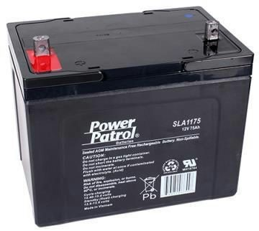​ 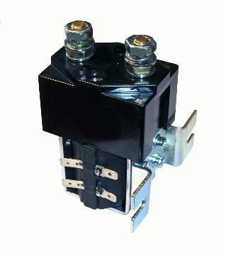​ 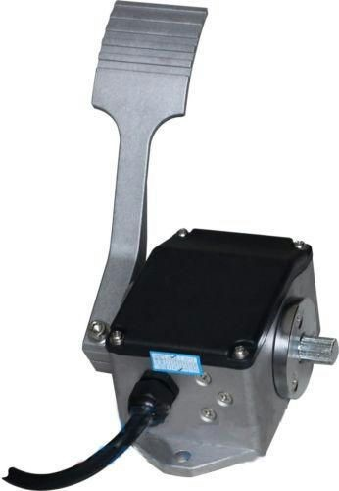
​ 4) Battery 5) Main Contactor​ ​6) Throttle (foot pedal)

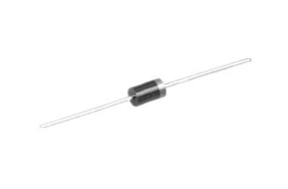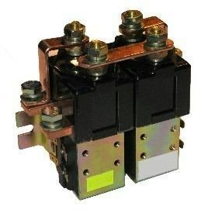​ 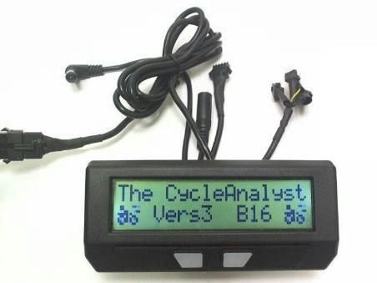

7) Reverse Contactor 8) Suppression Diode 9) Cycle Analyst
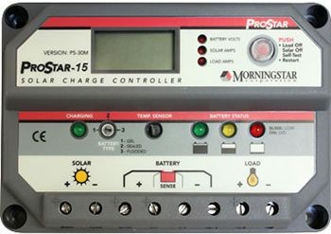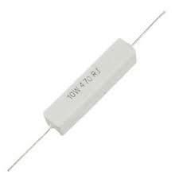​
10) Charge Controller 11) Fuse ​ ​ 12) Precharge Resistor

Figure 6 Equipment/Parts Images

​Figure 7 Equipment and Parts List with Costs

Part | Brand | Model | Specifications |  | Total
Solar Panel | Yingli Solar | YL235P ­ 29b | ­ | 29.5V  7.97A(8A) | Free, provided from previous SURP projects
Motor | Motoenergy | ME0909 | ­  ­ | 12­48V and 4 Hp cont. (12.8Hp peak) 4000 RPM at 48V | $385.00
Motor  Controller | Alltrax | AXE483 4 | ­  ­ | 24­48V  300A | $325.00
Charge  Controller | Morningstar | PS­15M 48V | ­  ­  ­ | digital screen  48V  15A | $190.00
Motor Fuse | ANN | ANN250 | ­  ­ | 5/16” terminal slots  250A | $20.00
Precharge Resistor | Xicon | 280­CR1 0­250­R C | ­  ­ | 470 ohms  10 watts | (4) $10.00
Main  Contactor | Albright | SW 180 | ­  ­ | 36­48V  200A cont. | $85.00
Reverse Contactor | Albright | SW 182 | ­  ­ | 48V 200A cont. | $104.95
Throttle | Curtis | FP ­ 6 | ­  ­ | 0­5K ohms  5 wiring­ outlets | $125.00
Battery | Power Patrol SLA (​sealed lead acid)​ | SLA115 5 | ­  ­ | 12V  35Ah | (1) $74.20  (3) Donated by James  Madison High School
Cycle  Analyst | Grin  Technologie s | CA­HC­W SHUNT | ­  ­ | 10­650V  300A (shunt) | $210.00
Battery Charger | Stanley | GBCPRO | ­  ­ | 12V 48V  3 stage battery charger | $99.76
Coil  Suppression  Diodes | Diodes  Incorporated | 1N4001 | ­  ­  ­ | 50V max  1V drop  1A max | (4) $.56
Acrylic Board | Plastic Supply | N/A | ­ ⅜” x 16.5” x 26.5” |  | $50.97

​Figure 7 Equipment and Parts List with Costs (continued)

Future Testing

Because this was such a labor intensive project with only a 10­week time frame, we were unable to conduct proper testing on the performance of the car. However, a future team could do so for their SURP project. Some suggestions for possible tests are as follows:
- Motor top speed under load with fully charged batteries
- Duration of motor operation starting with fully charged batteries at various motor speeds
- Battery charge time using the solar panel on a cloudy day and sunny day
- Solar Panel output at various times of the day (cloudy and sunny)

This team could also upgrade the various components of the car to make it more efficient. These upgrades could include:
- Upgrade current pulse width modulation charge controller to maximum power point tracking charge controller
- Upgrade battery pack amp ​hour capacity from current 35Ah rating
- Upgrade motor from permanent magnet brushed type to brushless
- Upgrade motor controller to work with brushless motor
Required testing equipment includes but is not limited to:
- Amprobe Digital Multimeter
- Laptop with Vernier software
- Vernier Equipment
- Voltage Sensor
- Current Sensor

Discussion & Conclusions

Obstacles and Future Suggestions
Over the duration of the project, the team encountered a number of obstacles. One of the first obstacles was that of concept familiarization. A number of team members were unfamiliar with some concepts involved in the design and manufacturing of the Sol GO electrical system. These concepts included basic circuitry, battery chemistry, and off ​grid photovoltaic system design. To address this, the team used the weeks prior to the start of the project to study and familiarize themselves with these concepts. This period of familiarization allowed the team to be more comfortable going into the beginning of the project and then they continued to familiarize themselves as the project went on. A suggestion for future teams that work on the Sol GO vehicle is to follow this example so that they will have enough of a foundation so that they utilize their time as efficiently as possible.
The team ordered all of the necessary components in the early stages of the project. A bulk of these components were ordered from the distributor Electric Motorsport. Because of communication issues, the order was not received until 6 weeks into the project. This resulted in the team not being able to do a bench test of the system before the manufacturing phase of the project as originally planned. A way for future teams to avoid this problem is to familiarize themselves with the purchasing process before the beginning of the project.
A major problem encountered during the manufacturing phase of the project was inadequate communications between the electrical Sol GO team and the mechanical Sol GO team. Because of electrical equipment safety and logistical reasons, a majority of the electrical system could not be installed until most of the mechanical work on the car had been completed. As a result, delays by the mechanical Sol GO team usually resulted in corresponding delays for the electrical Sol GO team, putting the project far behind schedule.
An example of one of these delays was found in the interfacing of the electrical equipment with the golf cart frame, specifically the electric motor. Because the donated golf cart was originally powered by gasoline, the motor mount was designed for a gas engine. This resulted in delays for both teams as an entirely new motor mount needed to be constructed by the mechanical team in order to install the new electric motor onto the cart.
In order for future teams to avoid this problem, both the mechanical and electrical teams should continuously communicate with each other throughout the entirety of the project. This will allow both teams to have enough of an understanding as to what each other’s project timelines are, so that delays can be minimized or avoided entirely.

Conclusion
Due to the many delays as mentioned above, the cart was not fully operational until late October, 2015. However, the project was an overall success. The SolGo ARV now has a fully functional motor system as well as solar charging system (Fig 8, pg. 20 and Fig 9, pg. 21). Despite being limited in both power and efficiency, the car is able to drive to different events across the SAC campus and community to showcase and promote renewable energy and serve as a recruitment tool for getting more students interested in pursuing Science, Technology, Engineering and Mathematics education and careers.

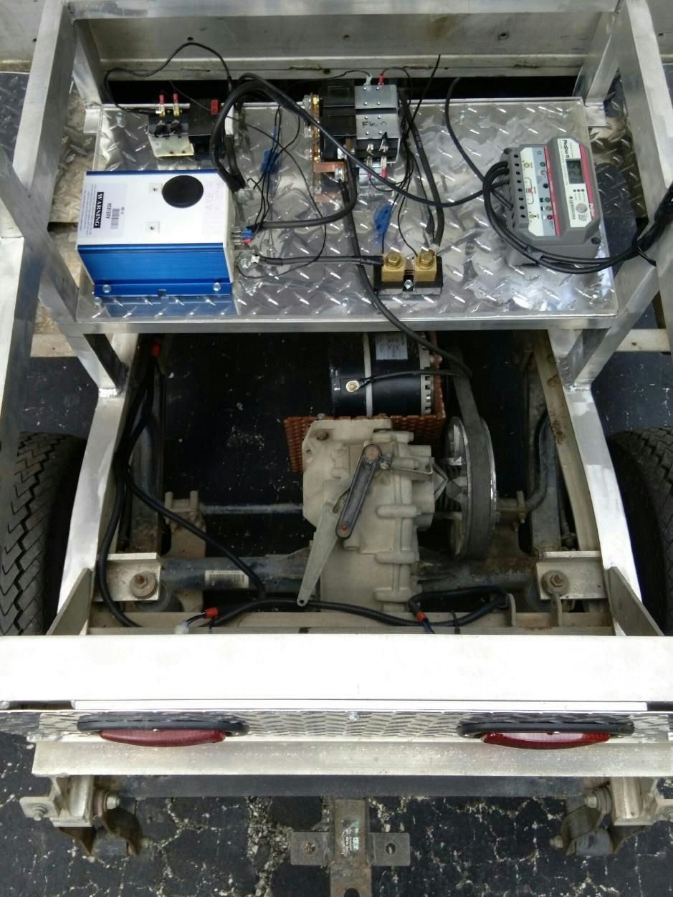
Figure 8 Electrical Subsystem and Electric Motor

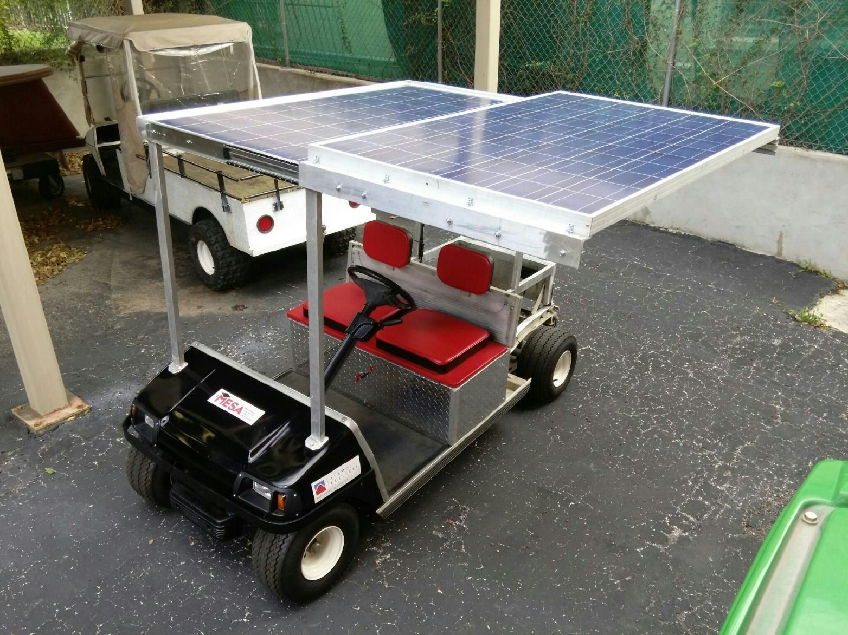
Figure 9 Completed Sol Go ARV with Solar Panels Extended for Solar Charging

Sol Go ARV Electrical System Participants

Dominic Ochoa ​ Team Leader
Kevin Castano ​ Team member
Yeojin Park ​ Team Member
Julio Banda ​ Team Member
​^{Klaus Bartels} ​ SAC Faculty Adviser

Acknowledgments

Dr. Gustavo Valadez​Ortiz ​ Mechanical Team Faculty Adviser
Ms. Analisa Sengele ​ MESA Center Director and SURP Coordinator
Ms. Sonia Aguirre ​ Equipment Purchasing Coordinator
Mr. Benjamin Uresti ​ MESA Workshop Coordinator
Mr. David Ortega ​ SAC Facilities Manager
Nicholas Jones ​ Industry Partner and Consultant
Mr. Andres Favela & Team Heavy ​ Previous Research
Dr. Joseph Dungan & the Madison Solar Car Initiative ​ Battery Donations
Dr. Dan Dimitriu ​ Engineering Program Coordinator
Mr. Jerry O’Connor ​ Physics, Engineering and Architecture Department Chair
Palo Alto College ​ Surplus Gas Utility Vehicle Donation
Broderick Camel ­ Mechanical Team Leader
Hunter Hodge ­ Mechanical Team Member
David Arambula ­ Mechanical Team Member
Rick De La Garza ­ Mechanical Team Member
Linda Hogner ­ Volunteer

References

- http://www.instructables.com/id/Lifepo4​solar​storage​battery​bank/?ALLSTEPS
- http://www.solar​electric.com/deep​cycle​battery​faq.html
- http://www.mpoweruk.com/lithium_failures.htm
- http://batteryuniversity.com/learn/article/absorbent_glass_mat_agm
- http://www.scribd.com/doc/234785801/Lithium​Polymer​Battery#scribd
- http://www.solar​electric.com/mppt​solar​charge​controllers.html
- http://www.diyelectriccar.com/forums/showthread.php/precharge​why​do​need​do​do​25 419.html

- Electrical Subsystem for Solar Panel Electric Cart, Final Research Report, ​​Luna, Favela, Trujillo, Rojas, 5 September 2013

- Spring Solar Undergraduate Research Program, Project 2 – Recirculated Water Cooling, Final
Research Project Report, ​​Aubin, Mata, Rodriguez, Rodriguez, 9 July, 2012
- Mechanical Branch Contribution to Solar Panel Electric Cart (draft), ​Camel, Hodge, Arambula, De La Garza, December, 2015

Appendix

Appendix A: Motor Controller Permanent Magnet Wiring Diagram
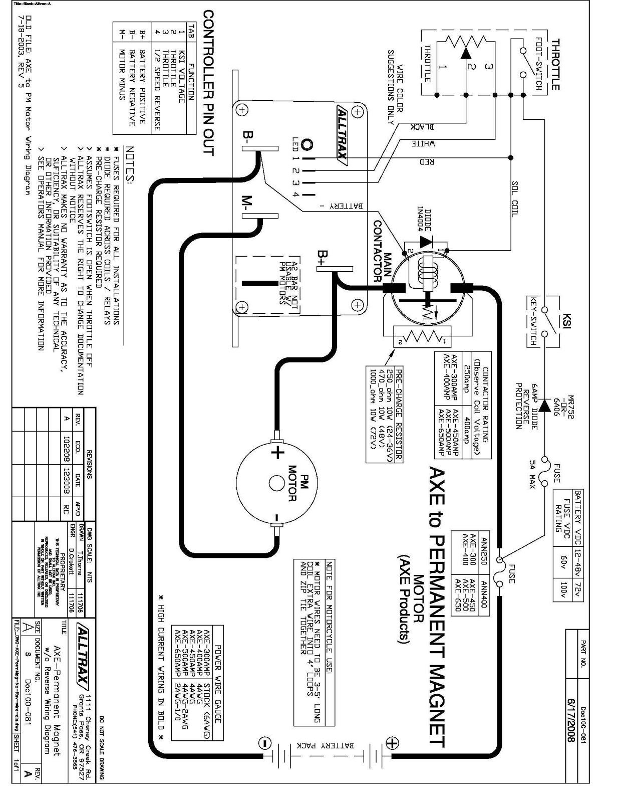
Appendix B: Electric Motor Measurement Diagram
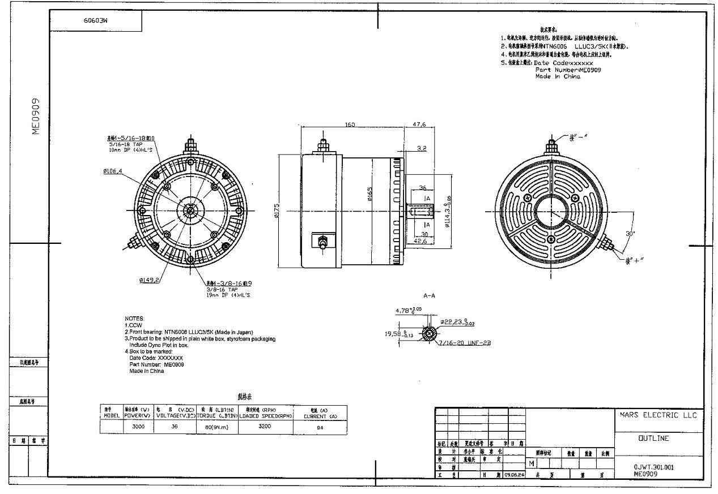
Appendix C: Motor Power Curve
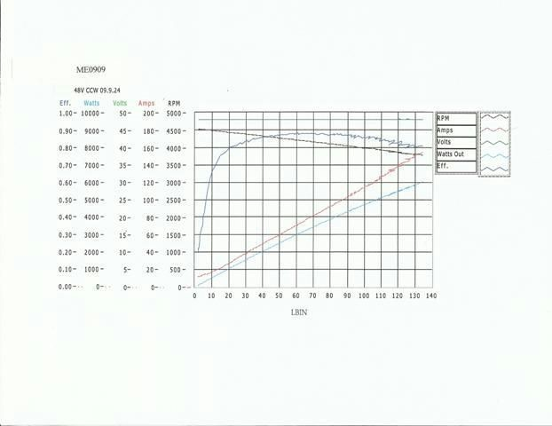
Appendix D: Charge Controller Specifications

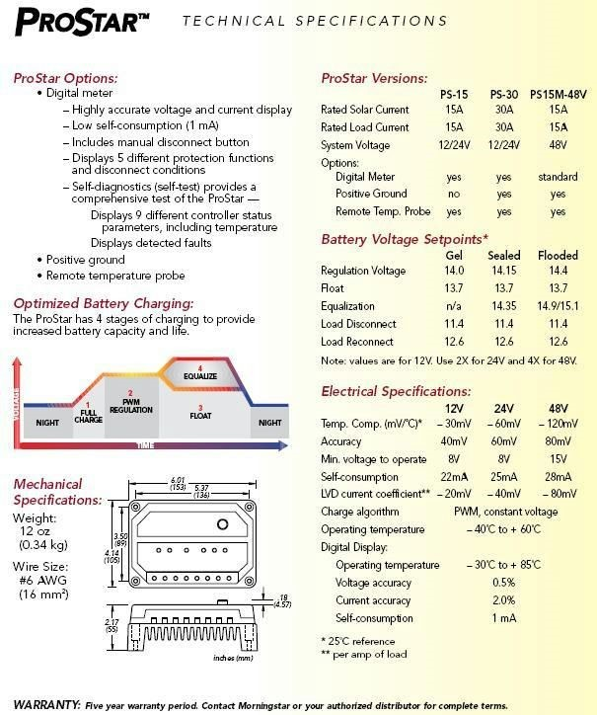

Appendix E: Coil Suppression Diode Working Theory
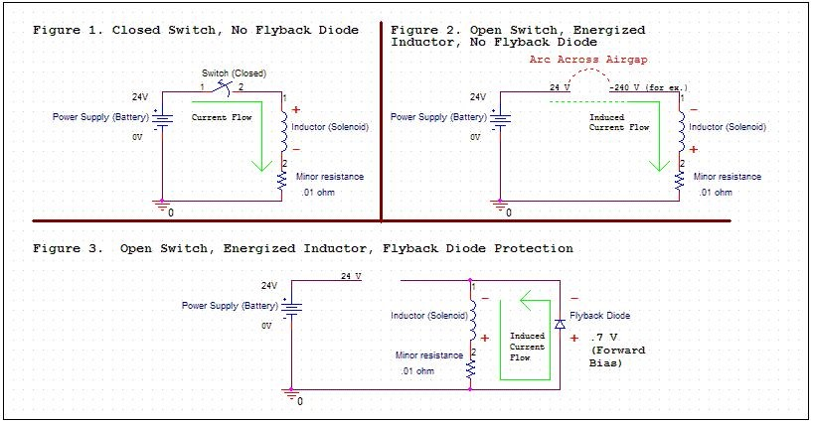

Appendix F: Solar Panel Specifications
