Project Title: REENERGIZE: Recruitment and Retention of Students in STEM Programs through a Renewable Energy Research and Education Partnership with Five Minority Institutions
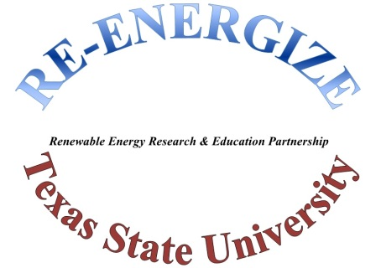
Part I: Physical mobile lab
- Rhyno 500 All-In-One Portable Solar Power Generator
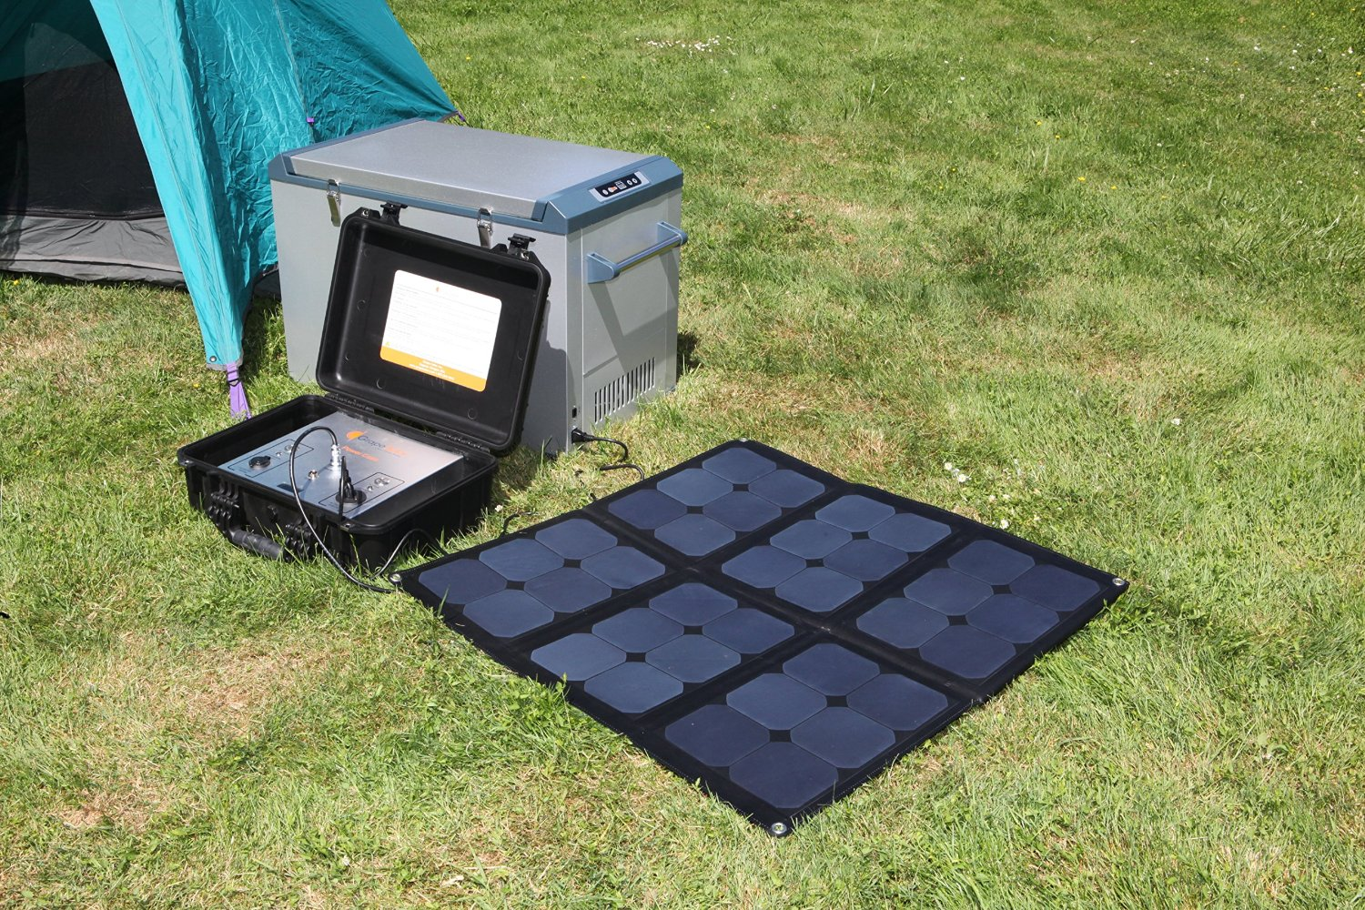

Solar E-Power Panel Cube

Wagan Tech Model # 2546
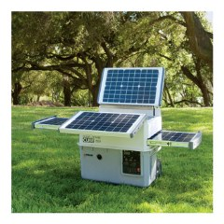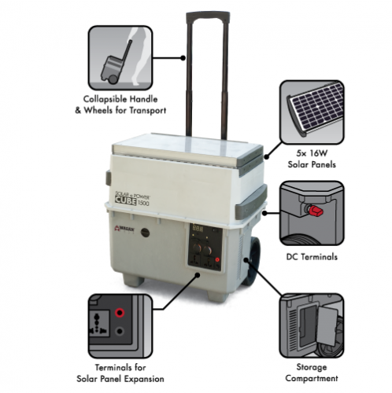
• SolSource Solar Cooker
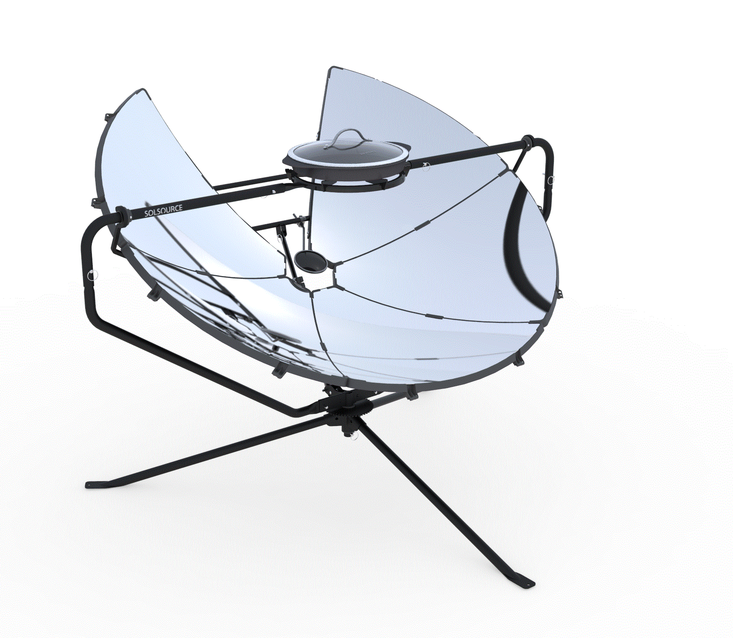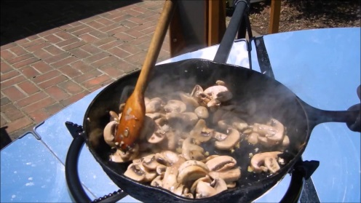

GoSun Stove, Sport Edition, Portable, High Efficiency Solar Cooker
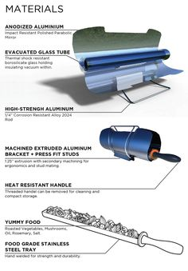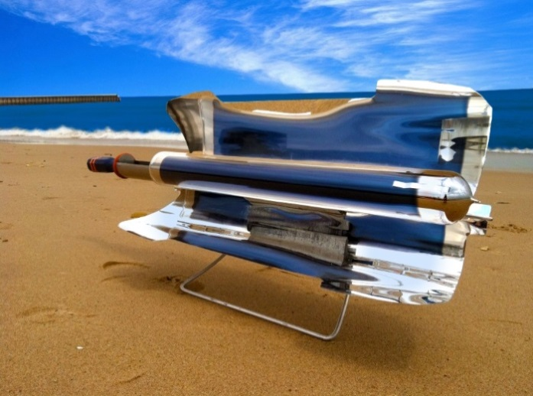

- Dewpointe dh9 atmospheric water purification system
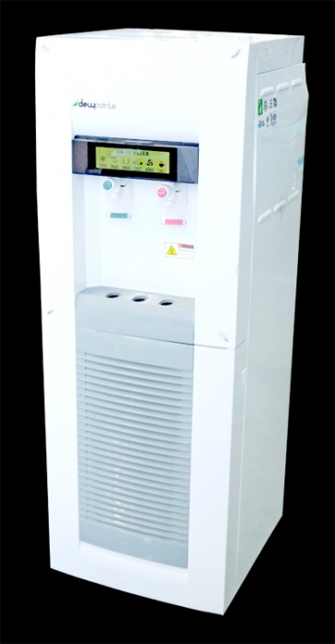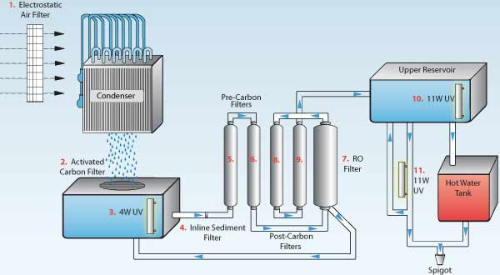
- Electric Popcorn Stand for Outreach activities
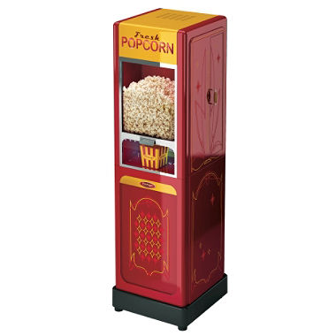

Left-Hand Single Sliding Vinyl Window White with Dual Pane Insulated Glass
