Project Title: REENERGIZE: Recruitment and Retention of Students in STEM Programs through a Renewable Energy Research and Education Partnership with Five Minority Institutions
Part II: Virtual renewable energy lab
*This section is submitted in the form of two conference articles (one accepted, one under review)
The growing need for renewable energy and improvements for efficiency shows the importance of data collection and analysis. Most of the efficiency and operational improvements focus mainly on local and regional problems relating to solar panels such as dirt/mold type, heat, and optimum orientation. To obtain the proper data and multifactor design of experiments, different sites are used to generate test data.

Nature of Input Data:
There are two main sensor components, the Egauge and the SMA SunnySensor Box. Together these sensors collect voltage, current, frequency, irradiance, solar module temperature and ambient temperature. Every minute these sensors collect data with a timestamp and sent data to the webserver and store them in the database. Basic connection scheme of the sensor boxes are shown in Figure 1 below.
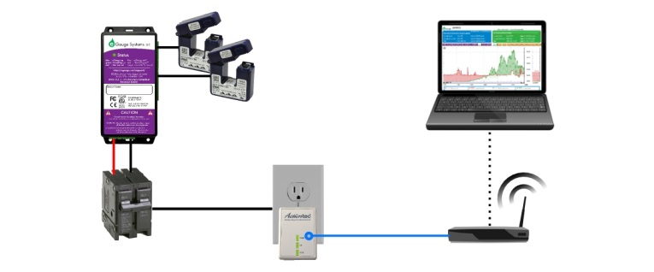
Web-based electric energy and power meter system

Database format, structure, and details:
Instead of data being pulled directly and served through MySQL, a restful API was implemented in Go where it offers built-in support for JSON encoding/decoding and built-in custom data types support. This format is standard and is used for many different applications to transport data in a compact, but easy to read format. Our API has several different routes. Each route returns a different set of data depending on the route and the parameters passed into the route. For example, the route /registersInfo/location/TxState/serial/0001 returns all the registers for serial 0001 at location TxState. It may return some JSON that look like one shown in Figure 2.
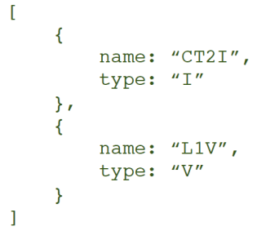
JSON data code sample

Server info:
A cloud based server was necessary to build this project. It provides a location to store and host our webserver and MySQL data server. The entire project runs on a Windows Server 2012 operating system. This system runs 24/7 as data is sent to it and stored one minute intervals. The entire web server was built in Go, also commonly referred to as Golang. Go is chosen due to wide range of web implementation and built in custom data support. The web applications that is used in this project can be summarized in two parts. There is the API and the Website. The API provides a raw source of data for computers or programs. The website provides an experience where data can be analyzed by a human. The block diagram of the proposed system is shown in Figure 3 below.
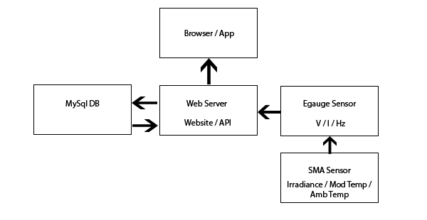
Web server data collection and API block diagram

Graphical User Interface (GUI) (Website input selection):
The website basic interface is shown in Figure 4 below provides a location on the Internet for any user to download, search or interact with the data that is collected and stored. The website also offers a way for others to communicate and share information. The data that is presented here using a JavaScript graphing library called HighCharts.
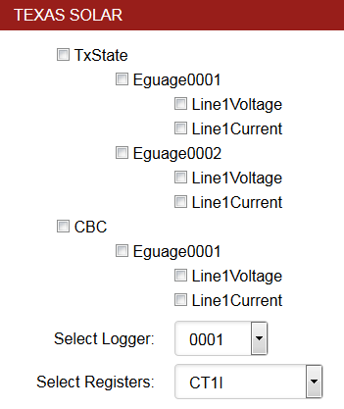
Texas Solar webpage interface

A graph can be generated for any measurement taken and compared to the other locations over any interval of time. A graph data display and time interval change are shown in Figures 5 and 6 respectively.
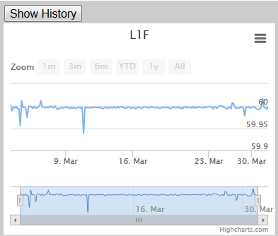
Data display using HighCharts
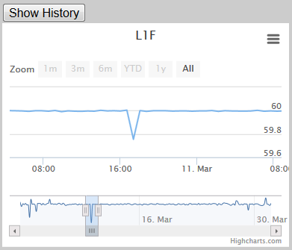
Data time interval change

App development:
This project currently has an android app in development. The app is being developed in Native android code with Android studio. The app allows access to live environmental data collected from different sites, and does so in a way that is tailored specifically to mobile devices. This is ideal for someone doing field analysis, and will be usable by anyone.
Details of Data Acquisition System: Programming for the system and App
Site and panel selection:
TX State Panel I (control) Panel II All
SAC Panel I (control) Panel II All
CBC Panel I (control) Panel II All
SWTJC Panel I (control) Panel II All
MI4 Panel I (control) Panel II All
MI5 Panel I (control) Panel II All
Output selection (for graph):
Voltage Ampere
Time scale quick selection:
Last hr Last 24 hrs Last 30 days Last year All history
Time selection:
Start Date: Start Time:
End Date: End Time:
Save as file (Excel format): Saves V, I, Weather Temperature, Panel Temperature, Humidity, Light Intensity, and Wind Speed.
Graph

Results, case study, and expandability
The proposed web-based data management system is deployed to manage data readings from different environmental sensors including temperature, humidity, light intensity, and wind speed as well as system performance specifications of the solar panels including current and voltage connected to multiple solar panels in the System Modeling and Renewable Technology (SMART) lab at Texas State University. The same system (solar panels and sensors) is also deployed at satellite labs at community colleges in neighboring cities (Coastal bend college-Beeville, San Antonio College, and Southwest Texas junior college at Uvalde) and real-time data are uploaded in the central database to manage data for comparisons and further analysis.

