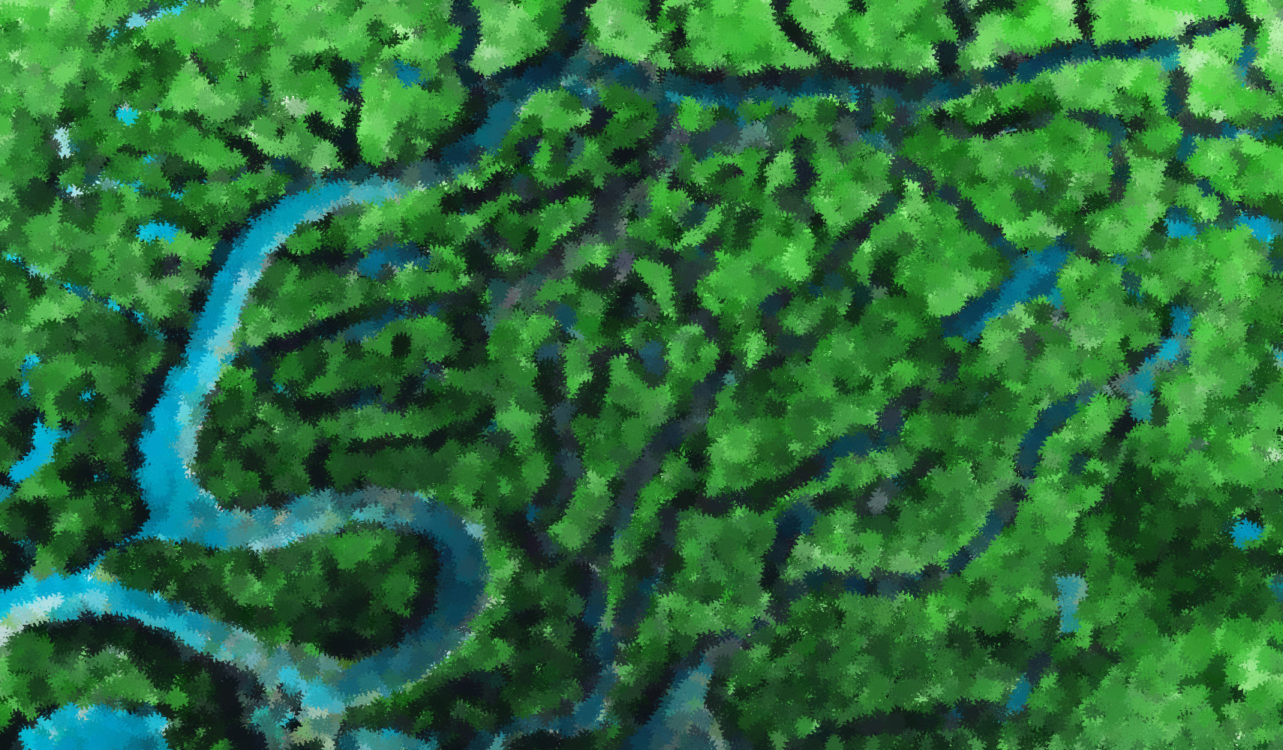
Geographic Skills Index

Please check which geographic skills the lesson plan addresses.

☐ Asking Geographic Questions
☐ Acquiring Geographic Information
☐ Organizing Geographic Information
☐ Analyzing Geographic Information
☐ Answering Geographic Questions

Lesson Plan Submission

Thank you so much for partnering with us to create quality resources for the geography teachers of Texas.

Please email final lesson plans to tage.geography@txstate.edu.

With each lesson plan we publish, we want the target audience to be a first-year teacher. We are looking to provide as complete a picture as possible, including both pedagogical and content knowledge. Please complete each section as comprehensively as possible.

Please know that we are here to collaborate with you and support you as needed. We know that we are asking a lot. Feel free to reach out to us at tage.geography@txstate.edu for anything that you need.

TITLE OF LESSON:

SUBJECT AREA:

GRADE LEVEL:

TIME FRAME/DURATION: If describing with class periods, please provide length of class period.

LEARNING OUTCOMES:
By the end of this lesson, students will be able to:

ESSENTIAL / GUIDING QUESTIONS:
What are the questions being asked and potentially answered for this lesson?

CONNECTION TO CURRICULUM/UNIT:
Provide a description of where/when this lesson would be taught.

BASIC TERMS AND VOCABULARY:

OVERVIEW OF LESSON:
Provide a brief description of the lesson.

STATE/NATIONAL STANDARDS:

RESOURCES/MATERIALS NEEDED:
For Students:

For Teachers:

PEDAGOGICAL STRATEGIES:
What pedagogical strategies will be used in this lesson? Please provide a link to a reputable online resource explaining each strategy.

PREREQUISTE KNOWLEDGE:
What is recommended/required knowledge that students should have before starting the lesson?

STARTING THE LESSON:
How will the lesson begin?

THE LESSON:
Describe lesson plan implementation here.

ENDING THE LESSON AND CLOSING PRODUCT:
How will the lesson end?

DIFFERENTIATION STRATEGIES:
What will be used to help differentiate for diverse learners?

EVALUATION/ASSESSMENT:
Include your complete assessment product or idea here. Include grading rubric.

EXTENSION AND ENRICHMENT:
What could be done to extend this lesson?

KEYWORDS:
Please provide a few keywords that apply to this lesson that could be used in a search.

