

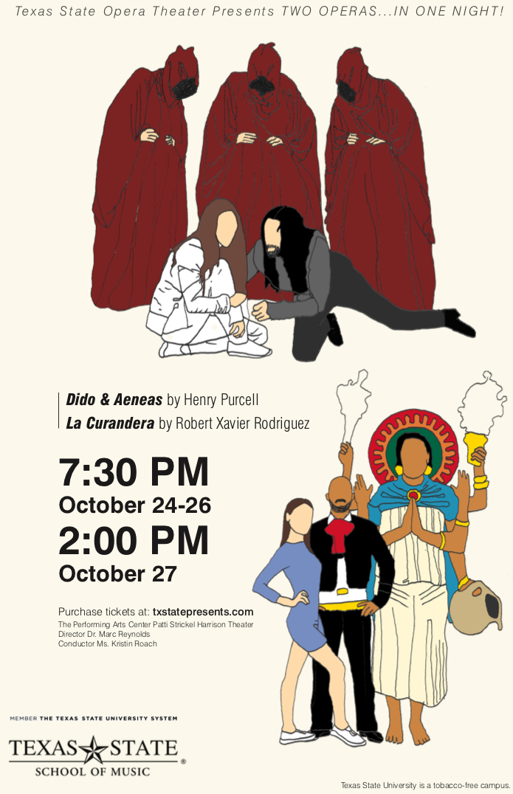

**Thank You For Your Generous Support of Texas State Opera Theater:**

Peggy Bruner Creeds & Crests

Pat Price Grins Restaurant

Ron Snyder Palmer’s Restaurant Bar & Courtyard

Dr. Shannon Hayes The Avenue at San Marcos

Dr. Ted Hayes

Lisa and Jim Bob Spencer

**Synopsis**

***Dido & Aeneas* by Henry Purcell**

*Present day Carthage, Tunisia.*

*Overture*

*The Mediterranean Ocean off the coast of Carthage, Tunisia.*

Prince Aeneas, vampire hunter, has been caught in a storm and is ship wrecked. A vampire sorceress and witches conspire to set in motion his destruction. The gods of the ocean intervene and save him by washing him up on Carthage shores. Queen Dido sees him wash up on shore from her balcony and sends guards to bring him in.

*Act I Scene I*

*Queen Dido’s Palace*

The widowed Queen Dido finds herself in love with Aeneas. She is tormented by the conflict between her love for Aeneas and her duty to the kingdom. Her second in command Belinda and her attendants encourage her to court and marry Aeneas for the sake of love and the kingdoms stability. She is reticent but ultimately falls to the persistent efforts and charm of Aeneas.

*Act II Scene I*

*The Vampire’s Lair*

The Vampire Sorceress summons her sisters. They now have the chance not only to destroy Aeneas, but Queen Dido as well. They revel in their power and plan their vengeance. They summon a messenger of Jove to deceive Aeneas into believing that destiny requires him to leave Carthage. When Belinda accidentally stumbles upon the lair, she plays into their hand, providing a person in Dido’s confidence now a vampire. The furies dance in anticipatory celebration as the Vampires power in Carthage ascends.

**Director’s Note**

Welcome to Texas State University Opera Theater’s production of *Dido & Aeneas* and *La Curandera*!

*Dido & Aeneas* by Henry Purcell is one of the earliest known and most loved English Operas. Based on Book IV of Virgil’s Aeneid, the opera traditionally picks up where Aeneas arrives on Carthage shores after being defeated in the Trojan wars. As you will notice in the synopsis, we have deviated from the traditional setting in anticipation of the upcoming Halloween holiday. We are joined by dancers led by Shay Ishii from the Department of Theater and Dance. Collaborating with them has added tremendous value to this production and I am thrilled to have them joining us!

*La Curandera* by Mexican-American composer Robert Xavier Rodriquez is a charming comedy that has let us explore what it means to foster an inclusive community. It has been an honor to learn from our students as they have shared how they relate to their cultural heritages and the community around them. Our hope is that it will make you laugh, lift your spirits, and foster greater love for whoever comes into your life.

Putting on an opera is a collaborative team effort to the extreme. My many thanks to the people to the people that made this possible, those listed on this program, as well as those that are not. A special thank you to the wonderful folks from the Department of Theater and Dance that have been so open and supportive of our opera productions. A special thanks to our voice faculty who have spent tremendous effort training and preparing their students for the roles that you will see them perform tonight. A tremendous thank you to Dr. Jacob Harrison for his generous collaboration in increasing the orchestra’s involvement with the opera. Thank you most of all to you, our audience, for supporting these singers on and off the stage. We could not be here without your support. Thank you!

Please consider supporting Texas State Opera Theater further by either scanning the QR Code below or going to the website. Donations go directly to helping us produce high quality productions that enrich our students’ education, as well as scholarships that will let them focus on their studies. We are grateful to our current donors and sponsors for helping us bring cultural treasures to San Marcos!

Please enjoy the show!

|  |  |  |  |
| --- | --- | --- | --- |
|  | **TXST Opera Orchestra** | | |
| **Dido and Aeneas** | |  |  |
| Violin I | Carlos Alvarado | Viola | Jamie Mager |
|  | Joshua Garcia |  | Christa Riter |
|  | Hannah Sipper |  | Payton McIntyre |
|  | Claire Pace |  | Giselle Izaguerre |
|  | Angel Fuentes |  | Maya Linney |
|  |  |  |  |
| Violin II | Karen Cramer | Cello | Chelsea Piel (continuo) |
|  | Angel Raygoza |  | Caleb Churchman |
|  | Claudia Ruiz |  | Skye Gill |
|  | Luis Guerrero |  | Cole Leonard |
|  | Angel Reyes |  | Rachel Watson |
|  |  |  |  |
| Organ | Dr. Eric Thompson | Bass | Morgan Milner |
| Harpsichord | Kristin Roach |  | Juan Solis |

|  |  |
| --- | --- |
| **La Curandera** | |
| Clarinet | Brittany Hernandez |
| Alto Sax | Josh Clark |
| Trumpet | Diego Rosales |
| Bass Trombone | Matt Acosta |
| Percussion | TJ Goss |
|  | Trysten Cook |
| Violin | Dr. Lynn Ledbetter |
| Cello | Emily Thiele |
| Piano | Dr. Eric Thompson |
| Accordion | Faith Debow |
| Synthesizer Programming | Darrin Newhart |

Act II Scene II

*A valley meadow retreat for the Queen and her Prince.*

Guards stand sentinel while Queen Dido courts Prince Aeneas. They bask in the beauty around them and the glow of new love. One of Dido’s attendants senses impending doom. She relates the classical tale of Actaeon, who when watching the nymph Diana bathe, discovered and splashed with magical water, turning him into a deer. The deer was chased and devoured, unrecognized by his own hounds. Now a vampire, Belinda looks down on Dido bathing in that very same fountain as her blood lust grows.

Aeneas leaves to hunt vampires and returns victorious! His announcement is interrupted by a storm conjured by the Vampires. Vampire Belinda, separates Aeneas from the group so the Spirit can deliver the crucial false decree that Aeneas must leave. Aeneas hears the decree and is devastated to leave Dido, but as a solider, knows his duty.

Act III

*The docks where Aeneas’s fleet waits.*

Aeneas gives the order to make ready to leave and the sailors celebrate. Dido arrives to find Aeneas’ men readying to leave. She draws her conclusions and despairs.

The Sorceress and her minions celebrate the success of their plan. Aeneas will leave and Dido, in her grief, will be vulnerable to revenge. Witches come to lure the Sailors away and hasten their departure.

Dido takes her own ship to confront Aeneas before he can leave the harbor. In despair, Aeneas offers to disobey the gods and stay, but the damage is already done.

Dido is led to the Vampires’ lair by Belinda looking for comfort and solace from her friend. She senses the danger at hand but is consumed by grief and resigned to death.

**Support Texas State Opera Theater**

<https://www.music.txstate.edu/voice/opera/Support-the-Opera.html>

***La Curandera* by Robert Xavier Rodriquez**

Present-day Tepoztlán, an actual village near Mexico City, known for its curanderos/curanderas, practitioners of folk magic.

*Scene One.*It is afternoon in the outdoor lobby of the fictitious Hotel Tepoztecatl. The elderly and distinguished General Godofredo de la Barca enters, accompanied by his pretty young nurse, Dionisia.  Ramón, proprietor of the hotel, has just given an annual fiesta in honor of the famous General de la Barca.  La Curandera enters, inquiring about The General’s health and about his American grand-nephew, Alberto, whom The General has not seen since the funeral of his beloved wife, Estela, two years ago.

*Scene Two.*  Later that same day, The General’s grand-nephew, Alberto, and his fiancée, Alba, count their luggage in an American airport, on their way to pay “Uncle Godo” a surprise visit. When Alberto leaves for a moment, the cell phone I his bag rings. Alba answers and hears a woman’s  voice asking in Spanish for Alberto.  When Alberto returns, Alba confronts him as to the woman’s identity, but he brushes off her question and hurries her onto their flight.

*Scene Three.*  That evening in Tepoztlán, on the patio of General de la Barca’s hacienda, The General repairs his deceased wife’s silver watch and muses on the passing of time.  Dionisia enters, brightly, bringing him a delicious dinner.  She jokes, teases and dances with him.  Soon he cheers up and observes, as she leaves, that “Time is the cure!”

*Scene Four.*  The next morning, Alberto and Alba arrive at the Hotel.  Alba, obviously upset, again questions Alberto about the suspicious female caller with the “beautiful voice.” When Alba storms off to the room, Ramón tries to console Alberto.  Alberto dejectedly calls Dionisia to arrange the surprise visit with his uncle.  Dionisia suggests that Alberto send Alba to La Curandera for a dose of her magic. Ramón reluctantly promises Alberto that he will take Alba for her visit, and calls La Curandera to make an appointment.

*Scene Five* *(Finale)* La Curandera’s house.  Inside, La Curandera gleefully awaits her new American client.  Little by little, La Curandera presses Alba to reveal her suspicions about the mysterious voice of the “other woman” on the telephone.  Alberto and Ramón listen outside the door as La Curandera performs a series of intense and exotic incantations, eventually causing Alba to swoon.

When General de la Barca and Dionisia arrive, uncle and nephew are joyously reunited. Alberto discovers that Dionisia was the mysterious female caller. Alba and Dionisia are introduced and, as the misunderstandings are finally clarified, Alberto is finally able to present his *fiancée* to his beloved uncle. La Curandera’s magic leaves all to live happily ever after.

A/V Lighting Supervisor Nick Swanson

Master Electrician Jesse Castro

Light Programmer and Operator James Funk

Lighting Programmers Hannah Corbett

Megan Whittington

Jesse Castro

Deck Chief Johnny Painter

Followspots Gerry Guerrero

Flora McNabb

Theater Dept Grad Students Mackenzie Mulligan

Austin Kelm

Choreographer, *La Curandera* Peter Ongolo

and *Sailor’s Dance* in Dido & Aeneas

Electricians

Tatyana Magee-Reese, James Funk, Max Wallace, Hannah Corbett, Megan Whittington, Johnny Painter, Gerry Guerrero, Flora McNabb, Mackenzie Mulligan, Austin Kelm, Eyda Baker

Voice Faculty

Ronald Ulen (Chair), Daveda Karanas, Dr. Richard Novak, Dr. Suzanne Ramo, Cheryl Parrish, Myra Vassian, Dr. Blythe Cates.

**Production Team**

Director of Opera Theater Dr. Marc Reynolds

Conductor Kristin Roach

Staff Pianist Eric Thompson

Assistant Director James Adamson

Assistant Director and Movement Specialist Peter Ongolo

Assistant Conductor Tyler Bainter

Stage Manager Olivia Fletcher

Assistant Stage Manager Maya Novit

Stage Manager Mentor Shannon Richey

Set Designer Anne McMeeking

Costume Designer Dr. Jessica Burton

Lighting Designer Carlos Nine-Vila

Lighting Designer Mentor Scott Vandenberg

Props Master Kendal Margotta

Assistant Props Master Emilia Hurtado Loe

Props Master Mentor Erin Kehr

Operations Manager Candice Mongellow

Opera & Voice Teaching Assistants Lyanne Alvarado

Karissa Kim

Peter Wheeler

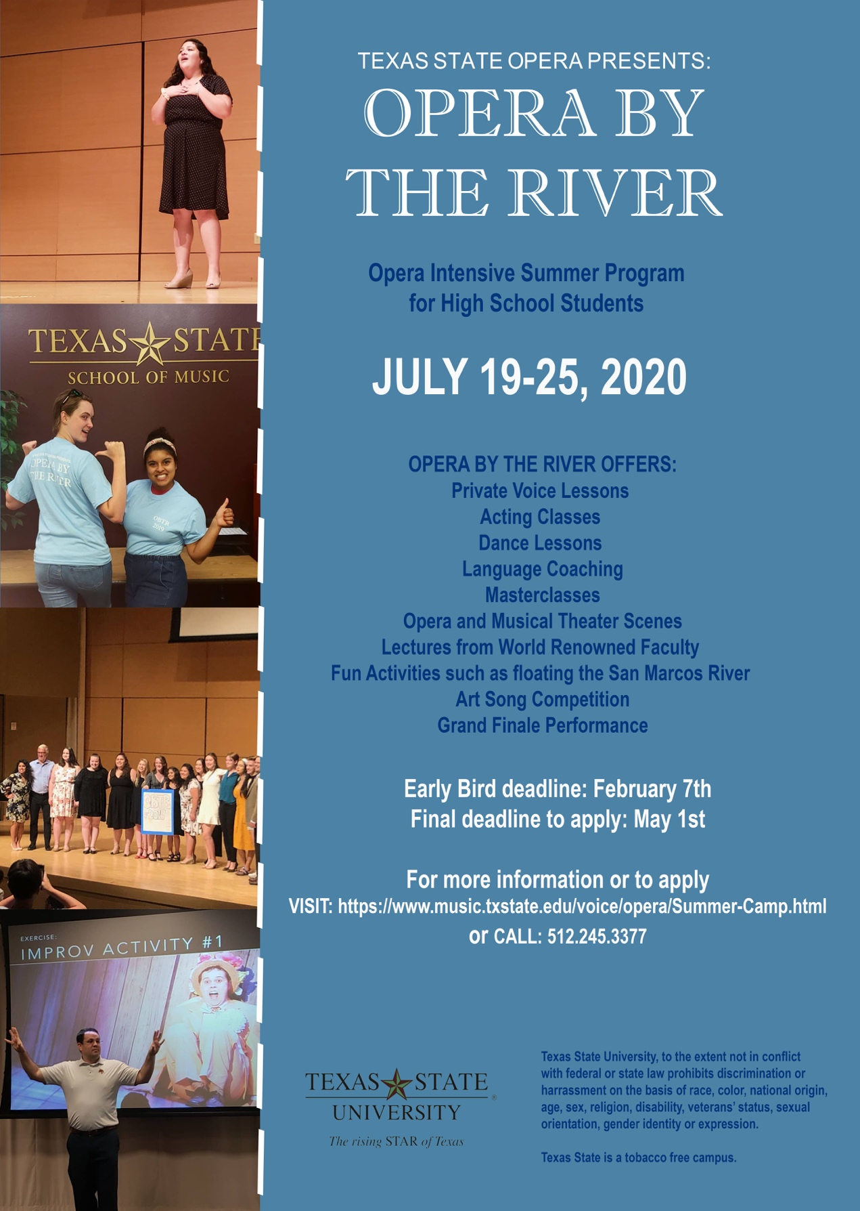

**Cast List**

***Dido & Aeneas* by Henry Purcell**

**Thus/Sat Fri/Sun**

Dido Cassidy Wallace Ivy Cantu

Aeneas Noah Reinhuber Peter Wheeler

Sorceress Hunter Sabin Michelle Sanchez-Gascon

Belinda Andee Winn Lyanne Alvarado

First Witch Annisha Mackenzie Brittney McKinney

Second Witch Madison McCarty Paiton Seals

Spirit Karissa Kim Sarah Hernandez

First Sailor Pedro Valdez Bradley Whitten

Second Woman/Attendant Jillian Brackett Christine Ashbaugh

Chorus : Darrin Ruiz, Sarah Hernandez, Faith Ely, Victoria Furlan, Gabryella Carrelli, Katherine Christie, Lyndsea Woodall, Karissa Kim, Pedro Valdes, Bradley Whitten, Damyen Sanchez, Joshua Moore, Garrett Douglas, Abraham Villarreal, Jordan Jones, Martin Ramirez Jr., Nathalie Calvo, Christine Ashbaugh

**Dance Team**

Shay Ishii Choreographer, *Overture, Echo of Furies, Witches Dance*

Clarissa Coronado Rehearsal Director

Shay Ishii Dance Costume Design

**Dancers**

Clarissa Coronado, Ashley Crayton, Tayler Jenkins, Marc Reynolds

***La Curandera* by Robert Xavier Rodriquez**

**Thus/Sat Fri/Sun**

General Godofredo de la Barca Joshua Moore Garrett Douglas

Dionisia Annisha Mackenzie Gabryella Carrelli

Ramon Martin Ramirez Jr. Noah Reinhuber

La Curandera Michelle Sanchez-Gascon Cassidy Wallace

Alberto Pedro Valdez Bradley Whitten

Alba Sarah Hernandez Sarah Hernandez

Cover/Educational Performance

Abraham Villarreal (General Godofredo de la Barca), Victoria Furlan (Dionisia), Peter Wheeler (Ramon), Faith Ely (La Curandera), Bradley Whitten (Alberto), Sarah Hernandez (Alba)