### Center for Multicultural and Gender Studies

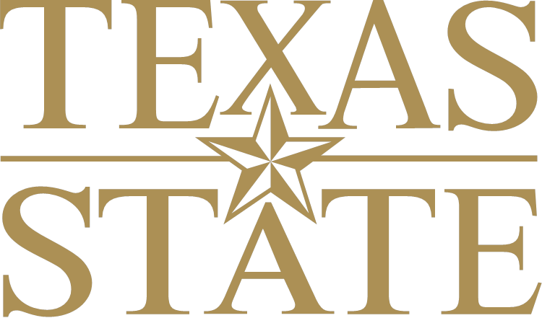**Quick Facts**

American Indian and Alaska Native

Population in United States: 5,120,813 (1.63% of total) 1

Median Age: 30.51

Average Household Size: 2.891

Family Households: 65.2%

Female, No Spouse: 14.9%

Male, No Spouse: 13.4%

Marital Status

Married, Spouse Present: 36.4%**1**

Divorced: 14.1%

Never Married: 41.4%

Separated: 3.1%

Widowed: 4.9%

Education (age 25 and over)**1**:

High School Graduate or Above: 81.7%

Some College or Associate’s Degree: 35.9%

Bachelor’s Degree: 11.2%

Advanced Degree: 6.1%

Median Income: $37,095**1**

Geographic Location**2**:

South: 32.8%

Midwest: 16.8%

Northeast: 9.7%

West: 40.7%

Voting Record:

Citizens Registered to Vote: N/A

Citizens Who Voted N/A

**For Additional Information:** <http://en.wikipedia.org/wiki/Alaska_Natives> and http://en.wikipedia.org/wiki/Native_Americans_in_the_United_States

1. US Census Bureau, “Selected Population Profile in the United States.” http://factfinder2.census.gov/faces/tableservices/jsf/pages/productview.xhtml?pid=ACS_11_1YR_S0201&prodType=table

2. US Census Bureau, “The American Indian and Alaska Native Population 2010 Census Briefs”

<http://www.census.gov/prod/cen2010/briefs/c2010br-10.pdf>