

**Fall 2023 PSY 1300 Research Experience: Participant Guidelines**

Please direct **any questions** regarding the research experience requirement to the Research Experience Coordinator at: [Psy-Research@txstate.edu](mailto:Psy-Research@txstate.edu)

# This information applies to these sections of PSY 1300 during Fall 2023:

M, W, F 8:00-8:50 AM Section 001 (CRN 12573) – Instructor: Dr. Reiko Graham

M, W, F 9:00-9:50 AM Section 002 (CRN 12093) – Instructor: Mr. John Angulo

M, W, F 10:00-10:50 AM Section 003 (CRN 12650) ­– Instructor: Dr. Jessica Cascio

T, TH 9:30-10:50 AM Section 004 (CRN 13282) ­– Instructor: Dr. Amy Meeks

T, TH 11:00-12:20 PM Section 005 (CRN 11811) ­– Instructor: Dr. Amy Meeks

T, TH 11:00-12:20 PM Section 006 (CRN 13283) ­– Instructor: Dr. Kristen Tooley

T, TH 3:30-4:50 PM Section 007 (CRN 13284) ­– Instructor: Mr. Mark Stern

T, TH 2:00-3:20 PM Section 011 (CRN 20048) ­– Instructor: Ms. Sierra Kaiser

Online Section 012 (CRN 20552) ­– Instructor: Ms. Macy Hicks

Psychologists conduct much of their research with human participants at universities such as Texas State University. To enhance your understanding of the nature of psychological research, it is important that you get some first-hand experience with research. For that reason, students are required to have direct experience with psychological research.

All research with human participants must be carried out in an ethical manner. For example, you cannot be required to participate in experiments against your wishes. Therefore, you have two options to fulfill the research experience requirement: one option involves participation in research studies whereas the other does not. Both options have been designed to take the same amount of effort. **You are free to choose either option or a combination of both** for a total credit balance of **6 credits**. **These 6 credits are worth approximately one-half of a letter grade (i.e., 5% of your overall course grade).**

**You must complete your research requirement NO LATER THAN Monday, November 27, 2023, by 11:59 pm**- this is the ***last*** day work can be submitted.

# Option 1. Research Participation

If you are 18 years of age or older, you are eligible to participate in research studies (the age restriction is due to federal policy). Your participation in these studies will give you a chance to have direct contact with research. Participation in psychology research studies at Texas State University that require 30 minutes or less are worth 1 credit; studies that take between 30-60 minutes are worth 2 credits; studies that take between 60-90 minutes are worth 3 credits; studies that take between 90-120 minutes are worth 4 credits, and so on. Laboratory studies (those that you have to participate in-person at a predefined location) are worth an additional bonus credit above what the time commitment dictates. Online studies are credited just based on the time commitments listed above. The number of credits will be noted in the study description that you see when you sign up. **The number of credits listed on SONA for any given study is accurate, and already includes the bonus point if applicable.**

|  |  |
| --- | --- |
| **Credit Distribution** | |
| **Length of Study** | **(In-person studies: add 1 additional credit)** |
| 1-30 minutes | 1 credit |
| 31-60 minutes | 2 credits |
| 61-90 minutes | 3 credits |
| 90-120 minutes | 4 credits |
| 121-150 minutes | 5 credits |
| 151-180 minutes | 6 credits |
| Research Article Summary | 2 credits |

Only studies listed at [http://txstate.sona-systems.com](http://txstate.sona-systems.com/) qualify for credit. In addition, paid studies cannot be used to satisfy the Research Requirement.

To sign up for a study, follow the steps below:

1. **Beginning on Friday, September 8, 2023**, go to the website [http://txstate.sona-systems.com](http://txstate.sona-systems.com/)
2. Log in with **Your Texas State net ID** (ex: abc1234) and password

* After you log in, you can sign up for studies, view your accumulated credits, and edit your profile, as shown in the screen shot below.

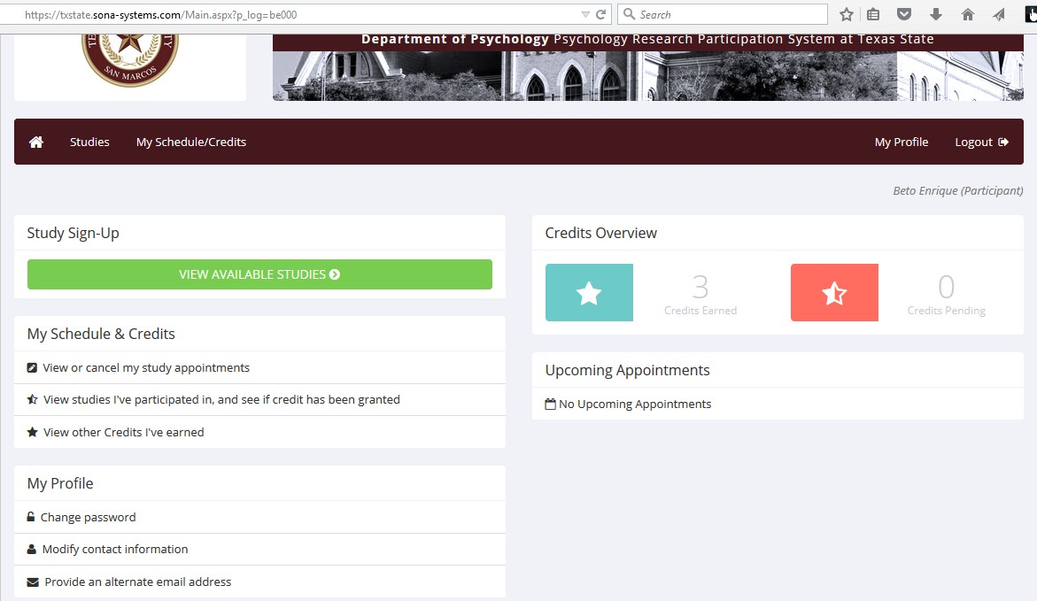

*Your name here*

# NOTE: If you sign up for a study and fail to show up for that study (and you haven’t canceled your appointment through the system or contacted the study’s researcher to cancel), you will not be allowed to sign up for future studies until you contact the researcher to set up a new time to participate in the study you missed.

**Option 2. Research Article Summaries**

You may also demonstrate direct contact with research by submitting a written summary of a research article published during 2021-2022 in *Psi Chi Journal of Psychological Research*. Credit will not be given for summaries of articles published in any other year or any other journal. **Each written summary is worth 2 credits.** To earn credits in this way, follow the steps below:

1. Visit the library homepage (<https://www.library.txst.edu/>), then click on “Periodicals”, then search for “Psi Chi Journal of Psychological Research”. When the result comes up, click on “Academic Search Complete”. Expand the year list (2022 or 2023) on the right side of the page, and choose one of the articles listed.
2. Read the article. Then type (**in 12-point font,** **single spaced**) a **1-page** paper in which you answer the following four questions.
   1. What question(s) did this research try to answer or what hypotheses did it test?
   2. What methods were used to answer the question(s) or test the hypotheses?
   3. What were the major findings of the research?
   4. What conclusions did the researchers draw based on the findings?
   5. **Please respond in your own words and avoid direct quotes. If plagiarism is detected in your article summary, you will lose the opportunity to earn that credit through article submission.**
3. **Submit** your summary via an **email with a file attachment** (.docx or .pdf, NOT SharePoint) to**:** [Psy-Research@txstate.edu](mailto:Psy-Research@txstate.edu)

# Monitoring your Credits

Research Experience is worth 5% of your course grade. Research credits for both options can be tracked by logging into <http://txstate.sona-systems.com/>as described above. In addition, your credits earned **will be updated in a column in your Canvas Gradebook at the end of each week.** Additional details, including frequently asked questions, can be found at: <https://www.psych.txst.edu/research/research-participation/psy-1300.html>

Please direct any questions regarding the research experience requirement to the Research Experience Coordinator at:

Psy-Research@txstate.edu