_______School of _______

New Times Roman

Size 16 Font

Heading ONLY on 1st Bio Page

** Heading should be the SAME on All Documents

BS, _____________

_____ Accreditation Review Team

Month ______, 20___

**BOLD**

Size 16 Font

**Dr. Dawn Zinnia-______Team Chair**

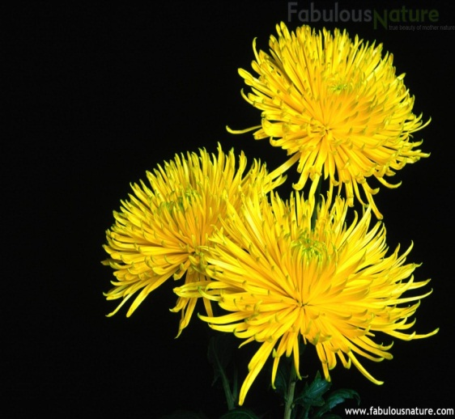

Must have Picture

Dr. Dawn Zinnia is the Director at Cosmos International Labs, in the Processing Department. This department processes new materials, characterizes and improves the processing methods for fabrication, and evaluates the physical, optical, and electronic properties and reliability of materials and components.

She has been the ZYXW evaluator or team chair for at least 10 years. She is also very active in several non-profit organizations. Dr.Zinnia has a Ph.D. in Materials Science from ABC University.

New Times Roman Size 12 Font

Paragraph Spacing: After-6 Pt, Line Spacing-Single, At-0.

Bio should include Degrees and where they received them, Place of Work, Title and a brief paragraph describing their work.

**Dr. Rachel Cactus Flower-Program Evaluator**

**BOLD**

Size 16 Font



Dr. Rachel Cactus Flower is the Associate Professor and Undergraduate Coordinator for the Department of Industrial Engineering at ABC University. She is a member of the Institute for Research and Management Science and a Senior member of the ZYX Engineers. Dr. Flower has been a program evaluator with ABET since the 2001.

Her research interests include developing different cacti species to find solutions for optimization problems as well as investigating the impact of cacti species design on color and growth factor.

Dr. Flower received a B.S., M.S., and Ph.D. in Agriculture from The University of LMNOP, with her doctoral degree focusing on the many species of cacti.