Office of Field Education
Unaffiliated Match Guidelines & Form

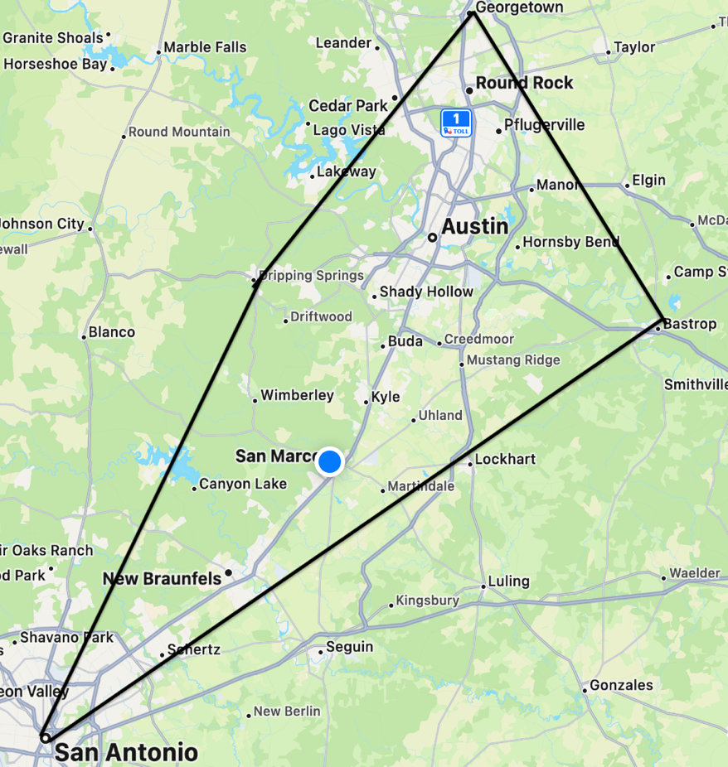
Social Work students living outside of Central Texas/the I-35 corridor surrounding the university (i.e., San Antonio to Georgetown and Dripping Springs to Bastrop) will be asked to provide the Office of Field Education with three potential agencies where an internship may be secured on your behalf. Please see the visual below. If your geographic area is outside of the outlined shape encompassing this section of the I-35 corridor, you must complete the Unaffiliated Match Form.
READ CAREFULLY!
Students who live outside of the Central Texas area need to collaborate with the Office of Field Education to secure an internship. This does not mean secure your own internship. Due to the vast geographic areas where students live, coordination of location for reasonable travel distance is needed. Additionally, there are many schools of social work placing students, the advantage local schools have is familiarity and networks in their respective community. We need your help to find the best opportunities for you to complete your educational requirements.
The formal vetting including meeting with the agency to determine if it is an appropriate placement, communication about the social work program, formalizing paperwork, gaining agency agreements, answering questions about requirements, supervision, or other practicum issues, is completed by the Field Office. Field advisors contact all agencies directly and complete this process to secure an agency possibility for each student.
Agencies contract with the University - NOT students, so engaging in field office responsibilities by any student in not appropriate. Students are given a suggestion sheet, to reasonable answer initial questions, but students’ responses should always include, "a Field Team Member will contact you with details about the program shortly."
Student Responsibilities:
- Obtain the information requested on the form
- Inform the agency that a field faculty office will contact them to provide additional information and detail
- Submit the completed form online as soon as possible
Field Faculty Responsibilities:
- Vet the agencies for appropriateness and scope of work
- Narrow down the 3 potential agency options provided by the student to 1-2 potential agencies
- Facilitate a Zoom meeting with 1-2 agencies to assess goodness of fit for the intern
- Complete the Agency Partner Confirmation form
- Secure the placement on your behalf
- Provide detailed information about practicum and the School’s requirements
- Secure required documentation
- Refer you to the appropriate person for interview
- Obtain interview feedback from the agency
What you are NOT responsible for:
- Securing a field placement
- Securing an interview prior to field advisor referring you for interview.
- Getting the agency to accept you as an intern
- Asking information about the agency that is not required on the form, or that you need to decide if you would like the agency considered.

When Contacting a Prospective Agency Partner

If making inquiry calls to agencies - Script:
Hello, my name is: and I am a social work student/faculty member at Texas State University School of Social Work. I am contacting agencies in the area open to hosting social work student interns (or those who are open to utilizing social work interns). I’m gathering information on behalf of the Field Education Office at my University and would like to ask you a few questions.
- What type of service is provided to the community (e.g. medical, child welfare, substance recovery, aging services, etc.…)? You can usually find this information out by reviewing the website and forgo asking this question. If no website, please call and ask about this information.
- Do you currently have a social work internship program? If so ask - “who is the primary contact person? Can I have their contact information?” (name, number and e-mail if possible) - reiterate that this information is for the Field Team who will follow up with the contact person.
- If not ask – “who is the primary person in charge of interns at the agency that I can speak with about possibly partnering with this agency?” (name, number and e-mail if possible)?
- Does your agency have either BSW’s or MSW’s available to provide supervision to social work interns? If you are asked for detailed information about supervision, please let the agency know that Field Education team will contact them and provide all details regarding supervision criteria.
- If not ask – “Do you currently have social work interns at the agency? What is the contact information for the person who supervises social work interns?” (name, number and e-mail if possible)?
Thank you for your time and information about the agency. The Field Education team at Texas State University School of Social Work will contact the agency about developing a partnership.
Types of Agencies to Consider:
- Foster Family Agencies
- Hospice
- Hospitals with social workers on staff
- Domestic violence services and shelters
- Drug recovery programs
- Family Services Agency
- County and State Social Services (CPS or APS)
- School Districts
- Criminal Justice Programs
- Non-Profits

Placement at these agencies is contingent on whether the agency can demonstrate that they have adequate supervision for social work students. The field team will address this with the agency. You should not have a discussion with any agency about supervision or schedules. Remember that you are not trying to secure a placement with these agencies, rather you are gathering information for the Field Education team, so we can determine if the agency meets the required criteria set by CSWE and the School of Social Work.
Titles of People in an Agency ask questions from:
- Director of Social Services
- Agency Supervisor
- Intern Coordinator
- Managing Supervisor
- Clinical Director
- Social Work Supervisor
- Human Resource Director
- Social Worker Supervisor
- School Counselor
- Chief Executive Officer (CEO)
- Executive Director

Please complete the attached form and submit to your field advisor as soon as possible.

SUBMIT THIS FORM
Prospective Agency Contacts

STUDENT NAME:
Instructions: Provide information for three agencies in your community where an internship/practicum may be feasible. You must contact agencies to ensure they are open to host a student and that they have a social worker with a BSW (for BSW students) or MSW (for either BSW or MSW students) with two years of experience post- graduation from a CSWE accredited school who could provide you weekly supervision. The Field Director, or designee, will provide the internship packet and answer any questions with any agency that is open to considering an intern. Only TYPED and fully completed forms will be accepted. Submit this form to the Canvas site. Incomplete forms will delay placement efforts and may result in a deferral of field education to another semester.

AGENCY 1:

- Type of Service Provided (aging, child welfare, medical, etc.):

- Agency Location (city/state/country):

- Does this agency take BSW level students? Y__ N__
- Does this agency take MSW level students? Y__ N__
- Does this agency have an BSW to provide supervision? Y__ N__
- Does this agency have an MSW to provide supervision? Y__ N__
- Does the agency currently have social work interns? Y__ N__

Name of contact you verified this above information with:

Title:
Are they the contact for internships or someone else? Y__ N__

If not, identify the contact person: Title:

Number: E-mail:

AGENCY 2:

- Type of Service Provided (aging, child welfare, medical, etc.):

- Agency Location (city/state/country):

- Does this agency take BSW level students? Y__ N__
- Does this agency take MSW level students? Y__ N__
- Does this agency have an BSW to provide supervision? Y__ N__
- Does this agency have an MSW to provide supervision? Y__ N__
- Does the agency currently have social work interns? Y__ N__

Name of contact you verified this above information with:

Title:
Are they the contact for internships or someone else? Y__ N__

If not, identify the contact person: Title:

Number: E-mail:

AGENCY 3:

- Type of Service Provided (aging, child welfare, medical, etc.):

- Agency Location (city/state/country):

- Does this agency take BSW level students? Y__ N__
- Does this agency take MSW level students? Y__ N__
- Does this agency have an BSW to provide supervision? Y__ N__
- Does this agency have an MSW to provide supervision? Y__ N__
- Does the agency currently have social work interns? Y__ N__

Name of contact you verified this above information with:

Title:
Are they the contact for internships or someone else? Y__ N__

If not, identify the contact person: Title:

Number: E-mail:

