Actions: Tracking Meaningful Contacts and Donor Replies

What is Meaningful Contact
A meaningful contact is defined as an action with a donor or prospect that moves the individual to a deeper relationship with the university. For instance, an interaction where new information is gained, a donor is moved closer to the organization, or moved forward to a gift. This is not an appointment scheduling conversation. A meaningful connection can be made any number of ways: a personal visit, a phone call, an email, a handwritten note, a formal proposal, or through a personal touch of another sort. It is done with preparation and intentionality.
- Any contact that is a personal visit or any contact that is solicitation, cultivation, negotiation (towards closing a gift), or stewarding a recent gift
- Anything that moves the prospect along the fundraising pipeline and can include qualification meetings or calls

What IS meaningful contact:
- Meeting a donor to discuss philanthropy, their relationship to the university, or other meaningful one-on-one time
- Email conversations with donors where interest in giving is discussed, personal details are learned, or the relationship is deepened
- Phone conversations with donors where interest in giving is discussed, gift solicitation is performed, personal details are learned, or the relationship is deepened
- Personal, hand-written letters or gifts mailed to donors ad-hoc
- Spending quality time with a donor at an event, speaking engagement, etc.

What is typically not meaningful contact:
- Leaving voicemails
- Phone calls or emails scheduling or confirming event attendance, etc.
- Emails or mailings sent as a follow up to a meeting, meaningful phone call, or email
- Quick calls or emails “checking-in” where nothing substantial is discussed or learned
- Seeing a donor in-passing at an event
- Sending bulk emails regarding Texas State news, upcoming events, etc.

To indicate a meaningful contact action, use the Action Priority button to flag them as high priority.
When entering non-meaningful actions, indicate if a donor replies by adding the Direction indicator/attribute.

Tracking Priority and Responses in Database View

Use Action Priority to signify meaningful actions
From the Database view, use the Priority radio buttons to mark an action as High for meaningful actions.
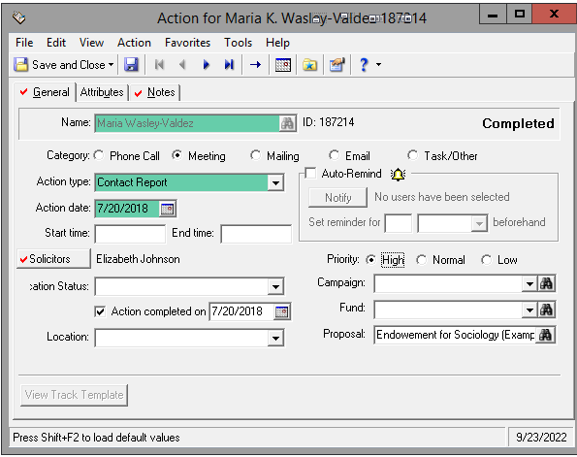

A benefit to using the Priority is the ability to assign a Legend color and/or column to highlight meaningful actions
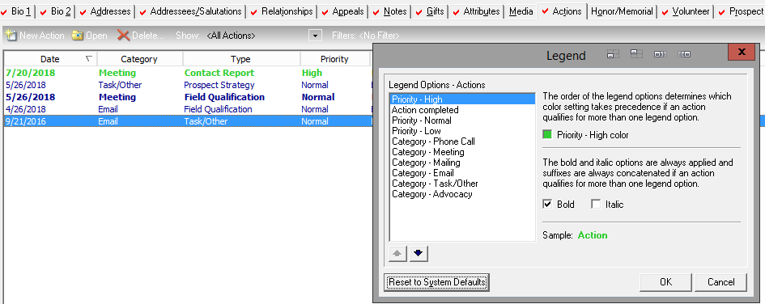

Indicate replies from donors with an Action Attribute
If sending routine/bulk emails or making routine phone calls, use the NXT Action Direction action attribute to indicate if you hear back from a donor, regardless of who initiated the contact. For example, a donor replies, “no thanks,” to a schedule request email, indicate they replied back using the NXT Action Direction of “Inbound”. In this case it would not need the priority indicator since the reply did not meet the definition of “meaningful contact”.
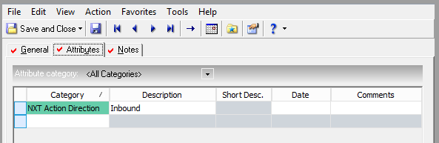

Tracking Priority and Responses in NXT

Use the “!” Priority Button to signify meaningful actions
When entering an action, use the Priority button to indicate a meaningful action
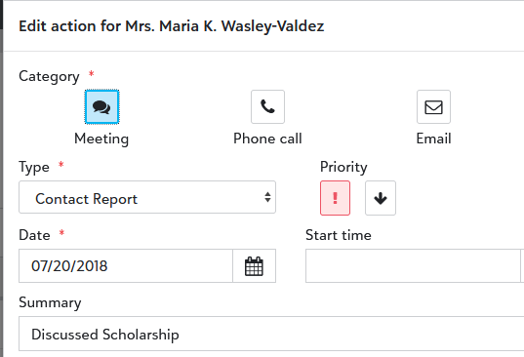
Once marked as high priority, the action record will show a “High priority” banner indicator.
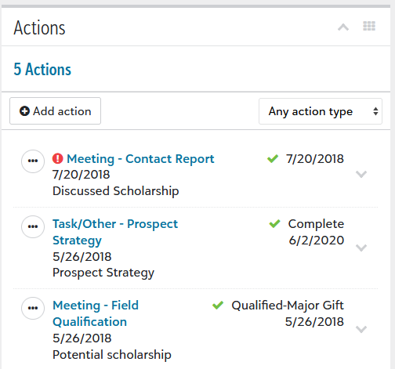
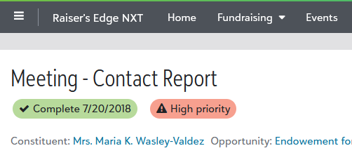

From a constituent profile, meaningful actions will show a “!” symbol in front of them.

Use “inbound” direction indicator for replies from donors
If sending non-meaningful emails or making non-meaningful phone calls, use the NXT Action Direction action attribute to indicate if you hear back from a donor, regardless of who initiated the contact. For example, a reply to a schedule request email should have the NXT Action Direction of “Inbound”.
