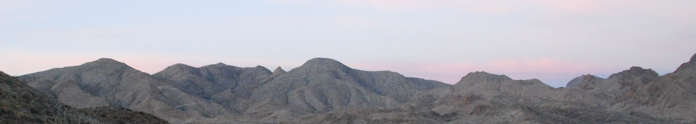

Christmas Mountains Research Symposium

May 19–21, 2024

Terlingua Ranch Lodge, Brewster County, Texas

The objective of the Christmas Mountains Research Symposium is to increase public and scientific understanding of the ecology, geology, culture and history of the Chihuahuan Desert ecosystem in the Big Bend region of West Texas and Mexico and to promote interactions among university researchers, agency personnel, and interested private landowners.

Our tenth two-day symposium will feature presentations by students and faculty from universities in the Texas State University System but welcomes contributions from researchers and interested individuals at other universities, federal and state agencies, non-governmental organizations, and residents of the area who have investigated aspects of the region’s ecology, geology, culture, and history. Presenters should plan to give a 12-minute talk followed by three minutes of questions and discussion. Powerpoint presentations will be supported but are not required.

The symposium will begin with an evening social and dinner on Sunday, May 19th. Each of the two following days will have field trips scheduled in the morning and presentations in the afternoon. The symposium will close with a dinner Tuesday evening, May 21st. This year we will again have multiple registration options: three-day registration ($95), which includes the social, field trips, attendance at paper sessions, and dinner Sunday, Monday, and Tuesday evenings; two-day registration ($75), which includes the social, field trips, attendance at paper sessions, and dinner Monday and Tuesday evenings; and a limited registration ($25), which includes the social, field trips, and attendance at the paper sessions. Other meals can be purchased on site.

Those wishing to make a presentation should submit an abstract by May 03, 2024. Each abstract submission should include the title of the talk, authors’ names and institutional affiliations, and a description of the main points of the talk not to exceed 350 words. Please plan your presentation for a general audience of scientists and students from a variety of disciplines, as well as interested individuals from the community. Visit the symposium web site to access the abstract submission form.

Registration for the symposium is limited to 80 participants due to space constraints. Visit the symposium web site to access the online registration and payment site. Registrations must be submitted by May 03, 2024 and payment can be made by most major credit cards or by electronic check.

Accommodations at Terlingua Ranch include 32 motel-style cabin rooms (two double beds), RV hookups, and campsites; visit terlinguaranch.com for more information on facilities. A block of discounted rooms has been reserved for the symposium and reservations should be made by contacting the Terlingua Ranch Office (432.371.3146). There are also other motel options, bed-and-breakfast accommodations and house and cabin rentals in the area. The Bad Rabbit Café, a full-service restaurant, is open daily for breakfast, lunch, and dinner.

For more information, feel free to contact the symposium organizer, David Lemke, by phone (512.245.3364) or email (david.lemke@txstate.edu). For links to the abstract submission form and the online registration and payment portal, please visit the symposium web site:

(https://www.bio.txst.edu/department-events/research-symposium.html).

The 2024 Christmas Mountains Research Symposium is sponsored by the Texas State University System, the TSUS Foundation and the Department of Biology at Texas State University

