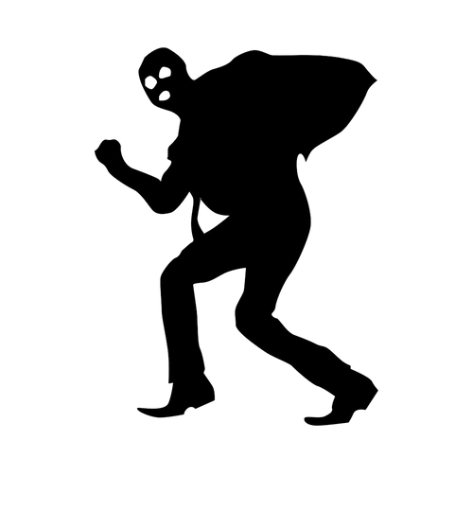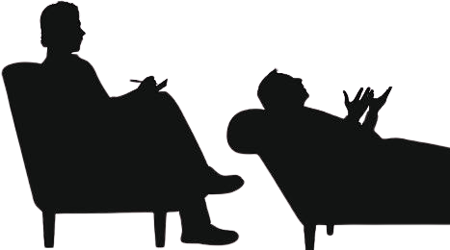

**directed by: Dr. Valentina Glajar & Zac Nelson**

Tatort Villa Bock

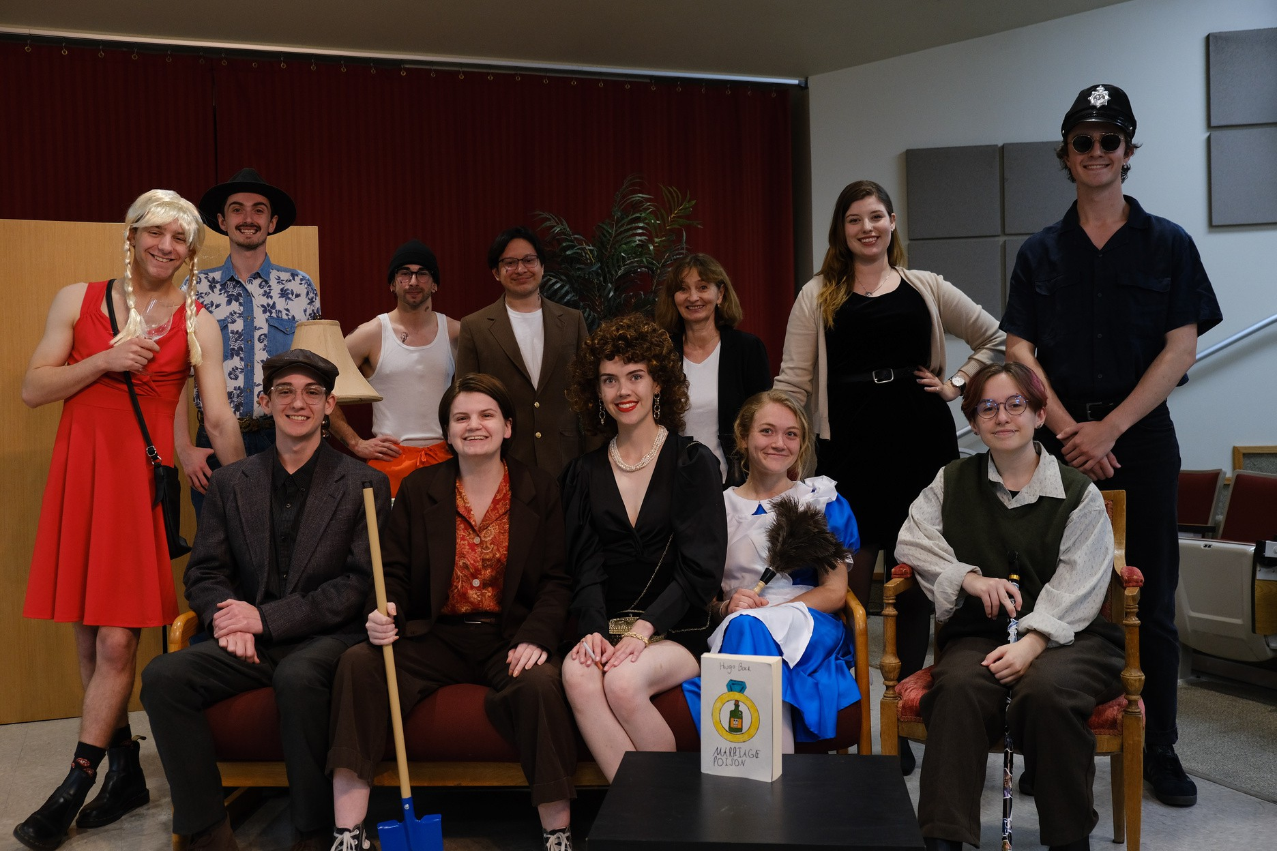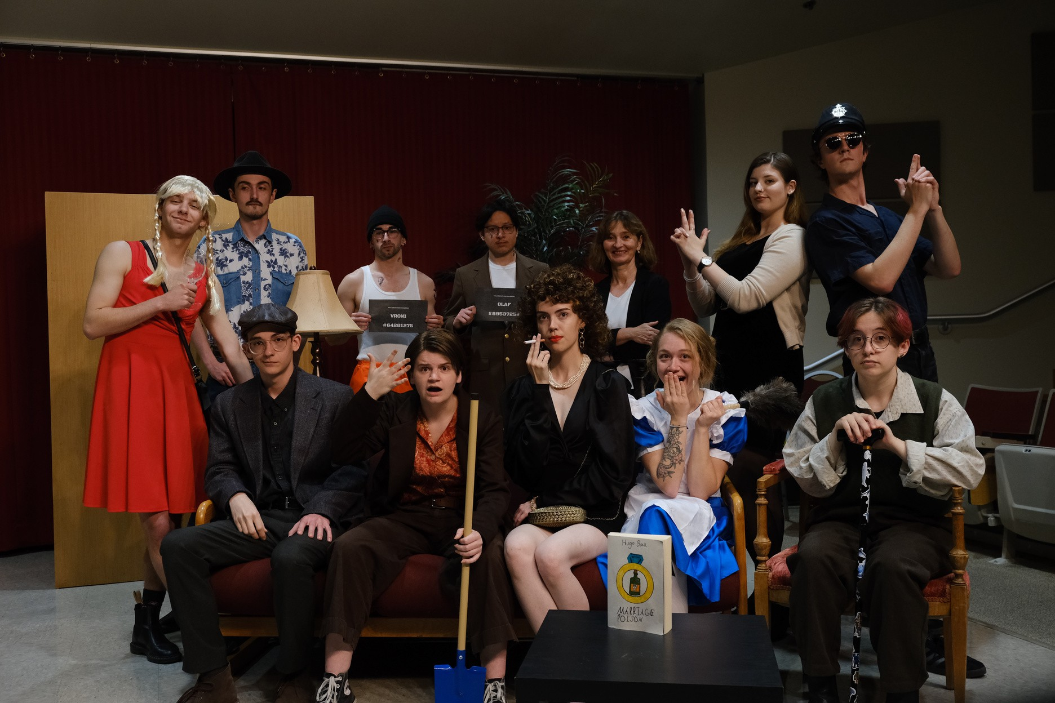

Sponsored by the department of World Languages and Literature

**April 25th, 2024 at 7:00pm in Cent G02**

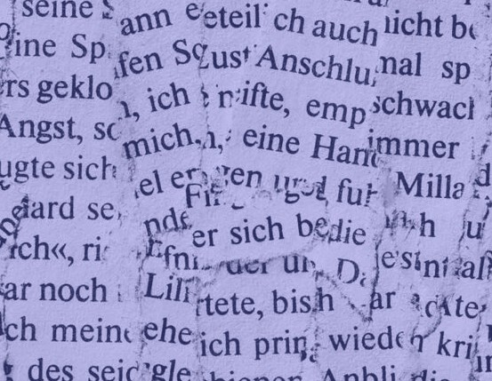



**D I R E C T O R**

D r . V a l e n t i n a G l a j a r

**A S S I S T A N T D I R E C T O R**

Z a c N e l s o n

**V I D E O G R A P H Y**

K a t i e M a c k i e

**S Y N O P S I S & G R O U P P H O T O S**

C o o p e r H a a c k

**P R O P S**

B e n F o g e l

**P O S T E R**

E r i n T a y l o r

**P R O G R A M**

C a r o l - A n n V e r e t t o

POLICE DECTECTIVE

Marcela Fass Piper Cotton

MOVIE PRODUCER

Charly Miller Zac Nelson

Hugo Bock Joci Tidey

AUTHOR

Jannet Bock Erin Taylor

HUGO’S WIFE

Marie Carol-Ann Veretto

MAID

Karl Haberli Trace Kleinecke

HUGO’S FRIND

Rolfi Spencer Fuson

JANNET’S FATHER

Olaf Manny Velsa

BURGLAR

Vroni Trent Mccarver

OLAF’S ACCOMPLICE

Amanda Ben Fogel HUGO’S EX MISTRESS Schnapp Cooper Haack

POLICE OFFICER

**LISTED AS THEY APPEAR ON STAGE**

**MEET THE CAST**

**SPECIAL THANKS!**



**ACT III**

TATORT VILLA BOCK

**SYNOPSIS**

der Gärtner- gardener/ der Koch-cook/ die Sekretärin- secretary/ Liebhaberin- Lover/ Polizei- Police

The next morning, Jannet enters the living room and finds Hugo asleep on the couch. Hugo begins an attempt to explain things to Jannet, but before he can, Marie enters with coffee and casually mentions Bock’s “corpses” to Jannet, who is clearly horrified.

Marie and Jannet have a brief conversation and leave the room before Olaf and Vroni emerge, this time from the closet. Fed up and confused, the escapees leave through the balcony.

Schnapp returns ahead of an inspector with a distinguished look and commanding tone. She says she is here to solve a blackmail case. Schnapp expresses his frustration at not catching the escapees just before he meets them at the office door, the two having been forced back inside by police cordons. Schnapp introduces “Hugo Bock” to the newcomer, who introduces herself as Criminal Inspector Marcela Fass.

Fass is constantly baffled by the odd comings and goings of people who Olaf and Vroni explain are the house staff. Their story becomes increasingly convoluted as they invent relationships to explain Fass’s strange interactions.

Amanda awakens from the closet but hides again before Fass sees her. Fass then goes looking for the stranger, with Schnapp in tow. Olaf and Vroni take the opportunity to hide in the closet again.

Hugo and Jannet return to the living room, followed by Schnapp and Fass, who reveals Hugo's affair to Jannet. Only Fass thinks they are the gardener and the governess.

While Fass is unraveling the web of relationships between the “staff,” Karl is being chased through the living room by Rolfi wielding his cane. Schnapp stops them, and with everyone gathered, Hugo reveals everyone's true identities. After he clears up some of the confusion, Amanda, Charly, Olaf, and Vroni are discovered hiding in the closet.

With everyone assembled, who will be revealed as the true blackmailer?

In the quiet German countryside, Hugo Bock, a successful crime novelist, lives with his doting wife, Jannet, an aspiring but dubiously skilled singer. Amid his writing, Hugo receives an ominous threat from a mysterious voice over the phone. It is his “Erpresser”

- his blackmailer. With no money to pay them off, Hugo uses his writing skills to commit “the perfect crime.” Combining his penchant for fictional crimes with reality, he plans his revenge against the blackmailer under the guise of a new crime novel. but there is one problem with Hugo's meticulous plot...

Through what seems to be a revolving door, a cast of characters arrive,whose timing always thwarts Hugo’s plans. With them, chaos descends upon the “Villa Bock,” leading Hugo to question his own sanity, as bodies seem to disappear and reappear elsewhere, as if by the work of ghosts. But this is not the case. It is simply the work of a strange group of individuals whose actions Mr. Bock could not possibly explain. They come from inside and outside Bock’s house for a variety of reasons as patchwork as Bock himself. To add to the confusion, they seem miraculously unaware of each other's presence and convoluted plans until the knot becomes too big to ignore. In the end, who will be revealed as the dastardly blackmailer?



**ACT I**

**ACT II**

Gelauscht- eavesdropped/ zusammenbrechen- To collapse/ Krimi- Criminal Novel/ Erpressung- Blackmail

It is the same day that Hugo received a call from his blackmailer. He sits at his desk, typing away, while in the other room, Jannet challenges his concentration and his eardrums. Hugo seems very on edge. Jannet notices this when the phone rings, but it is only Rolfi, Hugo’s contentious father-in-law. He is planning a visit to the couple's home. Jannet leaves the office to find Marie, their cheerful and remarkably naïve maid. They discuss Hugo's mysterious call but can’t come up with anything. Marie carries her tray of coffee into the office and innocently asks Hugo about the call. She almost takes the manuscript for Hugo’s murder plot, but he distracts her with another novel.

Later, the anxious tones of the day’s events are redoubled when the phone rings again. Hugo answers it, it is “Charly,” his blackmailer. He insists that the house must be empty and explains that he wants to meet that night to exchange one million for the security of Hugo and Jannet’s respective careers. Hugo strains to keep the meeting secret from the eavesdropping of Marie and his intrigued wife.

Suddenly, a man sneaks from the balcony into Hugo's office. He brusquely demands the million from Hugo but is soon revealed to be Hugo's friend and neighbor, the cynical psychiatrist Karl Häberli. Karl begins discussing Hugo's script for “The Perfect Crime,” unaware that it will become the story of Hugo's revenge. Hugo enlists Karl’s help to practice his murder, but they are interrupted by Marie. Despite Hugo’s best efforts, Marie stays in the house and becomes the first victim of Hugo’s murderous rehearsal when she faints at the sound of Hugo’s fake gunshot. She recovers and leaves.

Karl and Hugo continue to scheme. Just when they think they've figured it out, Rolfi walks into the living room at the wrong time. He faints at the shock of Hugo’s “pang pang!” and while Hugo and Karl split up in their efforts to revive him, a strange man sneaks into the living room and subdues Karl, whom he believes to be Hugo Bock, and hides both him and Rolfi in the closet. This intruder is Olaf, an escapee from a nearby prison. He and his accomplice Vroni are on the lam. It may seem a miracle that they escaped at all... Vroni lags behind and enters the house, only to be knocked unconscious by Bock’s office door. A fate that will soon be shared by Olaf. Marie returns to find Hugo hiding the bodies of the two escaped criminals, but she is none the wiser to the perilous reality of the scene before her.

erschossen- shot/ die Leiche- corpse/ das Verhältnis- Affair/ die Truhe- trunk/ der Schrank- Closet/ das Loch- Hole

After Hugo has stuffed the trunk behind the couch with the unconscious bodies of Olaf and Vroni, whom Hugo believes to be his blackmailers, he receives another phone call and is stunned when he hears the voice of the supposed “Charly” telling Hugo that he will be a little late. Shortly after the call, a seductive voice beckons Hugo from the front door. It is the honeyed tones of his former lover and the wife of his blackmailer, Amanda. The estranged couple must separate again when they hear Jannet calling from outside. Hugo tries to hide Amanda from his wife, but she also faints when she sees the many bodies now stuffed in Bock's chest and closet.

After everyone has left the living room, a sore Olaf and Vroni emerge from the chest. They see Amanda passed out at Hugo’s desk and are afraid of getting caught with what they think is a corpse. On their way out, they are intercepted by Marie, who innocently assumes them to be actors in the plot of Hugo's new book. Before leaving, she informs the escapees of a uniformed man she met outside the door. Another actor, she assumes.

On their way out again, the criminals are seemingly caught red- handed when a police officer greets them from the front door. Luckily for them, he is the self-serious but completely gullible officer Schnapp and a huge fan of Bock’s.

Olaf and Vroni escape through the balcony just before strange noises are heard coming from the closet. It is Karl and Rolfi, both awake after their forced sleep. Karl tries to diagnose Rolfi and is rudely rebuffed. Rolfi goes to the office and faints again when he sees Amanda slumped over the desk.

Karl leaves to fetch water for the passed out Rolfi, but shortly thereafter a loud thud is heard from the kitchen before Karl returns to the living room slung between Olaf and Vroni’s arms. They leave Karl on the floor next to Rolfi and go out into the garden. Marie returns shortly thereafter and, following her mischievous whims, decides to hide their bodies from Hugo.

Olaf and Vroni return just in time to be almost apprehended again by Schnapp, who has returned to get an autograph from Herr Bock that he'd forgotten to ask for earlier. In his frustration, Schnapp bangs Olaf and Vroni’s heads against the door they're hiding behind. Hugo re-enters the living room, exasperated by the reappearance of Olaf and Vroni’s bodies. Hugo hides them once more before being greeted by a Texan’s “Howdy.” A man in characteristic cowboy attire introduces himself as Charly and is led into Hugo’s office. There, Hugo distracts him with a manuscript and hits him on the head with a shovel. Believing again that he has foiled his blackmailer, Hugo hides his body in the closet before enticing a groggy Amanda to join him with a glass of her own wine.