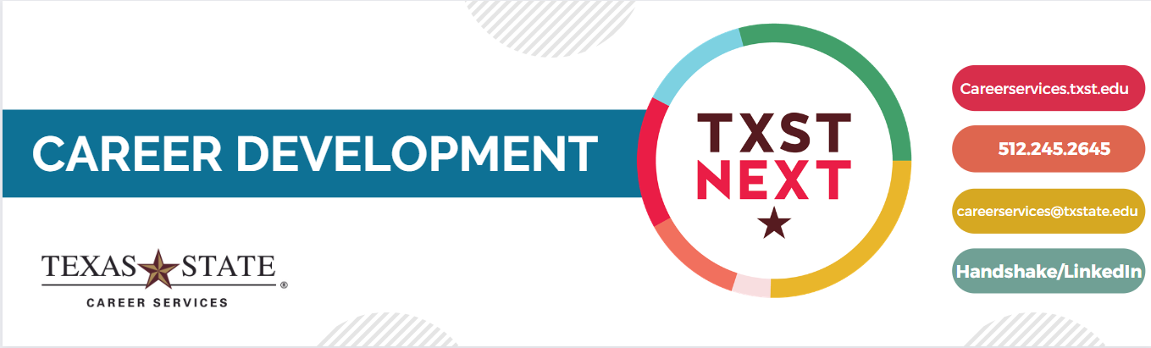

**Career Success Toolkit: Canvas Site Overview**

**Accessing the Site Materials**

* **Faculty/Staff –** Access course site materials through [Canvas Commons](https://canvas.txstate.edu/accounts/410/external_tools/56157?launch_type=global_navigation)
  + Search for “Career Success Toolkit,” then import modules into Canvas courses/project sites
  + Created for educational use within/outside of the classroom to better integrate career into the student experience
    - Each module contains at least one assignment/activity to help students apply the career information
      * Ability for faculty/staff to select and provide relevant modules to students as well as adapt the assignment/activity if needed
* **Students –** Access course site materials through [Canvas Self-Enroll](https://canvas.txstate.edu/enroll/G9TRJ4)
  + 24/7 access to all modules to engage in a self-paced journey for independent learning
    - Ability to self-select relevant modules by career topic and complete optional assignments/activities to enhance applied learning
  + Can be directed to these resources by Career Services and by our faculty/staff partners
  + Graduates lose access to Canvas about a year post-graduation. **Alumni can request access** from Career Services and Career Services can manually “invite” alumni to the Canvas site with their personal email addresses.

**Previewing the Module Content**

* Modules are categorized into four groups: Exploration (EX), Personal Preparation (PR), Professional Preparation (PP), and After Graduation (AG).
* See the below charts for a **summary overview** of each module:

|  |  |
| --- | --- |
| **Introduction to Career Services** | |
| **Module Overview** | This module walks students through the services and resources offered from the TXST Career Services Center and helps connect students with our appointment system. |
| **Learning Outcomes** | * Students will identify the services and resources offered by TXST Career Services. * Students will discover who their assigned Career Educator associated with their college is. * Students will gain awareness of how to schedule an appointment with Career Services. |
| **Module Activities** | * Explore Career Center website * Navigate to scheduling appointments on Handshake |

|  |  |
| --- | --- |
| **Self and Career Exploration**   | |
| **Module Overview** | This module walks students through the discovery of self and career exploration. It will allow students to gain an understanding of career paths that will align with their personal attributes and goals. |
| **Learning Outcomes** | * Students will identify resources and ways to explore major and career options. * Students will understand that career and major exploration is a process and requires one to expand their self-awareness and knowledge of the world of work. * Students will recognize that there are many paths to careers, which can include but aren't limited to one's major. |
| **Module Activities** | * Take two different career assessments * Browse our resource: "What Can I Do With My Major?" * Complete a major matching quiz * Create a list of career questions and practice career research strategies to seek out answers |

|  |  |
| --- | --- |
| **Resume/CV Building** | |
| **Module Overview** | This module teaches students about effective resume and curriculum vitae (CV) writing while connecting students with additional helpful resources in order to start creating/revising their own resume or CV document. |
| **Learning Outcomes** | * Students will distinguish the differences between resumes and CVs, including which document is best for them. * Students will identify the recommended content and structure for resumes and CVs. * Students will discover and apply helpful strategies and tools for effective resume and CV writing. * Students will produce a start to their resume/CV, completing at least one section. * Students will gain awareness of how to receive further resume/CV assistance from Career Services. |
| **Module Activities** | * Review applicable document resources (for resume and/or CV creation) * Practice writing one resume/CV section or more |

|  |  |
| --- | --- |
| **Handshake and LinkedIn** | |
| **Module Overview** | This module walks students through the process of creating their Handshake and LinkedIn profiles as these personal branding tools are super important in the career readiness and job search process. |
| **Learning Outcomes** | * Students will recognize the significance of Handshake and LinkedIn in starting to establish their personal brand. * Students will apply effective personal branding through creating profiles that positively represent their experiences, education, and professional goals. * Students will identify ways to utilize both platforms to connect with employers, colleagues, peers, professors, alumni, and mentors. |
| **Module Activities** | * Reflect on personal branding goals * Create Handshake and LinkedIn profiles and/or revise with personal branding in mind * Send a professional message/connection request on Handshake or LinkedIn |

|  |  |
| --- | --- |
| **Job/Internship Search** | |
| **Module Overview** | This module provides students an overview of the job/internship search process while emphasizing the importance of internships and connecting students to additional resources. |
| **Learning Outcomes** | * Students will gain awareness of job/internship search strategies and tips, realizing planning and preparation are key. * Students will recognize the value of internships/cooperative education experiences and assess whether an internship/cooperative education experience is a degree requirement for them. * Students will apply job search tools to identify possible jobs/internships and Career Fairs that interest them. |
| **Module Activities** | * Research academic requirements for an internship/cooperative education * Complete Career Launch assignment through practicing the use of job search tools |

|  |  |
| --- | --- |
| **Make an Impression: Interviewing and Networking** | |
| **Module Overview** | This module teaches students about effective interviewing and networking skills in order to make a good impression while also helping students realize who is already in their current network. |
| **Learning Outcomes** | * Students will gain awareness of interview preparation strategies. * Students will discover common types/examples of interview questions plus demonstrate effective ways to respond. * Students will name existing connections within their network and recognize opportunities to expand their network. * Students will acquire and apply strategies for navigating networking situations. |
| **Module Activities** | * Practice crafting interview responses * Try out Career Services' Big Interview system * Determine existing network contacts and consider plans for network growth * Formulate an elevator speech to use at networking events and interviews |

|  |  |
| --- | --- |
| **Exploring Graduate and Professional School**   | |
| **Module Overview** | This module offers students an introduction to exploring graduate and professional school as well as further resources to continue the exploration process. |
| **Learning Outcomes** | * Students will begin to assess if graduate/professional school might be a good fit for them. * Students will gain awareness of and practice with exploration and research tools regarding graduate and professional schools. * Students will identify the common components of a graduate school application as well as effective strategies regarding them. * Students will outline a tentative graduate and professional school planning timeline. |
| **Module Activities** | * Explore graduate school research websites * Reflect on/complete next steps regarding graduate and professional school exploration |

|  |  |
| --- | --- |
| **Negotiating, Accepting Offers, and Hired!** | |
| **Module Overview** | This module prepares students for their after graduation transition, providing first year professional tips and touching on an often taboo subject - offer negotiation! |
| **Learning Outcomes** | * Students will be equipped with first year professional transition strategies into the world of work. * Students will understand offer negotiation is common and will receive tips regarding negotiation. * Students will gain awareness of how to evaluate job offers. * Students will learn to calculate personal salary range needs and apply salary research skills. |
| **Module Activities** | * Review - and perhaps utilize - a job offer evaluation chart * Explore salary research websites * Utilize a budget calculator to determine personal salary range needs |

**Questions? Feedback?**

* Contact Career Services via email at [careerservices@txstate.edu](mailto:careerservices@txstate.edu). The builders of the site will get back to you in a timely manner!