Texas State University Overview of Financial Health FY 2023
The 2023-2029 Texas State University strategic plan, Hopes and Aspirations High, includes four pillars: elevating student success, becoming a Carnegie R1 institution, growing enrollment, and solidifying our position as a great place to work. The successful pursuit of these goals relies on the university’s overall financial health. Financial health, measured over time, helps to identify present and future opportunities and challenges. The Composite Financial Index (CFI) is the most widely used metric to provide simple, objective, insight into the overall financial health of an institution. The CFI was designed by higher education finance professionals in conjunction with credit ratings agencies and is described in greater detail in Strategic Financial Analysis in Higher Education. Since it was first published in 1980, through its most recent update in 2016, Strategic Financial Analysis for Higher Education has been acknowledged as the seminal work on ascertaining the financial health of an institution of higher education and is used extensively by trustees, senior leaders, and credit analysts.
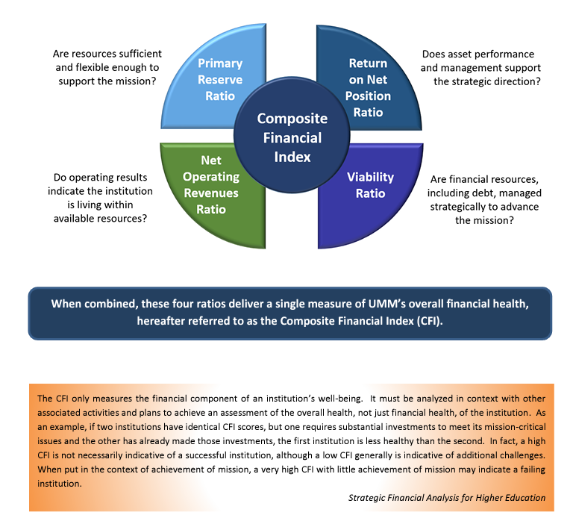

The CFI is comprised of four weighted ratios derived directly from an institution’s annual financial report. Two of the ratios are tied to current-year operational performance, the third is related to debt, and the fourth is related to institutional reserves.
CFI Component 1: Return on Net Assets (Weight 20 percent) (Threshold 6 percent)
Return on Net Assets compares the total earning capacity of the institution to its actual earnings results. It determines whether an institution is financially better off than in the previous year by measuring total economic return. As this is simply a measure of activity in a single year which is subject to large deviations, it comprises only 20 percent of the CFI score. Over the last 7 years, Texas State University has returned an average of 7.60 ⁽¹⁾ percent on its net assets annually, with a rate of 3.11 ⁽¹⁾ percent for FY2023. The 7-year average is above the recommended benchmark threshold value of 6.0 percent which is indicative of financial health. The lower rate in FY2023 was anticipated as the university made significant strategic investments.
Texas State reports the nominal rate of return on net assets unadjusted for inflation or other factors. Some universities present a real rate of return which adjusts for the effects of inflation. Over the past 30 years, the annual impact of inflation has been a relatively minor factor which did not materially change the meaning of this measure. With inflation over the past two fiscal years pushing into the 5% and 6% range, achieving the threshold value of 6% indicates keeping up with inflation. Should our current high inflationary environment persist, Texas State may need to consider using an inflation-adjusted reporting methodology in the future.
CFI Component 2: Net Operating Revenues Ratio (Weight 10 percent) (Threshold 4 percent)
The Net Operating Revenues Ratio measures annual operating performance, or, put simply, “profit & loss.” It answers the question, are we living within our means? Although very important, this ratio is still weighted less than those that follow because it is based only on a single year’s performance. The Net Operating Revenues Ratio for Texas State has averaged 6.90 ⁽¹⁾ percent over the past 7 years, with a 4.63 ⁽¹⁾ percent return for FY2023.
The FY2023 number, while still just above the threshold value, is lower than in recent years. This was anticipated as the university is entering a period of planned uses of reserves to advance numerous strategic initiatives. In fact, the university anticipated the possibility of a negative ratio this year. We continue to anticipate reduced, and perhaps even negative, operating ratios for the next several years as we invest in numerous strategic initiatives, including the launch of 10 new doctoral programs, more than 30 new online programs, and significant increase in our research investments to achieve, maintain, and exceed R1 status.
CFI Component 3: Viability Ratio (Weight 35 percent) (Threshold 1.25x)
The viability ratio is a measure of an institution’s level of debt and is tied with Primary Reserves as the highest-weighted factor in the CFI calculation since it can take decades to change this ratio in a meaningful way. This ratio measures expendable resources that are available to cover debt obligations (e.g., capital leases, notes payable, and bonds payable) and generally is regarded as governing an institution’s ability to assume new debt.
The threshold for financial health for this ratio is 1.25 at a minimum, with 2.0 being ideal. A ratio of 2.0 would mean that an institution has twice as much in expendable net assets as it does long-term debt. Texas State has carried an average ratio of 0.93 ⁽¹⁾ for the last 7 years with a value of 1.39 ⁽¹⁾ in FY2023. This is the university’s weakest indicator of financial health, although it is understandable given our rapid growth and construction in recent decades and that long-term debt often stretches over 20-30 years. It is unlikely that the university, given our aggressive growth plans, will be able to improve this ratio over FY23’s 1.39 figure for the foreseeable future. In fact, the university currently has plans to take on approximately $740 million in additional long-term debt, only $89 million of which will be supported from state appropriations, which will reduce this ratio for the next decade. We must continue to compensate for our relative weakness in this respect by retaining a healthy Primary Reserve Ratio to bolster our overall financial health.
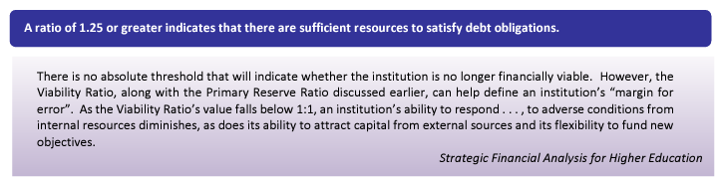

CFI Component 4: Primary Reserve Ratio (Weight 35 percent) (Threshold 0.4 or 146 days)
This ratio indicates how long an institution can operate on its reserves without needing to generate additional income. It is tied for the highest-weighted indicator of financial strength because these reserves have taken, in our case, since our founding in 1899 to amass. Texas State University has maintained an average of 255 ⁽¹⁾ days of reserves over the last 7 years. The recommended benchmark is 146 days, or approximately five months. The university had 301 ⁽¹⁾ days in reserves at the end of FY2023.

Carrying reserves at these healthy levels serves as a direct counterbalance to our relatively weak Viability Ratio. It also means that Texas State can weather most unforeseen adverse financial events and implement its strategic plans. It is important that we maintain primary reserves sufficiently above the benchmark in order to offset our plans to increase our debt over the next twenty years. Note that the 301 days includes funds that would not normally or legally be available to spend short of an exigent circumstance, like bankruptcy. Please see the following discussion of available reserves for a better understanding of the types of funds included in this calculation.
Composite Financial Index Summary Analysis
Texas State, on average, earned a CFI score of 3.91 ⁽¹⁾ over the last 7 years and a score of 4.06⁽¹⁾ for the most recent five years. While both of these exceed the threshold value for financial health of 3.0, our more recent 5-year average indicates the university’s financial health is improving. In short, Texas State has adequate financial health for a large public university. Our Primary Reserves of 301 ⁽¹⁾ days of expense coverage would allow us to meet operating obligations in the event of an emergency or catastrophe. We continue to grow net assets by maintaining positive annual operating returns, though we anticipate some negative years are possible in the near future.
In conclusion, Texas State has enough wealth and access to capital resources to finance its strategic plans and endure unanticipated financial challenges. It is imperative that we carefully manage debt and reserves in tandem with our plans to take on significant debt in the near future and use reserves to balance the budget over the next several years, and perhaps longer if we do not achieve anticipated enrollment growth or receive additional support from the Texas Legislature. The university has sufficient financial strength to continue to pursue its aggressive plans for growth in total enrollment, improvements to student success, and pursuit of becoming a Carnegie R1 University.
The Available Reserves Ratio
While the Primary Reserve Ratio used in the CFI measures the amount of funding we could access in an emergency, it is misleading as it includes funds from many sources that are typically restricted to very specific uses. In other words, a good portion of Primary Reserves is not available short of a financial calamity which threatens the existence of the institution.
For this reason, Texas State still uses Available Reserves, as explained in University Policy Statement 03.02.01 and first detailed in NACUBO’s Financial Self-Assessment: A Workbook for Colleges, as a measure of financial health in addition to the CFI. Available Reserves more adequately represents reserves as most people would use the term in that it excludes funds that are restricted in use. Our policy goal for Available Reserves is to maintain a ratio of 0.25 or 90 days of reserves.
As demonstrated in the chart below, Texas State prior to 2020 had averaged an Available Reserve Ratio of 0.1463 representing only 53 days of expense coverage. Only since 2020, have we achieved our goal of 90 days in Available Reserves, and we ended 2023 at 113 days or an Available Reserve Ratio of .3085. Noticeably, 2023 marked a significant reduction from 2022 as we made significant investments in our new vision for the future of Texas State, including support for our Run to R1 initiative. As we celebrate the 125th anniversary of Texas State University in 2024, we expect to continue to make strategic investments to ensure its viability for another 125 years which may further decrease Available Reserves, though we will endeavor to maintain our 90-day target.
Texas State University Available Reserves 2013-2023



Putting this in context, Texas State University is an institution with over $2 billion in total assets. As such, 113 days of Available Reserves is still a large sum, $161,113,542 to be exact. This amount is not in a single account at Texas State called “Reserves”. Rather, this amount lives in the account balances of hundreds of operating units across the institution. For example, small parts of this sum live in every college and school, every academic program, every administrative office, and every student support area. While all the funds in our Available Reserves are unrestricted from a legal standpoint, and we can use them for other things, one should not have the notion that there are no plans for the funds. Those offices and departments have annual goals and strategic plans that they are counting on using these funds to accomplish. The FY 2023 budget approved by the Board of Regents of the Texas State University System does include a single budget account called “Institutional Reserves” that is completely unallocated and is set aside for unexpected needs. The amount in that account is $2,500,000, or a fraction of one percent of our all-funds budget of more than $1 billion.
Finally, it is important to ensure that the university is transparent and accurate with regards to Primary Reserves and Available Reserves. Primary Reserves are comprised of the university’s Unrestricted Net Assets as reported in the Annual Audited Financial Statement. That amount is $588,877,770 for FY 2023. Below is high-level summary that explains the seven types of funds that makes up a little over 96 percent of Primary Reserves, including Available Reserves which is one of the eight. Most of the funds in Primary Reserves have restrictions on their use.
High Level Breakdown of Primary Reserves FY 2023
 | Fund Type |  | FY 2023
1 | Available Reserves
 | Primarily Tuition Revenue |  | $161,113,542
2 | Other Restricted Account Balances
 | Primarily Fee, Sales & Service, and Research Revenue |  | $53,788,445
3 | Auxiliary Account Balances
 | Primarily Housing, Athletics, Parking and Transit |  | $44,497,583
4 | Committed Plant Funds
 | Primarily Auxiliary and HEF facility reserves |  | $111,670,834
5 | Quasi-Endowments
 | Require Board of Regents Approval to spend |  | $138,544,914
6 | Prepaid Items
 | Primarily Commitments to Student Scholarships |  | $44,500,986
7 | Encumbered Funds Awaiting Expense at Year-End |  | $12,983,028
 |  | Totals to 96.3 percent of Unrestricted Net Assets | $567,099,331

