# Parent/Guardian Registration View

Ideal-Logic

February 7, 2025

[academiccamps@txstate.edu](mailto:academiccamps@txstate.edu)

**Registration Portal:** <https://apps.ideal-logic.com/txstreg>

**Creating an Account**  
Parents/guardians should create an account using the Non-Texas State Login. If the parent/guardian is affiliated with Texas State University (TXST), we recommend creating a personal account for the child's registration.

**Indicating Your Role**  
When prompted, select **"I am a parent or guardian."** *For guidance related to the minor registering and notifying the parent/guardian to complete consent forms, refer to page 12.*

**Entering Your Information**  
Once the account is created, you will be asked to provide both your personal information and your child's details. If you have multiple children, you can add additional children after the initial account setup. A screen shot of a computer

From your dashboard, select **"Edit Your Profile"** to add minors.

Navigate to **"Edit Profile"** and click **“Add Dependent”** to add each child.

**Program Registration Process**

* The **Program Operator** will either send you a direct link to the camp or you can select the camp from the catalog.
* When registering, choose this registration is for **“A Child or Dependent.”**

Select an existing dependent or add a new one. Fill out the necessary details for the child.

Ensure the parent/guardian’s information is accurate.

**Enter Medical History**

* Include details on allergies, prescription medications, physician, and insurance.
* If not applicable, indicate this as such.

If the camp has additional questions, you will be prompted to answer them.

**Complete Consent Forms**

Complete the required consent forms:

1. Minors/Adults Participation Release and Indemnity
2. Guardian Authorization for Self-Administration of Prescription Medication (if applicable)
3. Guardian Authorization for Over-the-Counter Medication
4. TXST Authorization for Medical Treatment for Minors
5. Photo Release for Minors

Parents/guardians must review and "check" all over-the-counter medications they authorize the camp to administer to their child as needed. If a medication is not checked, camp staff will be unable to administer it. Parents/guardians can update this information in Ideal-Logic at any time.

**Review All Registration Information**

Double-check the registration details to ensure accuracy.

**Payments**

* Payment options vary by camp. Some camps may require **full payment**, a **deposit**, or **no fee** to register.
* Example: In the screenshot below, the camp’s total cost of $1,400 is due by June 1. Parents/guardians may log in and make as many payments as necessary before the deadline—payments do not have to be in a lump sum.
* **To make a payment**, on the Home screen, you will have an "Account Balance" red box and a green "+ Make a Payment" button. Clicking "+ Make a Payment" will allow the parent/guardian to choose the specific registration items they want to make a payment on.

**Camp Details**

* All camps the minor is registered for will be displayed on the dashboard.
* Select **"View Details"** under the camp to make a payment.

**Post-Registration Notifications**

* **Program Operators** can post announcements or add questions/consent forms after registration.
* The parent/guardian will receive a red notification at the top of their dashboard if any new updates are posted.

**Consent Forms for Minor-Started Registration**

If the minor begins the registration process and requires the parent/guardian to complete consent forms:

Step 1: A minor completes the form and gets to the consent form page. They will see a message prompting them to click on the **“Email Parent or Guardian...”** link.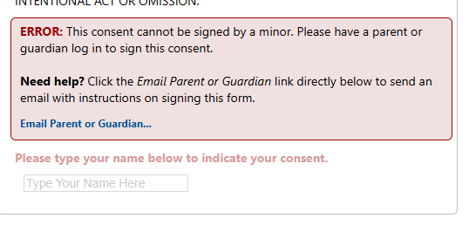

Step 2: The parent/guardian will receive the following email notifying them of the pending action.

Step 3: The parent/guardian will see a red “**Action Required**” notification at the top of their dashboard. Following “Action Required” the guardian will be able to sign the consent forms and complete the submission of the form.