# Session Dashboard for Program Operators

Ideal-Logic

February 10, 2025

[academiccamps@txstate.edu](mailto:academiccamps@txstate.edu)

**Registration Portal:** <https://apps.ideal-logic.com/txstreg>

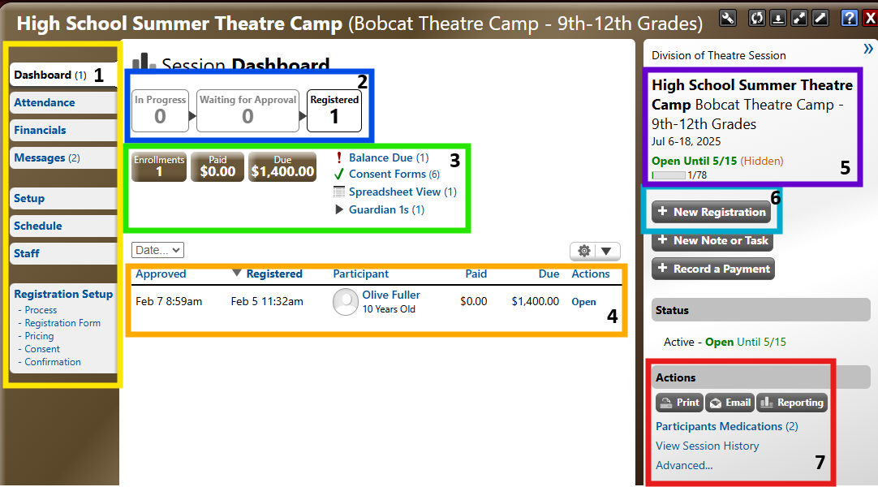

1. Session Tabs: Different tabs to navigate to different parts of the session as well as different parts of the registration form people complete to register for a session
2. If a session has a review process this will show the number of participants in each stage
3. An overview of finances as well as completed/missing items such as consent/medical forms
4. A spreadsheet of all fully registered/approved participants
5. An overview of what the session is, details about when/if it is open for registration, as well as number of open slots if there is a limited amount
   1. Note: Hidden means that someone needs a direct link to register for it as it will not show up on the catalog
6. “+ New Registration” is how you would open a view of the form as if you were a guardian/participant attempting to register
   1. Note: It is helpful as you are making changes to see how those changes are impacting the registration form from the perspective of those filling it out
7. Where you can print certain unique reports, as well as send mass emails to those who have applied

**Note: Throughout the system you will see text prompts, consent forms, emails, etc. include text such as “{&first_name}”. These are called aliases and are special text that display different text depending on who the registration is for etc.**

**Session Tabs**:

* Dashboard: The home screen to see the most comprehensive information about a session
* Attendance: TXST Academic Camps requires Camps to track attendance. You would go here to record attendance according to your specific camp setup. Reach out to TXST Academic Camps for more details
* Financials: Provides an overview of all payment information
* Messages: Records all messages sent to admins, guardians, and participants associated with a particular session.
  + These could be manually sent emails or emails sent by auto-notifications
* A screenshot of a box

  AI-generated content may be incorrect.Setup: Where an admin sets up session name, description, session dates, sponsoring unit, as well as some required information relating to details and location of the session.
  + Brief Description shows up directly under the session name and should be kept very brief
  + A screenshot of a questionnaire

    AI-generated content may be incorrect.Detailed Description is a much better place for details such as a description of the session, contact information, etc. Someone has to click the word “Details” on the catalog to see this description
  + Note: The “Activity Details” and “Activity Location” text boxes populate directly into the Assumption of Risk consent form
* A screenshot of a calendar

  AI-generated content may be incorrect.Schedule: Where you add details about when the session is occurring. Adding a schedule is especially helpful when the session only happens during the day.
  + Single Day: Session lasts only one day
  + Multiple Days: Session is overnight and continually goes from Day 1 to the last day
  + Recurrence: Session is a day camp that goes from 8am-5pm on selected days
    - Note: As you choose dates/times you will see a calendar start to populate with your chosen schedule. You can click on dates to add or remove them in case your recurring schedule falls on a holiday and you don’t have camp that day
* Staff: Where you add staff to a specific session in case they need access to registrations for administrative purposes
  + Camp staff not affiliated with TXST can have access, for example, a partner theatre company. Reach out to TXST Academic Camps with questions.
* Registration Setup - Process
  + **A screenshot of a computer

    AI-generated content may be incorrect.**Covers session availability, slot restrictions, approval process, cancellation options, and auto-notifications
  + Availability: Sessions can be restricted by dates (open/close), can be hidden so only those with a direct link can register, as well as by things such as grade and age
  + Choosing options under “Restrict Availability” will immediately alter who has access to see and/or submit a registration for a particular camp

* + Slot Restrictions: Where you alter how many slots you want available for people to fill when registering. By default, it is set to unlimited. Make sure to change this if you have limited space in your session.
  + When adding slot restrictions, you also gain access to the waitlist where people who register after a session is full or all spots are reserved by those waiting to be approved. The waitlist appears as an extra tab on the “Dashboard” for a session
  + You can also customize notifications and messages that go out to people on the waitlist
  + A screenshot of a computer screen

    AI-generated content may be incorrect.Approval: We default to using a simple approval process where an admin would get notified someone has applied and the admin will come into the system to approve or deny their registration.
  + If you need a more complicated review process, say one that involves multiple rounds and/or multiple people please contact TXST Academic Camps for assistance
  + A screenshot of a computer screen

    AI-generated content may be incorrect.Cancellation Options: Here you can alter the cancellation policy and who should be notified of cancellation requets. Typically we recommend using the “Participants can request to cancel their registration” option as it gives the most control to the admin
  + Auto-Notifications: If there are emails that you would want to be automatically sent from this system this is where those get configured. Please contact TXST Academic Camps for assistance configuring these
* Registration Setup – Registration Form
  + Covers the questions that participants are asked in the form
  + A screenshot of a computer screen

    AI-generated content may be incorrect.Participant Questions: Section of questions that use toggles to turn them on and off. These questions are attached to the person the registration is for and the answers will auto-populate the next time a registration form is being filled out and they are the participant
  + A screenshot of a contact form

    AI-generated content may be incorrect.Participant Contact Information: Section of questions that use toggles to turn them on and off. These questions are attached to the person the registration is for and the answers will auto-populate the next time a registration form is being filled out and they are the participant
  + Participant Medical Information: TXST Academic Camps are requiring all sessions to capture some basic medical information. If you have concerns please contact TXST Academic Camps. Medical forms can be delayed until someone is approved.
  + Demographics: These are built in demographic questions that feed directly into demographic reports.
  + Custom Questions: This is where questions unique to a Camp’s session would be created and added. Please contact TXST Academic Camps for assistance with creating questions you want to ask, but that don’t exist in the previous Participant question sections
    - A screenshot of a computer screen

      AI-generated content may be incorrect.Note: Participant questions are questions that repeat for a person from registration to registration and get auto-populated from the last registration that was completed for that particular participant. Historical data is not possible as even previous registrations will display the most recent answer for a question. Therefore, these should be questions you don’t expect to be updated often.
    - Enrollment questions on the other hand get answered every time a registration is completed.
* Registration Setup – Pricing
  + A screenshot of a computer screen

    AI-generated content may be incorrect.Covers the cost, deposit, due dates, payment instructions, and discounts/ additional fees. As pricing is very critical to get right, please consult TXST Academic Camps for assistance
  + One area that is okay to update is the “Payment Tab Text” as this is the information displayed to whoever is completing the registration. It is a helpful place to include cancellation policies, next steps while waiting to be approved, payment timelines, etc.
* Registration Setup – Consent
  + There are default required consent forms for all TXST Camps that are putting on programming for minors. They include the:
    - Release of Liability, Indemnification and Assumption of the Risk Agreement Minors
    - Parent/Guardian Authorization, Waiver, & Consent for Over-the-Counter Medication Administration
    - Parent/Guardian Authorization, Waiver, & Consent for Self-Administration of Prescription Medication – Minors on Campus
    - Texas State University Authorization for Medical Treatment for Minors
    - Photo Release
  + If you have additional consent forms such as a student and parent rules and regulations or a field trip waiver, please contact TXST Academic Camps for additional support in creating these consent forms in the system
  + Note: Consent forms can be delayed until someone is approved
* Registration Setup – Confirmation
  + Where you can customize the message that is displayed after someone has submitted a registration

**Actions:**

* Print
  + A screenshot of a computer

    AI-generated content may be incorrect.This is where you go to print/download reports such as rosters, but also covers extra reports such as:
    - Special Concerns – Contains certain important medical information such as allergies, medications, and can even contain no-photo indications if someone has opted out of the photo consent form
    - Emergency Sheets – Contains information about emergency contacts and also contains many of the same pieces of medical information found on the Special Concerns list
    - Check-In/Check-Out Lists – Contain information such as guardians and people listed as additional pick-ups for a participant
    - Consent Forms – Contains signed consent forms
* Email
  + A screenshot of a computer

    AI-generated content may be incorrect.This is where you go to send various mass emails quickly. It uses the same format as when sending emails from a Camp’s dashboard

* Participant Medications
  + **A screenshot of a computer

    AI-generated content may be incorrect.**Contains a spreadsheet of prescription medications and details around when and how they should be taken. Also includes the ability to record when a dose was taken