# Camp Dashboard for Program Operators

Ideal-Logic

February 10, 2025

[academiccamps@txstate.edu](mailto:academiccamps@txstate.edu)

**Registration Portal:** <https://apps.ideal-logic.com/txstreg>

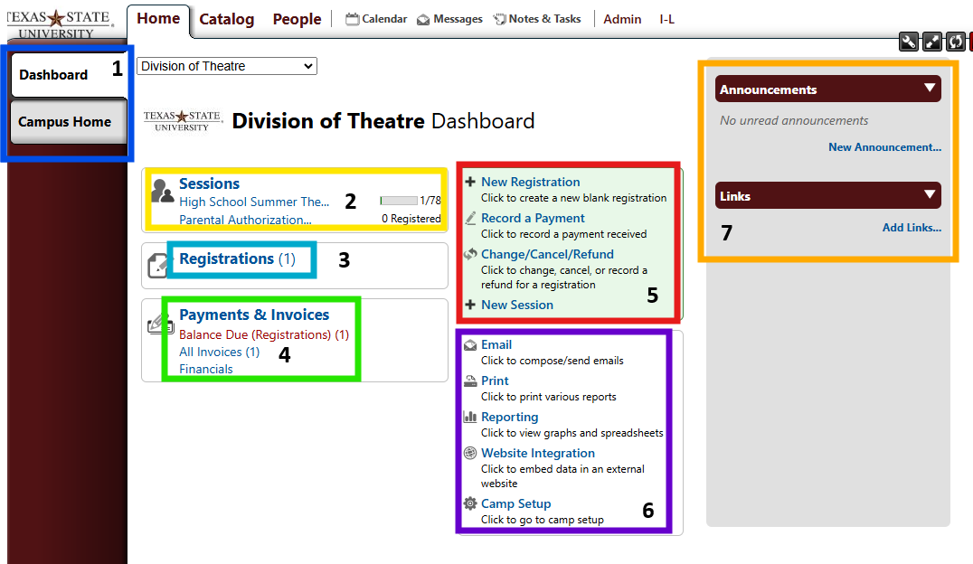

1. Camp Admins will have a Camp Dashboard that acts as an overview of everything associated with a Camp. In this example we use the Division of Theater.
   * “Campus Home” will be the view that is most similar to what guardians/participants will see
2. List of sessions that a Camp oversees. Clicking on these will pull up the admin view for a particular session
3. Lists all registrations, including in-progress/incomplete ones across a whole Camp
4. Contains different financial lists such as registrations with a balance due. As you have sessions that include more options, more lists will appear here such as “Refunds” or “Applied Discounts”
5. Admin functions. One to note, is “+ New Session” allows an admin to create a new session for people to register for. It can be created from scratch or you can copy from a previous one
6. Additional Admin Functions where you can send mass emails, view reports for a whole camp, and enter the Camp Setup window to customize some settings about a camp
   * **Mass Emails:** Please know it might be more helpful to mass email from within a particular session, but at the Camp level you could quickly email everyone who has registered for any item for a specific term (Spring, Fall, Summer, etc.). Clicking “Email” will pull up the left screenshot below. Navigating through those options will pull up the one on the right.
     1. Decide if this is a marketing or normal message. Please note that guardians/participants can unsubscribe from marketing emails which means it may not reach them.
     2. Choose who you want the emails to be from. Your options will differ depending on your level of access.
     3. 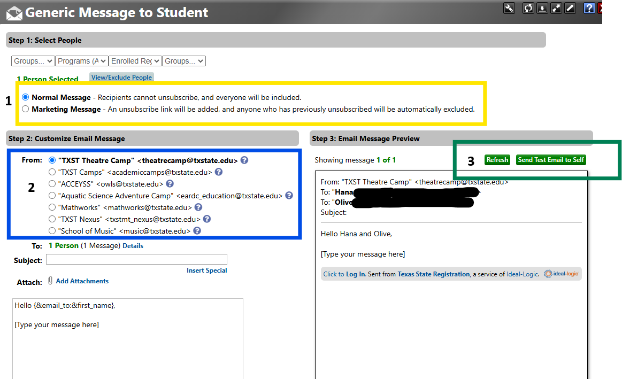A screenshot of a computer

        AI-generated content may be incorrect.If your email has more than one recipient you will see a “Next” button appear in this box allowing you to click through the emails you are about to send to make sure everything looks correct.

* + **Camp Setup:** This setup window offers a lot of control, but please keep in mind that majority of the options should only be adjusted by Academic Camp staff. Feel free to reach out to them if you need any changes made.
    1. However, on the “Setup” tab of “Camp Setup” the “Contact Information” section and “Branding” section are helpful to review. Here you can make sure the email, phone, and address are correct for your camp. You can also upload a Camp specific logo if you have one.