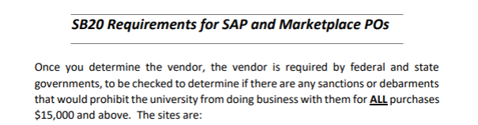

**There are a total of 10 Senate Bill 20 (SB20) Documents that must be attached to your requisition or eNPO at issuance. Not after the fact.**

**This is from the Texas State Legislation and is an Audit Compliance Requirement**

**Copy and paste each hyperlink in your browser to open:**

<https://mycpa.cpa.state.tx.us/coa/> **Franchise Tax**

<https://usfcr.com/search-federal-contracts/> **Federal – SAMS Check**

<https://comptroller.texas.gov/purchasing/programs/vendor-performance-tracking/debarred-vendors.php> **Texas Debarment**

<https://sanctionssearch.ofac.treas.gov/> **The OFAC**

**NOTE: This is the State Comptroller Site for the Divestment List**

<https://comptroller.texas.gov/purchasing/publications/divestment.php>

**In the Divestment listing, there are 6 documents that must be attached**.

The State included a Frequently Asked Question (FAQ). This document is not required to be attached.

In your vendor searches:

Franchise Tax, Federal – SAMS Check, OFAC; If your vendor search states, “no vendor found”, SAVE that look up as PROOF of the vendor not being found and attach to the requisition.

**See User Guides for Attaching a Document.**

<https://mycpa.cpa.state.tx.us/coa/> - **Franchise Tax**

<https://usfcr.com/search-federal-contracts/> - **Federal – SAMS Check**

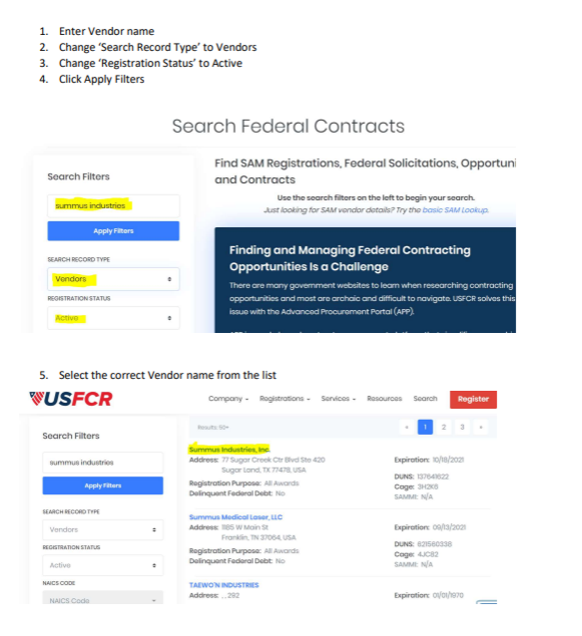

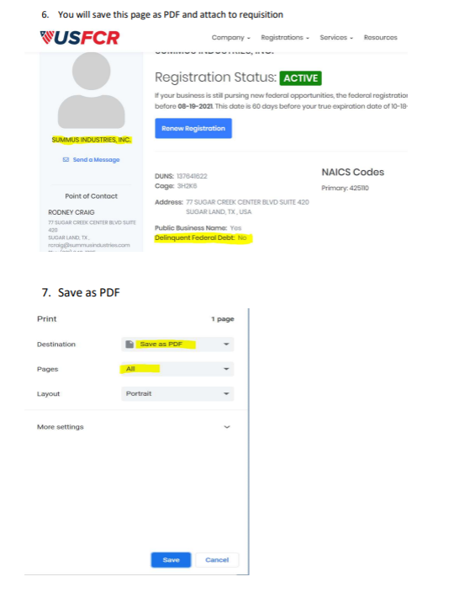

<https://comptroller.texas.gov/purchasing/programs/vendor-performance-tracking/debarred-vendors.php> **Texas Debarment**

**Once Comptroller site comes up type in: Debarred Vendor List**

<https://sanctionssearch.ofac.treas.gov/> **The OFAC**

**NOTE: This is the State Comptroller Site for the Divestment List**

<https://comptroller.texas.gov/purchasing/publications/divestment.php>

**In the Divestment listing, there are 6 documents that must be attached**.

**You must OPEN EACH link listed below, save as a PDF document and attach to your requisition. The FAQ list is not required but a good explanation**

