COURSE PROMOTION RESOURCES
Rev. 3/2025
This document provides suggestions for faculty who wish to communicate about their upcoming courses.

REMINDERS
As TXST employees, faculty are responsible for providing accessible content, presenting accurate course information, and correctly distributing materials in digital and print formats.
For more information, please see the document, “TXST English News and Publicity Resources” (Faculty Resources > News, Publicity, & Event Resources) especially the sections, “Accessible Content and Emailing” and “Distribution and Accessibility.”
When program directors and faculty communicate about courses, they should adhere to information in the TXST Provost’s email, “Ensuring Alignment of Course Titles and Content with Approved Curriculum,” sent on 3/10/25.
Specific concerns about individual course enrollment should be directed to the department Chair and/or the Director of Advanced Studies.
Faculty are encouraged to provide a statement such as the following when they communicate about their courses:
Questions? Email the instructor! Find out more about Advanced Courses on the Texas State English (@txstenglish) department website: https://www.english.txst.edu/student-resources/course-descriptions.html
The following are methods for communicating about courses.

METHODS & DISTRIBUTION

FLYER
A Microsoft Word template (with examples), which can be printed, emailed, and posted to Canvas, is available at the end of this document. Templates include directions for retaining formatting. Remember to use accessibility settings (such as ALT TEXT); do not convert the file to a PDF, which can compromise accessibility.
See also sections, “Required Course Information” and “Image Selection,” below.

CLASS VISIT
In-person class visits are the most effective course promotion. Faculty can ask colleagues (esp. those teaching 3301) to request a visit in person or via Zoom.

ANNOUNCEMENT
Faculty can ask colleagues to share course info with their classes in person or via email/Canvas. Please do not request a department-wide email from the chair’s office because mass announcements about specific classes are not effective.

SOCIAL MEDIA
COLA advises faculty to develop public-facing social media profiles to promote their work, including teaching (see “TXST English News and Publicity Resources.”)
Faculty are advised to post images (or graphics with very minimal text) on social media; use the written section of the post to provide details, e.g., the required course information. See sections, “Required Course Information” and “Image Selection,” below.
POST TO FEED (INSTAGRAM): tag @txstenglish in the written section of the post AND in the picture itself (the latter will allow post to show on department’s tagged grid)
SHARE TO STORIES (INSTAGRAM): tag @txstenglish, which will allow the department to share to the department's stories.
The above recommendations are for Instagram, the platform with student engagement. Faculty are welcome to use comparable tagging settings in Facebook, LinkedIn, and X although these platforms do not show high levels of student engagement.
The template (with examples) provided in this document are NOT designed for social media. Do not post them or other text-heavy flyers to social media because they are not accessible formats for those platforms.
For more information about social media, please see relevant sections in the document, “TXST English News and Publicity Resources” on department website (Faculty Resources > News, Publicity, & Event Resources).

REQUIRED COURSE INFORMATION
- Course Number, Section Number, Course Name (exactly as listed in course catalog)
- Topic Name (for designated Special Topics courses ONLY)
- Instructor Name (email)
- Day, Time, Modality (if online), Semester Year
- Course Description (exactly as listed in course catalog)
- Section Description (for designated topics courses ONLY)
  - Recommendation: keep this brief, i.e., less than 100 words; do not reduce font size of written text in template (compromises accessibility)

IMAGE SELECTION
Select an image(s) that is a straightforward representation of your course and that will be recognizable/appeal to undergrads. Ask your current students if you are considering different options.
The image MUST be
- a high-resolution image for which you own the copyright,
- a high-resolution public domain image from Pexels, Wikimedia, or another public domain site,
- a high resolution image from the TXST repository, Canto, and/or
- a high-resolution image of a book cover(s)
  - book covers fall under fair use if the book is taught in the course
See also university policy re: image use.
Additional suggestions for image selection:
- Literature courses: select author photos, well-known artwork, and/or book covers
- Writing courses: select images of TXST students from TXST image repository (Canto)

TEMPLATE FOR COURSE FLYERS & DIRECTIONS
Directions: 1) Use “Save As” to re-name file and save to your device. 2) Retain formatting by typing over text OR use “Merge Formatting” to copy and paste into the fields below. 3) Delete these directions; delete pages above and below. 4) Refer to the original version of this document for distribution suggestions.
ENG ####.### OFFICIAL COURSE NAME
TOPIC: NAME [for topics classes ONLY]
INSTRUCTOR NAME (xxxx@txstate.edu)
DAYS, TIME/MODALITY SEMESTER YEAR
[INSERT IMAGE]
[size/# of images depends on the amount of written text below;
use the “text wrapping” feature to place image side by side with written text]

COURSE DESCRIPTION (exactly as listed in course catalog)
Lorem ipsum dolor sit amet, consectetur adipiscing elit, sed do eiusmod tempor incididunt ut labore et dolore magna aliqua. Ut enim ad minim veniam, quis nostrud exercitation ullamco laboris nisi ut aliquip ex ea commodo consequat. Duis aute irure dolor in reprehenderit in voluptate velit esse cillum dolore eu fugiat nulla pariatur. Excepteur sint occaecat cupidatat non proident, sunt in culpa qui officia deserunt
SECTION DESCRIPTION (for designated topics courses ONLY)
Lorem ipsum dolor sit amet, consectetur adipiscing elit, sed do eiusmod tempor incididunt ut labore et dolore magna aliqua. Ut enim ad minim veniam, quis nostrud exercitation ullamco laboris nisi ut aliquip ex ea commodo consequat. Duis aute irure dolor in reprehenderit in voluptate velit esse cillum dolore eu fugiat nulla pariatur. Excepteur sint occaecat cupidatat non proident, sunt in culpa qui officia deserunt

EXAMPLE FLYER: NON-TOPICS COURSE
ENG 3307.001
INTRODUCTION TO THE STUDY OF FILM
DR. VICTORIA SMITH (vlsmith@txstate.edu)
MW, 11 A.M., SPRING 2025

COURSE DESCRIPTION
This course provides an introduction to basic film terms and concepts, various theoretical approaches to the study of film, and to important debates within film theory. Its focus will include, but is not limited to, theories of spectatorship, the debate between formalism and realism, psychoanalytic and feminist theories, and cultural approaches to film. This course should be taken before other upper-division film courses.
EXAMPLE FLYER: COURSE W/ DESIGNATED SPECIAL TOPIC
ENG 3340.001
SPECIAL TOPICS IN LANGUAGE & LITERATURE
TOPIC: DANTE
DR. LEAH SCHWEBEL (las235@txstate.edu)
TR, 2:00 P.M., SPRING 2025
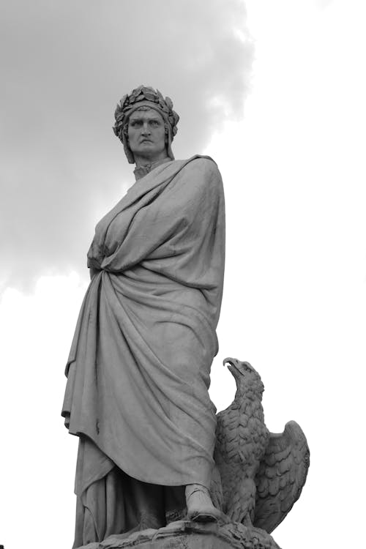
COURSE DESCRIPTION
This course covers a variety of topics proposed and taught occasionally by different English faculty members. Specific content and focus vary by section; past emphases have included Early Modern Evil, Sexing the Word, and The Beatles. This course may be repeated twice for credit when its emphasis varies.
SECTION DESCRIPTION
This course will provide you with an opportunity to read one of the greatest works ever written, Dante’s Divine Comedy. There will be neither quizzes nor exams; I will not ask you to memorize dates or names. Rather, we will spend our time thinking, talking, and writing about a text that remains as relevant today as it was in the late Middle Ages. Special attention will be given to Dante’s classical and contemporary sources, and to the historical, political, and literary context of the figures that populate Dante’s poetic world.

