Title: | Bilingual Program |  |  |  | Date: | Feb 7, 2024
Group Members: | Charise Pimentel  Juanita Silva  Kiyomi Colegrove  Mitch Ingram  Luz Murillo  Patrick Smith  Luz Maldonado Rodriguez  Jose Martinez |  | Cycle#: | ? |  | Driver: | ?
What change idea is being tested or explored? |  | Workshops for BTLPT, presenting PPR items in Bilingual Ed courses, inviting OEP to visit classrooms to discuss exam process, requiring Spanish in written assignments,
What is the overall GOAL of the project?* |  | Increase PPR and BTLPT Spanish, Bilingual Education Supplemental exam scores for Bilingual Education Majors
*Identify your overall goal: To make something work better? Learn now a new innovation works? Learn how to text in a new context? Learn how to spread or implement?
1) PLAN |  |  |  | 3) STUDY
Questions: Questions you have about what will happen. What do you want to learn? | Predictions: Make a prediction for each question. Not optional. | Data: Data you’ll collect to test predictions |  | What were the results? Comment on your predictions in the rows below. Were the correct? Record any data summaries as well.
Implement 5-10 min of instruction in BILG 4362 (Dr, Silva’s Class, Block 2) & BILG 3321 (Dr. Ingram’s class, Block 1) to discuss PPR items by domains in 2024. | Increase percentage test scores of PPR exam to meet standards. | Before and after exam PPR scores. Before (Prior 3-5 years, forthcoming) and after PPR (2024) data in changes occurring across passing rate and those that took it. | ➔ | 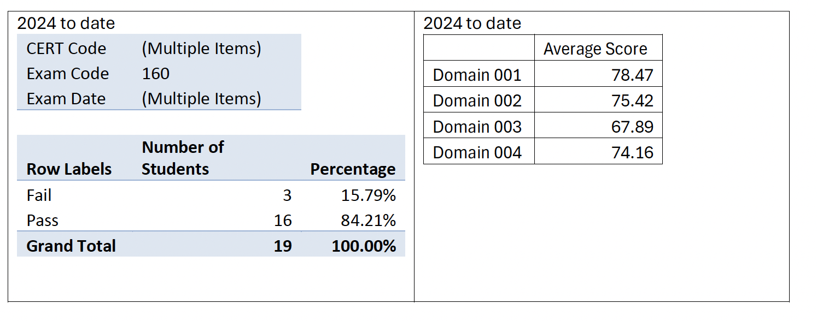
Dr. Colgrove and Dr. Ingram invited OEP to their classes to discuss with Bilingual Ed students the testing process. Students generated questions beforehand and sent them to OEP to maximize meeting. | Increase knowledge on when to take the exams, where to find funding, and timeline of when to take these exams. | More candidates taking exams sooner, and more appropriately. | ➔ | Increased understanding and insecurities have been alleviated. Confidence has been built.
Dr. Ingram conducted a 3 hour workshop for the BTLPT exam, after each semester in 2024. |  | Before and after BTLPT scores 2024 to 2025 | ➔ | 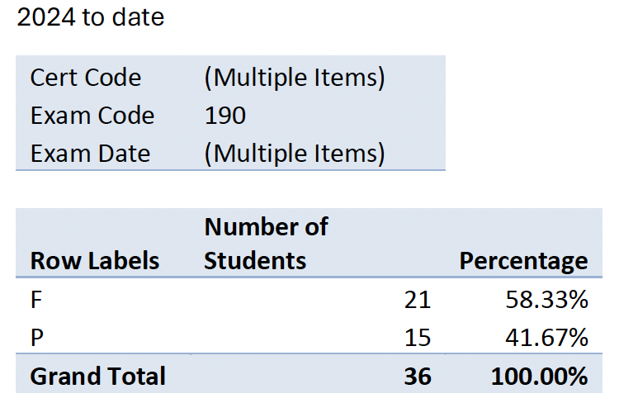  2025 to date  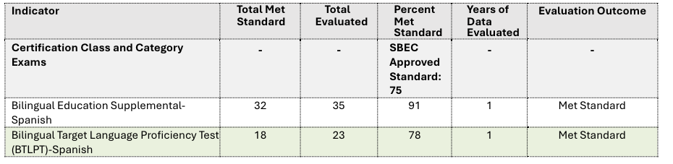
Dr. Pimentel and Dr. Smith taught content related to the Bilingual Education Supplemental Exam |  | Before and after BTLPT scores 2024 to 2025 | ➔ | 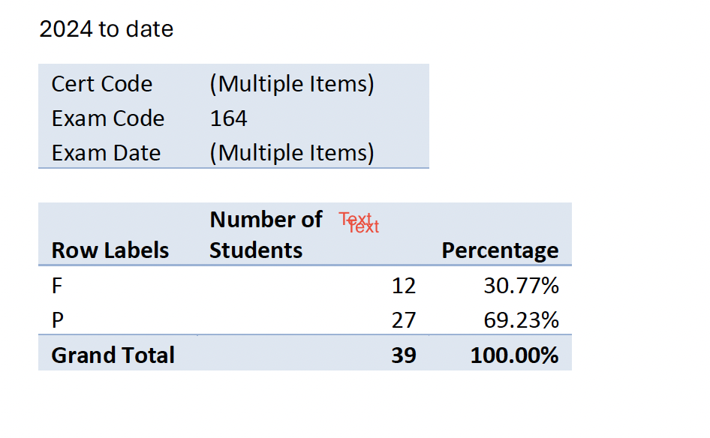  2025 to date
Bilingual Ed Instructors are delivering instruction in Spanish and implementing assignments that require teacher candidates to write and present in Spanish | Increase percentage scores for the Bilingual Ed Supplemental and BTLPT Spanish exams | Before and after BTLPT scores 2024 to 2025 |  | Academic Spanish is being more developed in their writing.
Outside help from an instructor, Ms. Maldonado, teaches accents for the BTLPT. She does four 1.25 hour lessons on accent marks (diacritics) and orthographic rules. | Increase percentage scores for the BTLPT Spanish exams | Before and after BTLPT scores 2024 to 2025 |  | Students are becoming more aware and are correctly using accent marks and standardized spelling.
Details: Describe the who/what/when/where of the test. Include your data collection plan. |  |  |  | What did you learn?

2) DO: Briefly describe what happened during the test, surprises, difficulty getting data, obstacles, successes, etc. |  | 4) ACT Describe modifications and/or decisions for the next cycle; what will you do next?

