1. Navigate to <https://apps.ideal-logic.com/txstpom>

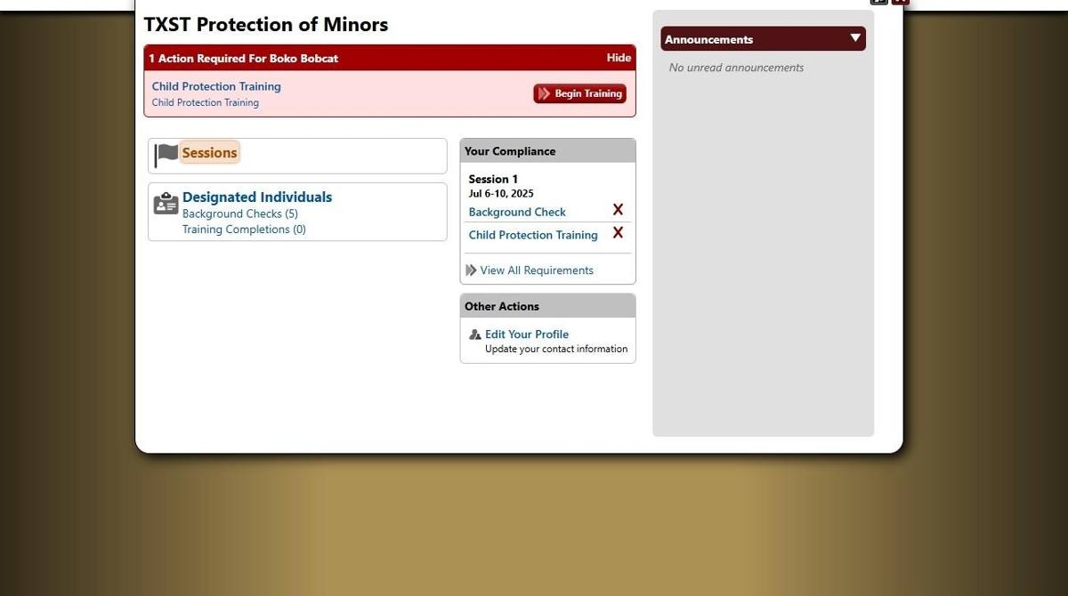

1. Click "Sessions"

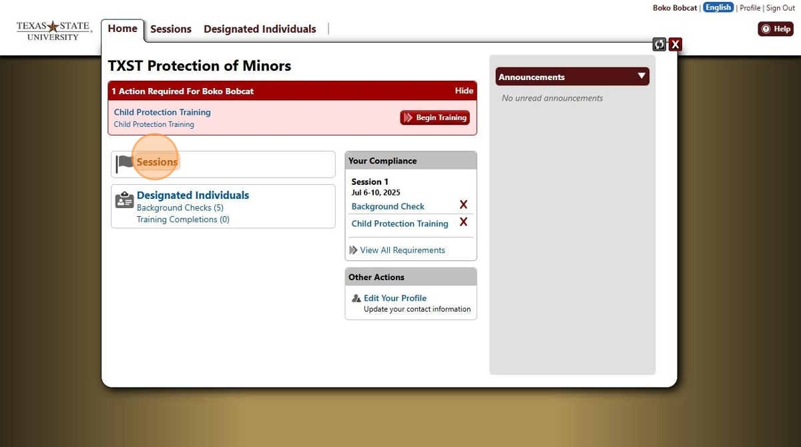

1. Click which session you would like to add your documents too. If you have multiple sessions, you will need to add emergency procedures and schedules to all of them.

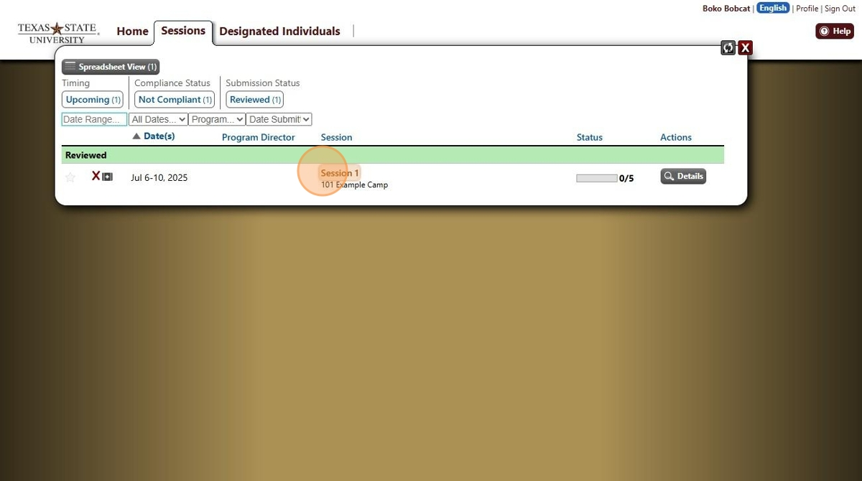

1. Click "Documents"

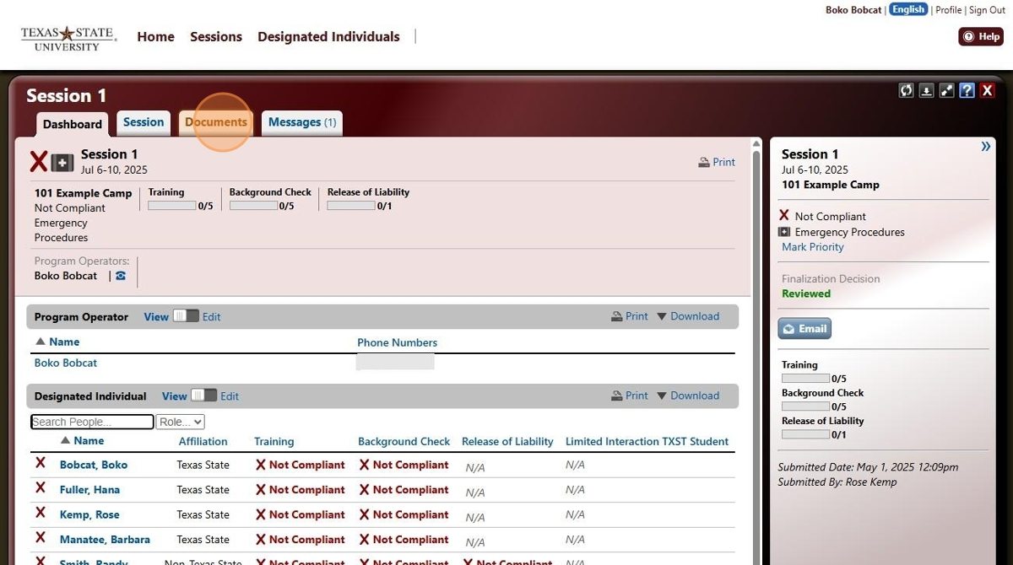

1. Click "Select Files to Upload" and upload your schedule

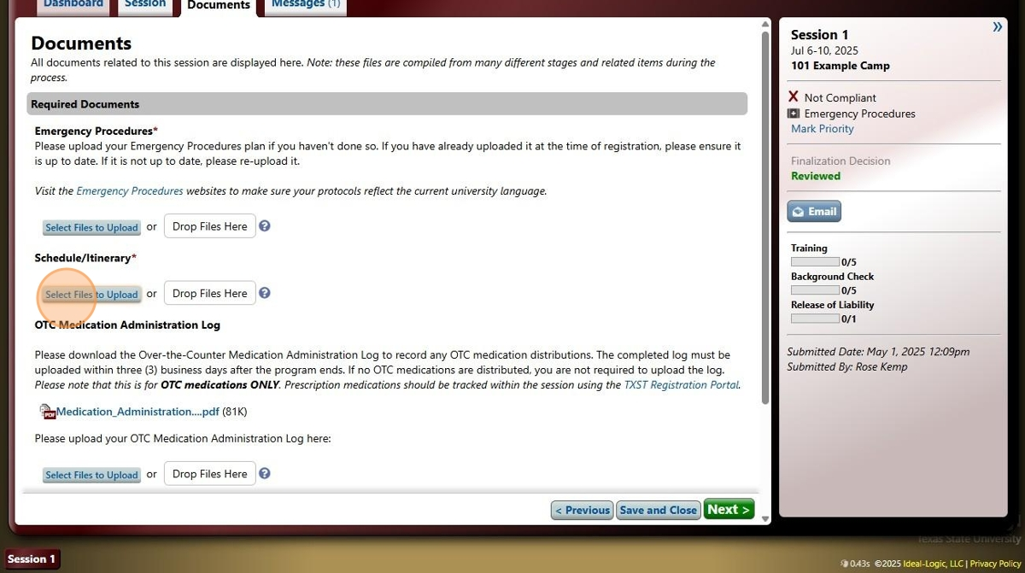

1. Click "Select Files to Upload" and upload your emergency procedures.

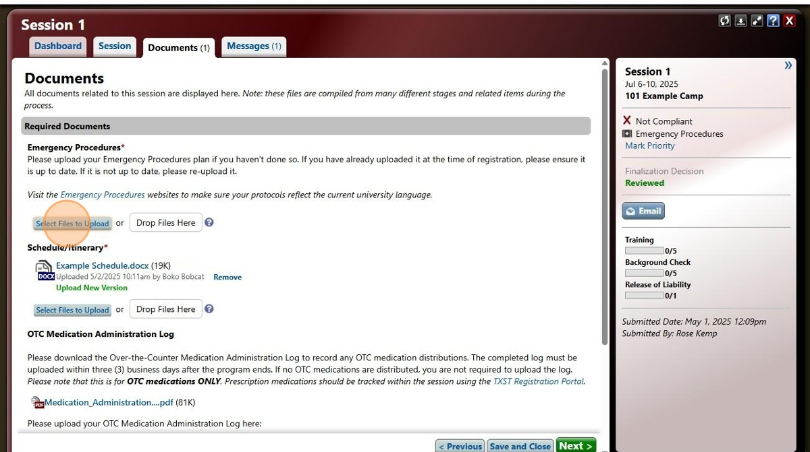

1. Your documents should pop up. If you're done, Click "Save and Close"

