1. Navigate to <https://apps.ideal-logic.com/txstpom>

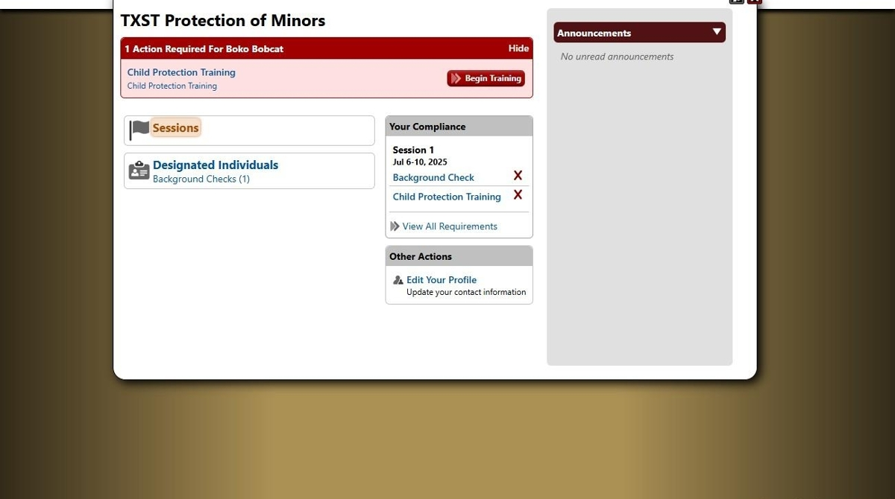

1. Click sessions

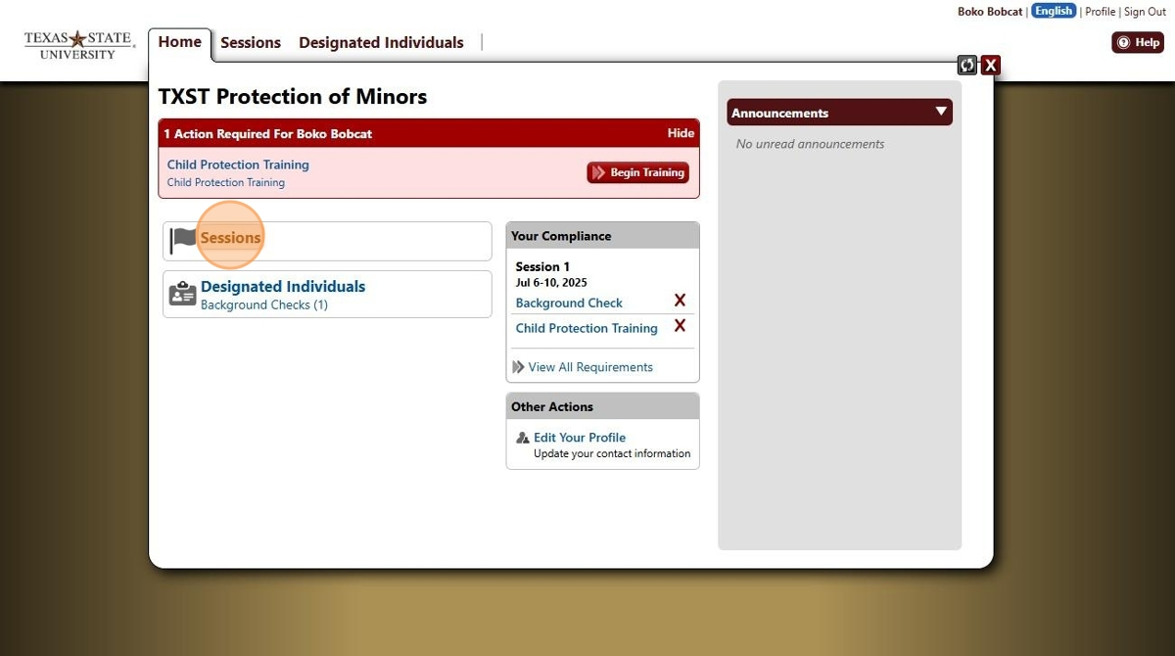

1. Click on the session you want to add designated individuals to.

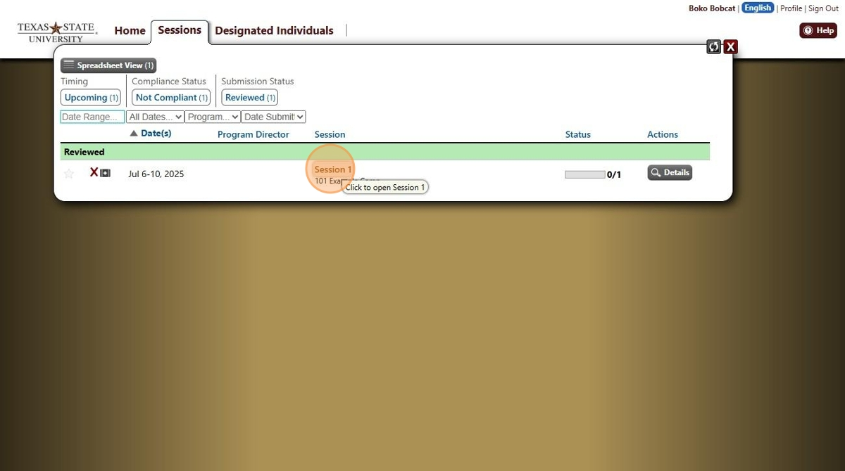

1. Toggle this button from "View" to "Edit".

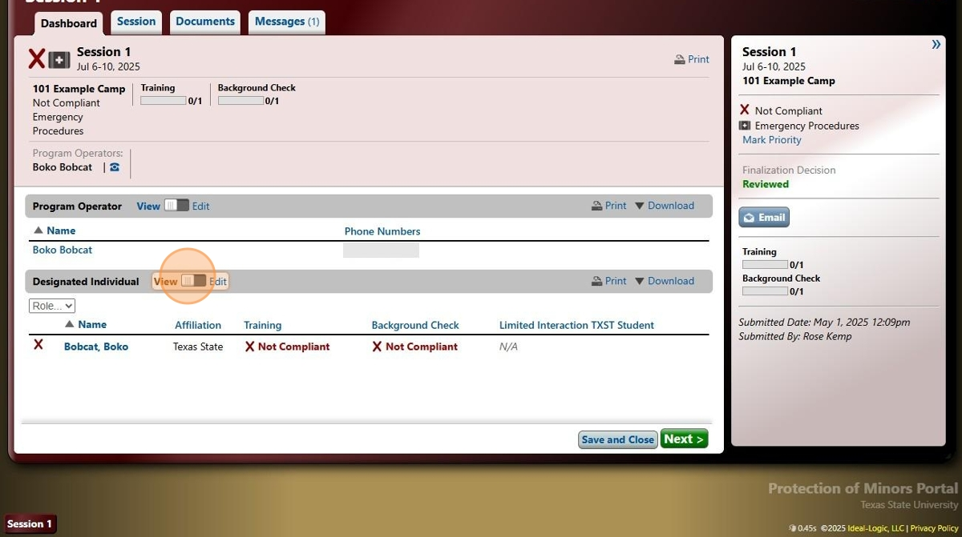

1. *If you want to upload individuals one by one, continue.* ***If you want to mass upload your individuals, skip to step 11.***

# Add Designated Individuals One by One

1. Click "Add New Person"

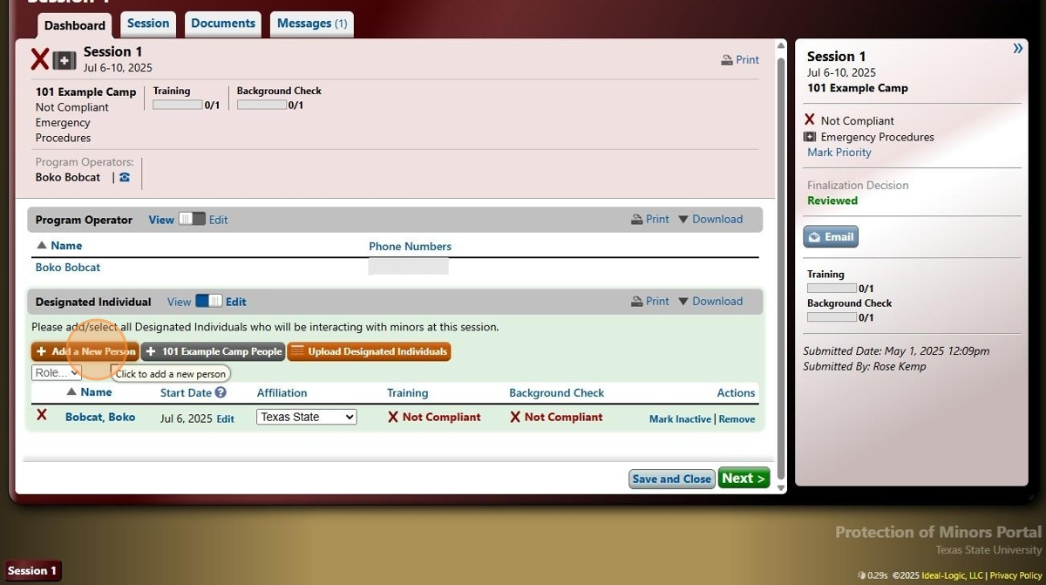

1. Ideal-Logic will want to see if this person is already in the system, so type in the name and click "Search"

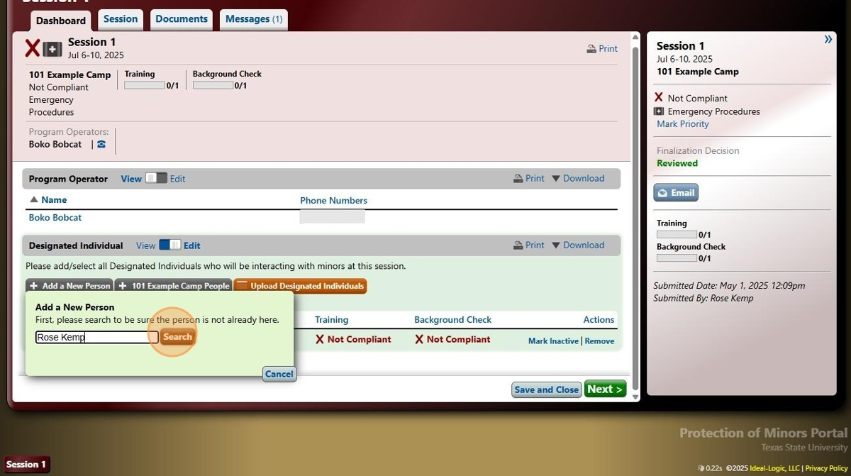

1. If they are not already in the ideologic system, then you'll have to add them in manually using their name and email.

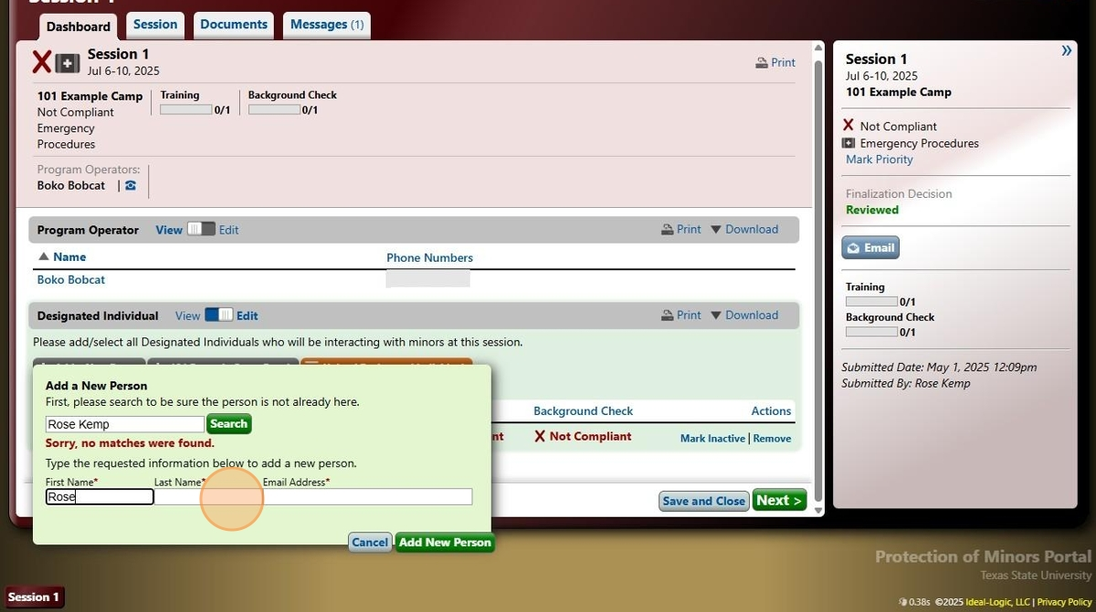

1. Click "Add New Person"

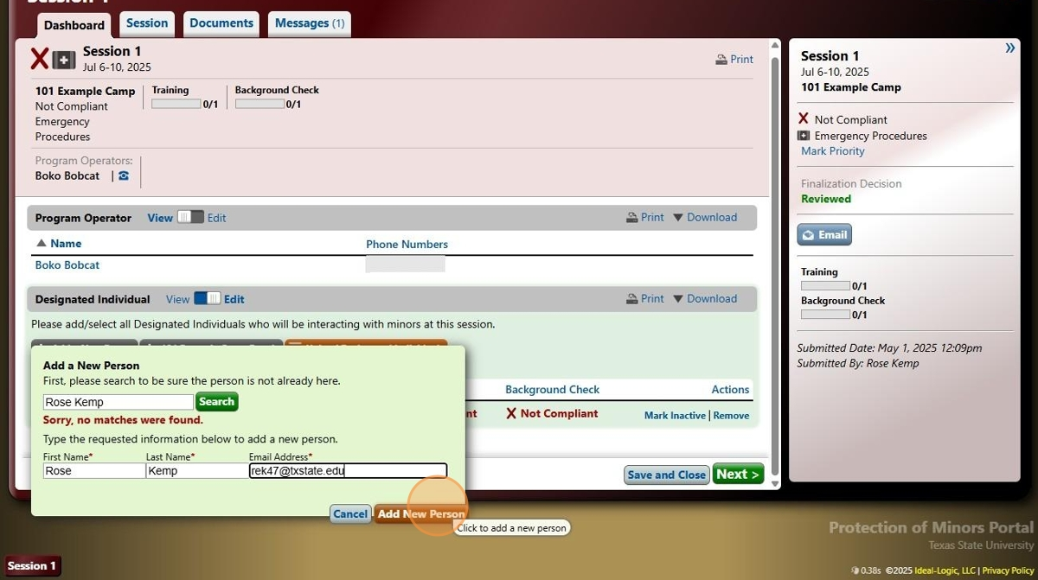

1. Double check that their affiliation is either Texas State or Non-Texas state.

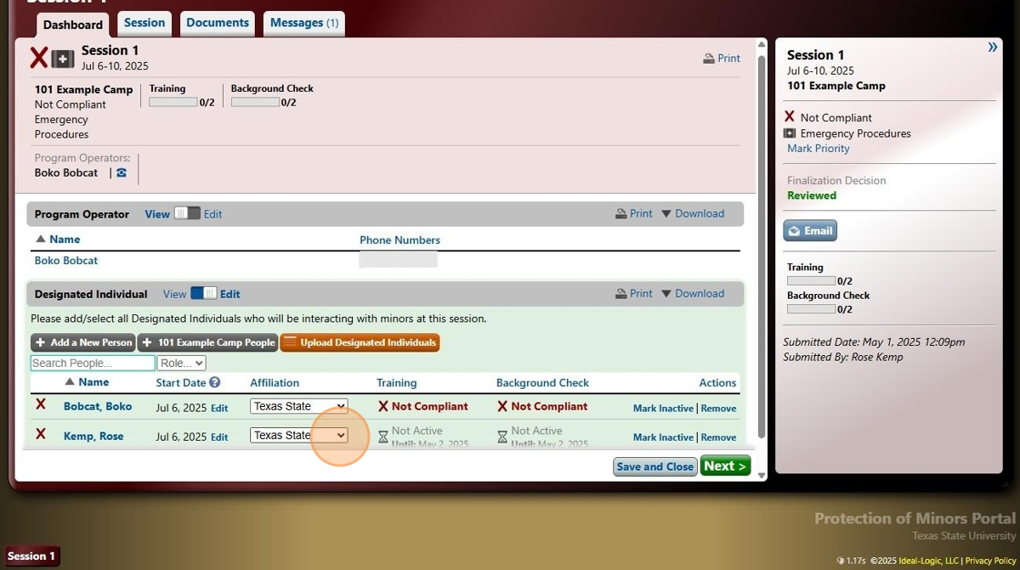

# Mass Upload Designated Individuals

1. Click orange "Upload Designated Individuals" button

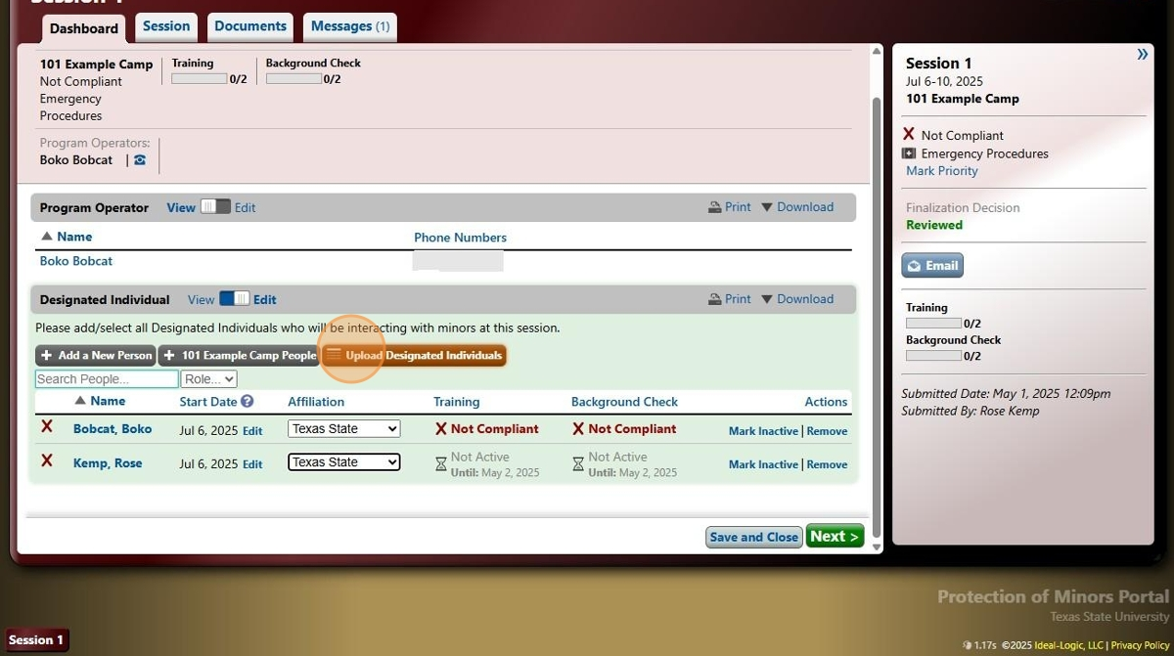

1. Click "Download a Sample Spreadsheet" and open the file. It shows how to format your list so Ideal-Logic can easily upload everyone's information

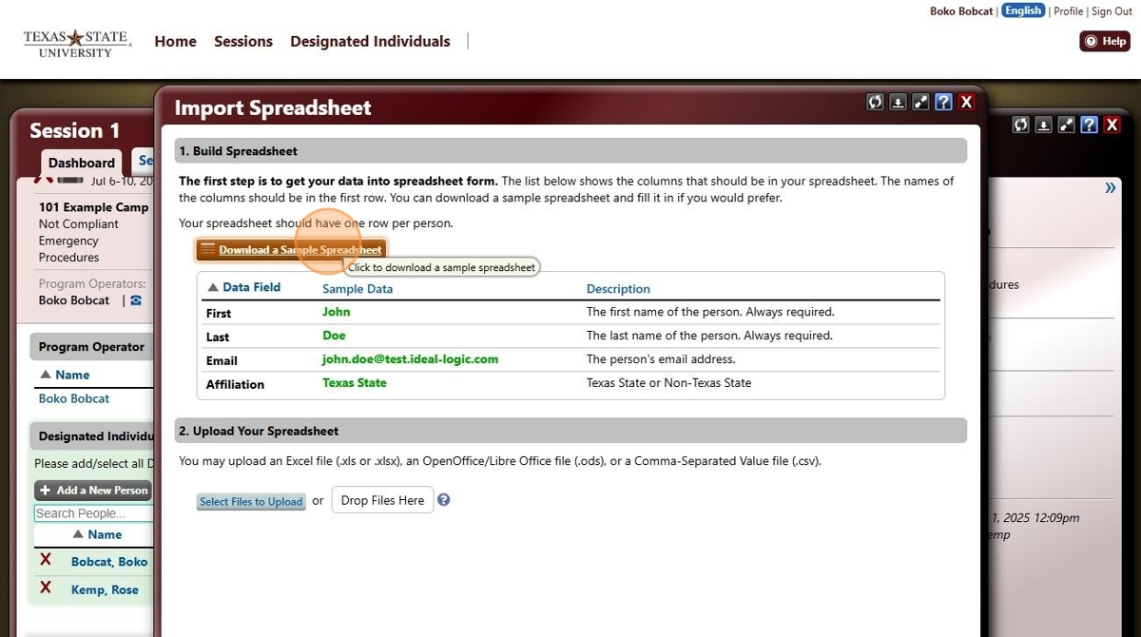

1. Once your spreadsheet is ready, click "Select Files to Upload"

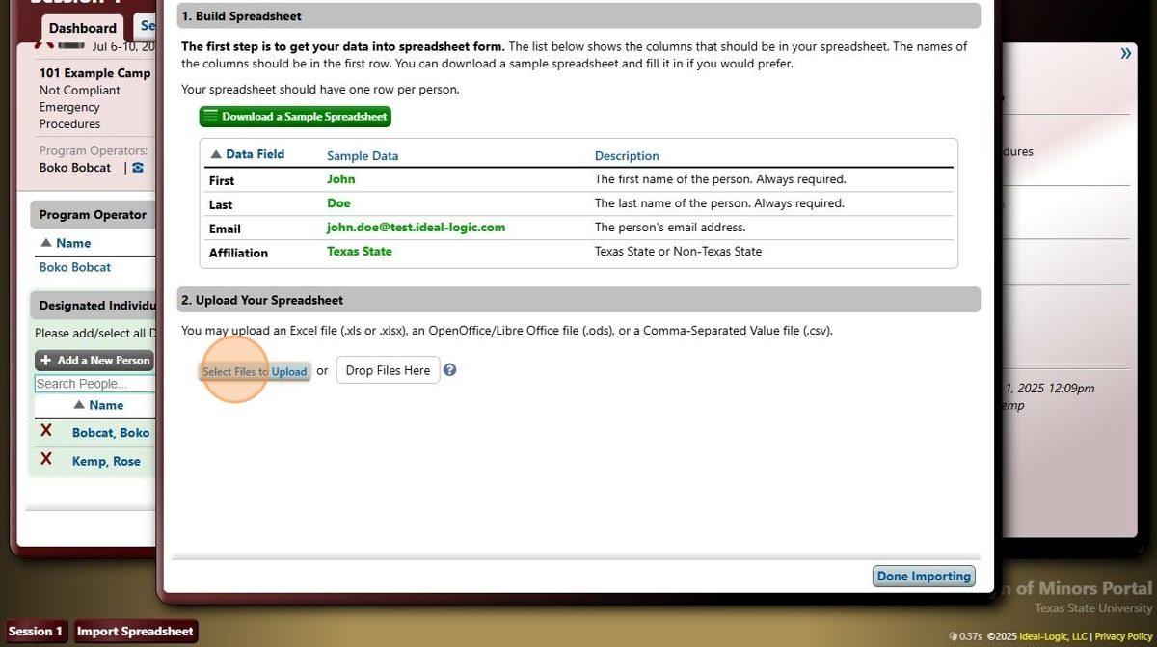

1. Click "Start Import"

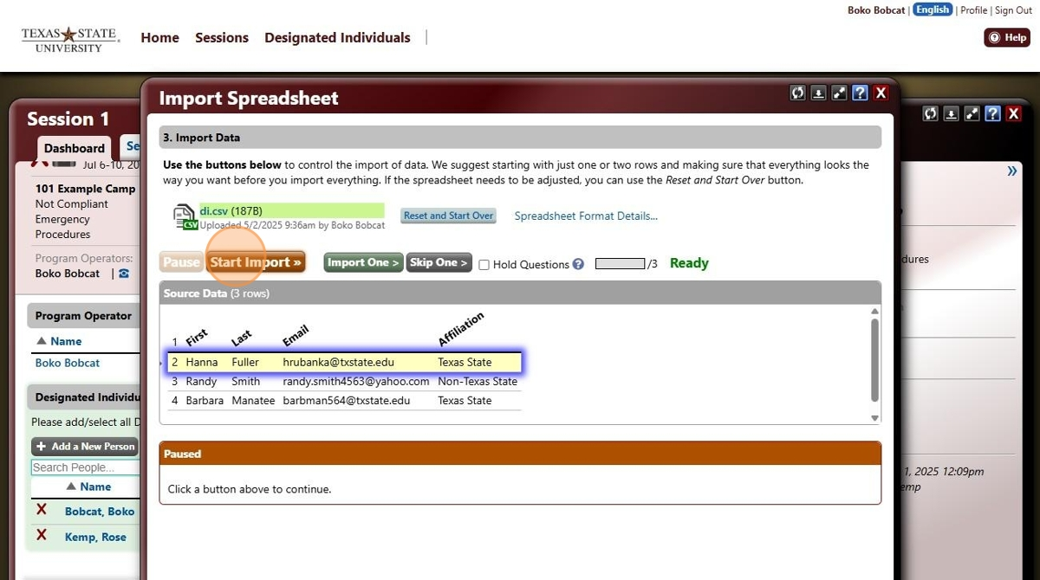

1. If everything was formatted correctly, the import should be a success. "Click Done Importing"

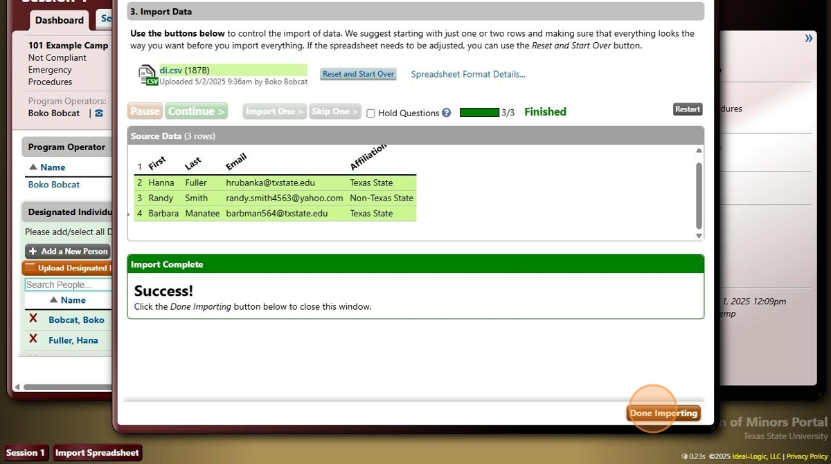

1. Click "Yes"

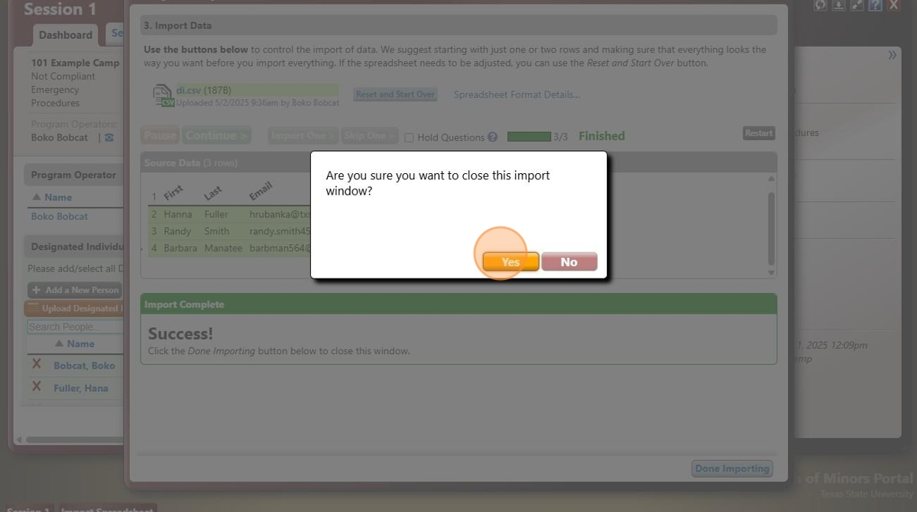

1. Back to the Session Dashboard, you should see all of the people you just uploaded. If you're done editing, toggle this button from "Edit" to View"

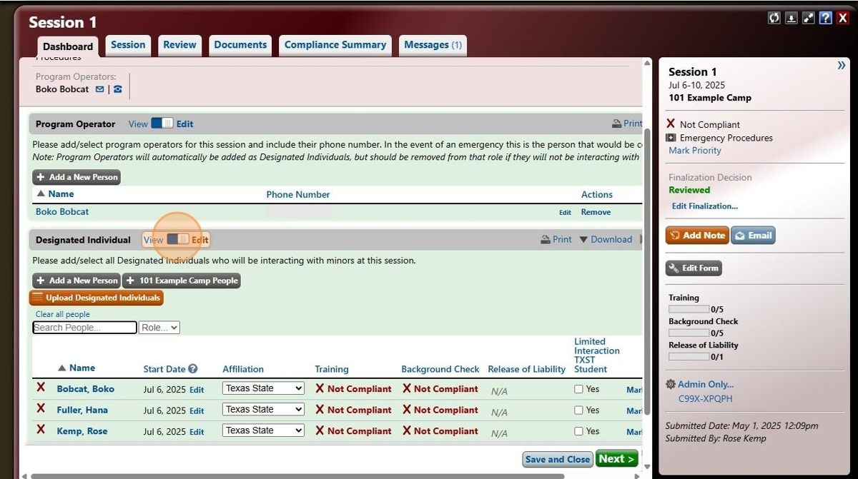

1. All of your designated individuals should now be uploaded. Four hours after the upload, they will receive an email from Ideal-Logic prompting them to activate their account, complete their CPT training, and watch for a background check email from Accurate. Within 24 hours, they will receive a separate email from Accurate requesting their information.