1. Navigate to <https://apps.ideal-logic.com/txstreg>, you should see your camp dashboard.

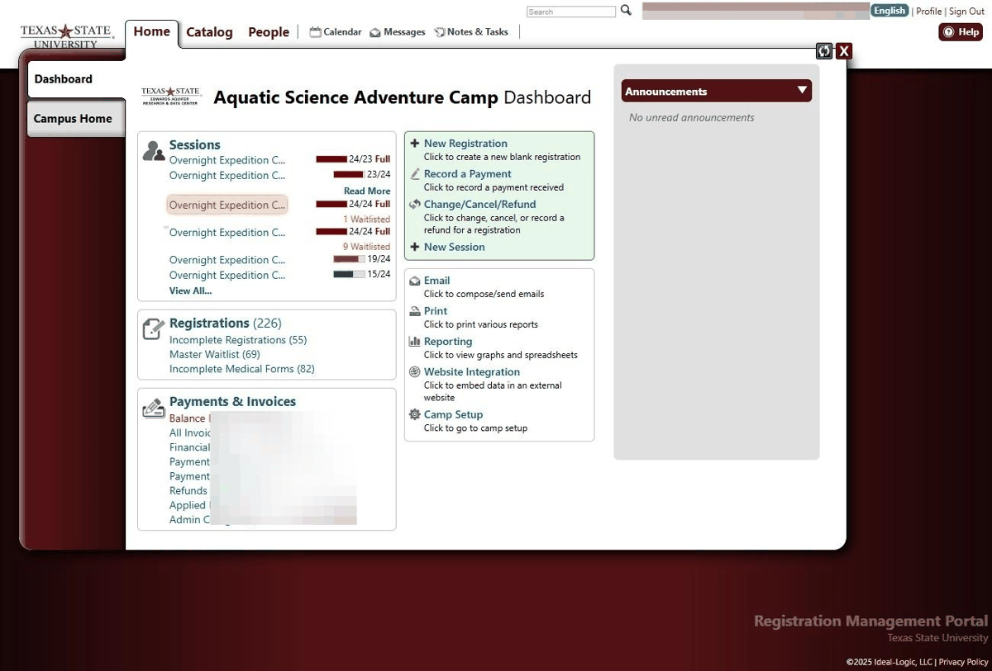

1. From your dashboard, click on which session you would like to record attendance for.

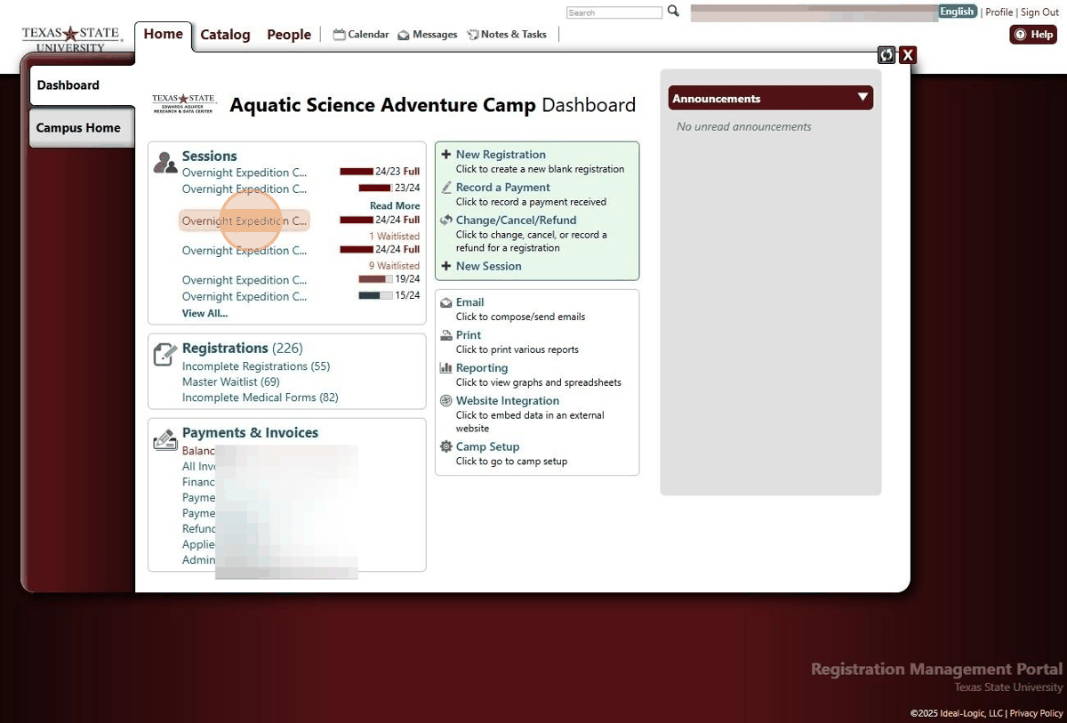

1. Click "Attendance"

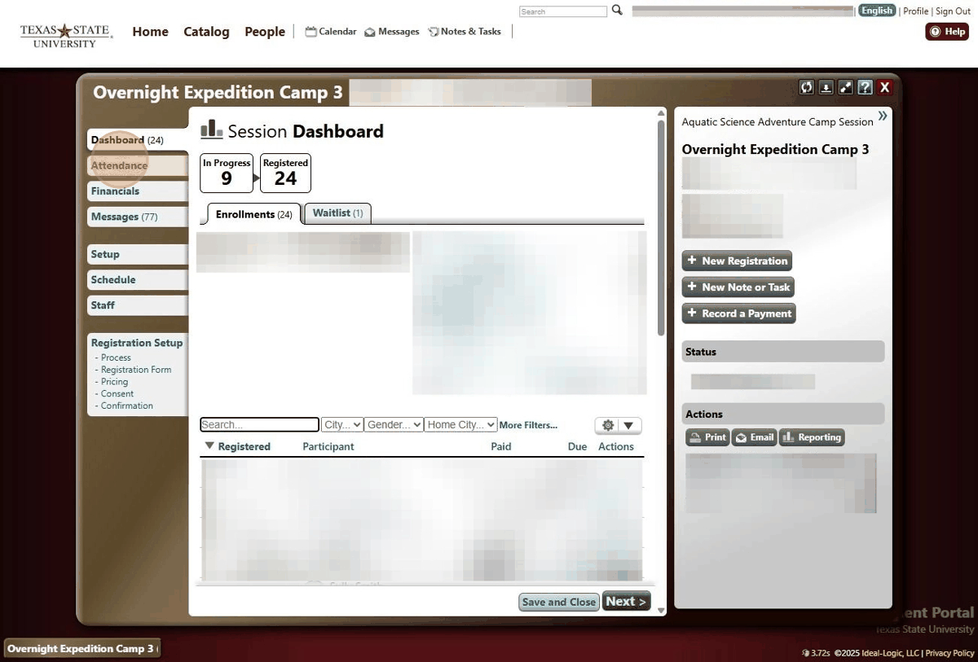

1. Click "Record Attendance"

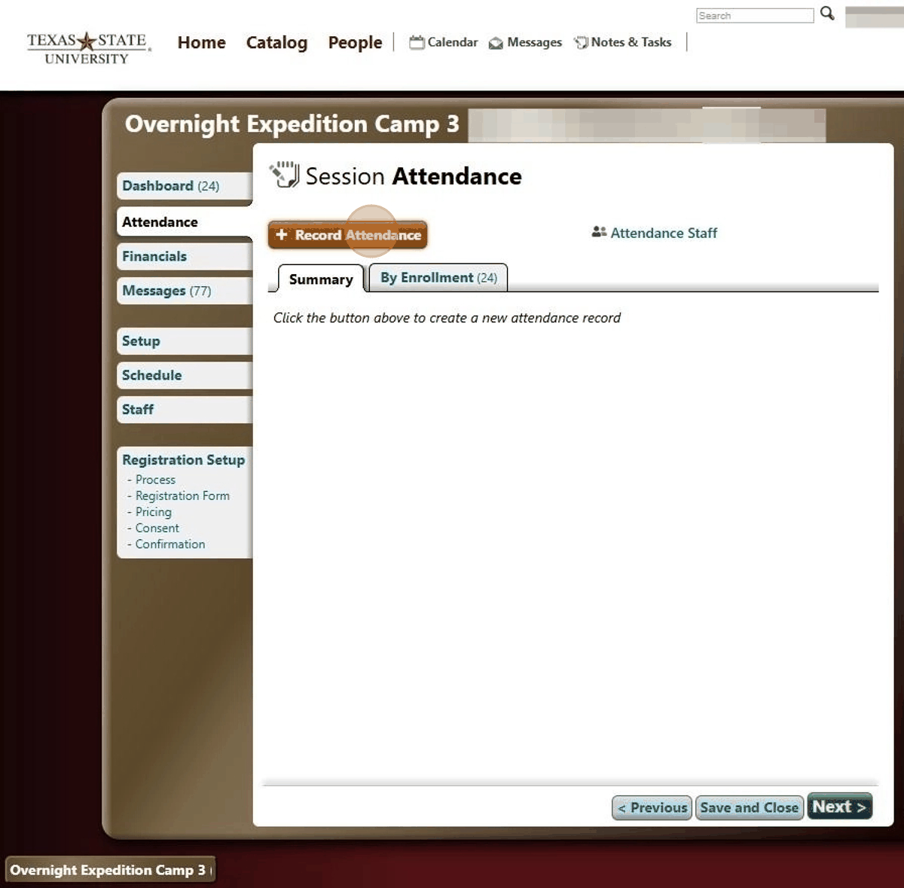

1. Select the first day of your camp if you are an overnight camp, if you are a day camp just select the day you are recording attendance for.

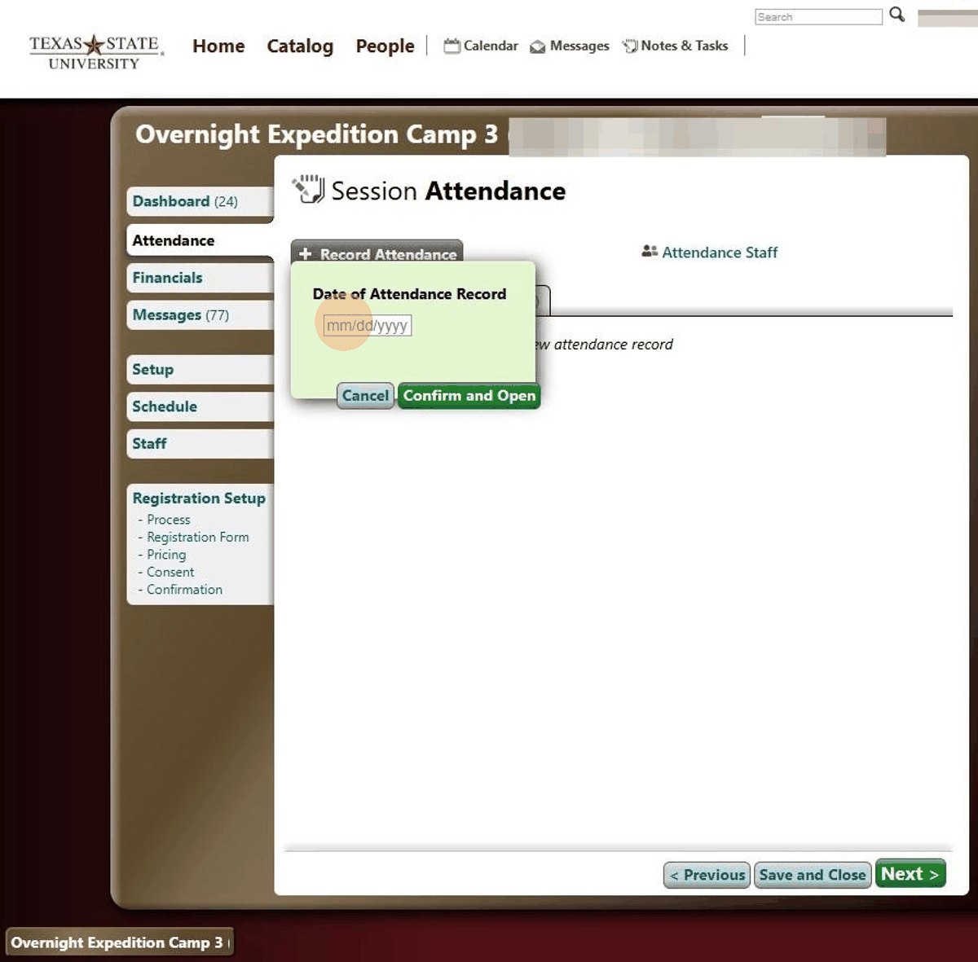

1. Click "Confirm and Open"

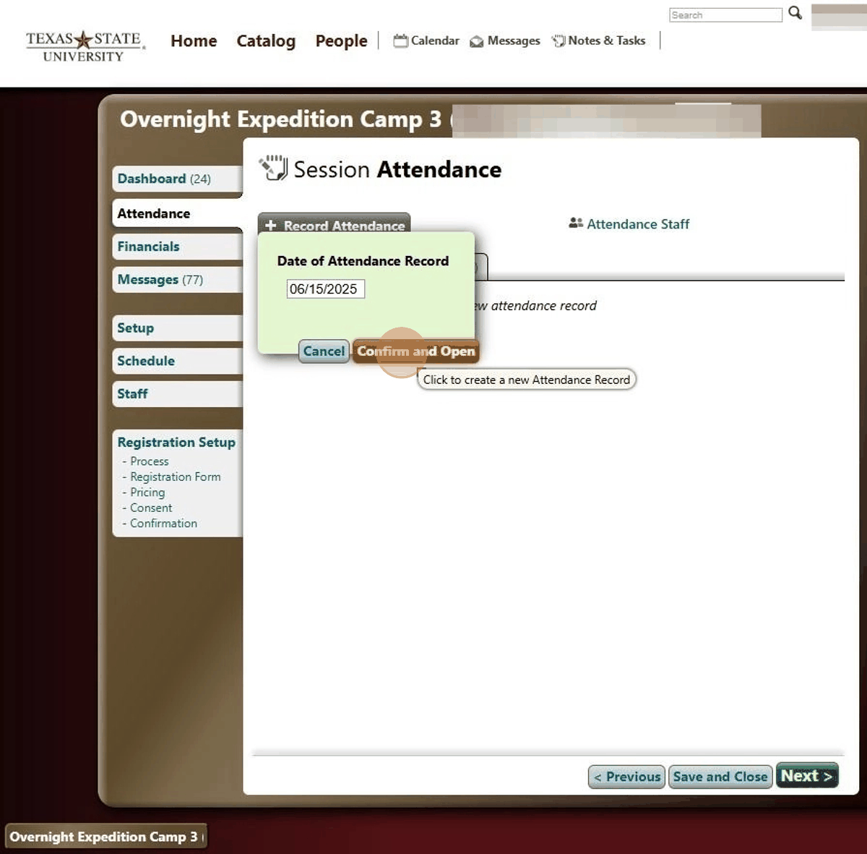

1. You will see all the participants who are registered for your session. click the check boxes to mark their attendance.

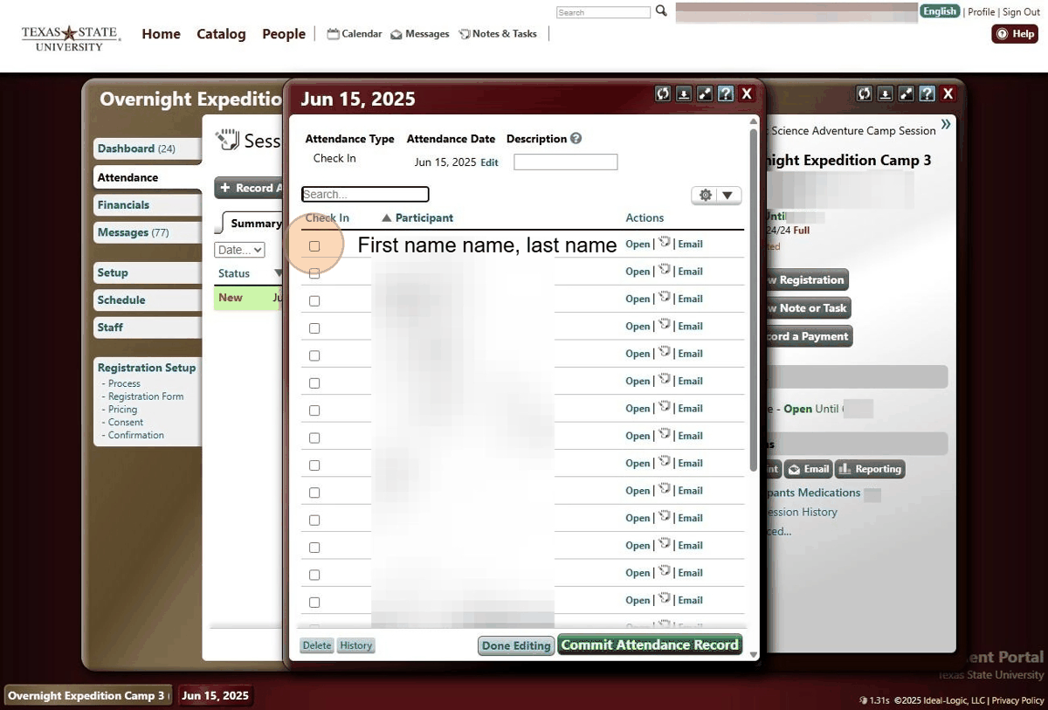

1. Click "Commit Attendance Record"

