Fall 2024 College of Applied Arts Faculty, Staff, and Student Research Activity

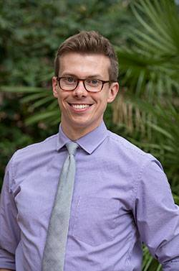Drs. Sean Patrick Roche and Amanda Graham, with co-authors Heejin Lee (Sam Houston State), Justin Pickett (SUNY Albany), and Frank Cullen (University of Cincinnati), published an article in *Justice Quarterly* titled **"Validation of Short-Form Scales of Self-Control, Procedural Justice, and Moral Foundations."**

This study develops and evaluates short measures for self-control, procedural justice, and moral foundations to address the challenges of long scales in surveys, such as increased cognitive burden and completion time. Using split-ballot experiments with a national sample of American adults (N = 1191), the short scales were compared to their longer counterparts on factor structure, reliability, and validity. Results show that the short scales performed as well, or better, than the long versions, suggesting they can be used to maintain data quality while improving survey efficiency.

[Read the full article](https://nam04.safelinks.protection.outlook.com/?url=https%3A%2F%2Fwww.tandfonline.com%2Fdoi%2Ffull%2F10.1080%2F07418825.2024.2406535&data=05%7C02%7Calyssalivernois%40txstate.edu%7Cf50d1cf327c54e76b4d708dd13c0f751%7Cb19c134a14c94d4caf65c420f94c8cbb%7C0%7C0%7C638688441688334523%7CUnknown%7CTWFpbGZsb3d8eyJFbXB0eU1hcGkiOnRydWUsIlYiOiIwLjAuMDAwMCIsIlAiOiJXaW4zMiIsIkFOIjoiTWFpbCIsIldUIjoyfQ%3D%3D%7C0%7C%7C%7C&sdata=%2B1qDimGyyQsLfVy1YGu0G04ha0suliLF0n8WdgrvTKY%3D&reserved=0)

Dr. Sean Patrick Roche

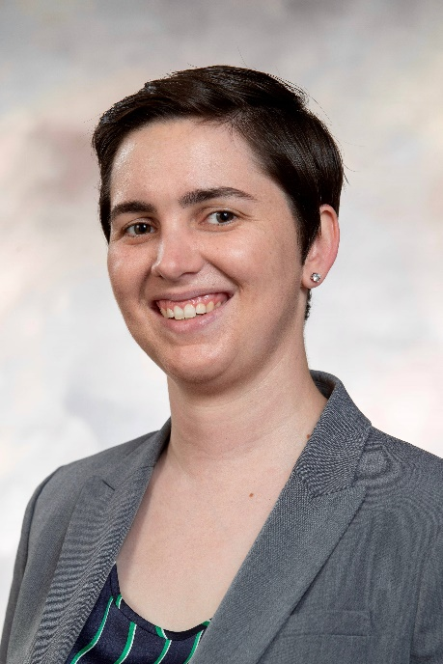Dr. Amanda Graham published an article titled **"Warrior or Guardian? Public Perceptions of Law Enforcement During Traffic Encounters and Domestic Disputes"** published by *Policing: A Journal of Policy and Practice*. The piece is co-authored with Dr. Logan Somers of Georgia Southern University.

This study examines public perceptions of police officers as guardians or warriors using experimental vignettes (N = 1,143). Officers were more likely to be viewed as guardians when demonstrating friendly, polite behavior and issuing verbal warnings rather than formal sanctions. Perceptions were also influenced by the perceived fairness of outcomes. Despite efforts to shift police culture from a warrior to a guardian mindset, achieving public recognition as guardians remains challenging, particularly when formal sanctions are required.

[Read the full article](https://nam04.safelinks.protection.outlook.com/?url=https%3A%2F%2Facademic.oup.com%2Fpolicing%2Farticle%2Fdoi%2F10.1093%2Fpolice%2Fpaae115%2F7908281&data=05%7C02%7Calyssalivernois%40txstate.edu%7C6eab321458824f686cd708dd13c3af53%7Cb19c134a14c94d4caf65c420f94c8cbb%7C0%7C0%7C638688453363690975%7CUnknown%7CTWFpbGZsb3d8eyJFbXB0eU1hcGkiOnRydWUsIlYiOiIwLjAuMDAwMCIsIlAiOiJXaW4zMiIsIkFOIjoiTWFpbCIsIldUIjoyfQ%3D%3D%7C0%7C%7C%7C&sdata=GMUhHIzQHMxAUCWXkdNuW0y2Gfiiu24ycNf0%2BfM9Q8o%3D&reserved=0)

Dr. Amanda Graham

Dr. Melanie Soderstrom published her latest peer-reviewed article with second coauthor Dr. Kristina Childs, a criminal justice faculty member at University of Central Florida, titled **“An evaluation of youth mental health first aid training with law enforcement officers.”** The piece was published in 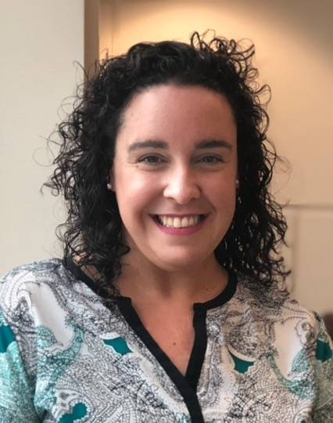*Psychological Services* and was co-authored by Dr. Kim Gryglewicz, who is a social work faculty member at the University of Central Florida.

Youth Mental Health First Aid (YMHFA) training, widely used in the U.S., equips adults to identify and respond to youth mental health challenges, though its impact on law enforcement remains underexplored. This study evaluated YMHFA with 446 law enforcement officers in a southeastern state using a longitudinal survey design (pretest, posttest, 90-day follow-up). Participants reported high satisfaction and showed significant improvements in mental health knowledge, confidence, attitudes, and preparedness immediately post-training. However, most gains diminished by the 90-day follow-up, except for sustained improvements in confidence and preparedness. These findings highlight considerations for law enforcement agencies and future research.

Dr. Melanie Soderstrom

[Read the full article](https://nam04.safelinks.protection.outlook.com/?url=https%3A%2F%2Fpsycnet.apa.org%2FdoiLanding%3Fdoi%3D10.1037%252Fser0000901&data=05%7C02%7Calyssalivernois%40txstate.edu%7Cf1705e133d0342c05e0c08dd13cad5d4%7Cb19c134a14c94d4caf65c420f94c8cbb%7C0%7C0%7C638688484083570828%7CUnknown%7CTWFpbGZsb3d8eyJFbXB0eU1hcGkiOnRydWUsIlYiOiIwLjAuMDAwMCIsIlAiOiJXaW4zMiIsIkFOIjoiTWFpbCIsIldUIjoyfQ%3D%3D%7C0%7C%7C%7C&sdata=BumrkvZKHy%2B9xKyO2Vzed46s7YJmuc7i3rs6OY2xZxM%3D&reserved=0)

Dr. Melanie Soderstrom was interviewed for a KXAN news story **“More violent offense arrests of young teens in Travis County this year.”** The story is informative, with a side order of positive publicity for the school.

Soderstrom explained one theory for why Travis County is seeing a rise in younger people being accused of assault-related offenses could be due to a new Texas law enacted in 2023 that requires an officer or armed guard be placed in all public schools, which for the first time included elementary schools. “Florida did something similar, and we saw an increase in referrals to police in schools, which of course lots of time will lead to formal arrests of students,” Soderstrom stated.

[Read the full article](https://nam04.safelinks.protection.outlook.com/?url=https%3A%2F%2Fwww.kxan.com%2Finvestigations%2Fmore-violent-offense-arrests-of-young-teens-in-travis-county-this-year%2F&data=05%7C02%7Calyssalivernois%40txstate.edu%7Cf1705e133d0342c05e0c08dd13cad5d4%7Cb19c134a14c94d4caf65c420f94c8cbb%7C0%7C0%7C638688484083595045%7CUnknown%7CTWFpbGZsb3d8eyJFbXB0eU1hcGkiOnRydWUsIlYiOiIwLjAuMDAwMCIsIlAiOiJXaW4zMiIsIkFOIjoiTWFpbCIsIldUIjoyfQ%3D%3D%7C0%7C%7C%7C&sdata=G6E0XixdBB508wtyLWyXb4%2FyUR8HVVVPUxnS%2BKWA0DM%3D&reserved=0)

Dr. Melanie Soderstrom and Dr. Jeff Bumgarner have an article titled **"Instructors' challenges facilitating mental health first aid training with law enforcement"** recently published by *Police Practice and Research: An International Journal*.

In response to public outcry over police interactions with individuals experiencing mental illness, law enforcement agencies have mandated mental health training, though these programs are rarely evaluated for implementation challenges. This study, based on interviews with 18 certified Mental Health First Aid instructors, identified four key themes: law enforcement officers (LEOs) are generally difficult to train; their expectations often differ from other groups; instructors must understand LEO-specific policies; and a lack of credibility with LEOs can hinder training effectiveness. The findings emphasize the need for careful selection of instructors and participants to improve training outcomes.

[Read the full article](https://nam04.safelinks.protection.outlook.com/?url=https%3A%2F%2Fwww.tandfonline.com%2Fdoi%2Ffull%2F10.1080%2F15614263.2024.2406836&data=05%7C02%7Calyssalivernois%40txstate.edu%7Cf1705e133d0342c05e0c08dd13cad5d4%7Cb19c134a14c94d4caf65c420f94c8cbb%7C0%7C0%7C638688484083582795%7CUnknown%7CTWFpbGZsb3d8eyJFbXB0eU1hcGkiOnRydWUsIlYiOiIwLjAuMDAwMCIsIlAiOiJXaW4zMiIsIkFOIjoiTWFpbCIsIldUIjoyfQ%3D%3D%7C0%7C%7C%7C&sdata=V35d4KPMApdpoLyx3AnEA4zIgozBb2%2FeyLl0Z6VTpks%3D&reserved=0)

Dr. Jeff Bumgarner co-authored a new book with Carla Lewandowski of Rowan University and was published by Bloomsbury Academic Press titled***Extremism in the Police: A Reference Handbook***.

This comprehensive resource explores historical and contemporary perspectives on ideological extremism in American law enforcement and its broader societal impacts. Combining narrative overviews, biographies, essays, and resource guides, it examines the extent, causes, motivations, and dangers of extremism within police ranks nationwide. Written by criminal justice experts, the book also reviews proposed and implemented reforms, including international approaches, to address the issue.

[Find the book on Bloomsbury Academic Press](https://nam04.safelinks.protection.outlook.com/?url=https%3A%2F%2Fwww.bloomsbury.com%2Fus%2Fextremism-in-the-police-9798216171447%2F&data=05%7C02%7Calyssalivernois%40txstate.edu%7C828facd98f8e4b45d71408dd19feeb32%7Cb19c134a14c94d4caf65c420f94c8cbb%7C0%7C0%7C638695304862429728%7CUnknown%7CTWFpbGZsb3d8eyJFbXB0eU1hcGkiOnRydWUsIlYiOiIwLjAuMDAwMCIsIlAiOiJXaW4zMiIsIkFOIjoiTWFpbCIsIldUIjoyfQ%3D%3D%7C0%7C%7C%7C&sdata=FdPbfj5V7Ni0QbEkpBR2J0I0ASP8zepUKonZu%2BxQWkA%3D&reserved=0)

Dr. Jeff Bumgarner

Dr. Kelly Clary and her team were awarded $1,872,567 from the Substance Abuse and Mental Health Services Administration for the FESTA Program.

**The Fentanyl Education, Support Training, and Awareness (FESTA) Program** aims to reduce substance misuse, particularly opioids and fentanyl, in Hays County, Texas. Aligned with the Strategic Prevention Framework-Partnerships for Success Program, FESTA will implement a multi-pronged approach including information dissemination, education, alternative events, problem identification, community-based processes, and environmental strategies. The program targets adolescents (grades 6-12) and the general adult population, focusing on increasing awareness and education about opioids, improving behavioral health outcomes, and reducing substance misuse throughout the county. This project is in response to Tucker's Law which mandates Texas youth in public schools to receive research-based instruction on prevention of the abuse of and addiction to fentanyl.

Dr. Kelly Clary

Dr. Kim Rossmo is the lead author of an article recently published in the *Journal of Criminal Justice* titled **"The journey-to-crime buffer zone: Measurement issues and methodological challenges."** Dr. Andrew Wheeler, a crime data scientist in North Carolina, served as co-author.

This study examines the challenges of accurately measuring the relationship between distance and offending probability in crime journeys, focusing on two key components: distance decay and the buffer A person in a suit and tie
zone. Using a defined framework, it identifies critical considerations to avoid ecological fallacies and proposes a testing procedure. Simulation analyses reveal that at least 50 observations are needed to reliably determine offender travel patterns, a threshold higher than many previous studies. Empirical case studies support these findings, emphasizing the importance of precise measurements for advancing crime theory and practice, including geographic profiling, target selection, and crime prevention.

[Read the full article](https://nam04.safelinks.protection.outlook.com/?url=https%3A%2F%2Fwww.sciencedirect.com%2Fscience%2Farticle%2Fpii%2FS0047235224001211&data=05%7C02%7Calyssalivernois%40txstate.edu%7C28d8fabbde0e45135c6808dd13f7ee30%7Cb19c134a14c94d4caf65c420f94c8cbb%7C0%7C0%7C638688677755011105%7CUnknown%7CTWFpbGZsb3d8eyJFbXB0eU1hcGkiOnRydWUsIlYiOiIwLjAuMDAwMCIsIlAiOiJXaW4zMiIsIkFOIjoiTWFpbCIsIldUIjoyfQ%3D%3D%7C0%7C%7C%7C&sdata=Czvi%2B50QgKkuvlewyCDJ5y7llIGH3QnZPxBBkDZxqPU%3D&reserved=0)

Dr. Kim Rossmo

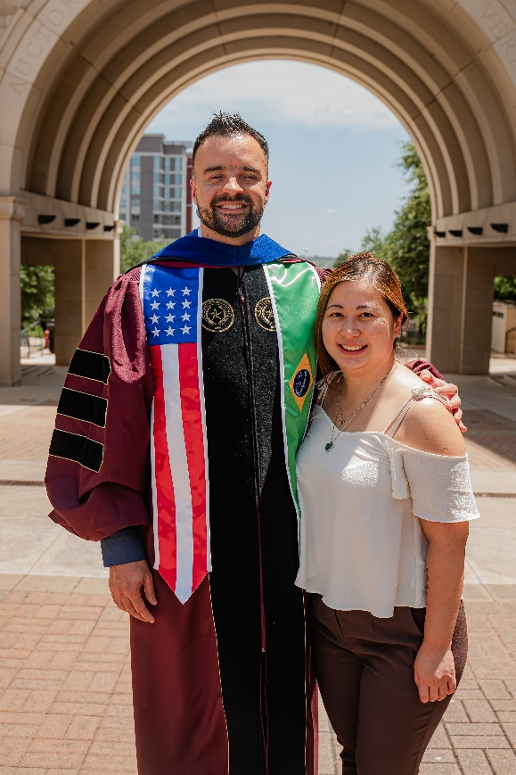Ph.D. graduate Dr. Vitor Goncalves and doctoral candidate April Chai recently co-authored, along with Mateus Santos of the University of South Florida, an article titled **"The Impact of COVID-19 Restrictions on Reports of Domestic Violence Against Women in the Context of a Middle-Income Country: The Case of Belo Horizonte, Brazil**" in the *Journal of Interpersonal Violence*.

This study examines the impact of COVID-19 restrictions on reports of domestic violence in Belo Horizonte, Brazil, a city with persistently high domestic violence rates. Using 260 weeks of data (2017–2021) and an Interrupted Time Series model, findings revealed that restrictive orders caused an immediate decline in reports, followed by a gradual return to pre-restriction levels. The subsequent lifting of restrictions had no effect, as trends had already stabilized. Unlike research in high-income countries showing increased reports during restrictions, these results align with findings in Mexico, suggesting restrictions may have limited victims' ability to report rather than reducing incidents. The study underscores the ineffectiveness of current policies and the need for evidence-based strategies while highlighting the unintended consequences of crisis-driven policies that exacerbate social isolation.

Dr. Vitor Goncalves and April Chai

[Read the full article](https://nam04.safelinks.protection.outlook.com/?url=https%3A%2F%2Fjournals.sagepub.com%2Fdoi%2Fepub%2F10.1177%2F08862605241285922%3Fdomain%3Dp2p_domain%26token%3DIMVWD8SFFNNG5G85IIT8&data=05%7C02%7Calyssalivernois%40txstate.edu%7C0bbceac979c849abc33b08dd13ca0499%7Cb19c134a14c94d4caf65c420f94c8cbb%7C0%7C0%7C638688480586947834%7CUnknown%7CTWFpbGZsb3d8eyJFbXB0eU1hcGkiOnRydWUsIlYiOiIwLjAuMDAwMCIsIlAiOiJXaW4zMiIsIkFOIjoiTWFpbCIsIldUIjoyfQ%3D%3D%7C0%7C%7C%7C&sdata=J4yrWNgTEz9G%2FqliNHGft4iNLEhw14Yu9DOwC8KpY58%3D&reserved=0)

Ph.D. candidate April Chai is co-author with several colleagues from Simon Fraser University on an article titled **"A ‘Pandemic within a Pandemic’: Metro Vancouver Women’s Experience with Intimate Partner Violence during the COVID-19 Pandemic"** in the *Journal of Family Violence.*

This study examines how COVID-19 restrictions in British Columbia impacted intimate partner violence (IPV) using an intersectional framework. An online survey of 1,504 women in Metro Vancouver revealed nearly 10% experienced IPV during the pandemic, with marginalized groups (racial/ethnic and sexual minorities, lower educational attainment) at higher risk. Women exposed to IPV faced greater barriers to accessing essential services, housing, and reported worse mental health outcomes, including higher anxiety, depression, and COVID-related distress. The findings highlight disparities in IPV exposure and outcomes along existing lines of oppression.

[Read the full article](https://nam04.safelinks.protection.outlook.com/?url=https%3A%2F%2Flink.springer.com%2Farticle%2F10.1007%2Fs10896-024-00787-9&data=05%7C02%7Calyssalivernois%40txstate.edu%7Cacb249fdd134469217aa08dd1633f881%7Cb19c134a14c94d4caf65c420f94c8cbb%7C0%7C0%7C638691134683980132%7CUnknown%7CTWFpbGZsb3d8eyJFbXB0eU1hcGkiOnRydWUsIlYiOiIwLjAuMDAwMCIsIlAiOiJXaW4zMiIsIkFOIjoiTWFpbCIsIldUIjoyfQ%3D%3D%7C0%7C%7C%7C&sdata=0fC%2FCt6vnVqYr4AJDPenBAJ%2BB06J3PFM5tYDu7qO1Dk%3D&reserved=0)

April Chai

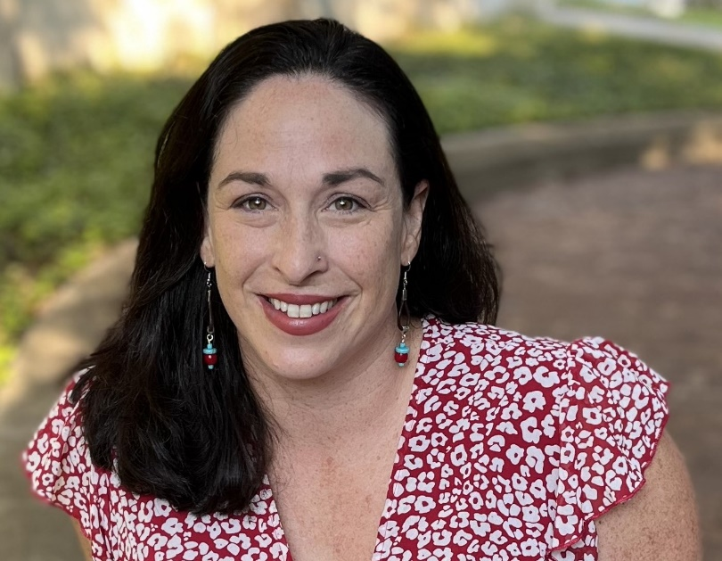Dr. Lesli Biediger-Friedman, along with Dr. Cassandra Johnson, Hanna Thornton, and Marissa Buckley, were successful in publishing their article **“Building Bobcat Bounty: The Design, Implementation, and Initial Evaluation of a Student-Led Food Pantry to Address College Food Insecurity.”** This article is the outcome of Marissa Buckley’s MS thesis.

This study evaluated the Bobcat Bounty food pantry at a Hispanic-Serving Institution (HSI), designed as part of a learning community for dietetics and nutrition students. Using a mixed-methods approach, it analyzed food inventories, client intake (n = 947), satisfaction surveys (n = 267), operational observations (n = 27), and stakeholder interviews (n = 16). Over its first year, the pantry, run by two faculty members and 19 students, served 3,567 students, and distributed 33,000 pounds of food. Client feedback confirmed its impact on reducing food insecurity, while volunteers and stakeholders offered insights into sustainability. Findings emphasize the value of integrating food pantries into dietetic education to provide experiential and culturally relevant learning.

Dr. Lesli Biediger-Friedman

[Read the full article](https://nam04.safelinks.protection.outlook.com/?url=https%3A%2F%2Fwww.mdpi.com%2F2674-0311%2F3%2F4%2F29&data=05%7C02%7Calyssalivernois%40txstate.edu%7Cafaa987d5ead4f31621608dd1a1ce921%7Cb19c134a14c94d4caf65c420f94c8cbb%7C0%7C0%7C638695433672693920%7CUnknown%7CTWFpbGZsb3d8eyJFbXB0eU1hcGkiOnRydWUsIlYiOiIwLjAuMDAwMCIsIlAiOiJXaW4zMiIsIkFOIjoiTWFpbCIsIldUIjoyfQ%3D%3D%7C0%7C%7C%7C&sdata=qW%2Fc6k6mzTCrOnPW9am8fK9DpMxeGQItYkiq4HzJmAQ%3D&reserved=0)

Dr. Shinwoo Choi has been awarded a grant from the Federal Emergency Management Agency.

Dr. Shinwoo Choi’s project, **“Strengthening Preparedness Against Texas Wildfire: Exploring Characteristics, Causes, and Potential Prevention Efforts through Community-Based Participatory Research,”** funded by FEMA’s Higher Education Award, aims to develop strategies to protect Texas communities from increasing wildfire threats. From 2005 to 2022, Texas experienced over 231,000 wildfires, burning more than 12 million acres, often due to human activity and worsened by climate change. The study will analyze past wildfire data, community prevention efforts, and mitigation strategies using interviews, surveys, and GIS analysis. Findings will support emergency management professionals, policymakers, and local communities in enhancing wildfire resilience.

Dr. Shinwoo Choi

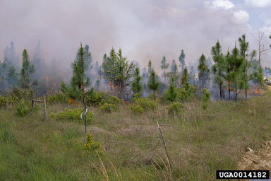

Criminal Justice students Zenden Antoine and Brooklyn Crawley participated in the Southwestern Association of Criminal Justice (SWACJ) conference in Fort Worth. Their involvement was guided and mentored by Alyssa Shallenberger, who also facilitated their poster presentations and paper submissions.

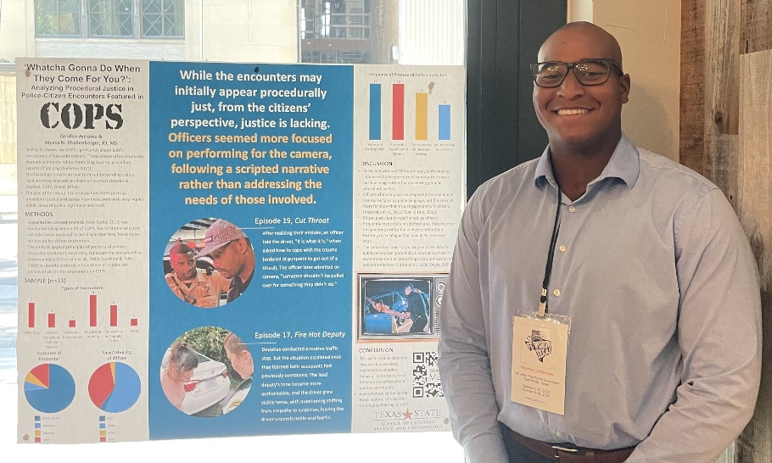Zenden and Alyssa presented a poster titled, “**‘Whatcha Gonna Do When They Come for You?’: Analyzing Procedural Justice in Police-Citizen Interactions Featured in COPS.”** This study analyzed episodes from season 35 of COPS to explore how procedural justice principles—such as respect, neutrality, and transparency—are portrayed in police-citizen interactions and their potential impact on public perceptions of law enforcement. While the show occasionally highlights aspects of procedural justice, its depictions are inconsistent and shaped by the need to entertain, often distorting the realities of policing. The findings underscore the need for more accurate and balanced portrayals of law enforcement in the media to build public trust and accountability.

Zenden Antoine

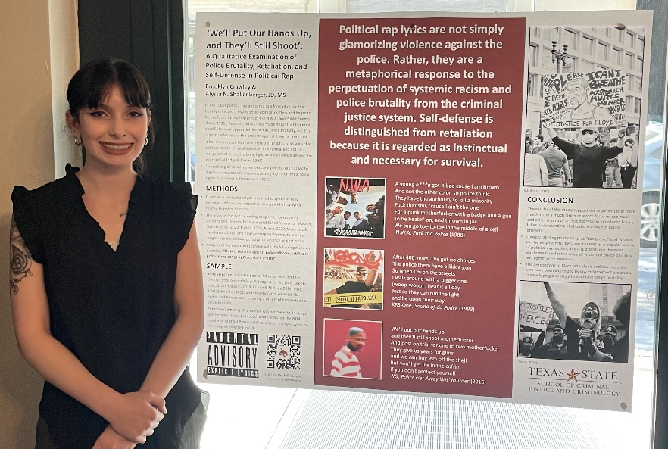Brooklyn and Alyssa presented a poster titled, **"We’ll Put Our Hands Up, and They’ll Still Shoot': A Qualitative Examination of Police Brutality, Retaliation, and Self-Defense in Political Rap,"** This study analyzed lyrics from 14 political rap songs by Black male artists to examine their justifications for violence against law enforcement in response to police brutality. The analysis revealed recurring themes of resistance, self-defense, and critiques of systemic racism, framing rap as a medium for marginalized voices to express dissent and advocate for change. The findings highlight rap's critical role in social and political commentary and call for protecting artistic freedom under the First Amendment, particularly as it relates to contentious but non-threatening expressions.

Brooklyn Crawley

Zenden Antoine and Brooklyn Crawley, both senior Criminal Justice majors, competed in SWACJ's undergraduate paper competition, earning first and second place, respectively. Their papers complemented their poster presentations. Zenden is considering graduate studies or law school, while Brooklyn is applying to clinical psychology PhD programs.

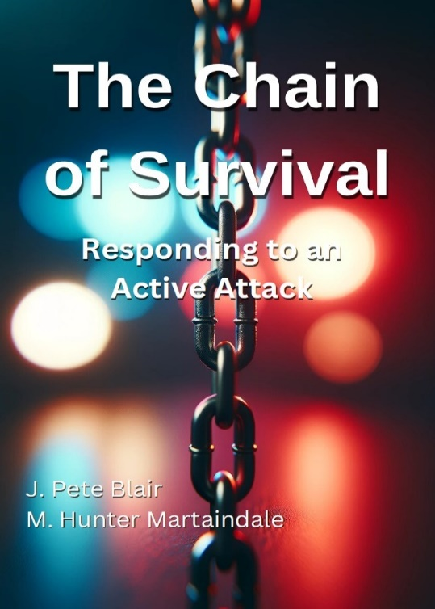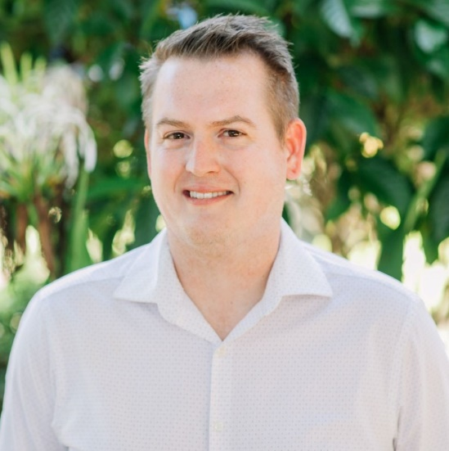Drs. Pete Blair and Hunter Martaindale's new book titled ***The Chain of Survival: Responding to an Active Attack***was just published on Sept. 3rd, 2024.

Dr. Pete Blair

Dr. Hunter Martaindale

*The Chain of Survival: Responding to an Active Attack* provides a framework for improving responses to active attack events, focusing on five critical links: Civilian Response, Law Enforcement Response, Stabilization, Transport, and Definitive Care. Combining practical experience and resilience engineering theory, the book equips civilians and first responders with strategies to anticipate, monitor, and respond effectively, aiming to reduce casualties and prevent avoidable deaths. Drawing on data and real-world scenarios, it emphasizes the dual goals of stopping the killing and stopping the dying, offering actionable insights to enhance emergency response protocols.

[Find the book on Amazon](https://nam04.safelinks.protection.outlook.com/?url=https%3A%2F%2Fwww.amazon.com%2FChain-Survival-Responding-Active-Attack%2Fdp%2FB0DFS3K8P8&data=05%7C02%7Calyssalivernois%40txstate.edu%7C016193e44b95408e1e4b08dd16115479%7Cb19c134a14c94d4caf65c420f94c8cbb%7C0%7C0%7C638690985864684630%7CUnknown%7CTWFpbGZsb3d8eyJFbXB0eU1hcGkiOnRydWUsIlYiOiIwLjAuMDAwMCIsIlAiOiJXaW4zMiIsIkFOIjoiTWFpbCIsIldUIjoyfQ%3D%3D%7C0%7C%7C%7C&sdata=b48ePSZlwif04AVq4efCntOmxdbvUmliyJv%2B3NuJkd8%3D&reserved=0)

Dr. Hunter Martaindale is a co-PI on a $450,000 grant awarded by the U.S. Department of Homeland Security to the Rockefeller Institute of Government in Albany, NY.

The proposal is titled, **“Understanding the Leakage That Precedes Mass Public Shootings and Its Utility for Prevention Efforts Through Public Awareness"** and was submitted along with PI Jaclyn Schildkraut (Executive Director, Regional Gun Violence Research Consortium) and co-PI Emily Greene-Colozzi (Assistant Professor, School of Criminology and Justice Studies, University of Massachusetts Lowell). The project intends to raise public awareness about the advance warning signs of mass public shootings, including dissemination of violent content by perpetrators, to improve reporting, and ultimately prevent these attacks. Public awareness and bystander intervention training will be based on patterns of “leakage” identified through an analysis of completed mass shootings between 1999 to 2023. By educating the public on these pre-attack warning behaviors, the project aims to enhance the likelihood of individuals reporting concerns, thereby preventing potential attacks. The project will also provide training and resources for local communities, enabling them to better understand and recognize the signs of potential violence. Ultimately, this initiative aims to create a more informed and vigilant public, capable of contributing to the prevention of mass shootings.

Ph.D. student Madison K. Doyle and Dr. Hunter Martaindale recently published their article titled **“#FalseFlag: Exploring themes in conspiracy theory tweets regarding the Robb Elementary School active shooter event”** in the Journal of Qualitative Criminal Justice & Criminology. Madison is the first author.

This study examines conspiracy theory tweets following the active shooter event at Robb Elementary School in Uvalde, Texas, analyzing 194 posts over six months. Two main themes emerged: False Flag and Hypothesized Reasoning, reflecting the content's similarities and variations. Many tweets sought causal explanations for the event, aligning with research showing increased vulnerability to conspiratorial thinking during unsettling incidents. The study discusses additional findings, implications, and directions for future research.

[Read the full article](https://www.qualitativecriminology.com/pub/qrnxbx4v/release/2)

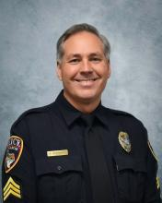Ph.D. student Duwayne Poorboy was selected as a 2024 National Institute of Justice Law Enforcement Advancing Data and Science (LEADS) Scholar.

Sergeant Duwayne A. Poorboy has served the San Marcos Police Department for over 18 years and currently supervises the Special Investigations Unit. His extensive career includes roles in crime reduction, field training, K-9 units, patrol, criminal investigations, narcotics task forces, and 15 years as team leader for the Hays County SWAT Crisis Negotiation Unit. Recognized as Officer of the Year in 2015, he also received the Texas Narcotics Officers Association Detective of the Year award for his role in a multi-year FBI investigation of the Texas Mexican Mafia. A 3rd-year Ph.D. student at Texas State University, his research focuses on crime patterns, problem-oriented policing, and hostage negotiation, and he collaborates with Dr. Lucia Summers on geospatial intelligence projects.

Sgt. Duwayne Poorboy

[Meet the LEADS Scholarship Recipients](https://nij.ojp.gov/funding/leads-scholar-biographies)

Ph.D. student Zena Rossouw is the lead author on an article with co-authors Eric Beauregard of Simon Fraser University and Julien Chopin of the University of Lausanne titled **"Stranger Danger: Analyzing Offender Behaviors Based on Victim Approach Tactics in Sexual Homicide"** and published in *Behavioral Sciences & the Law*.

This study analyzed the approach methods of sexual homicide offenders targeting strangers. It found that those using a deceptive "con" approach often targeted more male victims, exploited vulnerability, and exhibited post-crime organization, such as relocating the body and disposing of the weapon. These offenders were also more likely to engage in oral sex and had lower rates of victim beating compared to those using "blitz" or "surprise" attacks. The findings offer valuable insights into criminal investigations into sexual homicides.

Zena Rossouw

[Read the full article](https://onlinelibrary.wiley.com/doi/10.1002/bsl.2708)

Four doctoral students, under the direction of Dr. Lidia Nuño, presented their research topics developed in Dr. Nuño’s doctoral policing class at the American Society of Criminology Annual Meeting in San Francisco, California. Three of the four students—George Garza, Gilbert F. O'Brien, and Gwendelyn Kovaleski—were presenting for the first time.

**Perceptions of Procedural Justice and Police Legitimacy Among Detained Youth** -George Garza, MS

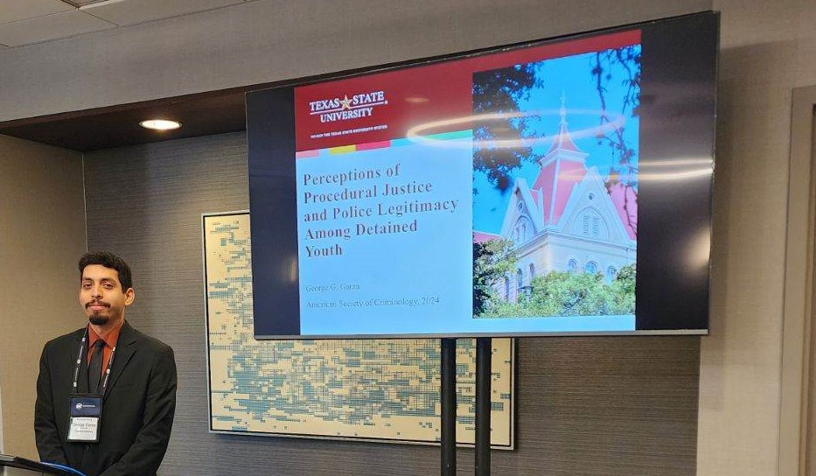A survey was conducted on detained youths at an Arizona detention center from 2011-2013. The survey asked various questions including the youths' perceptions of procedural justice, police legitimacy, and likelihood of cooperation. The results indicated that procedural justice was significant to police legitimacy and cooperation. However, youths who were African American and exposed to risk factors (i.e., no longer attending school and being unemployed) were found to be less likely to cooperate with police.

George Garza

**Perceptions of Police Legitimacy and its Impact on Recruitment** -Gilbert F. O'Brien, MS and Gwendelyn Kovaleski, MS

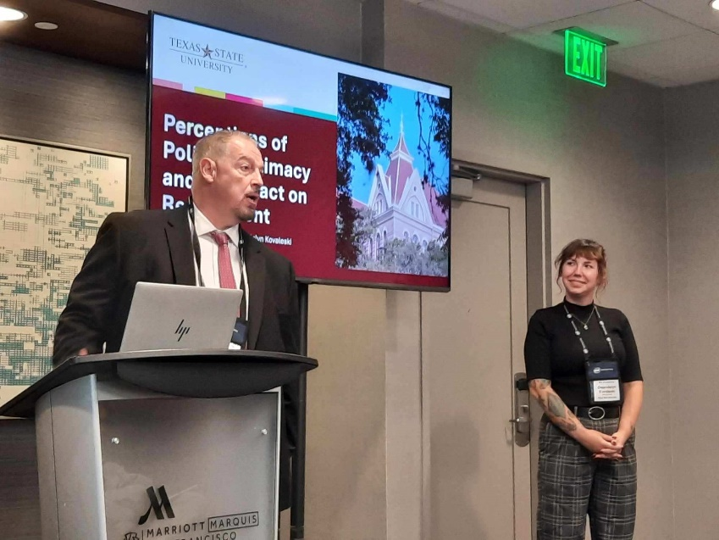Police departments across the nation are struggling to fill their ranks with new recruits. It has been suggested that perceptions of law enforcement, such as perceived legitimacy, can impact the interest in becoming a police officer. A limited number of studies have examined potential recruits’ views on the legitimacy problem and the impact this is likely to have on their decision to become a police officer. This paper examines the impact perceptions of police legitimacy may have on potential applicants applying to become a police officer. We rely on data collected from undergraduate students enrolled in criminal justice courses (n=450). Research findings and implications will be discussed.

Gilbert F. O'Brien and Gwendelyn Kovaleski

**The Police, Rape Myths, and Fictional Media: How “Law & Order: Special Victim’s Unit” Depicts Police-Based Rape Myths and the Implications of Its Portrayal** -Gemini Creason-Parker, MS

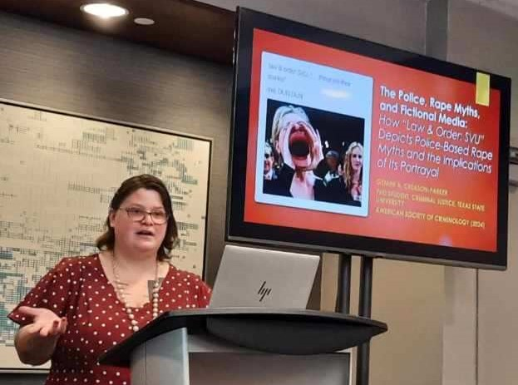

Gemini Creason-Parker

Scholars have found that the acceptance of rape myths, or stereotypes about the crime, victims and perpetrators, influences how the police interact with victims, the amount of effort officers put into investigating the crime, and their approach for doing so. Police-based rape myths are those that focus on victim behaviors toward officers and the reporting process. Despite evidence that contradicts myths like – for example, many victims do not report in a timely manner – they affect how the public and professionals perceive the reporting process and their respective parties (i.e., victims and officers). The researchers conducted a content analysis of the primetime drama, “Law and Order: Special Victims Unit.” Researchers quantitatively analyzed 24 seasons of the show to determine to what extent the show relies on rape myths in its depiction of cases. This paper specifically focuses on myths related to the reporting process and victim-officer interactions/expectations. The implication of police-based rape myths is a continued lack of reporting for one of the most underreported crimes there is. The question becomes, even with changes to policing, including how they interact with victims and handle cases, are victims being encouraged to report their experiences and seek justice by fictional media?

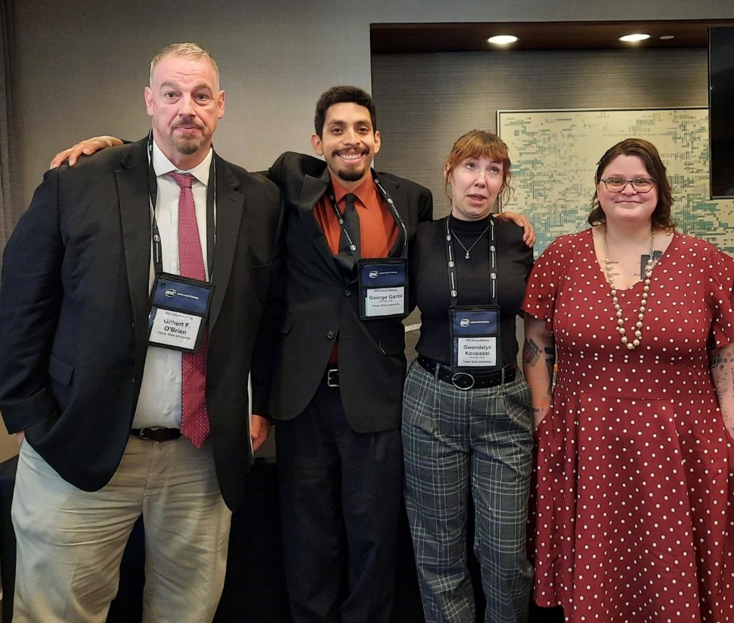

Left to right: Gilbert F. O'Brien, George Garza, Gwendelyn Kovaleski, and Gemini Creason-Parker