**Social Media Listening for Advertising — Analyzing Tweets mentioning Camping**

**Overview:** You’ll leverage social media listening data from [Brandwatch](https://www.brandwatch.com/) to understand consumer behavior, and extract insights on topics, sentiments, interests, and behaviors. Based on your findings, create a strategic outline for using those audience insights to build a hypothetical advertising strategy.

**Good to know**: The dataset was collected between November 1 and November 16, 2024, meaning that this is a collection of tweets mentioning “camping” that were published by a user or organization on X on one of those dates.

**Background:** Your advertising agency has a new business opportunity. Coleman, the maker of outdoor camping gear and equipment, is soliciting RFPs and your agency has been invited to pitch.

You’re a junior coordinator and your manager has asked you to help think about how to target potential audiences on Facebook and Instagram based on social listening data.

**Goal:** What can you learn from what people are saying on X about camping? Be specific. You must come up with something interesting/insightful because your job depends on it.

Don’t be shy when using Google or the university Library Databases to help when you encounter something you don’t understand or need inspiration on how to complete the assignment. The LinkedIn Learning *Social Media Marketing Certificate: Strategy and Optimization* by Martin Waxman is a nice precursor to this assignment to help you apply what you learn.

**Assets:** You’ll need to make a copy of the data to use on Julius.AI.

* Camping [dataset](https://docs.google.com/spreadsheets/d/1Nl2ZPSkqiuRzHzO1Sd7xL-zWJdyL1hSKIYmhedbReJ8/edit?usp=sharing) (*n* = 39,732 mentions)
* Copy the link and drop it into [Julius.AI](http://julius.ai) (you may need to create a free account first)
  + Note, that you will only have ~ten queries before exceeding your free limit on the tool, so be smart about how you use your prompts.

**Tasks**

Before you can access the data, make a copy of the Google sheet > then click on “share” > update the access to “anyone with the link” can be “editor” (see screenshot below) > copy the link into Julius.AI.

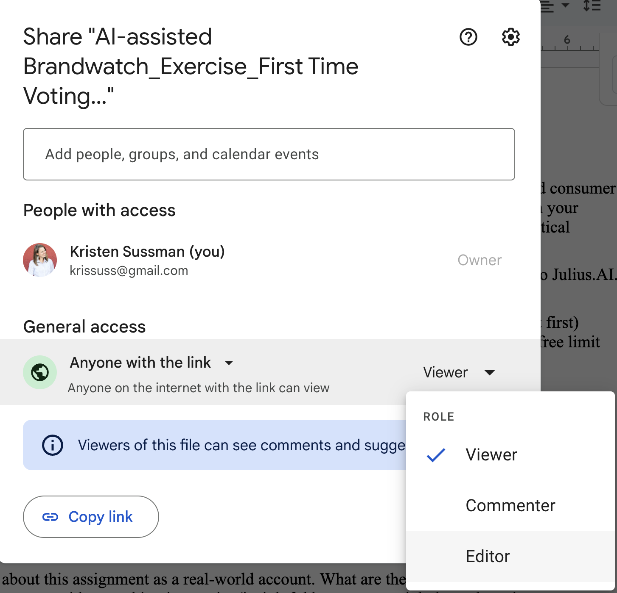

Once your data is shareable, drop the link into Julius.AI:

1. **Audience Identification:** Utilize Julius.AI to pinpoint positive and negative sentiment topics among social media users in your chosen dataset.
2. **Audience Analysis:** Examine the demographics, interests, and geographic distribution of the identified audience. Summarize and describe how your findings can lead to an understanding of the psychographics of the audience.
3. **Insights and Strategy Formulation:** Gather insights on preferences and interests, by comparing and contrasting timelines, sentiments, and topics. Outline a strategy for reaching and targeting this audience through Meta Ads.

Then submit your write-up in Canvas. Include screenshots and examples as are helpful.

**Rubric**

**Criterion 1: Identification of Target Audience**

* **Very Appropriate:** Successfully analyze a highly relevant and specific audience of campers and translate that to a targeting strategy for Meta using precise keywords, demographics, interests, and methodologies.
* **Somewhat Appropriate:** The audience identified is generally relevant but may include users not highly engaged with camping.
* **Inappropriate:** The identified audience has limited relevance to camping.
* **Totally Wrong:** The identified audience is unrelated to camping.

**Criterion 2: Precision of Audience Analysis**

* **Very Accurate:** Provides detailed and accurate analysis of audience demographics, interests, and behaviors with clear relevance to camping.
* **Somewhat Inaccurate:** The analysis covers relevant points but contains minor inaccuracies or lacks depth in areas.
* **Inaccurate:** Analysis contains several inaccuracies or is too general, providing limited useful insight into the camping audience.
* **Wildly wrong:** Analysis is completely off-target or based on incorrect data.

**Criterion 3: Completeness of Answers**

* **All Questions Answered:** Every part of the assignment is completed thoroughly, from audience identification to strategic export plan.
* **Missing 1:** One aspect of the assignment is not completed or is only briefly touched upon.
* **Missing 2+:** Fails to address two or more components of the assignment.

**Criterion 4: Spelling and Grammar**

* **Totally Correct:** No spelling or grammatical errors are present in the assignment.
* **1-2 errors:** The assignment contains 1-2 spelling or grammatical errors.
* **3-4 errors:** There are 3-4 spelling or grammatical errors in the submission.
* **4+ errors:** The assignment has more than four spelling or grammatical errors, impacting readability.