**Fall 2025 Criminal Justice Research Experience: Participant Guidelines**

**This information applies to the following courses:**

|  |  |  |  |
| --- | --- | --- | --- |
| **Course** | **Sec** | **Course Title** | **Instructor** |
| CJ 1310 | 001 | INTRO TO CJ | Madison Doyle |
| CJ 1310 | 002 | INTRO TO CJ | Wyatt Brown |
| CJ 1310 | 003 | INTRO TO CJ | Cheryl Rowden |
| CJ 1310 | 005 | INTRO TO CJ | Cheryl Rowden |
| CJ 1310 | 008 | INTRO TO CJ | Robee Ruiz |
| CJ 1310 | 009 | INTRO TO CJ | Jeffrey Bumgarner |
|  |  |  |  |
| CJ 3346 | 001 | RESRCH IN CRIM JST | Brian Withrow |
| CJ 3346 | 003 | RESRCH IN CRIM JST | Alyssa Shallenberger |
| CJ 3346 | 004 | RESRCH IN CRIM JST | Brian Withrow |
| CJ 3346 | 005 | RESRCH IN CRIM JST | Zena Rossouw |
| CJ 3346 | 006 | RESRCH IN CRIM JST | Joshua Davis |
| CJ 3346 | 007 | RESRCH IN CRIM JST | Andre Spence |
|  |  |  |  |
| CJ 3347 | 001 | STATS FOR CRIM JUS | Hunter Martaindale |
| CJ 3347 | 004 | STATS FOR CRIM JUS | Madison Doyle |
| CJ 3347 | 005 | STATS FOR CRIM JUS | Wesley Smith |
| CJ 3347 | 007 | STATS FOR CRIM JUS | Lucia Summers |
| CJ 3347 | 008 | STATS FOR CRIM JUS | Lucia Summers |
| CJ 3347 | 009 | STATS FOR CRIM JUS | George Garza |

As you progress in the Criminal Justice major, you will learn about research in many areas of criminal justice. To enhance your understanding of the nature of social science research, it is essential that you get some first-hand experience with research. For that reason, students are required to have direct experience with social science research.

All research with human participants must be carried out ethically. For example, you cannot be required to participate in studies against your wishes. Therefore, you have two options to fulfill research experience requirement: one option involves participation in studies whereas the other does not. Both options have been designed to take the same amount of effort. You are free to choose either option or both for a total credit balance of 4 credits. The research requirement will be worth 5% of your final grade!

If you fail to complete the research experience requirement (either Option 1 or 2 below, or a combination), then your final course grade will be reduced by one-half of a letter grade (i.e., 5%). No late submissions will be accepted. **The deadline to complete credits is 5 pm on Friday, December 5th.**

**Option 1. Volunteer as a Research Participant.**

If you are 18 years of age or older, you are eligible to participate in studies (the age restriction is due to federal policy). Participation in studies at Texas State University that require 29 minutes or less is worth one credit; studies that take between 30-59 minutes are worth two credits; studies that take between 60-89 minutes are worth three credits; studies that take between 90-119 minutes are worth four credits. The number of credits will be noted in the study description that you see when you sign up. Only studies approved by the criminal justice department qualify for credit. In addition, paid studies cannot be used to satisfy the research requirement.

To sign up for a study, follow the steps below:

1. Go to the website [https://txstatecj.sona-systems.com](https://txstatecj.sona-systems.com/)
2. Log in with your NetID 2-step authentication.
3. After you log in, you can sign up for studies, view your accumulated credits, and edit your profile as shown in the screenshot below. **Please note that you will not have access to Sona until after roster certification is complete. This usually occurs around the third week of classes.**

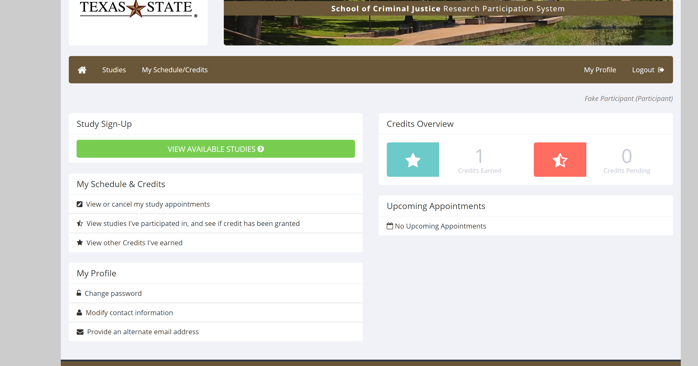

1. Look up studies that fit your schedule.

* Online studies can be completed at any time in advance of the researcher’s deadline. Do not sign up for online studies ***until you are ready to take the study***.
* For in person studies, do not sign up to participate ***unless you intend to show up***.
* You may not be able to sign up for future studies if you fail to show up for an appointment that you have made with a researcher, or any time you arrive more than 5 minutes late.
* You may avoid this penalty by canceling your appointment at least 24 hours in advance.
* Please do not argue with researchers if you arrive late. Once a study has started it is often impossible for a late student to be accommodated.

1. Keep your own record of the studies you participate in.
2. You may need to periodically check in to Sona to see what studies are available. Study availability will change throughout the semester at each researcher’s discretion. Do not wait until the last minute to complete studies, as this will limit what options you have available.

**Option 2. Research Article Summaries**

As an alternative to participating in a research study, you may submit a written summary of a research article published in the **most recent volume** of the journal *Criminology* or *Journal of Experimental Criminology*. Each 500-word written summary is worth two credits. To earn credits in this way, follow the steps below:

1. Obtain the article(s) in Volume 63 of *Criminology* or Volume 21 of *Journal of Experimental Criminology*. Download the article(s) from the online library database. Follow these instructions below to learn how to locate research articles via the library [website](https://www.library.txstate.edu/):

Using the Periodical List to Find Articles

1. **Click on Journals/Periodicals on the homepage.**

1. **Type the journal name in the text box:**

1. **Click on any of the issues from the most recent volume and choose an article of your liking to summarize.**

1. Each summary should include a description of the research problem, the theory being tested, the methodology used, the findings, and how the study contributed to social science research.
2. Papers should be written in your own words, avoiding direct quotes. If plagiarism OR the use of AI is detected in your article summary, you will lose the opportunity to earn credit through article submission.
3. Each summary should be **approximately 500 words.**
4. Submit article summaries to the following email: [sonasystem4cj@txstate.edu](mailto:sonasystem4cj@txstate.edu) by the research experience deadline**. You must include your name, class and section number, and your professor’s name in the subject line. You must also include the APA reference for the article you are summarizing in the body of the email. Save the file as either a Word document or PDF as Lastname_Firstname#. If your name is Angela Jones, save as Jones_Angela1 or Jones_Angela2 (if you are submitting two summaries).**

**Summary**

* Research Experience is worth 5% of your course grade. Research credits can be tracked by logging into <https://txstatecj.sona-systems.com> as described above.
* Additional details, including frequently asked questions, can be found at: <http://www.cj.txstate.edu/resources/research-experience.html>.
* Please direct any questions regarding the research experience requirement to the Research Experience Coordinator at [sonasystem4cj@txstate.edu](mailto:sonasystem4cj@txstate.edu).
* Make sure that your research summaries meet the word count
  + Please include your name, what class and section you are in, and the APA reference of what journal article you used when you submit the research summary
  + Save the file as either a Word document or PDF as Lastname_Firstname#.
  + Titles, your name, and references do not count towards the word count
  + Any summaries that are submitted without meeting the word count will not be graded
  + Any submissions past the due date will not be graded
* Please do not email your professor or the SONA coordinator asking if there is anything you can do to make up the grade once the deadline has passed
* If you sign up for a face-to-face research study, please be on time and make your appointment. If you cannot make your appointment, please let the researcher know a MINIMUM of 24 hours in advance. If you do not show up and the researcher was not notified, this may affect your ability to participate in research studies on the SONA website. In other words, ONE TIME of not showing up to a research study or doing an online study before the deadline has passed can automatically limit you from doing any further research studies.