**8) Technology in Vertical Farming**

Sustainable Solutions: Technology in Vertical Farming

**Overview and Objectives**

This submodule introduces the role of technology in enchaining sustainable vertical farming practices.

This module goes over:

* Understand the importance of controlled environments in agriculture.
* Identify key technologies used in vertical farming systems.
* Evaluate the sustainability benefits of vertical farming vs. traditional agriculture.
* Recognize the challenges and limitations of high-tech vertical farms.

In this module, we will explore emerging how technology supports vertical farming

Read and watch the following material to gain the necessary information to complete this lesson.

**Introduction to Vertical Farming**

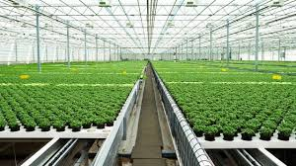

**[1: Read] Introduction to Vertical Farming Technology**

Intro into this topic of vertical farming!

<https://agrisiti.com/uncategorized/introduction-to-vertical-farming/>’

**[1: Watch] Growing Up: How Vertical Farming Works**

[<https://www.youtube.com/watch?v=QT4TWbPLrN8>] [cc] [6 min]:

*This video explains vertical farming, highlighting its space efficiency, reduced water usage, and use of advanced technologies like hydroponics and LED lighting.*

**1.** What is a primary advantage of vertical farming over traditional agriculture?

A) Requires more land  
B) Uses more pesticides  
C) Minimizes water usage  
D) Depends on natural sunlight

Timestamp: 0:45-1:10

**2.** How does artificial lighting benefit vertical farming?

A) It warms the soil  
B) It replaces the need for fertilizers  
C) It provides photosynthetic light in the absence of sunlight  
D) It automates irrigation

Timestamp: 1:15-1:45

**[2: Read] Vertical Farming – No Longer A Futuristic Concept** – USDA Agricultural Research Service  
An introduction to vertical farming methods, including hydroponics and aquaponics, and their advantages over traditional agriculture.

[*https://www.ars.usda.gov/oc/utm/vertical-farming-no-longer-a-futuristic-concept/*](https://www.ars.usda.gov/oc/utm/vertical-farming-no-longer-a-futuristic-concept/?utm_source=chatgpt.com)

**[2: Watch] Vertical Farming 2024 | 3 Different Types Of Vertical Farms**

[<https://www.youtube.com/watch?v=suYcri3FzcI>] [cc] [6 min]: This video outlines the three main vertical farming methods hydroponics, aquaponics, and aeroponics explaining their benefits for sustainable indoor agriculture.

**3.** In hydroponic systems, plants are grown:

A) In soil  
B) In nutrient-rich water solutions  
C) On sand beds  
D) Using only sunlight

Timestamp: 0:30-1:00

**4.** Which of the following is *not* a common vertical farming system?

A) Aquaponics  
B) Aeroponics  
C) Hydroponics  
D) Erosion farming

Timestamp: 0:20-0:50

**5.** What is one way that **aeroponics** differs from hydroponics?

A) It uses no water  
B) It uses mist to deliver nutrients  
C) It uses soil and sand  
D) It relies only on rainwater

Timestamp 1:00-1:30

**IoT and Automation in Modern Farming**

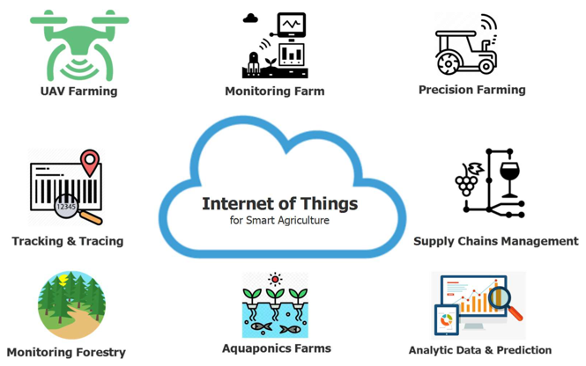

**[3: Read] IoT in Agriculture: 9 Technology Use Cases for Smart Farming** – Eastern Peak

<https://easternpeak.com/blog/iot-in-agriculture-technology-use-cases-for-smart-farming-and-challenges-to-consider/>

**[3: Watch] The Most Modern Agriculture Machines Implemented with Al**

[[https://www.youtube.com/watch?v=qIAm3zqK81Y]](https://www.youtube.com/watch?v=qIAm3zqK81Y%5d) [cc] [8 min]: This video explores how vertical indoor farming can significantly enhance food production efficiency and sustainability, while also addressing key challenges.

**6.** What role does automation play in vertical farming systems?

A) Harvesting only  
B) Planting only  
C) Monitoring and controlling environmental conditions  
D) Exporting produce

Timestamp: 2:10-2:50

**7.** Why is vertical farming considered climate-resilient?

1. It is protected from outdoor weather conditions
2. It uses fewer computers
3. It is built underground
4. It depends on monsoon rainfall

Timestamp 0:40 – 1:10

**[4: Watch] Smart Faming with IoT: Enchacing Soil Health with IoT Technology**

[<https://www.youtube.com/watch?v=hXC7vCcg2xo>] [cc] [9 min]: This video evaluates the sustainability and economic viability of indoor farming, presenting both optimistic perspectives and potential challenges.

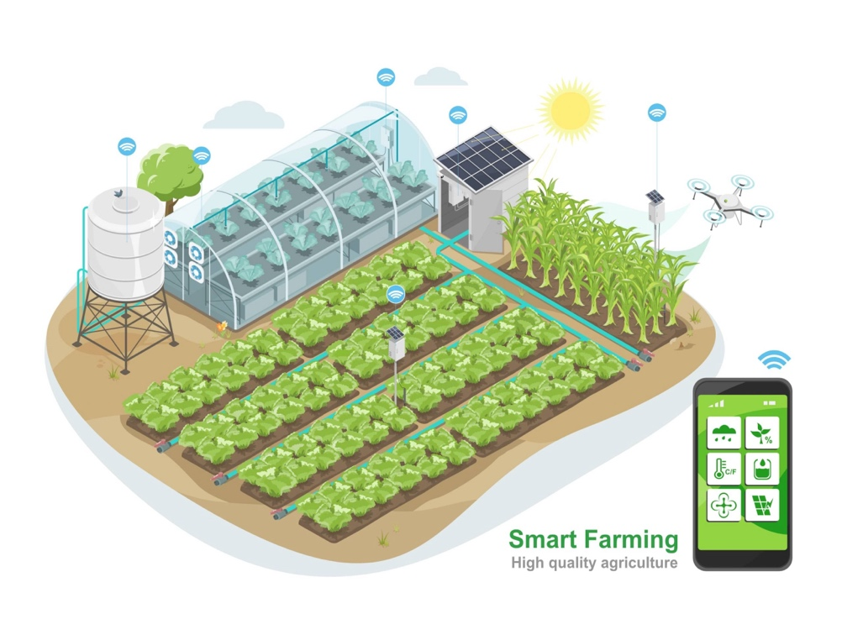

**8.** Which technology is commonly used in vertical farms to monitor environmental conditions?

A) Wind turbines   
B) IoT sensors  
C) Pesticide drones  
D) Animal tracking collars

Timestamp: 1:20-2:00

**9.** How can IoT improve sustainability in vertical farming?

A) By replacing human workers entirely  
B) By randomly changing temperatures  
C) By providing real-time data on plant needs  
D) By using gasoline-powered equipment

Timestamp: 1:30 – 2:00

**10.** According to the AI in agriculture video, how is AI improving crop yields?

A) By replacing human labor entirely  
B) By analyzing large datasets to optimize growing conditions  
C) By limiting water use completely  
D) By manually fertilizing plants

Timestamp 2:15-2:45

CLICK HERE FOR ANSWERS:

**Sources**

[1] Agrisiti. (n.d.). *Introduction to vertical farming technology*. Retrieved from <https://agrisiti.com/uncategorized/introduction-to-vertical-farming/>

[2] USDA Agricultural Research Service. (n.d.). *Vertical farming – No longer a futuristic concept*. Retrieved from <https://www.ars.usda.gov/oc/utm/vertical-farming-no-longer-a-futuristic-concept/>

[3] Eastern Peak. (n.d.). *IoT in agriculture: 9 technology use cases for smart farming and challenges to consider*. Retrieved from <https://easternpeak.com/blog/iot-in-agriculture-technology-use-cases-for-smart-farming-and-challenges-to-consider/>

[4] Pinduoduo. (2021, March 1). What is vertical farming? | Explained in under 6 minutes [Video]. YouTube. <https://www.youtube.com/watch?v=QT4TWbPLrN8>

[5] HP Future Cities. (2020, July 8). Vertical farming: Growing up instead of out [Video]. YouTube. <https://www.youtube.com/watch?v=suYcri3FzcI>

[6] Sustainable Human. (2021, June 15). How vertical farming can revolutionize food production [Video]. YouTube. <https://www.youtube.com/watch?v=qIAm3zqK81Y>

[7] The B1M. (2022, February 2). Is indoor farming the future of food? [Video]. YouTube. <https://www.youtube.com/watch?v=hXC7vCcg2xo>