**9) Technology to feed a growing earth and world**

Innovative Technologies for Global Food Security

**Overview and Objectives**

This submodule introduces the role that technology plays in addressing the challenge of feeding a growing population across the globe.

Upon completion of this module, you will be able to:

* Identify key technological advancements in agriculture and food production.
* Explain how precision agriculture enhances crop yield and resource efficiency.
* Evaluate the global impact of emerging food technologies on food access and sustainability.
* Understand the science behind lab-grown meat and its potential role in future food systems



Read and watch the following material to gain the necessary information to

complete this lesson.

**[1] National Geographic: The Next Green Revolution**:

<https://www.nationalgeographic.com/foodfeatures/green-revolution/>

*A look at how science and technology are reshaping farming to feed 9 billion people by 2050 while protecting the environment.*

**[5] Can we create the “perfect” farm?** [https://www.youtube.com](https://www.youtube.com/watch?v=xFqecEtdGZ0) [cc] [8 min]

**1.According to Brent Loken, what is one key principle of designing a “perfect” farm?**

A) Maximizing short-term crop yields above all else  
B) Eliminating natural ecosystems to expand farmland  
C) Balancing food production with ecosystem preservation  
D) Using only organic farming methods

**2.What does Brent Loken suggest is a major flaw in many current food systems?**

A) Too little use of fertilizers  
B) Dependence on seasonal labor  
C) Overreliance on organic-only methods  
D) Prioritizing quantity of food over quality and sustainability

**3.According to the talk, what is one of the biggest threats caused by current farming practices?**

A) Decline in crop flavor and nutrition  
B) Disconnection between farmers and consumers  
C) Loss of biodiversity and natural ecosystems  
D) Rising costs of organic certification



**[2] Culture, meat, and cultured meat – Journal of Animal Science (2020):** <https://academic.oup.com/jas/article/98/8/skaa172/5880017?login=false> [PDF here](https://watermark.silverchair.com/skaa172.pdf?token=AQECAHi208BE49Ooan9kkhW_Ercy7Dm3ZL_9Cf3qfKAc485ysgAAA0wwggNIBgkqhkiG9w0BBwagggM5MIIDNQIBADCCAy4GCSqGSIb3DQEHATAeBglghkgBZQMEAS4wEQQM1zsm1VUPW04Jk10_AgEQgIIC_5YMWwAaMPkE8dz3YXJD944YAYXde4lBpskNga372f-jg2Ng7vKPl9xTuH0u6QJP7ZRJG3P-kYV0W78KWfJKKFpdHZIHZNzRy03pQRWPdsiet_l2dd3WTx7dLkXBl0EpFi6OhZZqgC8yI6BiDbH8Mrui5JL7lnc-2hcw4yblHHpms2cSYs75nMvHUtAULX0EGFLiuKpGBIj-wfOtxZpeErBmoDdQi5K0jfz690oKz4tNfZr-asE4eScS_AMikYMSNl1uGTKH6lnFmvgrYtTuy_A_KqxyrUGX_5MgKxHNvEd4hjmFKLbCCEmaSygsbMOD5Cs3PoO41SfT4o4D0pkJ-8B_rhyBiA3loJYXkAHb2c3NjGGd3wKbLP7PdrIuJuF8em7oHMCIPh1nhwvmpk1Y0Uc6CcxgSaJEYCWOy0Gm5HmBvo0hBcCkSjv2uNz875abBUSYFzPkbtWV8O8sHrz4cqFQg0wzUXguWeCEB_zT9v3Ze8nddcUutfcKVgfVOTGjc7rQy0Wc8dpQl0zkPKwWNjk7slV7Vf-q7hUtUblZ2b3X0amzT8sqVs5rY-ckclD5E82MDWldLF8xvHXUBWhMw2fg8zq-aUt3e6aJteaiOze8rP3n0933n4bcFzLVbP_nzo9NTUq8t2Jxq160nzE28JwCRsNn7jsIZ5VCxrlfMpLL8vww163AjR9ROGHGtTFFMnyMkkxx3quChcmIv0JcR0Hcu8jHRI9yp7bddkIALq-gTl_tWBT7hyspvdqWLyKmp-G3vV4FcNzauAOsq6sXWaIuU9zMTFcJeL-BFYT7_JUluE80nL4h8tsvj1osjalDH2m_ESp5-Z0bggZFqs9Cdot-WXMdWZH85A-x0JendRuyn7bCdwJgP-ebXXkkZ0bm8lWdAoE0lgBWzU5QDQjvmrug2ClcqLmSUmLMlNCUpIPTKvLRy6EAQ4l94R0eK9dP70dzLpTx276JnLUw60H2elYKVD7VfIF0ECv4fypYvVsZiGmw_R580aReTWglJEdv)

*Explores the societal, religious, and regulatory challenges facing lab-grown meat and its*  *potential to replace conventional meat.*

**[6] The Meat of the Future: How Lab-Grown Meat is Made** [https://www.youtube.com](https://www.youtube.com/watch?v=u468xY1T8fw) [cc] [3 min]

**4.In the video How Lab-Grown Meat is Made, what is the basic unit used to start the process?**

A) Synthetic proteins  
B) Genetically modified corn  
C) Animal cells  
D) Insect tissue

**5.Why is lab-grown meat considered more sustainable than conventional meat?**

A) It is grown outdoors with natural light  
B) It uses significantly less land and water  
C) It produces more methane gas  
D) It can be grown without any energy use

**6.What is one ethical advantage of lab-grown meat mentioned in the video?**

A) It reduces the need to raise and slaughter animals   
B) It eliminates the use of all technology in food production  
C) It encourages people to become vegetarians  
D) It guarantees global food equality

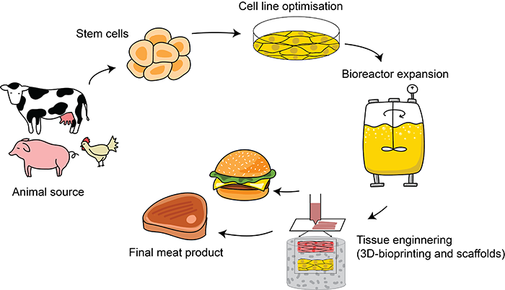

**[3] Modern Agricultural Technologies for Sustainable Food Production: A Comprehensive Review:**

<https://www.ijisrt.com/assets/upload/files/IJISRT25FEB987.pdf>

*This review synthesizes cutting-edge research on modern agricultural technologies, including precision farming, biotechnology, digital agriculture, and automation, demonstrating their role in reshaping sustainable food production systems*

**[7] Precision Agriculture – The Future of Farming** [https://www.youtube.com](https://www.youtube.com/watch?v=WhAfZhFxHTs) [cc] [6 min]

**7.What is a primary benefit of smart irrigation systems in agriculture?**

A) Increased pesticide application  
 B) Optimized water use and conservation  
 C) Decreased seed germination  
 D) Prevents plant growth

**8.What is one major advantage of using GPS-guided machinery in farming?**

A) It eliminates the need for crop rotation  
B) It allows farming to happen without human supervision  
C) It ensures precise planting and reduces overlap in field operations  
D) It replaces the need for irrigation systems

**9.How does precision agriculture help farmers make better decisions?**

A) By replacing soil with artificial growing platforms  
B) By using data from sensors and satellites to guide actions  
C) By relying solely on past seasonal trends  
D) By standardizing farming practices across all crops

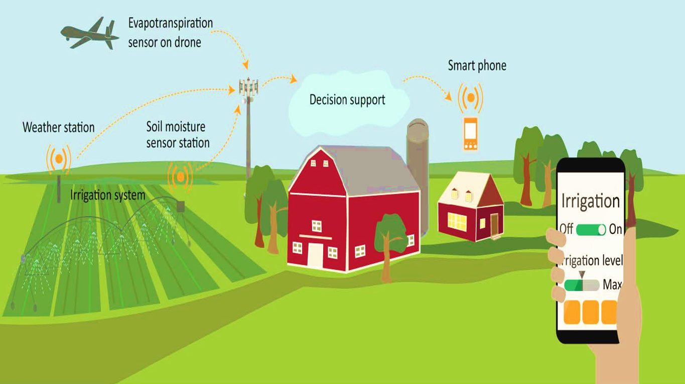

**[4] Insight on Current Advances in Food Science and Technology for Feeding the Growing Global Population:**[**https://helda.helsinki.fi/server/api/core/bitstreams/46ad5172-6223-4022-8d76-863974cbb84a/content**](https://helda.helsinki.fi/server/api/core/bitstreams/46ad5172-6223-4022-8d76-863974cbb84a/content)

*This article provides insights into the latest advances in food science and technology aimed at feeding the growing global population, addressing challenges related to resource limitations and environmental sustainability.*

**[8] How Singapore is using Tech to grow food without Farmland**: [www.youtube.com](https://www.youtube.com/watch?v=GKZwMdxNerU) [cc] [9 min]

**10.What was a key takeaway from the video on Singapore’s urban farming strategies?**  
 A. Farming without the use of any light  
 B. Importing all food from nearby countries  
 C. Using technology to grow food in limited land space  
 D. Relocating farmland to suburban areas

**11.What role do indoor farming systems play in Singapore’s food strategy?**

A) They support crop rotation on traditional soil farms  
B) They eliminate the need for any artificial lighting  
C) They enable climate-controlled environments to grow food year-round  
D) They are used primarily for raising poultry  
  
**12.Which of the following technologies is highlighted in the video as part of Singapore’s urban agriculture efforts?**

A) Hydroponic and vertical farming systems  
B) Manual irrigation with rain barrels  
C) Open-field organic rice farming  
D) Drone delivery of imported food

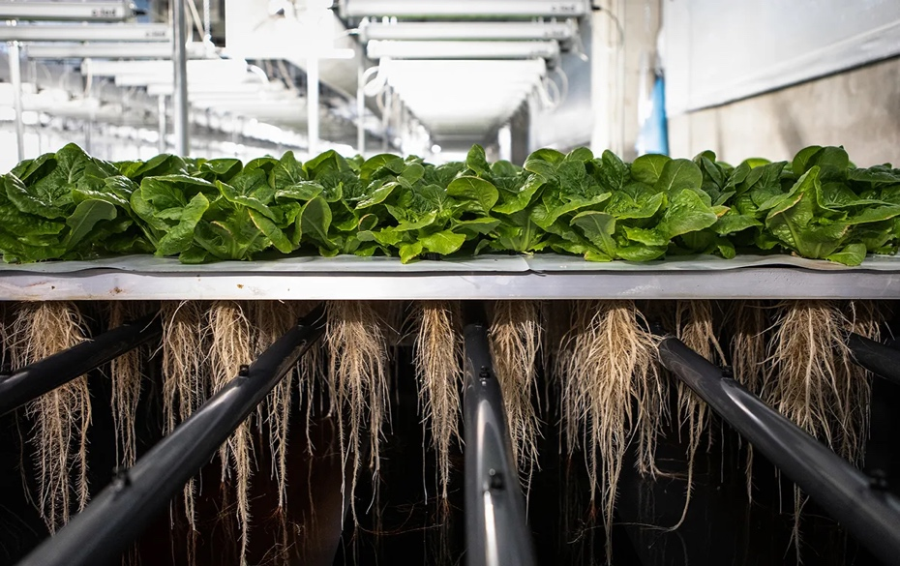

**Sources**

[1] T. Folger, “The next green revolution,” *National Geographic*, 2014. [Online]. Available: <https://www.nationalgeographic.com/foodfeatures/green-revolution/>

[2] C. J. Bryant, “Culture, meat, and cultured meat,” *Journal of Animal Science*, vol. 98, no. 8, Aug. 2020. [Online]. Available: <https://doi.org/10.1093/jas/skaa172>

[3] B. J. Anyibama et al., “Modern agricultural technologies for sustainable food production: A comprehensive review of technological innovations and their impact on global food systems,” *Int. J. Innov. Sci. Res. Technol.*, vol. 10, no. 2, pp. 1466–1475, 2025. [Online]. Available: <https://www.ijisrt.com/assets/upload/files/IJISRT25FEB987.pdf>

[4] F. Valoppi et al., “Insight on current advances in food science and technology for feeding the world population,” *Frontiers in Sustainable Food Systems*, vol. 5, 2021. [Online]. Available: <https://doi.org/10.3389/fsufs.2021.626227>

[5] BRIDGES, “Precision Agriculture: The Future of Farming,” *YouTube*, Sep. 13, 2018. [Online]. Available: <https://www.youtube.com/watch?v=WhAfZhFxHTs>

[6] TED-Ed, “Can we create the ‘perfect’ farm? – Brent Loken,” *YouTube*, Apr. 29, 2021. [Online]. Available: <https://www.youtube.com/watch?v=35CTFyO1J9w>

[7] Insider Science, “The Meat of the Future: How Lab-Grown Meat is Made,” *YouTube*, Dec. 1, 2020. [Online]. Available: <https://www.youtube.com/watch?v=473GFtYPrGc>

[8] CNA Insider, “How Singapore is using tech to grow food without farmland,” *YouTube*, Aug. 8, 2021. [Online]. Available: <https://www.youtube.com/watch?v=umsZkcoK3Y0>

**CLICK** [**HERE**](https://txst-my.sharepoint.com/:w:/g/personal/mdr243_txstate_edu/ETABzMoIFMlJqTChfNKwQJUBm-uZveS0JbkA347ZGnKxNA?e=f0PUvh) **FOR ANSWERS**