Spring 2025 Faculty, Staff, and Student Research Activity

*The Future of Youth Violence Prevention: A Mixtape for Practice, Policy, and Research*, edited by Drs. Paul Boxer and Raphael Travis Jr., presents adaptable, culturally responsive strategies grounded in best practices to prevent youth violence. The book unites scholars with real-world experience to blend research, theory, and applied knowledge, preparing a new generation of professionals to design collaborative, context-specific interventions across settings like schools, clinics, and justice systems.

This work aligns with the mission of the CREATE Research Lab, led by Dr. Travis in the School of Social Work, which explores how engagement with the arts — especially Hip-Hop culture — supports healthy development and academic growth. In Spring, Austin Partners in Education (APIE) visited the CREATE Lab Studio and Makerspace for hands-on activities exploring connections between music and well-being. The event was organized by TXST Social Work alum Elena Aguayo, now a College Readiness Advocate with APIE, who will begin graduate school at UT Austin this fall.

* [Find The Future of Youth Violence Prevention: A Mixtape for Practice, Policy, and Research in Rutgers University Press](https://www.rutgersuniversitypress.org/the-future-of-youth-violence-prevention/9781978833777/)
* [Explore the CREATE Research Lab](https://traumaresearchfoundation.org/flowstory-and-the-create-research-lab/)

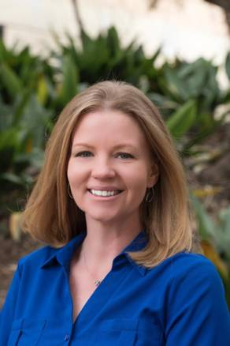Dr. Angela Jones has recently co-authored several impactful studies addressing key challenges in research methodology and criminal justice. In *Nature Human Behavior*, her article “Predicting the Replicability of Social and Behavioural Science Claims in COVID-19 Preprints” explores how structured group predictions can assess the reliability of emerging research, showing that both novice and experienced participants performed better than chance. In the *Journal of Experimental Criminology*, Dr. Jones and PhD student Beth Quinby published “Texas attorneys recognize problematic eyewitness procedures, but plea away anyway,” finding that attorneys often overlook flawed police practices when making plea decisions, signaling a need for greater sensitivity to eyewitness bias. In *Justice Quarterly*, Drs. Jones and Sean Roche authored “Introducing Item-Specific Formatting to Scales of Criminal Justice Attitudes: Evidence from a National Experiment,” which demonstrates that agree/disagree survey formats commonly used in criminology produce biased and unreliable results. Their study found that item-specific question formats offer stronger psychometric properties and suggest that public support for both punitive and rehabilitative policies may be a measurement artifact. Together, these publications contribute to improving research accuracy, legal practice, and public opinion measurement in high-stakes contexts.

* [Read “Predicting the Replicability of Social and Behavioral Science Claims in COVID-19 Preprints” on *Nature Human Behavior*](https://www.nature.com/articles/s41562-024-01961-1)
* [Read “Texas attorneys recognize problematic eyewitness procedures, but plea away anyway” in *Journal of Experimental Criminology*](https://link.springer.com/article/10.1007/s11292-025-09668-7?utm_source=rct_congratemailt&utm_medium=email&utm_campaign=oa_20250321&utm_content=10.1007%2Fs11292-025-09668-7)
* [Read “Introducing Item-Specific Formatting to Scales of Criminal Justice Attitudes: Evidence from a National Experiment” in *Justice Quarterly*](https://www.tandfonline.com/doi/full/10.1080/07418825.2025.2463414)

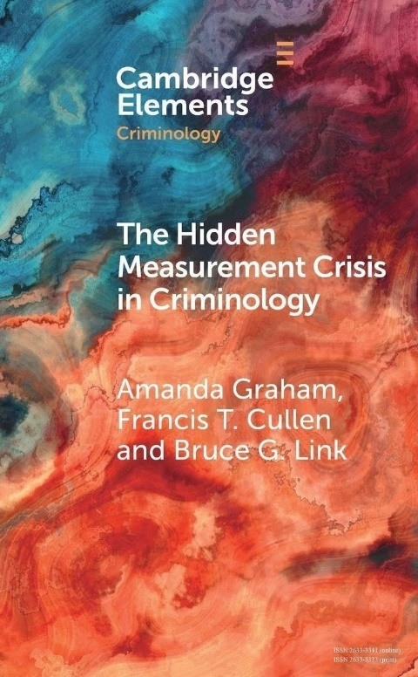 Dr. Amanda Graham recently co-authored an article in *Police Practice and Research* titled “Police K-9 Line-of-Duty Deaths and Heatstroke 2000–2023.” Using data from the Officer Down Memorial Page, the study analyzed 407 K-9 deaths to identify trends and risk factors, with a focus on heatstroke. Heatstroke was found to be the second-leading cause of death after gunfire, often linked to dogs being left unattended or mechanical failures, particularly during summer months. The study highlights the urgent need for improved preventive measures, as factors like age, gender, breed, and climate region showed no significant association. Dr. Amanda Graham co-authored *The Hidden Measurement Crisis in Criminology* with Frank Cullen and Bruce Link, recently published by Cambridge University Press. The book argues that criminology faces a largely unacknowledged measurement crisis due to widespread use of outdated and unsystematic methods. Using a case study on procedural justice in policing, the authors demonstrate how modern psychometric techniques—like item response theory—can improve scale development. Their work aims to expose this hidden issue and offer a path forward for more rigorous, reliable measurement in criminological research.

* [Read “Police K-9 Line-of-Duty Deaths and Heatstroke 2000–2023” in *Police Practice and Research*](https://www.tandfonline.com/doi/full/10.1080/15614263.2024.2438681)
* [Find *The Hidden Measurement Crisis in Criminology* in Cambridge University Press](https://www.cambridge.org/core/elements/hidden-measurement-crisis-in-criminology/F7936EAB6BB5683D77DA91230EC62E53)



Dr. Kathleen Padilla has recently contributed to multiple publications and media addressing critical issues in law enforcement wellness and gender equity. In *Police Practice and Research*, she co-authored “Unveiling the silent battle: suicide rates among law enforcement personnel,” which examined suicide rates among law enforcement officers from 2016 to 2022, finding higher rates among male officers and in the Midwest and Northeast, and emphasizing the need for consistent data collection and targeted prevention. She also co-authored “Bearing the Badge, Battling Inner Struggles: Understanding Suicidal Ideation in Law Enforcement” which analyzed data from 883 personnel and found that psychological factors—especially PTSD—significantly influence suicidal ideation, underscoring the need for robust mental health support. In “Balancing duty and family: the effects of support systems on women in law enforcement” Dr. Padilla explored how parental and social support impact women officers' organizational commitment, revealing that challenges like scheduling, promotion, and unequal expectations contribute to workplace disparities. These findings have direct implications for retention and support efforts in policing. Additionally, Dr. Padilla appeared on the *Police In-Service Training* podcast to discuss the cumulative impact of trauma on officers and the growing emphasis on mental health services in law enforcement. Her work collectively advocates for evidence-based wellness strategies and organizational reform to support officer health and equity.

* [Read “Unveiling the silent battle: suicide rates among law enforcement personnel” in *Police Practice and Research*](https://www.tandfonline.com/doi/full/10.1080/15614263.2025.2454467)
* [Read “Bearing the Badge, Battling Inner Struggles: Understanding Suicidal Ideation in Law Enforcement” in *Journal of Police and Criminal Psychology*](https://link.springer.com/article/10.1007/s11896-025-09741-x)
* [Read “Balancing duty and family: the effects of support systems on women in law enforcement” in *Police Practice and Research*](https://www.tandfonline.com/doi/full/10.1080/15614263.2025.2452649)
* [Listen to Episode 9: Police Mental Health and Wellness in *Police In-Service Training*](https://www.buzzsprout.com/2413505/episodes/16665052-episode-9-police-mental-health-and-wellness)

Dr. Matt Logan and PhD student Frank Benton co-authored “Pareto in Prison” in *Behavioral Sciences & the Law*, analyzing inmate misconduct through the lens of the Pareto principle. Using a national sample, they found that 20% of inmates were responsible for around 90% of all institutional rule violations, with patterns consistent across sex and sentence length. High-rate offenders were more likely to be younger, Black, have violent criminal histories, use drugs, and be diagnosed with personality disorders or ADHD. These chronic rule violators have a disproportionate negative impact on prison environments. In a separate report titled *“Why 'Rehabilitating' Repeat Criminal Offenders Often Fails”* published by the Manhattan Institute, Logan, alongside co-authors John Wright and Hannah Meyers, critiques the effectiveness of criminal rehabilitation programs, arguing that many lack rigorous evidence and are shaped by political narratives rather than outcomes. He recommends policy reforms that prioritize randomized controlled trials, transparent definitions of success, and a renewed focus on public safety. Dr. Logan also appeared on the podcast *The Right Idea*, where he discussed forthcoming criminal justice work and how recent political shifts may influence future policy at the state and federal levels.

* [Read “Pareto in Prison” in *Behavioral Sciences & the Law*](https://onlinelibrary.wiley.com/doi/full/10.1002/bsl.2716)
* [Read *“Why 'Rehabilitating' Repeat Criminal Offenders Often Fails”* from the Manhattan Institute](https://manhattan.institute/article/why-rehabilitating-repeat-criminal-offenders-often-fails)
* [Listen to Episode 67: “In Depth”: Crime, Punishment & All Things In Between With Matt Logan with The Right Idea](https://www.texaspolicy.com/multimedia/article/the-right-idea-episode-67-in-depth-crime-punishment-all-things-in-between-with-matt-logan)

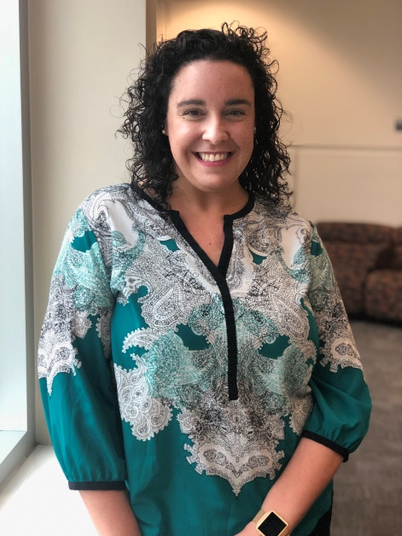Dr. Melanie Soderstrom’s solo-authored article, “A qualitative exploration of school resource officer training in a Florida school district,” was recently published in *Policing: An International Journal*. The study investigates the content and perceived effectiveness of training provided to school resource officers (SROs), a topic that remains underexplored despite the growing presence of SROs in schools nationwide. Findings reveal that while training is required and facilitated in the school district under study, it did not adequately prepare officers for the complex responsibilities they face. The research underscores the need for more targeted and meaningful training to better equip SROs working with vulnerable student populations.

* [Read “A qualitative exploration of school resource officer training in a Florida school district” in *Policing: An International Journal*](https://www.emerald.com/insight/content/doi/10.1108/pijpsm-06-2024-0092/full/html)

Drs. Lidia Nuño and Veronica Herrera of California State University, Fullerton recently published “Immigrants' Perceptions of the Police: Does Undocumented Status Matter?” in *American Behavioral Scientist*. The study examined whether undocumented status influences perceptions of police among 208 Latin American immigrants in the U.S. Southwest. Findings showed no significant differences between undocumented and documented immigrants in views of procedural justice, police legitimacy, or willingness to report crimes. Instead, perceptions of justice and trust in police were the strongest predictors of reporting willingness, with older immigrants expressing more favorable views overall.

* [Read “Immigrants' Perceptions of the Police: Does Undocumented Status Matter?” in *American Behavioral Scientist*](https://journals.sagepub.com/doi/full/10.1177/00027642241302777)

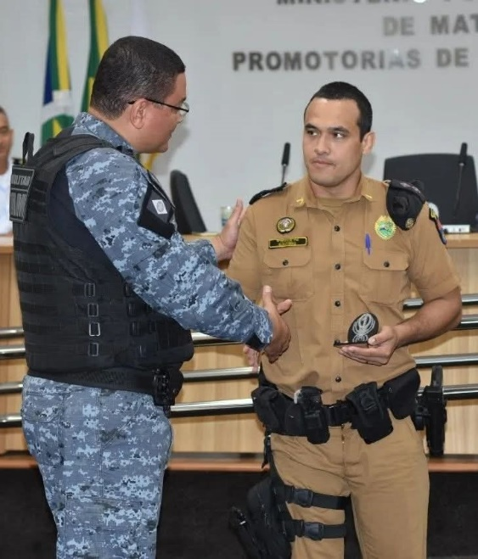

School of Criminal Justice and Criminology PhD student José (Joe) Eleuterio, a former Brazilian police captain with 16 years of service, focuses his research on improving police training and use-of-force practices. His work, which began after a visit to the ALERRT Center and the loss of colleagues, has led to multiple publications, including a recent co-authored with CJ&C PhD student Romane (Romy) Zingraff an article in *Women & Criminal Justice* titled *"*Officer Gender and Suspects Resisting Arrest: A Case-Control Study in Brazil*."*

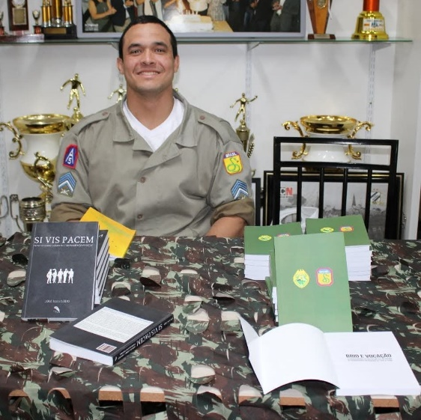

During his master’s in psychology, Eleuterio used evidence to enhance arrest and self-defense training and led projects that gained international attention. Now pursuing his PhD at Texas State, he is developing a situational-based training method that integrates de-escalation, verbalization, threat assessment, and force variation. Despite facing hardships with losing departmental support and retiring from policing, he remains committed to advancing training through research and collaboration.

• [Read "Officer Gender and Suspects Resisting Arrest: A Case-Control Study in Brazil." in *Women & Criminal Justice*](https://www.tandfonline.com/doi/full/10.1080/08974454.2025.2460984)

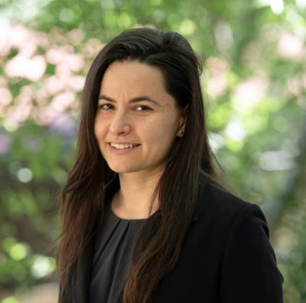Dr. Laure Brimbal has recently co-authored several articles exploring communication dynamics in policing. In *Criminology & Public Policy*, her article titled “Does humanizing the police improve the effectiveness of police recruiting efforts” uses a randomized experiment to assess how portrayals of officers in recruitment videos affect public attitudes and interest in policing careers. A related study, “Police recruitment through an intergroup communication lens: a randomized experiment,” published in the *Journal of Experimental Criminology*, emphasizes the role of social identity in shaping applicant interest and highlights the need for identity-aligned recruitment materials. In *American Behavioral Scientist*, her article “The Effects of Communication Accommodation on Hispanic Immigrants' Willingness to Cooperate with the U.S. Police” examines how communicative adjustments influence immigrant cooperation with law enforcement. Most recently, in the *Journal of Criminal Psychology*, she co-authored along with PhD students Kevin Martinez, Beth Quinby, and PhD grad Dr. Madison Doyle an article with colleagues at Iowa State University titled “A framework of motivations that drive communicative resistance and cooperation in interviews: perspectives from the field,” which introduces a tripartite model for understanding suspects’ resistance during investigative interviews. Together, these studies underscore the importance of communication in improving police-community relations and recruitment.

* [Read “Does humanizing the police improve the effectiveness of police recruiting efforts” in *Criminology & Public Policy*](https://onlinelibrary.wiley.com/doi/full/10.1111/1745-9133.12698)
* [Read “Police recruitment through an intergroup communication lens: a randomized experiment” in *Journal of Experimental Criminology*](https://link.springer.com/article/10.1007/s11292-024-09659-0)
* [Read “The Effects of Communication Accommodation on Hispanic Immigrants' Willingness to Cooperate with the Police” in *American Behavioral Scientist*](https://journals.sagepub.com/doi/10.1177/00027642241301659)
* [Read “A framework of motivations that drive communicative resistance and cooperation in interviews: perspectives from the field” in *Journal of Criminal Psychology*](https://www.emerald.com/insight/content/doi/10.1108/jcp-12-2024-0132/full/html)

Dr. Jennifer King was recently awarded $159,999.19 through UT Austin’s WeTeach_CS Secondary Certification Hubs program. The grant supports efforts to recruit and train in-service Texas science teachers to earn certification in computer science by passing the CS 8–12 or EC–12 Technology Applications TExES exams. The WeTeach_CS program, based at the Texas Advanced Computing Center, partners with Texas institutions to expand the pool of qualified computer science teachers. This initiative aims to strengthen computer science education across Texas schools.

* [Learn about the WeTeach_CS Secondary Certification Hub](https://stemstarts.utexas.edu/program/2024-weteach_cs-secondary-certification-hub/)

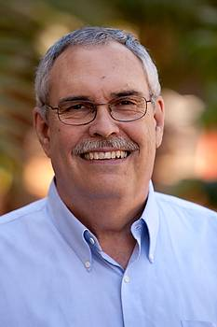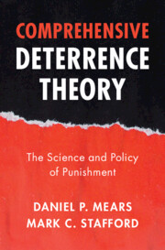Dr. Mark Stafford’s new book, *Comprehensive Deterrence Theory: The Science and Policy of Punishment*, coauthored with Dr. Daniel Mears of Florida State University, was recently published by Cambridge University Press. The book reexamines deterrence theory—long central to criminology and criminal justice policy—and offers a modern, evidence-based update to its classical foundations. In addition to presenting a reconceptualized theory of deterrence, Stafford and Mears critique the overreliance on increasingly punitive measures and propose a more nuanced framework for understanding how legal punishment can deter crime. Their work provides a valuable resource for scholars, policymakers, and practitioners seeking to develop more effective and scientifically grounded crime policies.

* [Find *Comprehensive Deterrence Theory: The Science and Policy of Punishment* in Cambridge University Press](https://www.cambridge.org/core/books/comprehensive-deterrence-theory/80740975881D00F8C05916F965BE6803)

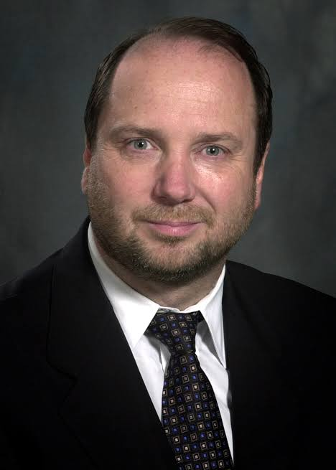**Dr. Kim Rossmo has released the second edition of his groundbreaking book *Geographic Profiling* with Routledge, updating his influential work on using crime location patterns to identify where offenders are likely to live. The book offers an in-depth exploration of the theory, research, and practical applications of geographic profiling, now expanded with new case studies such as the Golden State Killer and DC Snipers, and broader applications including counterterrorism and wrongful conviction reviews. Rossmo, a former police officer and Simon Fraser University graduate, originally developed this method to support investigations of serial crimes, and his work has since influenced fields as diverse as epidemiology and the arts. Celebrated for both its scholarly depth and practical relevance, *Geographic Profiling* remains an essential resource for law enforcement, analysts, and students of criminology.

* [Find *Geographic Profiling* in Routledge](https://www.routledge.com/Geographic-Profiling/Rossmo/p/book/9781032347394?srsltid=AfmBOoob-fj3BD1PcNUK4kppStdKbdqyq4YUPB5g4uXLM4vtK5U_oAtb)

Dr. Omar Lopez, Professor in the Department of Organization, Workforce, and Leadership Studies, is a STEM higher education reformer dedicated to addressing challenges faced by vulnerable populations. A native of South Texas’ Rio Grande Valley, he uses transdisciplinary approaches to tackle complex societal issues. His recent research explores the intersection of higher education preparation and STEM workforce readiness. In his recent 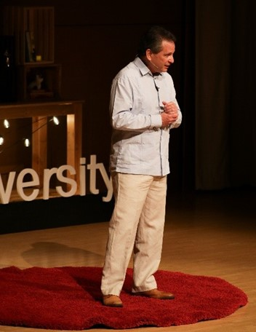TEDx Talk at TXST, Dr. Lopez emphasized the need for higher education to address inequities by equipping students with the competencies needed to thrive in the global labor market.

• [Read about Tedx Talk at Texas State University](https://www.commstudies.txst.edu/news-and-updates.html)

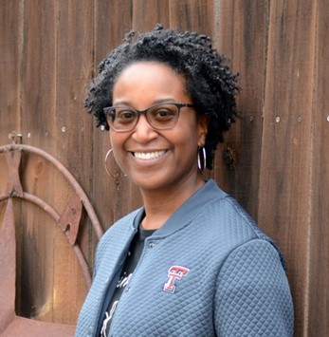Dr. Twyla Hough presented research at the World Conference on Qualitative Research examining the under-representation of women of color in computing. The presentation detailed a convergent mixed-methods research design encompassing surveys, secondary national data, and 90-minute counter-life herstory interviews with 35 Latina and African American women at seven minority-serving institutions in Texas. Emphasis was given to the qualitative strand of this study, including strengths and challenges in implementing the mixed-methods research design.

• [Learn about the World Conference on Qualitative Research](https://wcqr.ludomedia.org/)

The School of Family and Consumer Sciences hosted its signature end-of-year event, FCS in Bloom, on April 25 to celebrate graduating seniors, as well as undergraduate and graduate student presenters. The symposium featured student posters and presentations showcasing work from programs including Fashion Merchandising, Consumer Affairs, Human Development & Family Sciences, and Interior Design. Guests—including students, faculty, alumni, donors, and families—enjoyed an evening of music and light refreshments while engaging with the students’ accomplishments. The event highlighted the creativity, research, and dedication of the school’s graduating class.

* [Learn about FCS in Bloom](https://www.fcs.txst.edu/about/fcs-bloom.html)

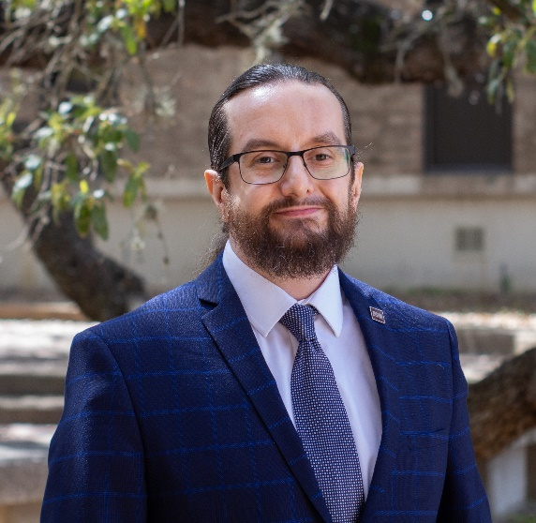Dr. Nadim Adi served as a speaker at the inaugural AI in Teaching and Learning Symposium 2025 at TXST, presenting “Harnessing Artificial Intelligence in Interior Design Education.”

His talk explored the growing role of AI as a transformative tool in creative education, particularly in the field of interior design. He addressed the challenge of balancing traditional design instruction with the need to prepare students for an AI-influenced industry. Drawing from direct experience, Dr. Adi offered practical insights and strategic recommendations for effectively integrating AI into the design curriculum.

* [Explore Dr. Nadim Adi’s LinkedIn](https://www.linkedin.com/in/dr-mohamad-nadim-adi-5179283/)
* [Learn about AI in Teaching & Learning Symposium at Texas State University](https://doit.txst.edu/txstai/symposium.html)

Dr. Elisa Toman is a co-author of the newly published article *"*Between a Rock and Solitary Confinement: Gendered Perceptions of Women Working in Restricted Housing Units" in *Women & Criminal Justice*. Co-authored with George Mason University doctoral students Lindsay Smith and Sydney Ingel, and Dr. Danielle Rudes of Sam Houston State University, the article examines how women correctional officers are perceived in restricted housing units (RHUs). Using interview data from RHU staff, the study explores gendered perceptions, and the distinct challenges women face in these settings. It addresses a gap in existing research by focusing specifically on women working in solitary confinement environments.

* [Read "Between a Rock and Solitary Confinement: Gendered Perceptions of Women Working in Restricted Housing Units" in *Women & Criminal Justice*](https://www.tandfonline.com/doi/full/10.1080/08974454.2025.2500015)

 Dr. Katherine Selber has served on the George W. Bush Institute’s Veteran and Military Family Initiative, including within their Higher Education Policy Working Group for several years. The Policy Group’s most recent publication includes “Helping Veterans Achieve Their Potential With Higher Education Resources.” This initiative advocates for policies that ensure veterans and military-connected students can efficiently access their education and health benefits. Achieving this requires the VA to address administrative barriers through targeted reforms and improved service delivery. Enhancing program evaluation and raising awareness of available resources will better support veterans’ transitions and honor their service. Throughout the years, the Institute has worked in the areas of mental health policies, educational policies and health issues that impact veterans and their families.

* [Read about the Policy Recommendations from the George W. Bush Institute](https://gwbushcenter.imgix.net/wp-content/uploads/EO_Veteran-Education_2.11.25.pdf)

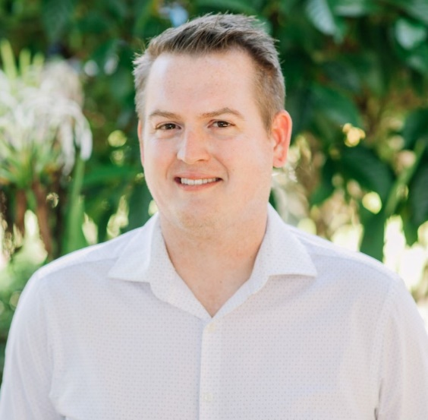

Dr. Hunter Martaindale from the School of Criminal Justice & Criminology has received $89,861 from The Research Foundation of State University of New York for the project *“*Fiscal Year 2024 Targeted Violence and Terrorism Prevention Grant Program*.”* As Director of Research at the ALERRT Center and Associate Professor of Research at TXST, Dr. Martaindale studies law enforcement performance during high-stress incidents like active shooter events. His work focuses on decision-making under pressure and the effects of acute stress on officer performance. Through the ALERRT Center, he also disseminates national data on active attack events.

* [Learn about The Research Foundation for the State University of New York](https://www.rfsuny.org/)

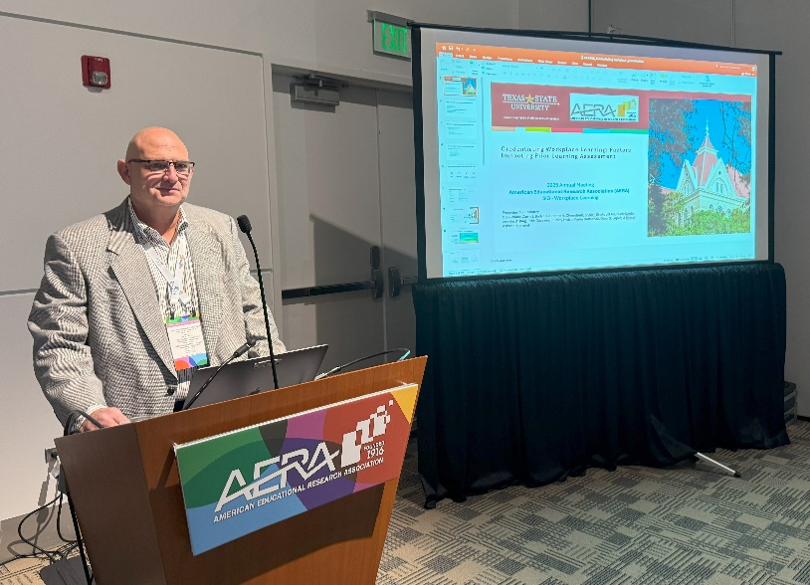Dr. Todd Sherron from the Department of Organization, Workforce, and Leadership Studies presented three papers and two posters at the 2025 American Educational Research Association Annual Meeting in Denver, Colorado. His accepted works included *Analyzing Competency in Block Credit Prior Learning Assessment: Machine Learning Model Comparisons*, *Constructing Educational Possibilities With Experiential Learning and Prior Learning Assessment*, *Credentialing Workplace Learning: Factors Impacting Prior Learning Assessment*, *Logistic Regression and Decision Tree Predictive Modeling: A Fit Function Comparison*, and *Decision Tree Classification: An Important First Step*. As part of the world’s largest gathering of education researchers, their contributions added to dynamic conversations on innovative practices in education and workforce development. The event provided a valuable opportunity to share research, engage with thought leaders, and build professional connections.  Dr. Sherron was nominated for Program Chair for the AERA Workforce Learning and Career Technical Education special interest group.

* [Learn about the American Educational Research Association](https://www.aera.net/Events-Meetings/AERA-2025-Annual-Meeting)

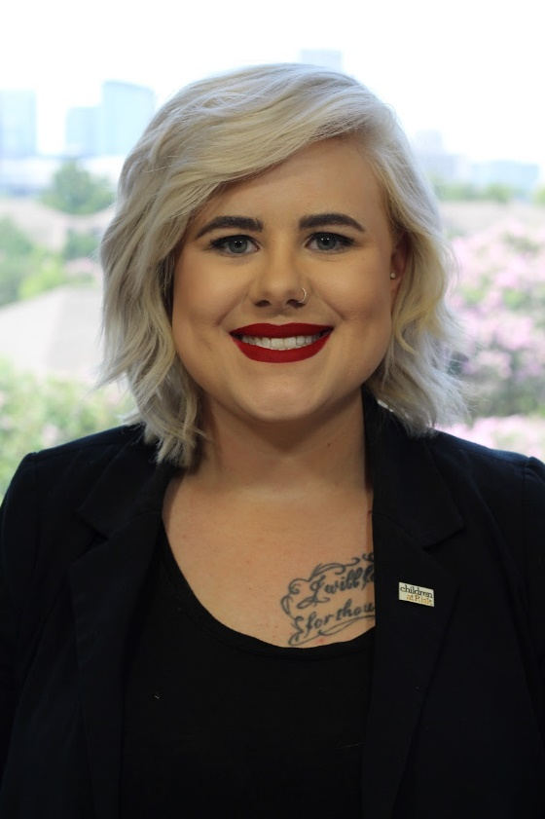PhD student Alyssa Shallenberger recently earned 2nd place in the Academy of Criminal Justice Sciences (ACJS) Student Paper Presentation Competition for her paper, *"Institutional Conflicts and Gender Dynamics: Gender's Influence on Social Structures in Institutional Anomie Theory."* Alyssa’s paper explored how gender functions, at the macro-level, as a social institution within the framework of Institutional Anomie Theory (IAT). Drawing on qualitative interviews with women and gender-expansive students, it illustrates how institutional conflicts—such as educational systems prioritizing perpetrators over survivors or workplace norms deterring women from certain careers—reproduce harm and restrict opportunity, particularly for those navigating intersecting forms of marginalization. She was recognized at the ACJS Awards Luncheon during the annual meeting in Denver in March.

* [Learn about the Academy of Criminal Justice Sciences](https://www.acjs.org/)