
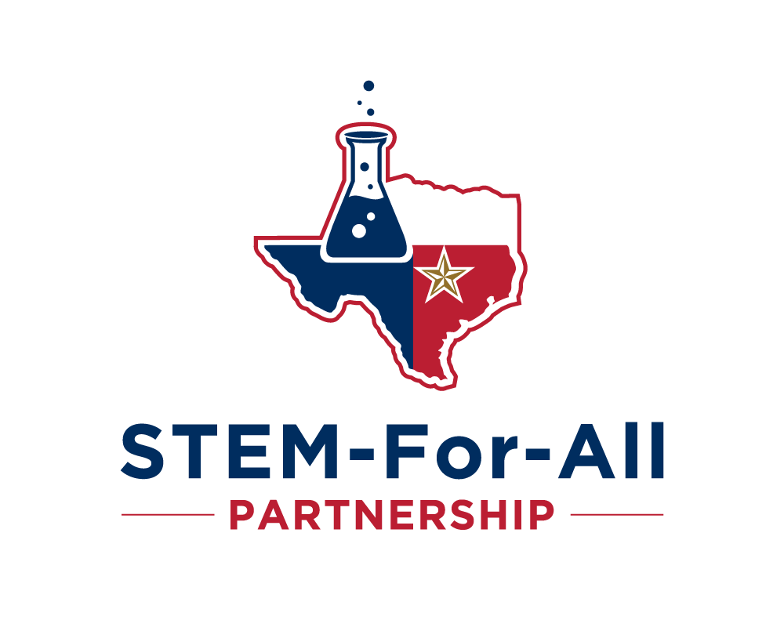

Health and Life Sciences Existing Businesses
Focus Group Report
August 9, 2023

I. Summary
In collaboration with the Round Rock Chamber of Commerce (RRC or Round Rock Chamber), the Texas State University’s STEM-For-All Partnership convened a focus group on August 9, 2023 consisting of individuals from four firms operating within the health and life sciences sector in Round Rock/Williamson County. To begin the group discussion, the invited participants were provided an overview of last year’s activities where the RRC helped to coordinate a Round Rock Life Science Strategic Visioning series in which community leaders explored the opportunities and possibilities for a Life Sciences Industry Cluster for the Round Rock/Williamson County area. Through the focus group process, facilitators gathered information from the invited participants to help chamber stakeholders gain further insights into possible issues based on the group’s input.

II. Introduction
A focus group is a research method used to collect opinions and feedback from a group of people about a specific product, concept, or service. The group is typically made up of individuals selected for their expertise and background relevant to the aim of the research and thereby, who are invited to discuss their opinions, thoughts, and concerns in a facilitated discussion. In so doing, the proposed research’s aim for the focus group process was to collect information to help Round Rock stakeholders gain further insights into possible issues based on the invited participants’ input. To do so, the discussion questions were designed to gather information that would address the following outcomes:
- Identify factors that may be limiting growth of firms within the health and life science sector.
- Clarify life science workforce needs for quality workers and training, including hard-to-fill jobs and positions where retention is difficult to maintain.
- Areas that would be most beneficial for the Round Rock Chamber to recruit in this effort to grow the Life Sciences Industry Cluster in the Round Rock/Williamson County area.
- Discover what programs, courses, and micro-credentials would be most beneficial to help provide the workforce needed to continue to grow the health and life sciences sector.
- Document other issues for further study essential to growing the Life Sciences Industry Cluster in the Round Rock/Williamson County area.

III. Participants - Firms
Participants in the focus group consisted of individuals from four firms operating in the health and life sciences sector in Round Rock/Williamson County. These firms included:
- Avison Young
- ClearCorrect LLC
- Microchem Laboratory
- Zeteo Biomedical LLC

IV. Focus Group Guiding Questions
After introductions from each of the attendees, the invited participants were provided an overview of last year’s activities where the RRC helped to coordinate a Round Rock Life Science Strategic Visioning series in which community leaders explored the opportunities and possibilities for a Life Sciences Industry Cluster for the Round Rock/Williamson County area. Given this backdrop, the group was asked the following question to begin the discussion:
- For your current business operations, what is the one issue that is limiting your ability to grow?
- Regarding workforce needs, are you easily able to find qualified candidates for the roles that you need? If not, what are the hardest roles to hire?
- Are you able to retain talent easily? What are the methods/best practices used for you to retain talent?
- Texas State Round Rock Campus is looking to expand their presence in Round Rock to 10,000 students by 2030. What programs or course offerings would be beneficial to help provide the workforce needed to continue to grow your business in the area?
- What other thoughts do you have related to this undertaking to grow the Life Sciences Industry Cluster in the Round Rock/Williamson County area and to provide resources needed for existing businesses in the area?

IV. Participant Insights and Recommendations
The invited participants provided the following insights from their discussions, and possible recommendation(s) follow for consideration.
- Access to funding limits their ability to grow.
  - The Texas Emerging Technology Fund (often abbreviated as TETF or ETF) was a technology investment fund created by legislation in 2005 at the urging of the Governor to provide Texas with an unparalleled advantage in the research, development, and commercialization of emerging technologies. ETF was abolished by the 84th Texas Legislature in 2015 without a similar program available at the state level. A similar fund created by the Legislature could be useful to scale firms on a state-wide level but further information and discussions with representatives would be needed to see how likely the Legislature would be to consider such a program. Additionally, further research would need to be completed to see if a smaller fund could be implemented at the local level and still be impactful.
  - Another strategy that could be considered to promote growth is to sponsor and fund a life sciences “pitch” competition. University, community and chamber partners could be involved in the development of the guidelines for the competition, the judging of the competition, the awarding of the prize money, and the mentoring of contest winners and meritorious competitors. Further discussion is needed with partners to see if this could be a successful venture.

- The workforce in the life-sciences consists of both technical and non-technical positions. Micro-biologists, biomedical engineers, mechanical engineers, process engineers, injection molding technicians, and CNC machinists are examples of technical jobs; non-technical jobs include business functions like inventory control, IT, marketing, and administration. In some firms, employees are expected to work across multiple functions. A common issue with hiring new employees from college is a lack of essential writing skills, especially in the business of pharmaceutical testing which requires detailed and technical documentation of lab procedures and results. There is also an attitude among recent college graduates where failure is not anticipated as part of doing business which adversely affects the problem solving and decision making abilities of new hires. Due to the rapid pace of innovation in the life sciences field, even recent college-graduates’ knowledge is rapidly becoming obsolete by the first day on the job necessitating an enormous demand for work-based learning for a new-hire to become productive.
  - Texas State University cannot easily address the challenge of providing new-hires with the technical skills required for life sciences industry, except for providing a regional supply of graduates in micro-biology—as pointed out by one invited participant. However, real-world examples of why certain skills such as writing, checking work and basic workplace etiquite can be highlighted in introductory courses to emphasize the importance of basic skills expected in the workforce. Some technical positions (e.g., injection molding) fall more in the purview of the community college. That some firms require employees to work across multiple fields requires effective work-based learning programs consisting of content and instructional practices effective with adult learners. For example, the writing skills area is one where work-based learning has potential to improve employee productivity.

- Many entrepreneurs have had limited opportunities to strategize their business within the context of future possibilities of the marketplace.
  - A series of life sciences leadership or entrepreneurial seminars could address this issue. Such an educational program for entrepreneurs would consist of micro-credentials toward earning a certificate in strategy and futures research, but also to creating plans for scaling their firms. Further discussions are needed to further discuss the vialbility of an entrepreneurial seminar program.

- The invited participants agreed that creating a life sciences cluster for the Round Rock/Williamson County region would draw other such firms in the sector to the area, but also businesses that supply materials and expertise essential to scaling. Materials often must be imported from other countries making it difficult to plan production. Thus, it is not just life science firms needed for regional economic growth, but those businesses along the supply chain. To do so, one must know with more certainty just what life sciences firms are in the Round Rock/Williamson County area. A comprehensive inventory of businesses operating within the life sciences sector would be essential to address this issue.
  - According to participants, attempts have been made in the past for a business needs assessment, but the last time a comprehensive life science industry survey took place may have been 7 to 8 years ago. Unfortunately, no such inventory of life sciences firms and their auxiliary businesses exists that is current. Such research does fall within the expertise of Texas State University but would need funding to complete such a study and would benefit with working with other partners in the area such as Opportunity Austin, Bio AustinCTX, Austin Technology Council, ACC InnovATEBIO and other organizations with interested members. Further discussions are needed. This would also follow the recommendation from the RRC’s Life Sciences Strategic Vision conducted in 2022 to conduct a life science industry scan/survey.

- As the life sciences industry cluster development initiative progresses, there is a critical need for continued collaboration and communication between the San Marcos and Round Rock campuses. The recent arrival of the new Vice President for the Round Rock Campus provides an excellent opportunity for focused discussions around these initiatives, particularly as they relate to the Round Rock Campus.

- It is recommended that such discussions be scheduled during the Fall semester and that key stakeholders and faculty with mutual interests be included. Further, an ongoing process should be established for periodic reviews and updates as timelines are established and refined.

V. Conclusions – Final Thoughts
During the post meeting debriefing among the focus group organizers, a suggestion was made to consider site-visits to life sciences incubators operating in select regions. Discussion also highlighted the need of more business participation in order to strengthen the data gathered. This includes outreach to more additional Austin area businesses in order to continue to gather more needs in the area. Information gathered from future discussions will help to ensure the long-term success of the proposed incubator at the Round Rock Campus and will also validate the RRC’s vision to establish such a cluster in Round Rock.

