Directions: This test has 15 problems, with a time limit of 120 minutes. Do not use a calculator. Show all your work on the test, and how you obtained each answer. Partial credit will be given even if you do not obtain an answer. Do not worry if you cannot do all the problems. We are interested in how you approached each problem.

- How many squares are visible in the diagram? Count all squares, 1x1, 2x2, 3x3, 4x4 and 5x5.

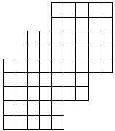

Answer: _________________

Work:

- Ann takes a pill at 8 a.m. Monday and will take a pill every 3 hours. Betty takes a pill at 9 a.m. Monday and will take a pill every 5 hours. Cindy takes a pill at 10 a.m. Monday and will take a pill every 7 hours. When is the first time that all three girls will take a pill at the same time?

Answer: _________________

Work:

- A bag contains 22 marbles, all either red or white. When three are drawn without replacement the probability that all are red is the same as the probability that exactly one is white. How many of the 22 marbles are white?

Answer: _________________

Work:

- A frog can leap 1, 2 or 4 steps at a time in going up a stairway. How many different sequences are possible for the frog as it hops up 10 steps but avoids landing on the seventh step.

Answer: _________________

Work:

- For numbers x,y define x◊y to mean xy+x+y. Hence, 1◊1 = 3 and 2◊3 = 11. Determine 1 ◊ 2 ◊ 3 ◊ 4 ◊ 5 ◊ 6.

Answer: _________________

Work:

- Find the last two digits in base 10 of 3²⁷⁸⁹²⁹⁵³.

Answer: _________________

Work:

- Triangle ABC has AC = 13, BC = 15 and AB = 14. Segment CG is an altitude of the triangle and D, E, and F are the midpoints of AC, BC and AB respectively. What is the area of the quadrilateral DEFG?

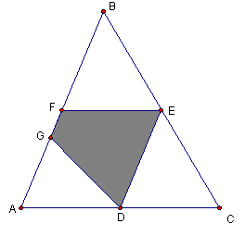

Answer: _________________

Work:

- Triangles ABC and ACD are non-overlapping right triangles with right angles at B and C respectively. If AB = 3, BC = 4 and CD = 12 what is the length of segment BD?

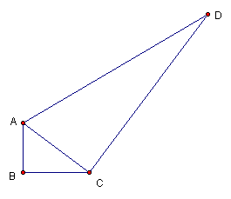

Answer: _________________

Work:

- Five cards are drawn at random from a standard 52 card deck with 13 of each suit, clubs, diamonds, hearts and spades. What is the probability that exactly 3 different suits occur in the 5 cards drawn?

Answer: _________________

Work:

- ABCD is a square with sides of length 4. AE, BF, CG and DH all have length 1. Find the area of the quadrilateral IJKL.

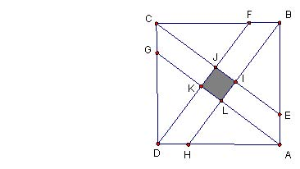

Answer: _________________

Work:

- Suppose all four sides of a parallelogram have integer lengths. Suppose the diagonals of the parallelogram have lengths 7 and 9. If the perimeter of the parallelogram is not equal to 18, what is the perimeter?

Answer: _________________

Work:

- A sequence of integers has T₁ = 1 and T_{n+1} = T_{n} – n for n ≥1. What is the sum of the first 25 terms of this sequence?

Answer: _________________

Work:

- How many integers between 100,000 and 1,000,000 have at least 3 consecutive 4s in usual base ten representation?

Answer: _________________

Work:

- Triangle ABC has area of 165. AD:DB=1:2 and BE:EC=2:3. Find the area of the quadrilateral BDFE.

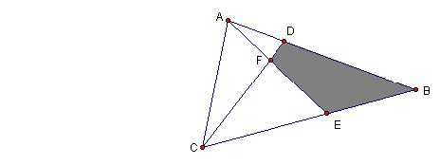

Answer: _________________

Work:

- In the diagram, G is the midpoint of CD and I is the midpoint of GE. BE:EA=4:1 and CF:FB=2:5. Find DH:HA.
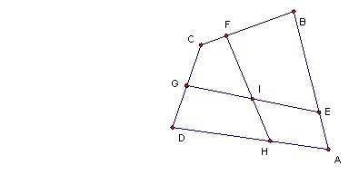

Answer: _________________

Work:

