XXX School of XXX

Times New Roman Size 16 Font

Heading ONLY on 1st Bio Page

Heading is the SAME on All preparatory documents

BS, xxxxxx xxxxxx

XXX Accreditation Review Team

Month XX-XX, 20XX___

**BOLD**

**Dr. Dawn Zinnia- ______Team Chair**

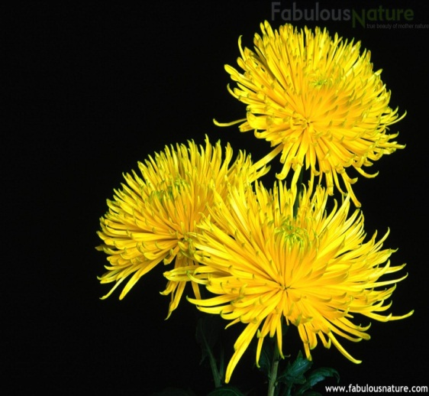

Must have a picture

Dr. Dawn Zinnia is the Director at Cosmos International Labs, in the Processing Department. This department processes new materials, characterizes and improves the processing methods for fabrication, and evaluates the physical, optical, and electronic properties and reliability of materials and components.

She has been the ZYX evaluator or team chair for at least 10 years. She is also very active in several non-profit organizations. Dr. Zinnia received a B.S. in Education from ABC University, a M.S. in Industrial Education from ABC University, and a Ph.D. in Materials Science from ABC University.

Times New Roman Size 12 Font

Paragraph Spacing: After-6 Pt, Line Spacing-Single, At-0.

Bio should include title and place of work, a brief paragraph describing their work, and degrees and awarding institutions.

**Dr. Rachel Cactus Flower- Program Evaluator**

**BOLD**



Dr. Rachel Cactus Flower is the Associate Professor and Undergraduate Coordinator for the Department of XXX at ABC University. She is a member of the Institute for Research and Management Science and a Senior member of the ZYX Engineers. Dr. Flower has been a program evaluator with XXXX since 2001.

Her research interests include developing different cacti species to find solutions for optimization problems as well as investigating the impact of cacti species design on color and growth factor.

Dr. Flower received a B.S., M.S., and Ph.D. in Agriculture from The University of ABC, with her doctoral degree focusing on the many species of cacti.