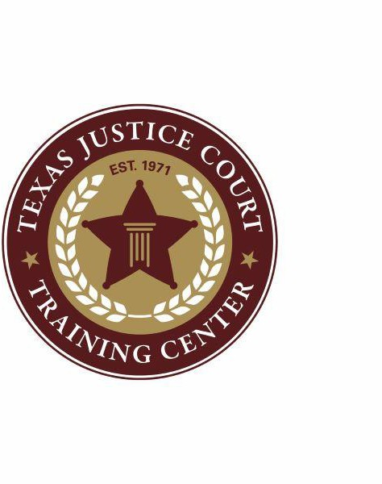
Magistration Judicial Education Certification Form

SB 6 (the Damon Allen Act) requires all justices of the peace to receive 8 hours of initial training on magistrate duties, and then 2 hours each subsequent state fiscal biennium. This form serves to certify that you have received the initial required 8 hours. Upon completion, please email this form to jessforeman@txstate.edu.

Virtual Modules and Recorded Webinar
By selecting this option, you certify that you have completed both the module and webinar listed below. These courses are certified for 8 hours of magistration education.

I certify that I have completed the following training:
  - Webinar “Family Violence Update” – 2 hrs
  - Module “TJCTC Magistrate Duties Overview” – 6 hrs

Name Date of Course Completion

County and Precinct

Email Phone

