

Spring 2026 Criminal Justice Research Experience: Participant Guidelines

This information applies to the following courses:
Course | Sec | Course Title | Instructor
CJ 1310 | 251 | INTRO TO CJ | Cheryl Rowden
CJ 1310 | 252 | INTRO TO CJ | Kathleen Padilla
CJ 1310 | 253 | INTRO TO CJ | Cheryl Rowden
CJ 1310 | 254 | INTRO TO CJ | Elisa Toman
CJ 1310 | 255 | INTRO TO CJ | Madison Doyle
CJ 1310 | R01 | INTRO TO CJ | David Kurylowicz
CJ 3346 | 251 | RESRCH IN CRIM JST | Brian Withrow
CJ 3346 | 252 | RESRCH IN CRIM JST | Brian Withrow
CJ 3346 | 253 | RESRCH IN CRIM JST | Joel Denney
CJ 3346 | 254 | RESRCH IN CRIM JST | Zena Rossouw
CJ 3346 | 255 | RESRCH IN CRIM JST | Angela Jones
CJ 3346 | 256 | RESRCH IN CRIM JST | Logan Somers
CJ 3346 | M01 | RESRCH IN CRIM JST | Logan Somers
CJ 3346 | R01 | RESRCH IN CRIM JST | Georgen Guerrero

As you progress in the Criminal Justice major, you will learn about research in many areas of criminal justice. To enhance your understanding of the nature of social science research, it is essential that you get some first-hand experience with research. For that reason, students are required to have direct experience with social science research.

All research with human participants must be carried out ethically. For example, you cannot be required to participate in studies against your wishes. Therefore, you have two options to fulfill the research experience requirement: one option involves participation in studies, whereas the other does not. Both options have been designed to take the same amount of effort. You may choose either option or both, for a total credit balance of 4 credits. The research requirement will be worth 5% of your final grade!

If you fail to complete the research experience requirement (either Option 1 or 2 below, or a combination), then your final course grade will be reduced by one-half of a letter grade (i.e., 5%). No late submissions will be accepted. The deadline to complete credits is 5 pm on Monday, May 4th.
Option 1. Volunteer as a Research Participant.

If you are 18 years of age or older, you are eligible to participate in studies (the age restriction is due to federal policy). Participation in studies at Texas State University that require 29 minutes or less is worth one credit; studies that take between 30-59 minutes are worth two credits; studies that take between 60-89 minutes are worth three credits; studies that take between 90-119 minutes are worth four credits. The number of credits will be noted in the study description that you see when you sign up. Only studies approved by the criminal justice department qualify for credit. In addition, only studies completed in the current semester count toward your credit requirement.

To sign up for a study, follow the steps below:
- Go to the sona website.
- Log in with your NetID 2-step authentication.
- After you log in, you can sign up for studies, view your accumulated credits, and edit your profile as shown in the screenshot below. Please note that you will not have access to Sona until after roster certification is complete. This usually occurs around the third week of classes.

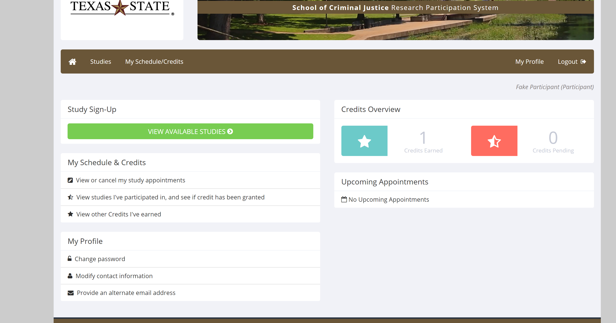

- Look up studies that fit your schedule.
- Online studies can be completed at any time in advance of the researcher’s deadline. Do not sign up for online studies until you are ready to take the study.
- For in person studies, do not sign up to participate unless you intend to show up.
- You may not be able to sign up for future studies if you fail to show up for an appointment that you have made with a researcher, or any time you arrive more than 5 minutes late.
- You may avoid this penalty by canceling your appointment at least 24 hours in advance.
- Please do not argue with researchers if you arrive late. Once a study has started, it is often impossible for a late student to be accommodated.
- Keep your own record of the studies you participate in.
- You may need to periodically check in to Sona to see what studies are available. Study availability will change throughout the semester at each researcher’s discretion. Do not wait until the last minute to complete studies, as this will limit the options available to you.

Option 2. Annotated Research Articles and Reflection

As an alternative to participating in research studies, you may submit an annotated research article and reflection based on an article published in the most recent volume of the Journal of Experimental Criminology. Each annotation and reflection is worth two credits. Therefore, you would need to annotate and reflect on two different articles to earn four credits. This alternative assignment requires students to demonstrate active engagement with criminological research by annotating a peer-reviewed journal article and reflecting on their learning process. To earn credits in this way, follow the steps below:

- Obtain the article(s) in Volume 21 of the Journal of Experimental Criminology. Download the article(s) from the online library database. Follow these instructions below to learn how to locate research articles via the library website:

Using the Periodical List to Find Articles
- Click on Journals/Periodicals on the homepage.


- Type the journal name in the text box:

- Click on any of the issues from the most recent volume and choose an article of your liking to annotate.
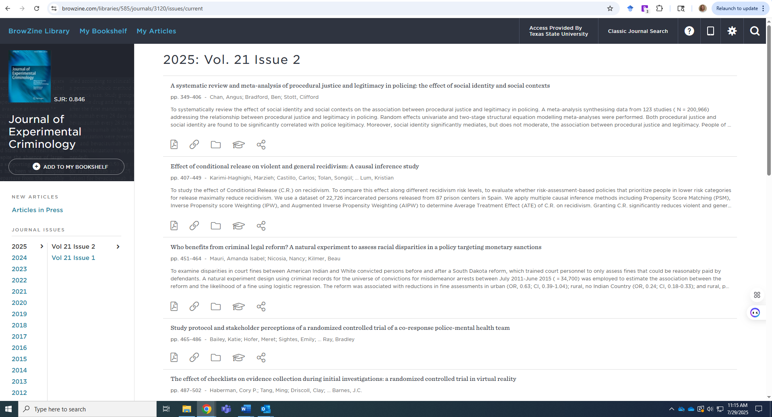
- Part 1: Submit a PDF of the article with visible annotations in the margins. Annotations must include:
Highlight:
  - The research question
  - The theory or theoretical framework (or note if missing)
  - The methodology section
  - At least one key finding
At least five substantive annotations, such as:
  - Explaining why a particular method was used
  - Interpreting a statistical result or table
  - Noting a limitation acknowledged by the authors
  - Connecting a finding to theory or policy
Annotations must reflect engagement with the specific content of the article.

- Part 2: In a short reflection (between 200-250 words), respond to the following prompt: What aspect of this study was most challenging to understand, and how did you work through that challenge? What did this process teach you about reading criminological research? This reflection should focus on your learning process, not a summary of the article.
- Each two-credit submission must include both the annotated article in PDF form (Part 1) and a reflection of the learning process (Part 2). Missing either part will result in no credit.
- The alternative assignment should be written in your own words, avoiding direct quotes. If plagiarism OR the use of AI is detected in your article summary, you will not receive credit.
- Submit annotations and reflections to the following email: sonasystem4cj@txstate.edu by the research experience deadline. You must include your name, class and section number, and your professor’s name in the subject line.

Summary

- Research Experience is worth 5% of your course grade. Research credits can be tracked on the sona website.
- Additional details, including frequently asked questions, are available on the TxSt CJ website.
- Please direct any questions regarding the research experience requirement to the Research Experience Coordinator at sonasystem4cj@txstate.edu.
- If you choose the alternative assignment, ensure you provide both the annotation and the reflection. Any submissions received after the due date will not be graded, nor will those that do not follow the directions.
- Please do not email your professor or the SONA coordinator to ask whether there is anything you can do to make up the grade after the deadline has passed.
- If you sign up for a face-to-face research study, please be on time and make your appointment. If you cannot make your appointment, please notify the researcher at least 24 hours in advance. If you do not show up and the researcher was not notified, this may affect your ability to participate in research studies on the SONA website. In other words, one time of not showing up to a research study or doing an online study before the deadline has passed can automatically limit you from doing any further research studies.

