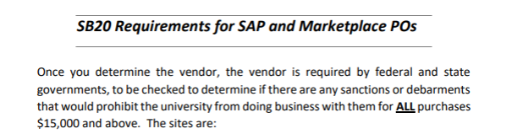

There are a total of 10 Senate Bill 20 (SB20) Documents that must be attached to your requisition or eNPO at issuance. Not after the fact.
This is from the Texas State Legislation and is an Audit Compliance Requirement

Copy and paste each hyperlink in your browser to open:
https://mycpa.cpa.state.tx.us/coa/ Franchise Tax
https://usfcr.com/search-federal-contracts/ Federal – SAMS Check
https://comptroller.texas.gov/purchasing/programs/vendor-performance-tracking/debarred-vendors.php Texas Debarment
https://sanctionssearch.ofac.treas.gov/ The OFAC

NOTE: This is the State Comptroller Site for the Divestment List
https://comptroller.texas.gov/purchasing/publications/divestment.php
In the Divestment listing, there are 7 documents that must be attached.
The State included a Frequently Asked Question (FAQ). This document is not required to be attached.

In your vendor searches:
Franchise Tax, Federal – SAMS Check, OFAC; If your vendor search states, “no vendor found”, SAVE that look up as PROOF of the vendor not being found and attach to the requisition.

See User Guides for Attaching a Document.

https://mycpa.cpa.state.tx.us/coa/ - Franchise Tax
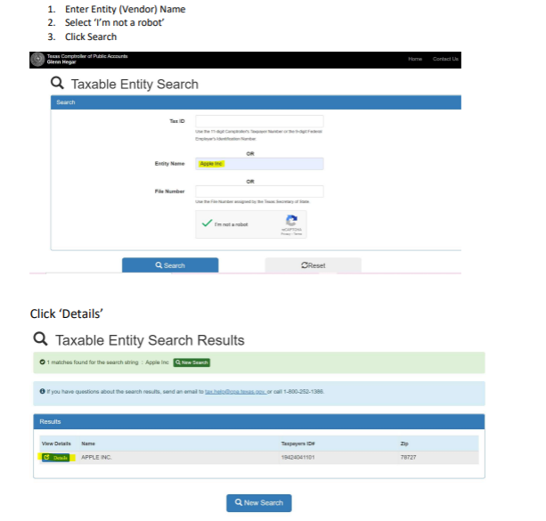
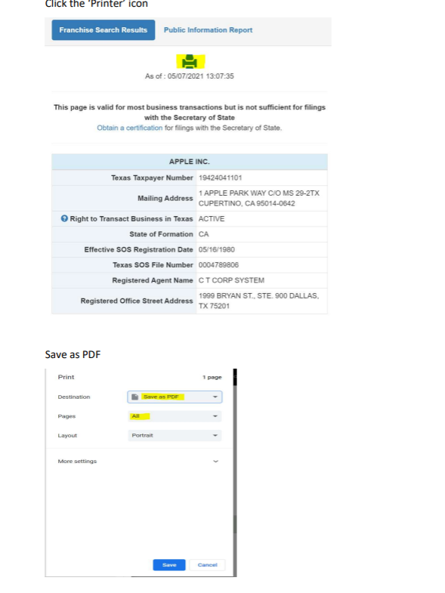

https://usfcr.com/search-federal-contracts/ - Federal – SAMS Check
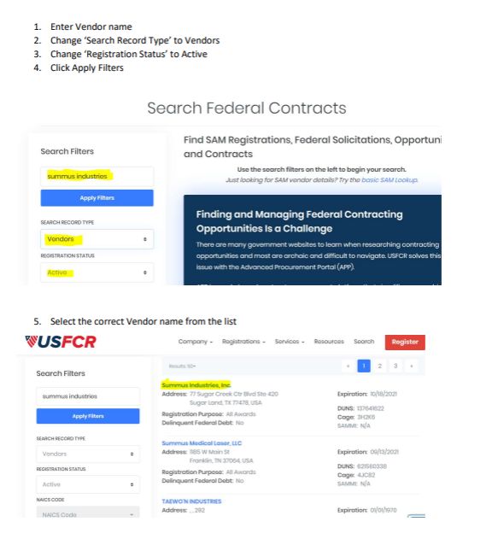

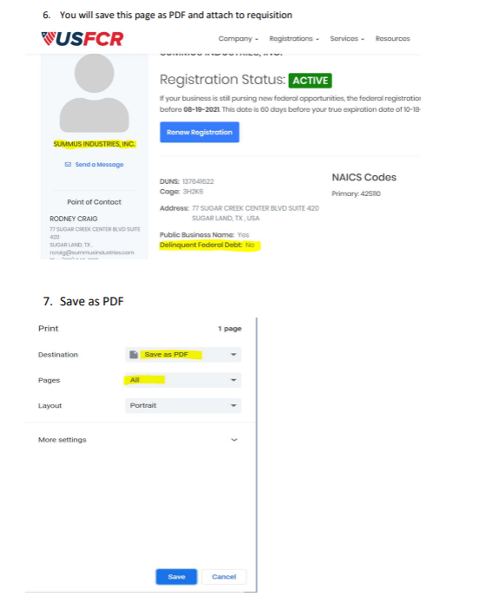

https://comptroller.texas.gov/purchasing/programs/vendor-performance-tracking/debarred-vendors.php Texas Debarment
Once Comptroller site comes up type in: Debarred Vendor List
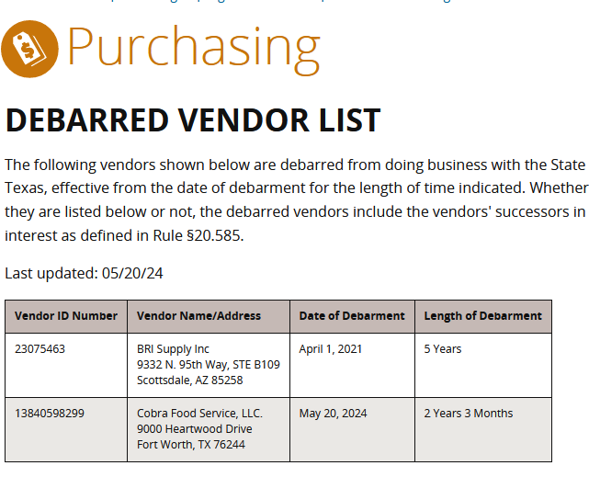
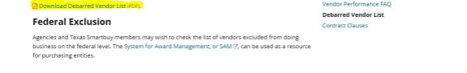
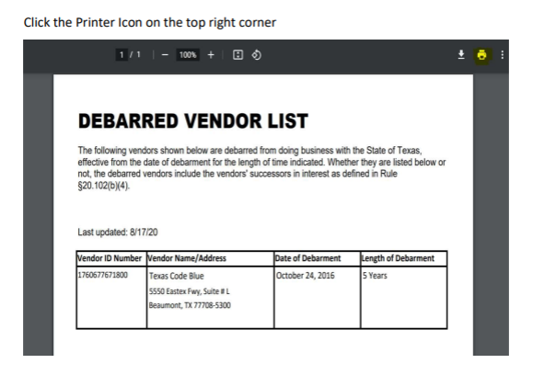
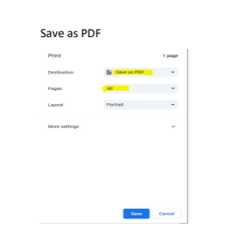

https://sanctionssearch.ofac.treas.gov/ The OFAC
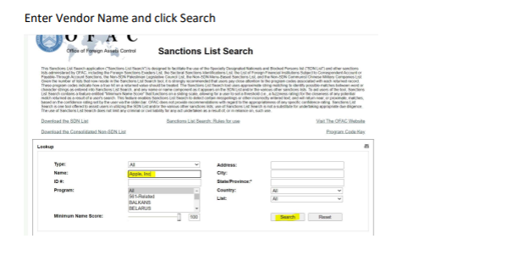

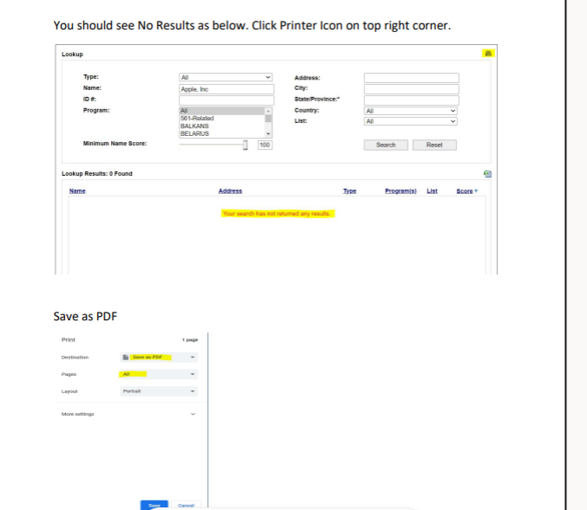

NOTE: This is the State Comptroller Site for the Divestment List
https://comptroller.texas.gov/purchasing/publications/divestment.php
In the Divestment listing, there are 7 documents that must be attached.
You must OPEN EACH link listed below, save as a PDF document and attach to your requisition. The FAQ lists are not required but a good explanation
