Flower Freshness Project
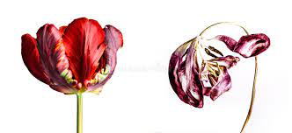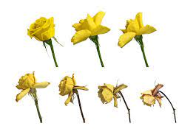
Fresh flowers at the store can be expensive, so most people would like to be able to keep them from wilting for as long as possible. Can you think of any ways we can do this? Consider the factors involved in flower freshness: storage temperature, water quality, additives to the water (flower food), light exposure, humidity, and many more. How many can you think of?
What is important to consider are the factors that we can easily influence at home, the main one being additives to the water. Things like temperature, humidity, and light exposure can be harder to control for flowers you want to display in your home, so let's focus on water additives.

Research Questions: Does flower water supplementation delay wilting of fresh cut flowers? How much longer do flowers stay fresh if their water has been supplemented? Do different supplements have varying effects on flower freshness? What is the most optimal supplement for flower freshness? Is this the same for different flower types?
Experiment Duration: 1-2 weeks
Materials needed:
- 12 flowers
- 12 small flower containers or vases
- Scissors
- Sugar
- Apple cider vinegar
- Water
- Measuring spoon
- Sticky labels
- Marker
- Notebook
- Pencil

Procedure:
- Put one flower in each container.
- Fill all the containers with enough water to reach right below the flowers' leaves.
- Using the marker, write "Flower 1" on a label, then stick it on your first flower container.
- Using the marker, write "Flower 2: Cut" on a label, then stick it on your second flower container.
- Cut the end of your Flower 2 at an angle and put it back in the second container.
- Write "Flower 3: Sugar 1" on another label, then stick it on your third container.
- Measure 1 teaspoon of sugar and add it to your third container.
- Write "Flower 4: Sugar 3" on another label, then stick it on your fourth container.
- Measure 3 teaspoons of sugar and add it to your fourth container.
- Write "Flower 5: Vinegar 1" on another label, then stick it on your fifth container.
- With the help of an adult, measure 1 teaspoon of apple cider vinegar and add it to your fifth container.
- Write "Flower 6: Vinegar 3" on another label, then stick it on your sixth container.
- Measure 3 teaspoons of apple cider vinegar and add it to your sixth container.
- Place all six plants next to each other, in a sunny area.
- Think about how you grow. What do you need to grow strong and healthy? What do plants need to stay alive? Write down your notes in your notebook.
- Using your thoughts from Step 15, make a guess about whether Flower 1 or Flower 2 will stay fresh longer, including why you think your guess is correct. Write down this guess—called a hypothesis—in your notebook.
- Repeat Step 16, comparing Flower 3 and Flower 4, as well as Flower 5 and Flower 6.
- Check on your flowers every day, writing any observations (what you see) in your notebook. You can also draw what you see.
- When a flower has withered up, write down how many days it lasted in your notebook. Do this until all of the flowers have died.
- Replicate procedures with a different type of flower (Experiment 2)
Special Considerations: In research it is imperative that your sampling is consistent and thorough. To control environmental interference, experiments 1 and 2 should be conducted simultaneously. Samples for these experiments should also be collected simultaneously. In research there will always be things you cannot control which lower the accuracy of your data, so being meticulous and thorough where you can will reward you in the end!
References:
https://www.education.com/science-fair/article/keeping-flowers-fresh/

