Mold Growth Experiment:
How temperature, light, and moisture affect mold growth

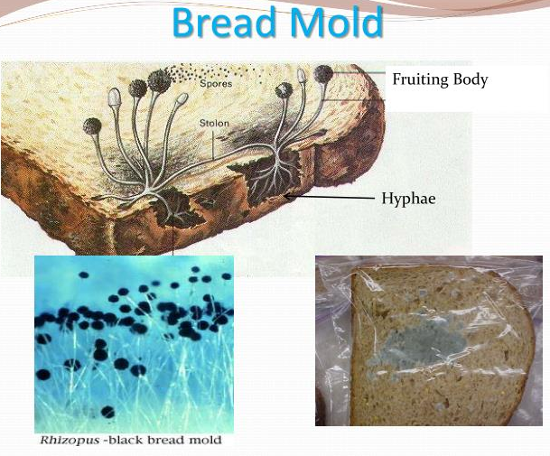
Mold is a fungus that grows in the form of multicellular filaments called hyphae. Molds are part of the natural environment. Outdoors, molds play a part in nature by breaking down dead organic matter such as fallen leaves and dead trees, but indoors, mold growth should be avoided. Molds reproduce by means of tiny spores; the spores are invisible to the naked eye and float through outdoor and indoor air. Mold may begin growing indoors when mold spores land on surfaces that are wet. There are many types of molds, and none of them will grow without water or moisture. One mold that grows on lemons looks like a blue-green powder. A mold that grows on strawberries is a grayish-white fuzz. A common mold that grows on bread looks like white cottony fuzz at first.
Not all mold types are the same, but we can roughly divide them into 3 big types:
- Allergenic – this type of mold is the least harmful of all mold types; however, it can cause problems for people who are allergic to mold or have asthma. Allergenic mold is usually not life-threatening.
- Pathogenic – this type is often harmful, not only for people with asthma or mold allergies but for healthy people too. For example, this type of mold can cause hypersensitivity pneumonitis, an acute response resembling bacterial pneumonia
- Toxigenic mold – this type of mold can actually cause serious health issues, both temporary (eye irritation or cough) and permanent (e.g. immunosuppression, neurological disorders, or cancer). Toxigenic mold produces mycotoxins – a toxic chemical present inside or on the surface of the mold spore, which can be inhaled, ingested, or touched.
It can be annoying to find moldy food in your refrigerator. But in nature, mold is a very useful thing. Mold helps food and other materials rot, which is an icky but necessary thing. In a natural environment, rotting things return to the soil, providing nutrients for other living things. Mold is a natural recycler.
Research Questions: What factors impact mold growth? Which environment do you think will have the most mold? How does heat and light exposure affect mold growth? Which environment fostered the most mold growth, the fastest growing mold, lease amount of mold, etc.?
Experiment Duration: 2 – 4 weeks
Experiment Cost: $10-$15
Materials Needed:
- 4 slices of bread (Has to be from the bakery, not preserved)
- 4 paper plates
- 4 Ziploc bags
- Markers
- Labels
- Observation worksheet or lab notebook
- Ruler

Procedures:
- Place a slice of bread on a paper plate and seal in an individual Ziploc bag. Repeat this with 4 slices of bread so that you have 4 total bread-in-Ziploc-bag samples.
- Put one plate on a sunny windowsill, one in the fridge (one student may have to do this at home if no fridge is available at school), one in a dark place, and one taped to the window. Use a marker to label the Ziploc bag with the date and location chosen.
- In their worksheet or lab notebook, students should predict how the samples’ mold growth will be affected by the different environmental conditions.
- Observe the rate of mold growth in all samples each week. Note any changes (smell, texture, color, etc.) in your worksheet or lab notebook.
- Use a ruler to measure the sizes of spore colonies on the bread and compare these aspects to the other samples in different locations. Look at the colonies closely and record differences (color, texture, etc.).
- After recording all the changes after the 4-week project, infer how the environmental factors affected the different mold growths.
- Create a graph (using graph paper or Excel) that shows the growth and development of the mold in different samples.
- Share and interpret your graph or chart with other students in the class.
References:
- https://www.exploratorium.edu/science_explorer/mold.html#:~:text=Unlike%20plants%2C%20molds%20don't,materials%2C%20they%20grow%20into%20molds.&text=As%20the%20food%20is%20broken,mold%20absorbs%20them%20and%20grows.
- https://www.epa.gov/mold/brief-guide-mold-moisture-and-your-home

