Texas State University Overview of Financial Health FY 2025
Executive Summary
Texas State University (TXST) is in a strong financial position in FY2025, with a Composite Financial Index (CFI) above the benchmark for financial health and positive momentum over time, indicating the capacity to support its strategic plan and absorb shocks. TXST has consistently delivered solid operating results and growth in net assets, demonstrating that it is living within its means while building long-term strength, and it maintains reserve levels well above recommended thresholds, with available reserves now exceeding its internal goal. Debt levels and the viability ratio are identified as the primary watch areas, especially given plans for additional borrowing, but this risk is currently balanced by strong reserves and ongoing operating surpluses. Overall, the report concludes that TXST can confidently invest in key initiatives—including new academic programs, online expansion, ERP modernization, and enhanced research activity—using reserves by design rather than out of financial distress.
The CFI is comprised of four weighted ratios derived directly from an institution’s annual financial report. Two of the ratios are tied to current-year operational performance, the third is related to debt, and the fourth is related to institutional reserves.
Composite Financial Index Defined
The 2023-2029 Texas State University strategic plan, Hopes and Aspirations High, includes four pillars: elevating student success, becoming a Carnegie R1 institution, growing enrollment, and solidifying our position as a great place to work. The successful pursuit of these goals relies on TXST’s overall financial health. Financial health, measured over time, helps to identify present and future opportunities and challenges. The Composite Financial Index (CFI) is the most widely used metric to provide simple, objective insight into the overall financial health of an institution. The CFI was designed by higher education finance professionals in conjunction with credit rating agencies and is described in greater detail in Strategic Financial Analysis in Higher Education. Since it was first published in 1980, through its most recent update in 2016, Strategic Financial Analysis for Higher Education has been acknowledged as the seminal work on ascertaining the financial health of an institution of higher education and is used extensively by trustees, senior leaders, and credit analysts.
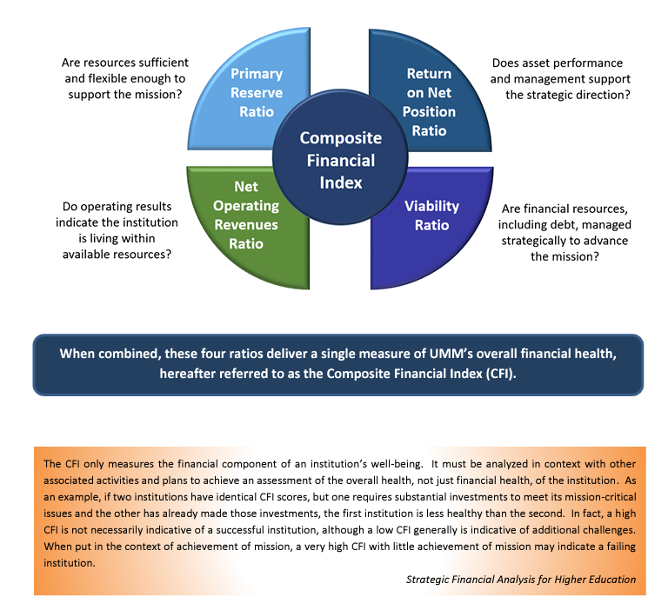
When combined, these four ratios deliver a single measure of TXST’s overall financial health, hereafter referred to as the Composite Financial Index (CFI).

CFI Component 1: Return on Net Assets (Weight 20 percent) (Threshold 6 percent)
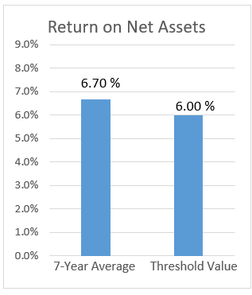
Return on Net Assets compares the total earning capacity of the institution to its actual earnings results. It determines whether an institution is financially better off than in the previous year by measuring total economic return. As this is simply a measure of activity in a single year, which is subject to large deviations, it comprises only 20 percent of the CFI score. Over the last 7 years, TXST has returned an average of 6.70 percent on its net assets annually, with a rate of 11.99 percent for FY2025. The 7-year average is above the recommended benchmark threshold value of 6.0 percent, which is indicative of financial health.
TXST reports the nominal rate of return on net assets unadjusted for inflation or other factors. Some universities present a real rate of return that adjusts for the effects of inflation. Over the past 30 years, the annual impact of inflation has been a relatively minor factor that did not materially change the meaning of this measure. With inflation in 2021-2022 pushing into the 5% and 6% range, achieving the threshold value of 6% indicates keeping up with inflation. With inflation cooling now into the 2% and 3% range, the need to consider using an inflation-adjusted reporting methodology in the future should be alleviated.

CFI Component 2: Net Operating Revenues Ratio (Weight 10 percent) (Threshold 4 percent)
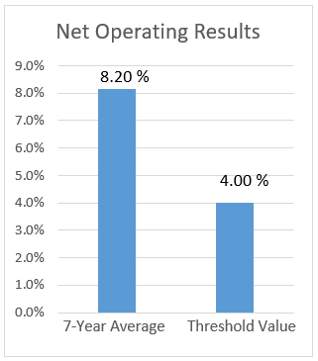
The Net Operating Revenues Ratio measures annual operating performance, or, put simply, “profit & loss.” It answers the question, “Are we living within our means?” Although very important, this ratio is still weighted less than those that follow because it is based only on a single year’s performance. The Net Operating Revenues Ratio for TXST has averaged 8.20 percent over the past 7 years, with a 10.98 percent return for FY2025.
TXST anticipates entering a period of planned uses of reserves to advance numerous strategic initiatives. We are investing in numerous strategic initiatives, including the launch of 10 new doctoral programs, more than 30 new online programs, and a significant increase in our research investments to achieve, maintain, and exceed R1 status.

CFI Component 3: Viability Ratio (Weight 35 percent) (Threshold 1.25x)
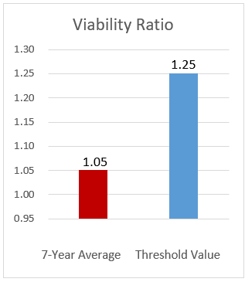
The viability ratio is a measure of an institution’s level of debt and is tied to Primary Reserves as the highest-weighted factor in the CFI calculation since it can take decades to change this ratio in a meaningful way. This ratio measures expendable resources that are available to cover debt obligations (e.g., capital leases, notes payable, and bonds payable) and generally is regarded as governing an institution’s ability to assume new debt.
The threshold for financial health for this ratio is 1.25 at a minimum, with 2.0 being ideal. A ratio of 2.0 would mean that an institution has twice as much in expendable net assets as it does long-term debt. TXST has carried an average ratio of 1.05 for the last 7 years, with a value of 1.05 in FY2025. This is our weakest indicator of financial health, although it is understandable given our rapid growth and construction in recent decades and that long-term debt often stretches over 20-30 years. In fact, TXST currently has plans to take on approximately $550 million in additional long-term debt in the near future, which will reduce this ratio. We must continue to compensate for our relative weakness in this respect by retaining a healthy Primary Reserve Ratio to bolster our overall financial health.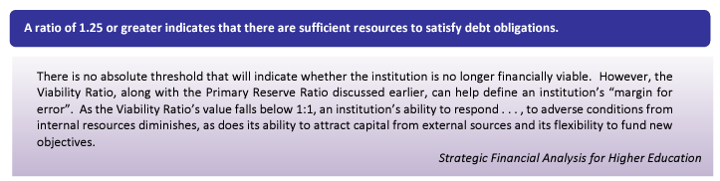

CFI Component 4: Primary Reserve Ratio (Weight 35 percent) (Threshold 0.4 or 146 days)
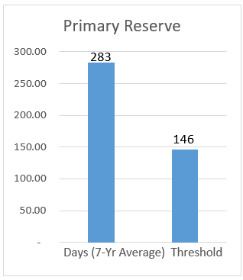
This ratio indicates how long an institution can operate on its reserves without needing to generate additional income. It is tied for the highest-weighted indicator of financial strength because these reserves have taken, in our case, since our founding in 1899 to amass. TXST has maintained an average of 283 days of reserves over the last 7 years. The recommended benchmark is 146 days or approximately five months. TXST had 300 days in reserves at the end of FY2025.
Carrying reserves at these healthy levels serves as a direct counterbalance to our relatively weak Viability Ratio. It also means that TXST can weather most unforeseen adverse financial events and implement its strategic plans. It is important that we maintain primary reserves sufficiently above the benchmark in order to offset our plans to increase our debt over the next twenty years. Note that the 300 days include funds that would not be available to spend short of an exigent circumstance, like a severe financial emergency. Please see the following discussion of available reserves for a better understanding of the types of funds included in this calculation.

Composite Financial Index Summary Analysis
TXST, on average, earned a CFI score of 4.22 over the last 7 years and a score of 4.57 for the most recent five years. While both of these exceed the threshold value for the financial health of 3.0, our more recent 5-year average indicates TXST’s financial health is improving. In short, TXST has adequate financial health for a large public university. Our Primary Reserves of 300 days of expense coverage would allow us to meet operating obligations in the event of an emergency or catastrophe. We continue to grow net assets by maintaining positive annual operating returns, though we anticipate some negative years are possible in the near future.
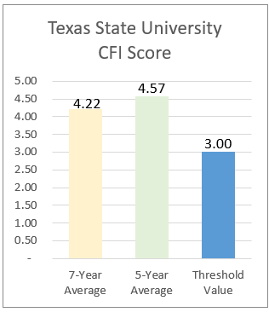
In conclusion, TXST has enough wealth and access to capital resources to finance its strategic plans and endure unanticipated financial challenges. It is imperative that we carefully manage debt and reserves in tandem with our plans to take on significant debt in the near future and use reserves to balance the budget over the next several years, and perhaps longer if we do not achieve anticipated enrollment growth or receive additional support from the Texas Legislature. TXST has sufficient financial strength to continue to pursue its aggressive plans for growth in total enrollment, improvements to student success, and the pursuit of becoming a Carnegie R1 University.

The Available Reserves Ratio
While the Primary Reserve Ratio used in the CFI measures the amount of funding we could access in an emergency, it includes funds that are often restricted to specific uses, making a significant portion of these reserves unavailable except in dire circumstances. For this reason, TXST uses Available Reserves as an additional measure of financial health, as detailed in University Policy Statement 03.02.01 and Financial Self-Assessment: A Workbook for Colleges. Available Reserves represents reserves as most people would use the term in that it excludes funds that are restricted in use. Our policy goal for Available Reserves is to maintain a ratio of 0.25 or 90 days of reserves.
As demonstrated in the chart below, TXST prior to 2020 had averaged an Available Reserve Ratio of 0.17 representing only 62 days of expense coverage. Since 2020, TXST has successfully achieved its goal of maintaining 90 days in Available Reserves, ending 2025 with 102 days or an Available Reserve Ratio of .28.

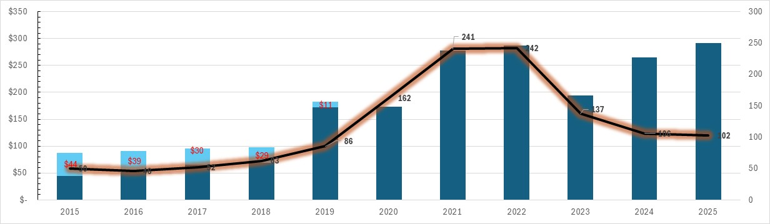
TXST Available Reserves 2015-2025

Putting this in context, TXST is an institution with over $2 billion in total assets. As such, 102 days of Available Reserves is still a large sum, $291,747,723 to be exact. This amount is not in a single account at TXST called “Reserves”. Rather, this amount is distributed across hundreds of operating units within the institution who have plans for these funds. TXST budget approved by the Board of Regents of the Texas State University System (TSUS) does include a single budget account called “Institutional Reserves” that is completely unallocated and is set aside for unexpected needs. The amount in that account is $2,500,000, or a fraction of one percent of our all-funds budget of more than $1 billion.

