Self-Service Z_MIGO Goods Receipt Instructions
At times, departments will need to use the SAP T-Code Z_MIGO to process the Goods Receipt (GR) data. The following are the situations when this action is required:
- The vendor delivers goods to your department directly.
- Your department picks up goods from the vendor.
- Materials Management delivers goods to your department with a Hand Receipt that does not reference the correct PO. In this case, there was no purchase order number included in the delivery from the vendor that is associated with the goods.
If you receive a delivery from Materials Management and the receipt references the correct PO from the vendor, you do not need to process a GR through Z_MIGO.
The instructions for creating a GR using SAP transaction Z_MIGO are:
Log in to SAP Transaction Code Z_MIGO: Enter the correct PO number.
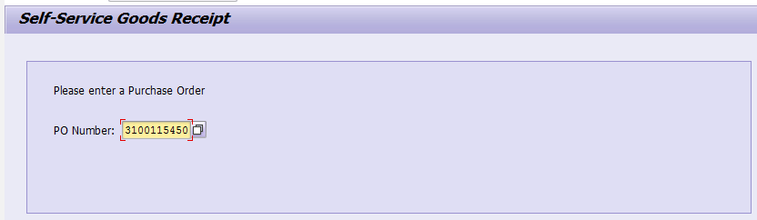
- After the PO is entered the following fields will auto populate (red arrows below).
- Posting Date: This date is the day you are processing the GR and may not be the actual goods receipt date.
- Name: The name of the person creating the GR document in SAP using Z_MIGO.
- Vendor: The name of the vendor data from the PO.
- Department: Department name of the person entering the GR data.

Date Item Received: Enter the actual goods receipt date (field with the blue arrow below). If you don’t know the actual date received, use your best estimate. This date is very important and must be as accurate as possible. It is used to determine the Baseline Date. Baseline Dates are what determines if the University complies with the Prompt Pay Act.
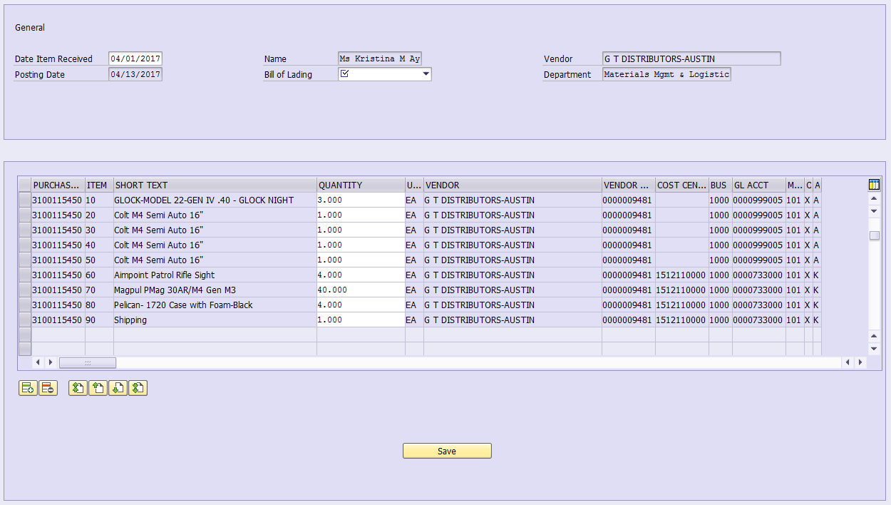
You cannot enter a future date in the Date Item Received field or you will receive the following error message:
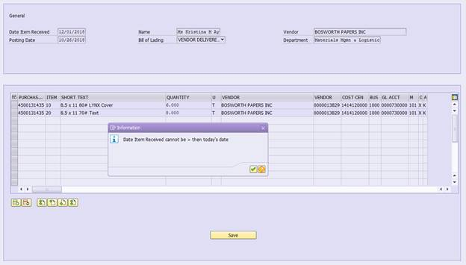
Bill of Lading: Select one of the following from the dropdown box (blue arrow below).
- Dept. Pickup
- FED EX
- Mail
- Other
- UPS
- Vendor Delivery
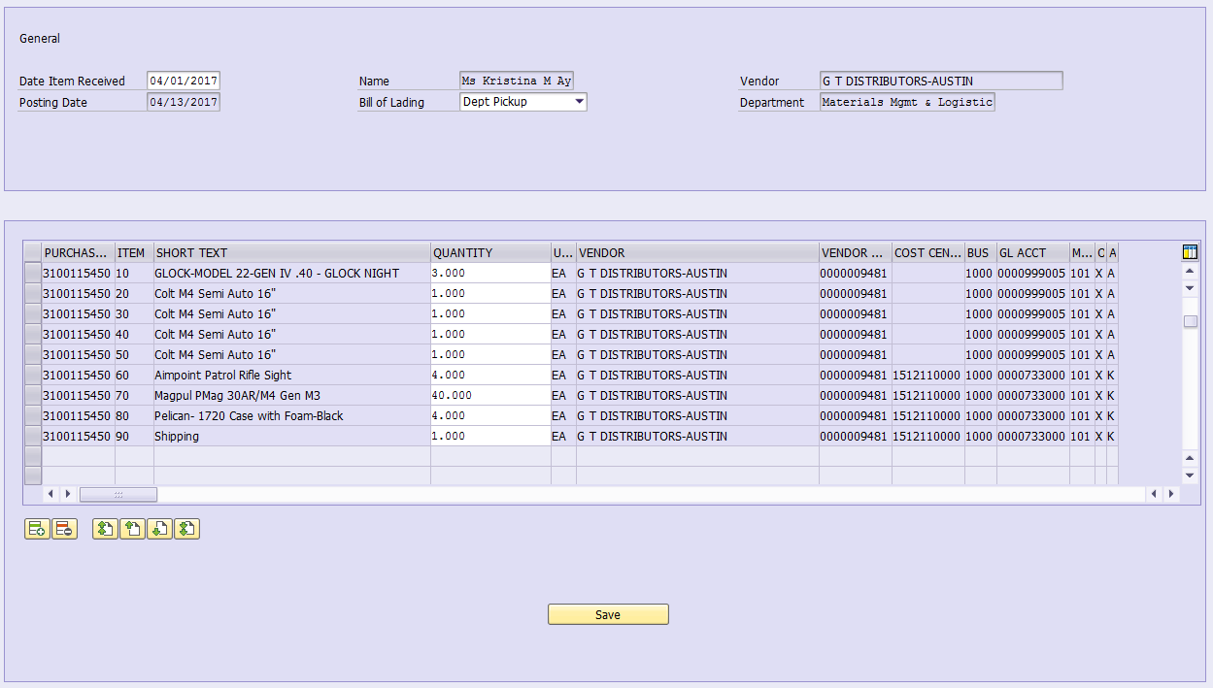
Select Lines: Select the line items for the goods that have been received.
- The quantity may be changed if not all items for that line are received. (See the screen shot below. The selected lines will be highlighted in orange.)
- If you need to delete a line selected in error as the goods were not received, then highlight the line and select the Delete Row icon (see the red arrow below).
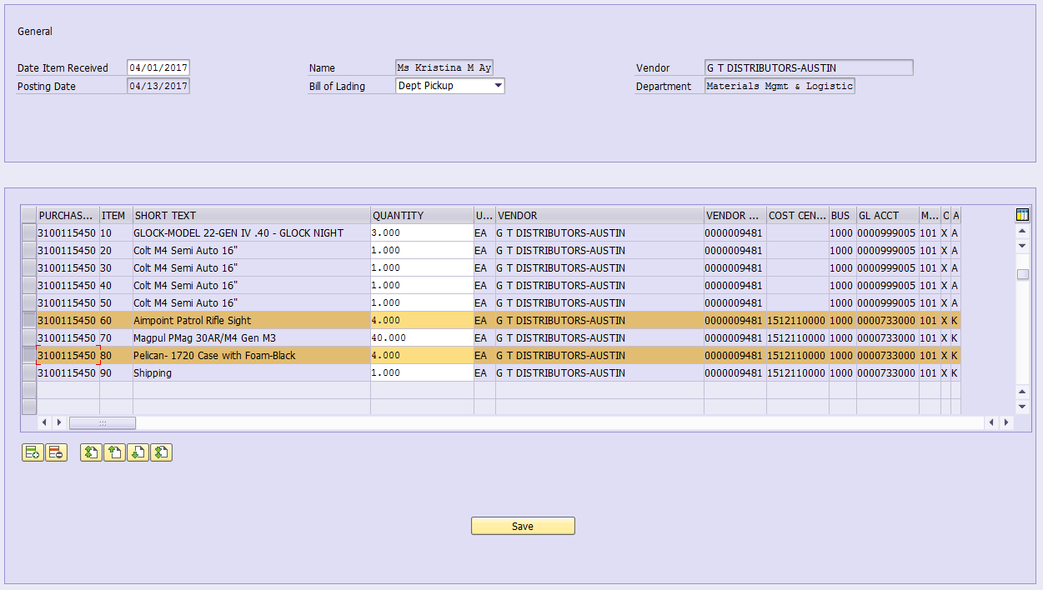
Click Save to post the transaction.
A material document number is assigned to a posted transaction.
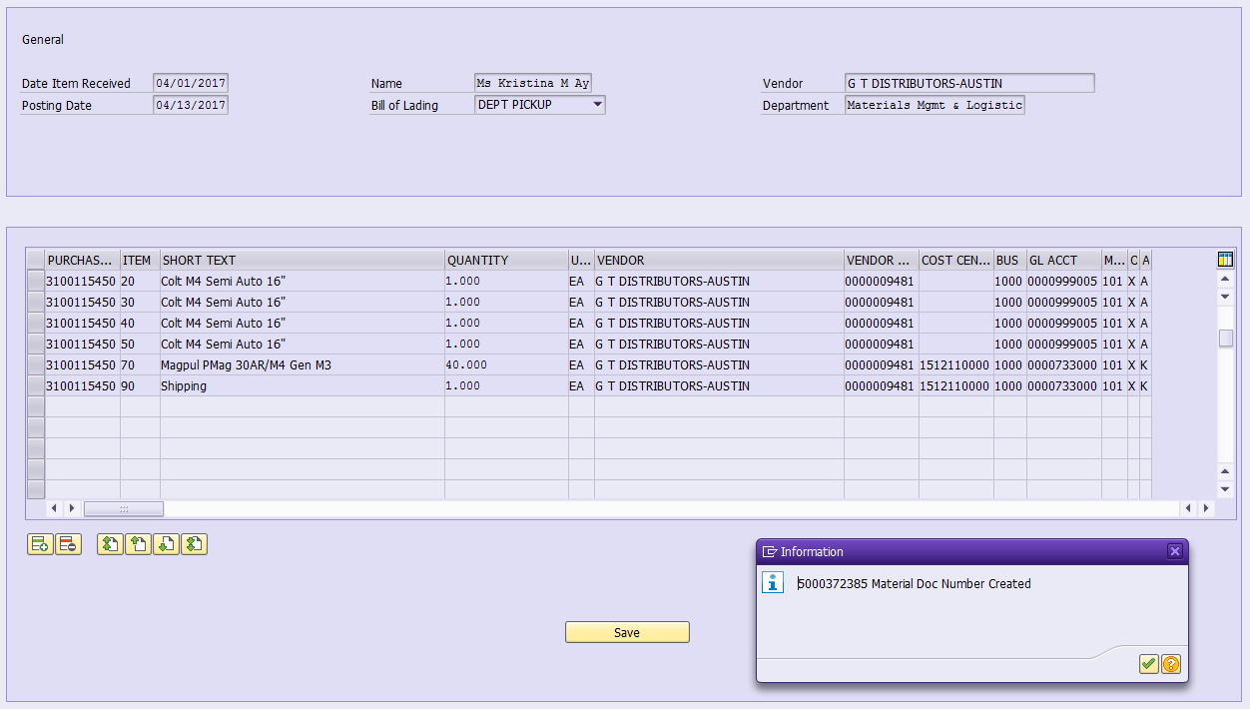

Receiving documents MUST be attached to GR prior to submitting the notification. SAP will assign the information in the Created BY and Created On fields. You do not need to enter those.
  - Packing Slip
  - Invoice or Receipt
  - Or word document stating why there is no supporting paperwork.
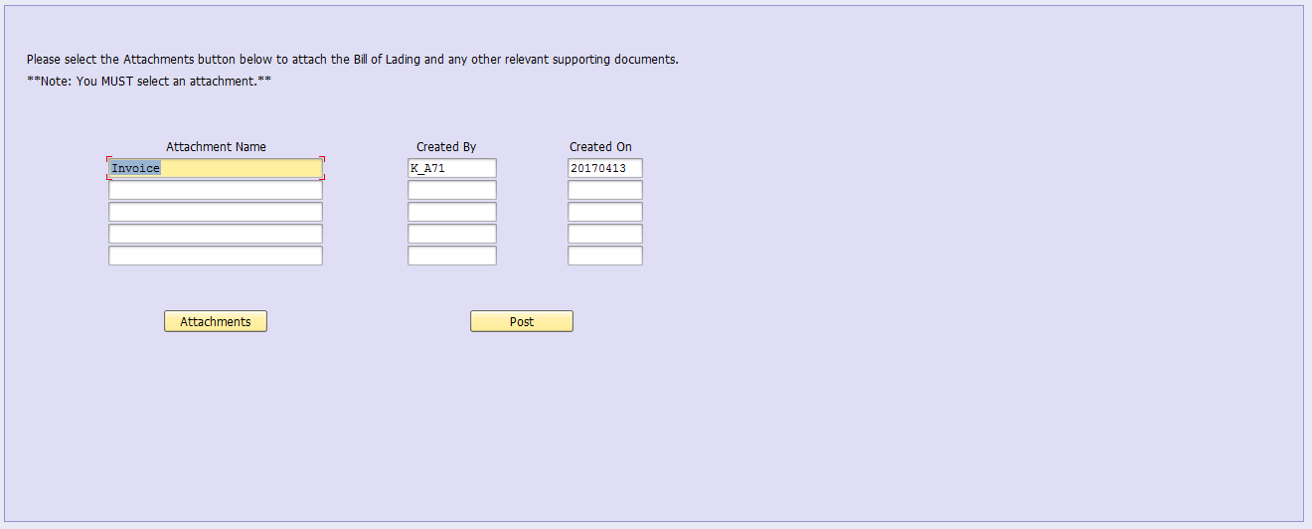
Click Post when attachments are completed. This adds the GR to the PO History. AP can process an invoice and pay once the invoice is received for the GR document.

Suspend GR Delivery E-mail Notifications

Go to transaction Z_MIGO to Suspend GR delivery e-mail notifications:

.

Enter the SAP invoice document number from Purchase Order “History Tab”:

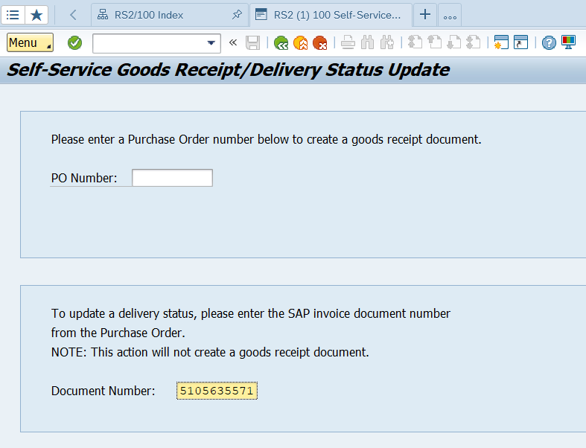.

Enter a delivery “delay” reason (from the dropdown list) and an estimated delivery date. Please enter “other” if you just haven’t received the items yet:

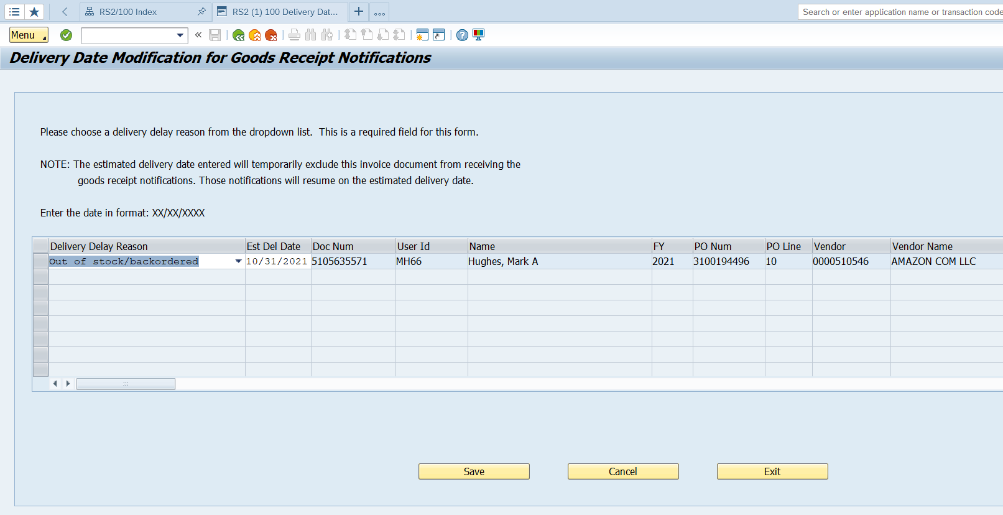.

Hit save and the following message will pop up:

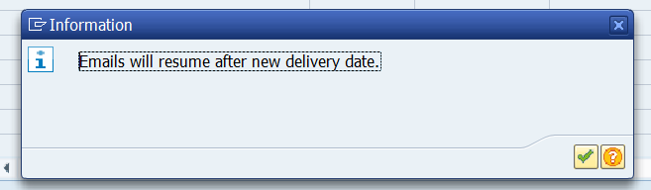.

If you still haven’t received the items or resolved an issue by the estimated delivery date you can go back into Z_MIGO enter the same invoice document number and a new estimated delivery date, and this will continue to suspend the GR delivery e-mails until a Goods Receipt (GR) is done or another reason and estimated delivery date is entered.

