Department Charge Adjustment Uploads

Departments will now be responsible for uploading their own charge adjustments to student accounts in Banner. This guide explains how departments may complete this process using GJAJFLU and TZS0058.
- Create your list of charge adjustments in an Excel spreadsheet. Make sure to use the following format:

STUDENT ID, TERM CODE, DETAIL CODE, AMOUNT

Do not include any additional text, notes, or headers in your spreadsheet. Make sure the AMOUNT column is in number format.

Example spreadsheet:
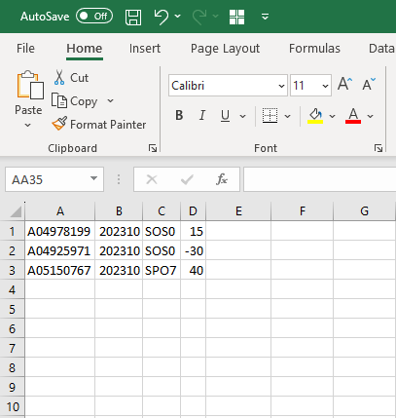

Term Code Key:
Year10 = Fall of year prior (202310 = Fall 2022)
Year30 = Spring
Year50 = Summer

Save the spreadsheet as .csv and use a short, simple naming formula.
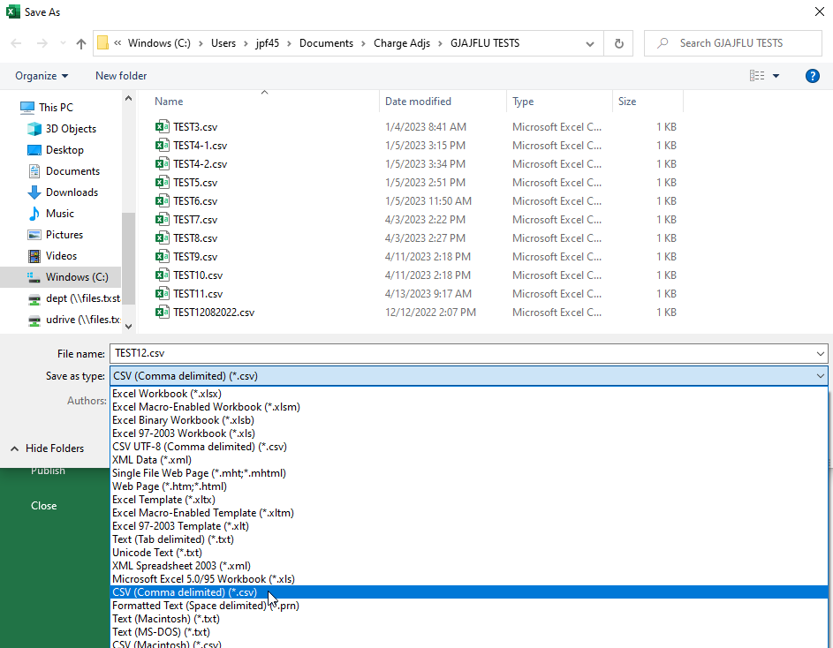
EX: BANDUNIF202330.csv

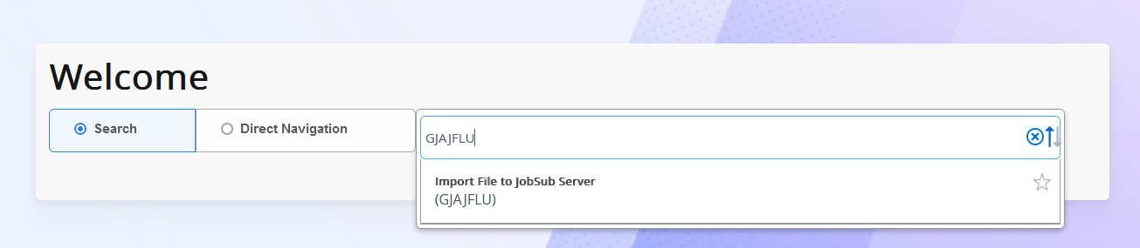
- Log in to Banner and type GJAJFLU into the search bar. Banner login link: https://sis.txstate.edu/applicationNavigator

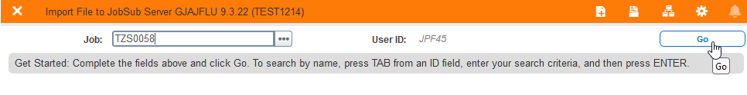
- Type in TZS0058 into the Job textbox and click Go.
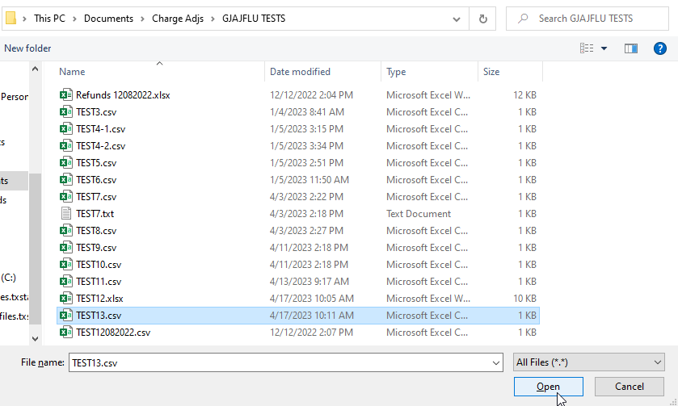
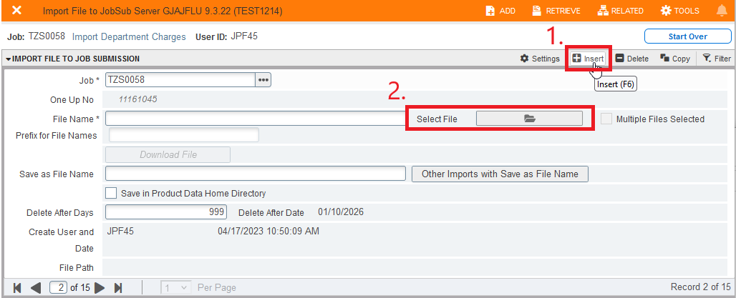
- On the next page, click the Insert button at the top. Then, click the Select File button and choose the file you wish to upload.

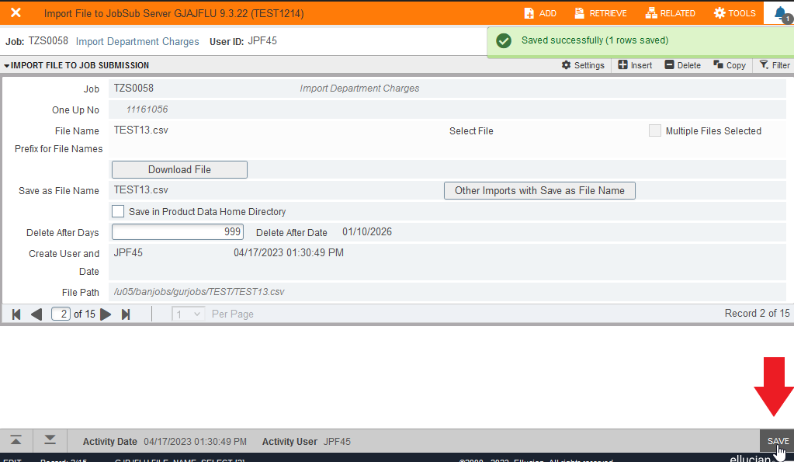
- Once you have selected your file, click Save at the bottom right side of the screen.

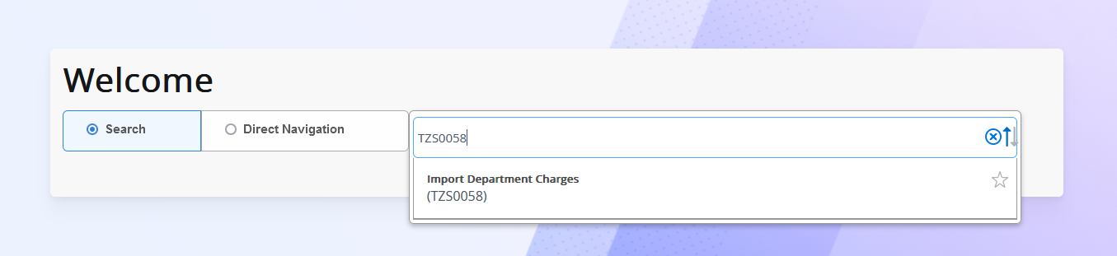
- Click the X on the top left to close out of GJAJFLU. Type in TZS0058 into the Banner search bar and click Go on the next screen.
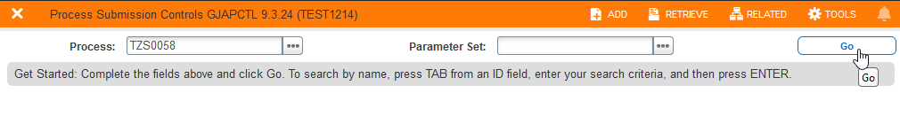

- Type your file name into the Values box on line 01 exactly as you named it, including the .csv ending. Type the letter “U” into line 02.
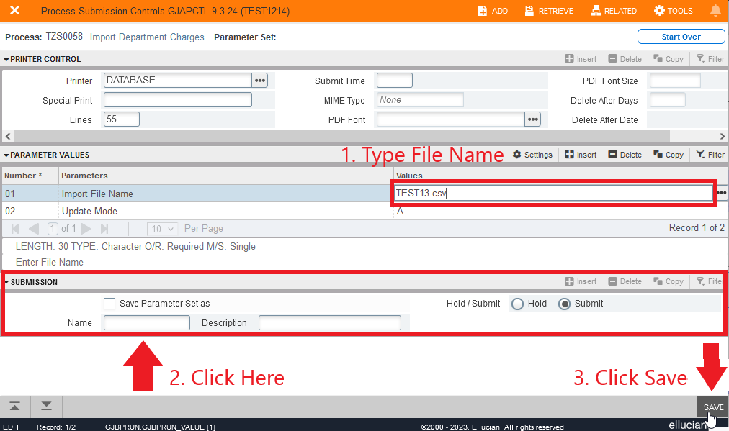
Before clicking save in the lower right corner, you must click anywhere in the Submission box at the bottom first. The job will not let you save unless you do so.

- Once you click save, you will receive an email to your Texas State email address showing you the output of the upload. On the output, any lines with errors will be displayed along with the reason for the error. Lines with no errors will not be shown. See below example:
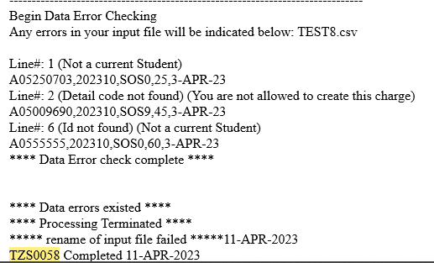

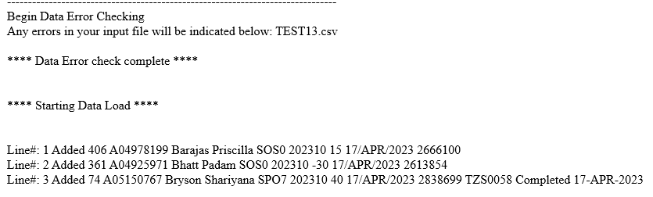
- If your file was found to have errors, NONE of the charges will be loaded to student accounts and the job will automatically abort the upload. Correct the errors in your source file and repeat the process again from Step 2. You can keep the same file name when you re-upload it, as it will be overwritten. If your upload had no errors, then the email will display all of the lines from your upload file as successfully added to the student accounts.

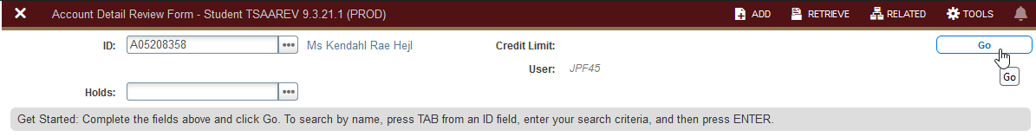
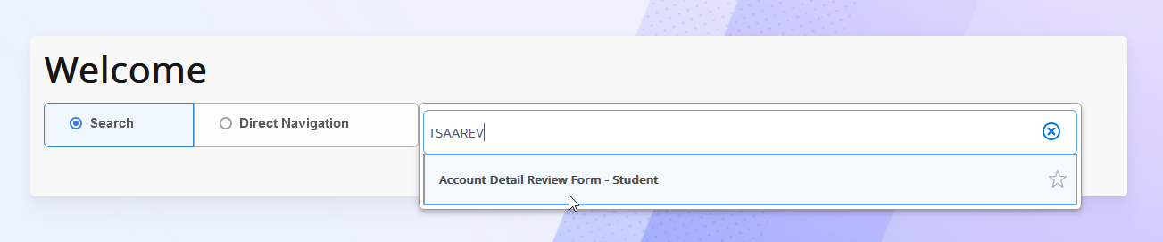
- To double check that your charges were successfully added to the student accounts, type TSAAREV into the Banner search bar and enter some of the student IDs from your uploaded list.
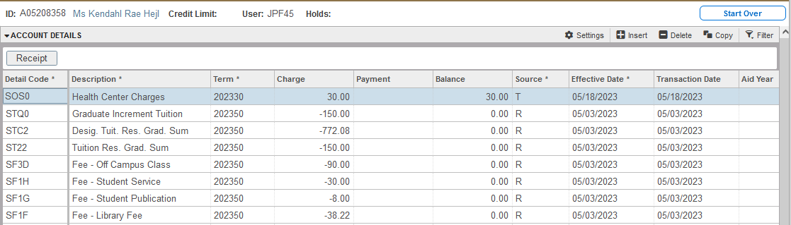
The top-most line item should be the charge you just added, and will have today’s date listed in the Effective Date column. This means your charge is now on the student account.

