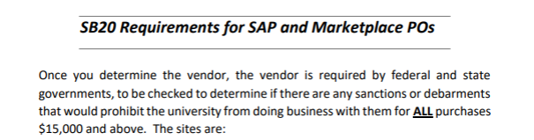

There is a total of 4 Senate Bill 20 (SB20) Documents that must be attached to your requisition or eNPO at issuance. Not after the fact.
This is from the Texas State Legislation and is an Audit Compliance Requirement.

Copy and paste each hyperlink in your browser to open:
https://mycpa.cpa.state.tx.us/coa/ Franchise Tax
Designated Foreign Terrorist Organizations (XLSX) — Updated December 2025
Scrutinized Companies in Countries of Concern (XLSX) — Updated December 2025
Chinese-affiliated Entities (XLSX)

In your vendor search:
Franchise Tax: If your vendor search states, “no vendor found”, SAVE that look up as PROOF of the vendor not being found and attach to the requisition.
See User Guides for Attaching a Document.

https://mycpa.cpa.state.tx.us/coa/ - Franchise Tax

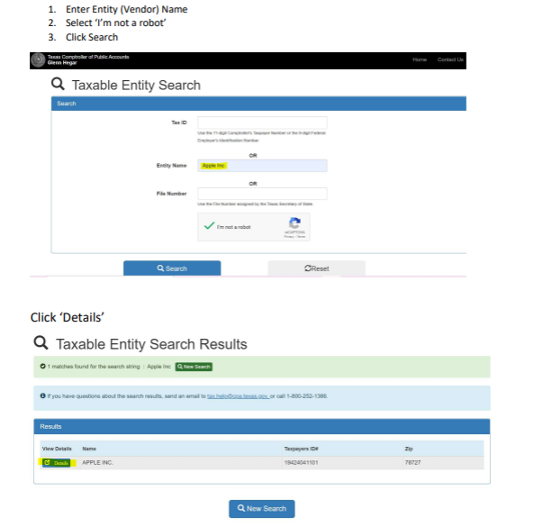
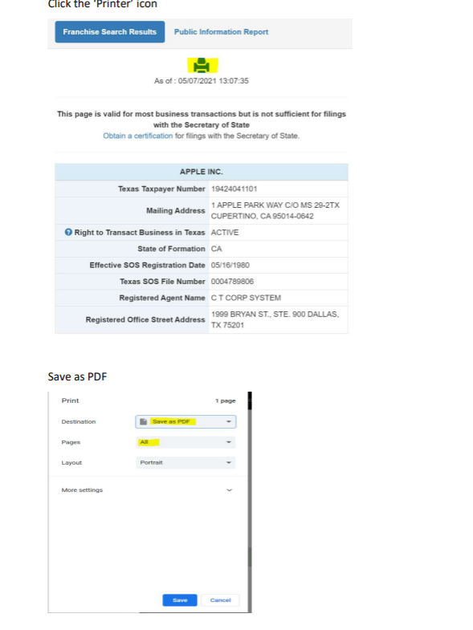

Designated Foreign Terrorist Organizations (XLSX) — Updated December 2025
This is what the document should look like. Simply save the Excel document as a PDF.

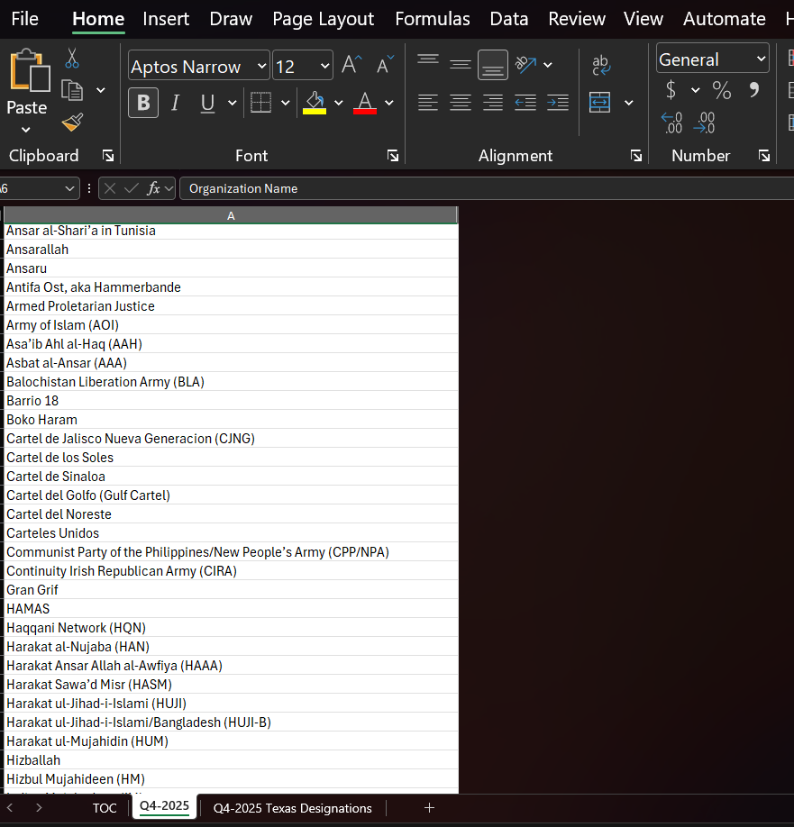

Scrutinized Companies in Countries of Concern (XLSX) — Updated December 2025
This is what the document should look like.
* Due to the size of the file, departments may attach and save a partial PDF copy of the Excel document.

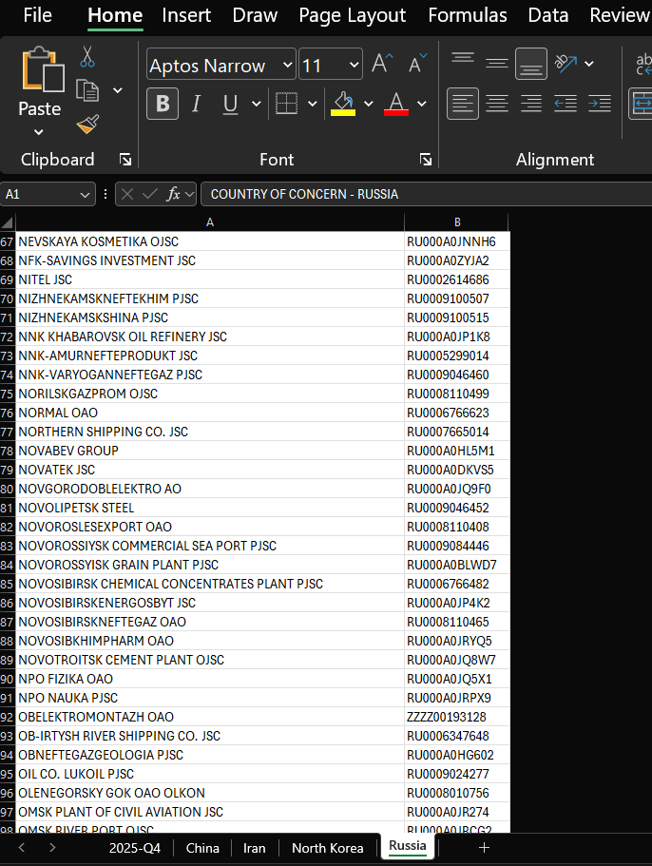
Chinese-affiliated Entities (XLSX)
This is what the document should look like. No special Instructions are required; simply save the Excel document as a PDF.

