We Are What We Drink: A Bobcat’s Guide to Campus Water Resources

Learning Objectives:
Students will be able to describe the basic mechanics of the Edwards Aquifer and how the Texas State and San Marcos communities rely on it as a source of water. Students will also be able to explain how human behavior can be connected to drought conditions, as well as name examples of actions that can be taken on an individual level to conserve water on campus.

Delivery (Presentation Notes):
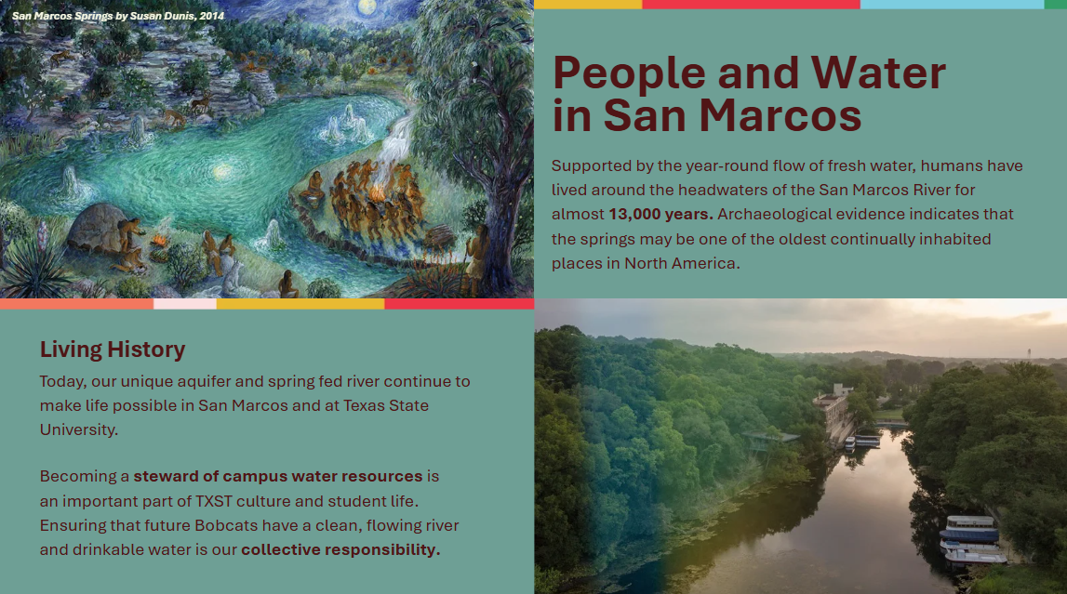 | People and Water in San Marcos  This slide serves as an introduction to the relationship between humans and water in San Marcos. Instructors should emphasize that humans have relied on the water of the river and springs for 13,000 years, acknowledging the long-term presence of indigenous peoples like the Coahuiltecan culture in the region. Begin the conversation by framing students as a part of this ancient history of stewardship.
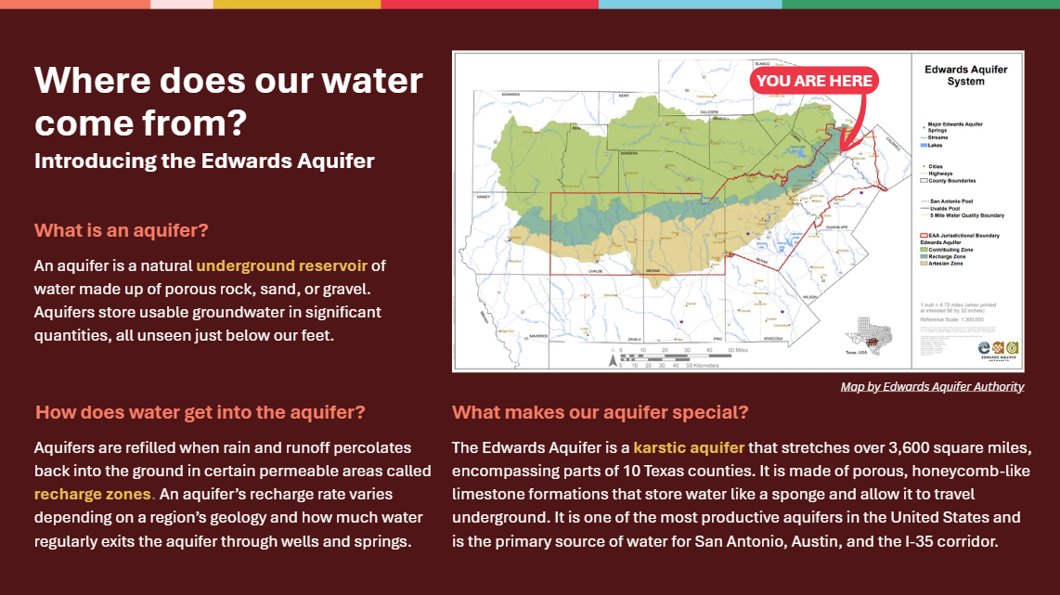 | Where does our water come from?  This slide begins with a basic scientific explanation of how the Edwards Aquifer works. Subsections are organized sequentially, so that discussion begins with a definition of all aquifers and how they are filled with water before identifying what makes the Edwards Aquifer unique. Instructors should refer to the map to illustrate the scale of the aquifer, pointing out San Marcos as well as the urban areas of San Antonio and Austin.
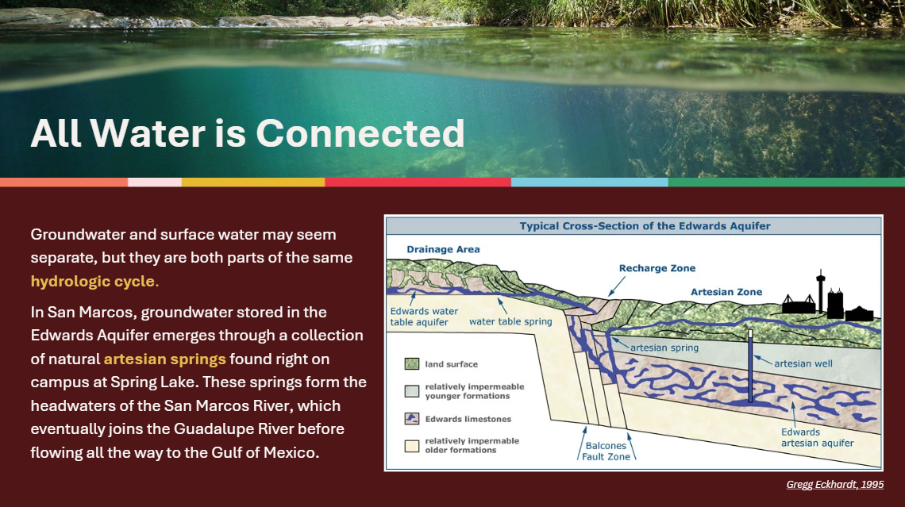 | All Water is Connected  While the aquifer may be invisible beneath our feet, this slide emphasizes the cyclical and interconnected nature of all water resources. Instructors should explain how the Edwards Aquifer is the origin of the San Marcos River, utilizing the diagram to show how water moves from drainage areas into the aquifer and up through artesian springs. The central point of this slide is to show how actions on the surface impacts groundwater and vice versa.
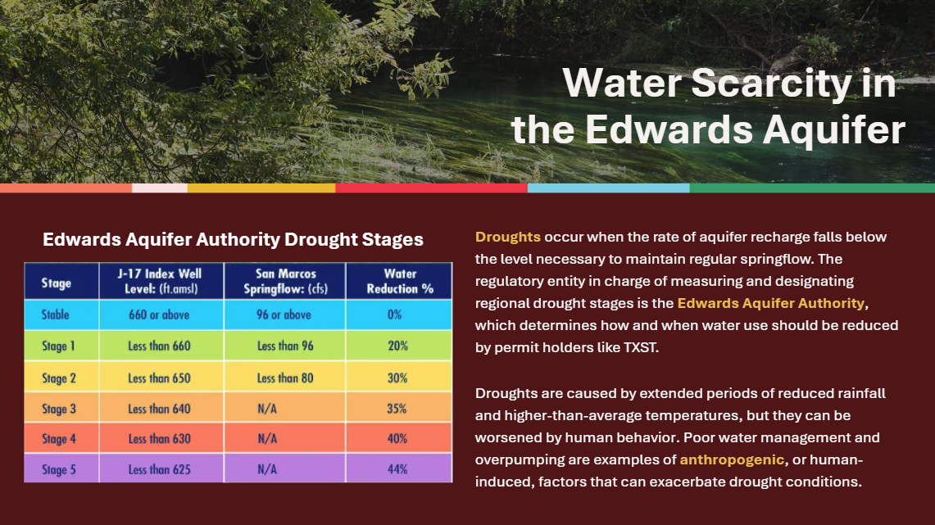 | Water Scarcity in the Edwards Aquifer  After going over how the Edwards Aquifer functions under optimal conditions, this slide introduces the concept of droughts and drought stages, which serve as regulatory tools for the Edwards Aquifer Authority in order to limit water consumption in times of scarcity. While students do not need to know the details of each drought stage, the chart is present on the slide to provide a visual for the varying levels of drought conditions. “Anthropogenic,” is the key word on this slide, highlighted to show how though drought can be natural it is also worsened by human influence.
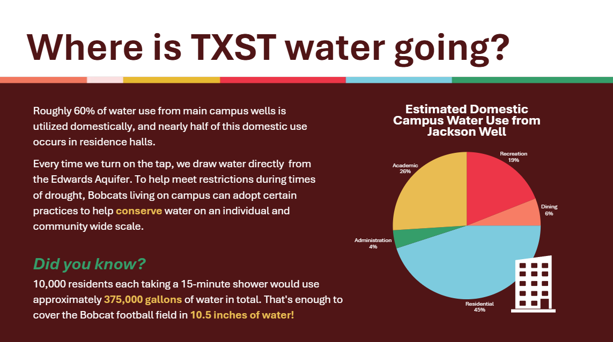 | Where is TXST water going?  This slide focuses on how Texas State University in particular interacts with the Edwards Aquifer, and features a pie chart breaking down the proportions of domestic water use on campus. Water use in residential halls is highlighted to connect the goal of water conservation to first year students specifically, since those living in on-campus housing will not have separate utility bills to gauge how much water they consume. Instructors should use the graphic and “Did you know?” section to contextualize for students their individual water footprints.
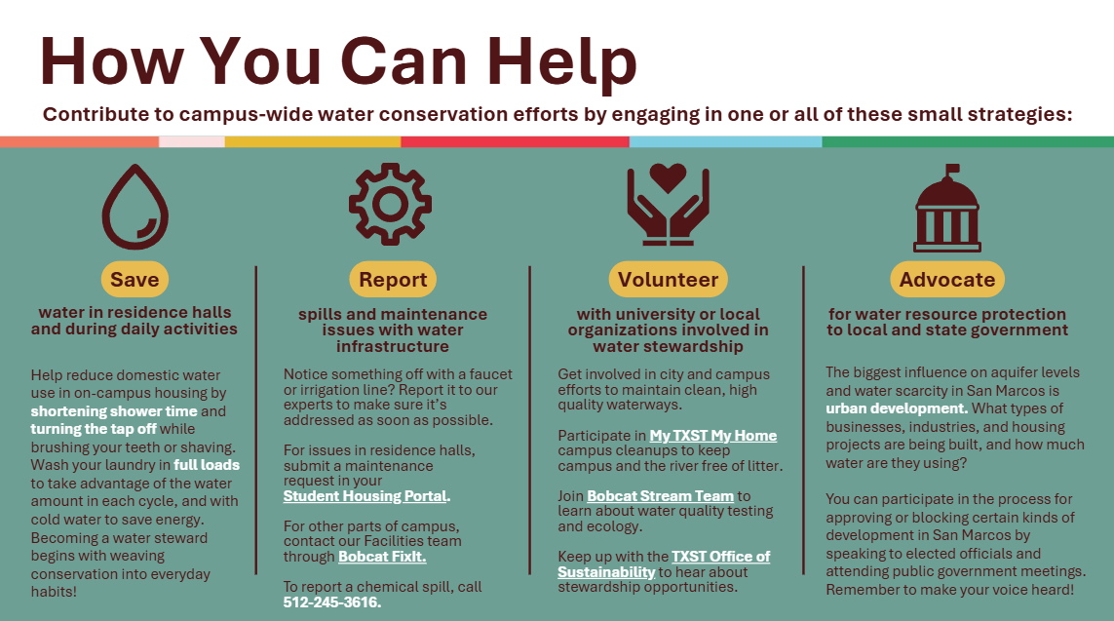 | How You Can Help  This slide provides four categories of strategies that students can participate in to further water conservation as a first-year Bobcat. Instructors can walk the class through each one, clicking on the links embedded in the underlined words to show students how to navigate maintenance requests and university websites. Instructors should also note how each category addresses a different scale of water conservation, from individual to participation in broader governance, emphasizing the need for a combination of action on all different scales.
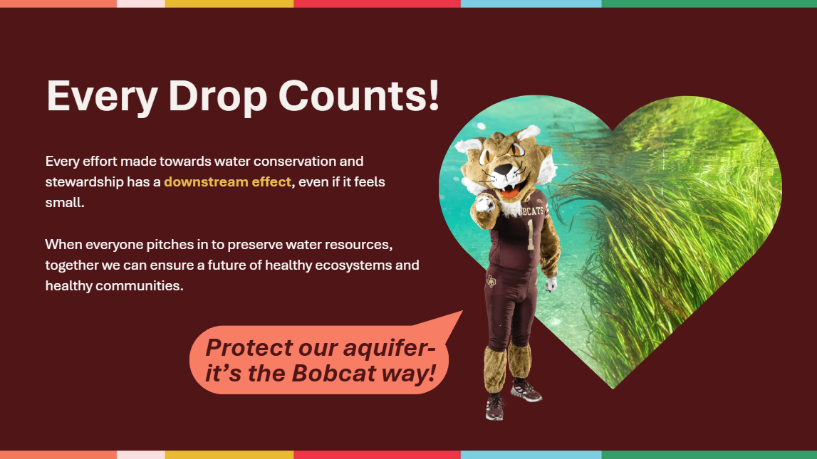 | Every Drop Counts!  The presentation concludes with a call to action intended to leave students with a sense of optimism and responsibility about the future of water conservation at TXST. Instructors should impress upon students that TXST, the San Marcos River, and the broader city community all rely on the region’s unique water resources, and are thus uniquely united in ensuring their care and conservation. Students should feel by the end of the presentation that consideration for water resources is an integral part of student life and local culture.

To accompany the water resources presentation, instructors may choose one of the following two activities to encourage class engagement with material, both of which utilize digital educational outreach material provided by the Edwards Aquifer Authority. To complete the activity, students may use their own devices or share one amongst themselves.

Activity 1: Mapping the Edwards Aquifer
On a projector or whiteboard, open this map of the Edwards Aquifer and have students follow along on their own devices as you point out which part of the region is labeled as a Contributing Zone, Recharge Zone, and Artesian Zone. Encourage students to familiarize themselves with the map by zooming in and out of different areas and clicking on the different colors to see what each one means.
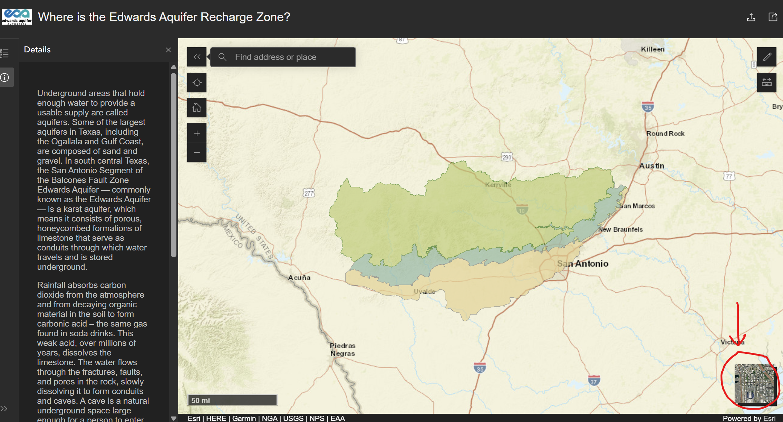
Together with the class, navigate to the bottom right corner of the screen (as shown above) to click on the function that superimposes satellite imagery onto the aquifer map. Have them zoom into different areas of the Recharge Zone delineated in blue.
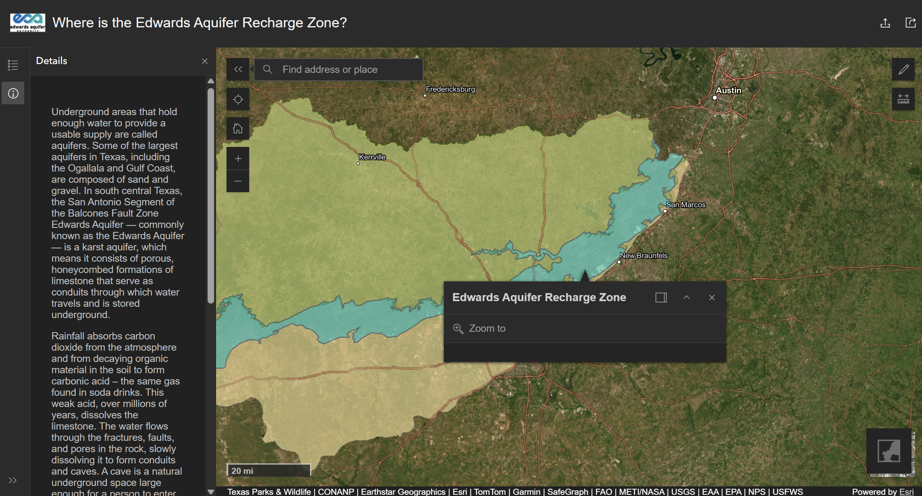
As students explore, pose the following questions for them to discuss in partners or groups based on their observations from the map, giving them about 5 minutes to converse before bringing it back to a central class discussion to learn what students have been brainstorming.
- What kind of human-made (anthropogenic) modifications to the environment do you observe within the Edwards Aquifer Recharge Zone?
Answers to look for: Mining (around Comal County), new housing developments (in Bexar County)
- Of these modifications, which ones do you think might have the biggest impact on water recharging the aquifer? Why?
Answers to look for: anything related to increase in pavement and urbanization. Increasing construction of impermeable surfaces like asphalt from roads and parking lots prevents water from being able to drain back into the ground and reach the aquifer.
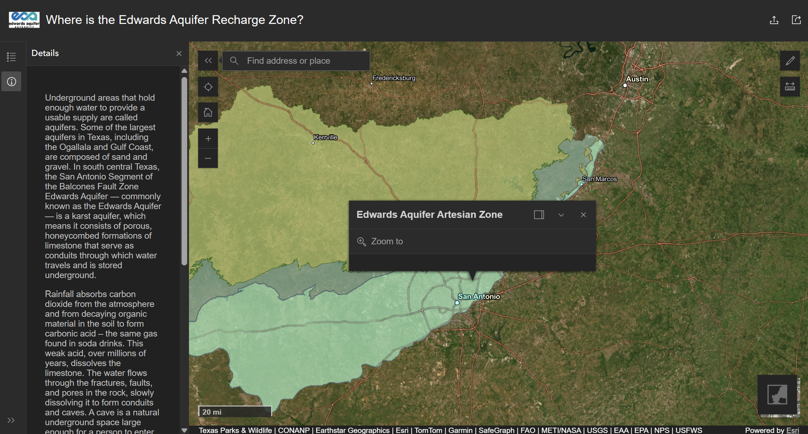
After the short class discussion about the Recharge Zone, orient the conversation to focus now on the Artesian Zone. In a similar vein, ask the students to explore satellite imagery within the Artesian Zone on the map and discuss amongst themselves the following questions:
- What type(s) of anthropogenic activity do you observe within the Edwards Aquifer Artesian Zone?

Answers to look for: dense urban and suburban living, roads and highway systems, industry and business

- Of these activities, which ones do you think might have the biggest impact on water levels in the Edwards Aquifer?
Answers to look for: municipal water use, anything related to commercial or residential water needs

Activity 2: Drop in the Edwards Aquifer
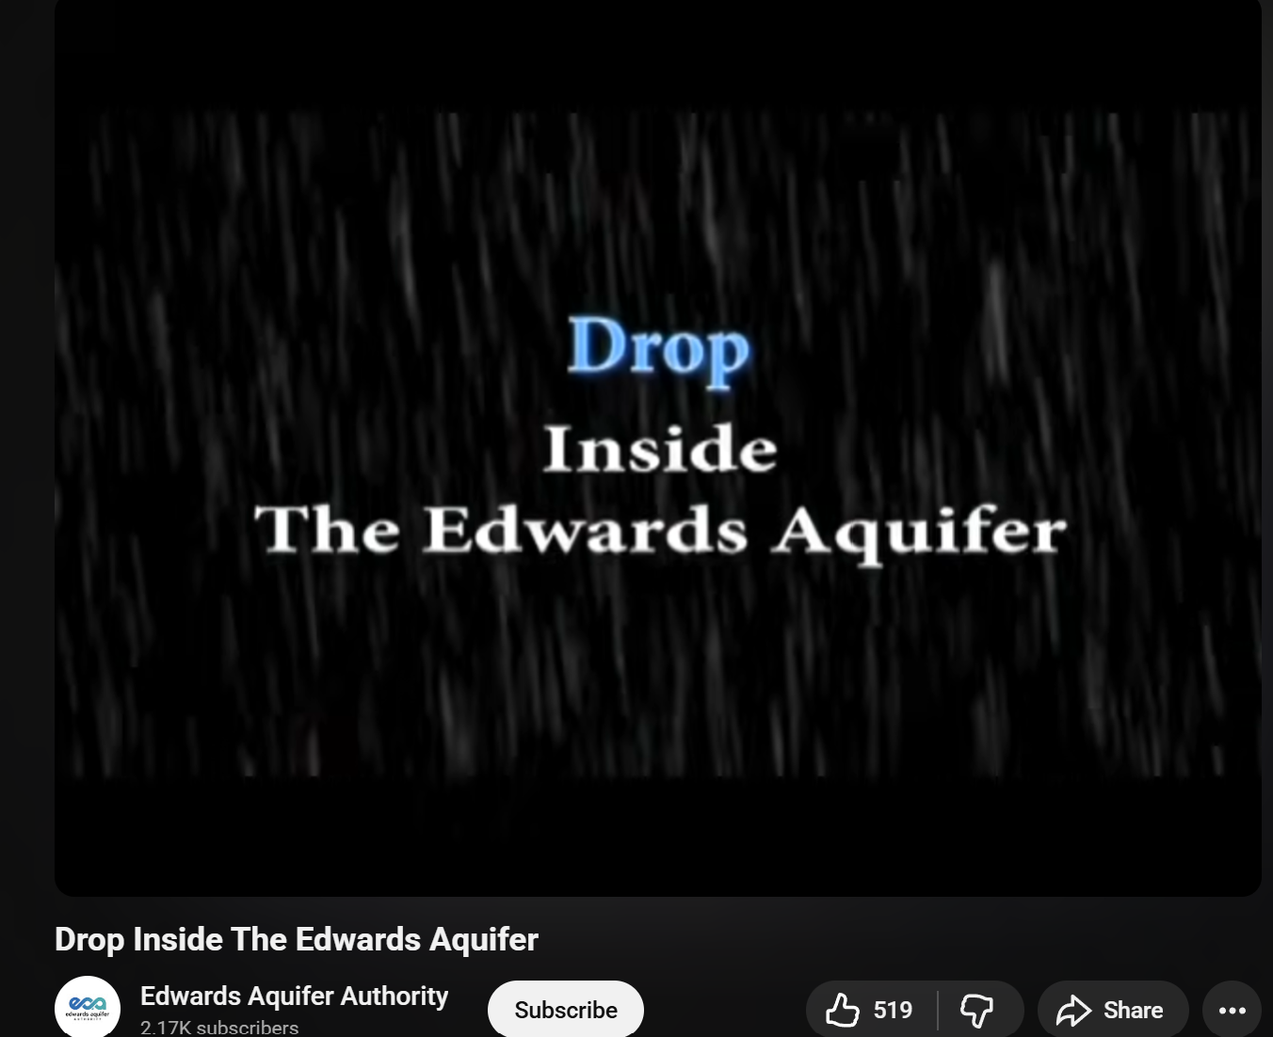
Have the class watch this video from the official Edwards Aquifer Authority YouTube channel. After watching, organize students into groups and ask that they brainstorm a list of five activities in their daily lives on campus that use water.
After allocating about five minutes for students to brainstorm water consumption activities, have a representative from each group write their top activity on a whiteboard, ensuring that there are no repeats between groups. Then as a class, rank each activity from highest to lowest impact in terms of the quantity of water they believe is used by each activity.
Example:
High Impact > showering___
____________
____________
Low Impact > leaving lights on
Keep in mind that there is no “concrete” way to rank each activity, the goal is simply to encourage students to think about where water use is integrated into their daily lives beyond just drinking and showering. Encourage students to think not just about how water is used on a primary level (where they see water running from a faucet themselves), but also on a secondary and tertiary level (such as water used in mining, energy production, or computer data storage).
When the class has agreed on a list, facilitate a short class discussion about the results using the following questions as the lesson concludes.
- Is there something on the class list that you didn’t initially imagine to be connected to water use? Why do you think that is?
- How is conserving water at home different from doing so as a student in San Marcos? Is it easier? Harder?
- What motivates (or doesn’t motivate) you to try different water conservation strategies? What kinds of barriers are there for students to save water on campus? What kinds of incentives are there?
- When it comes to water conservation, where do you think the line is between individual responsibility and collective or systemic responsibility? Is there a line at all?

