Our Habitat, Our Home: Endangered and Endemic Species of the Edwards Aquifer

Learning Objectives:
Students will be able to explain the difference between native and invasive species, as well as the difference between endemic and endangered when it comes to describing a species’ ecological versus federal protection status. Students should name the five protected endemic species of the San Marcos River, and name some basic behaviors at riverside parks that are required to engage in their conservation.

Delivery (Presentation Notes):
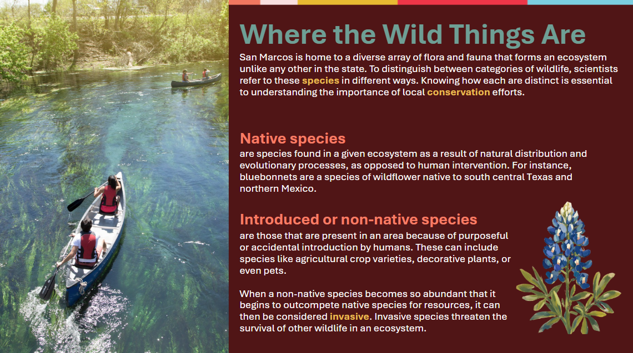 | Where the Wild Things Are  Before delving into the specifics of San Marcos ecosystems, this slide reminds students of the difference between native and non-native species. Note that not all introduced/non-native species are invasive, but that invasive species are a specific kind of overpopulous and competitive introduced species.
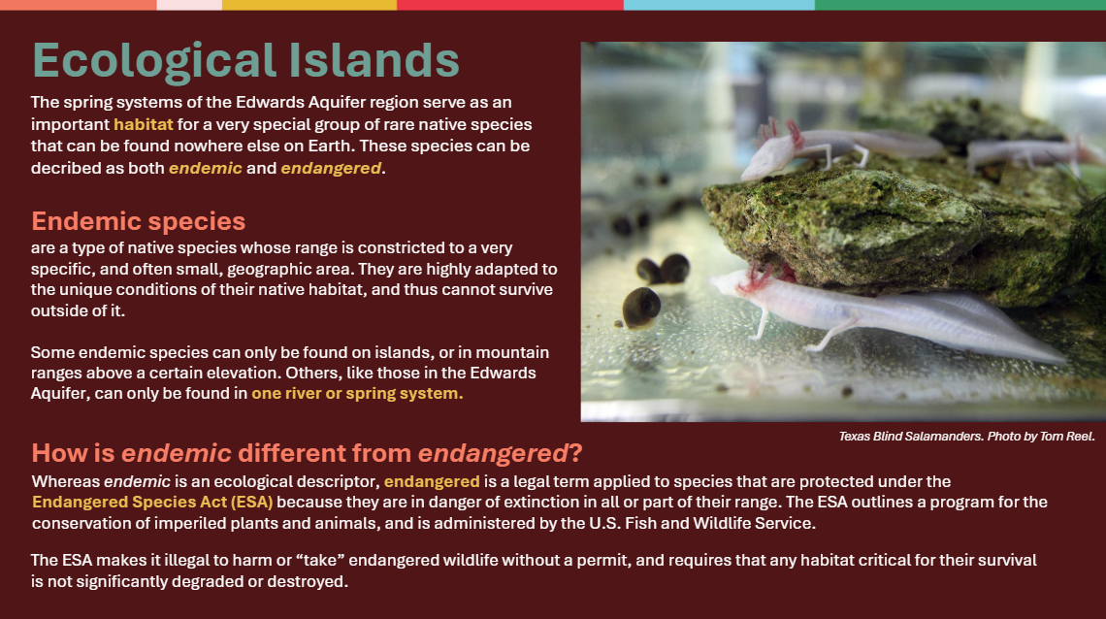 | Ecological Islands  Narrowing the topic down further, this slide introduces the two most important terms in the lesson – endemic and endangered. Emphasize that although these terms sound similar and are often used together, they have different meanings. Distinguish that although all endemic species are native, endemic is used often specifically in the context of species which are found in very small geographic contexts because of their extremely unique adaptations to their home environment. To build off existing student knowledge, consider asking students if they can name any other endemic or endangered species, or where they have heard the terms used before.
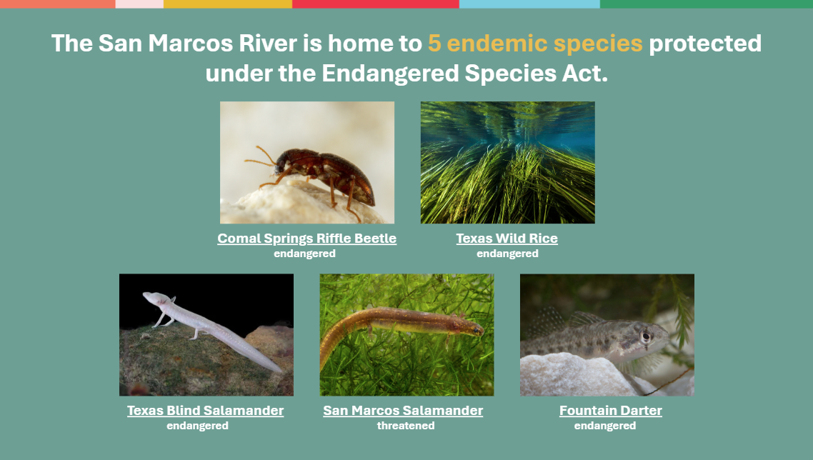 | San Marcos Species  This slide introduces the five species of the San Marcos River that are federally protected by the Endangered Species Act. Each underlined name is a clickable link to the species’ profile in the US Fish and Wildlife Service endangered species database, which highlights details about their behavior and native range. Click on a few of the links to encourage students to explore these pages on their own.  Note to the class that all species are listed as endangered with the exception of the San Marcos Salamander, which is categorized as threatened. Explain the difference is that threatened species are not actively endangered, but are likely to become endangered in the foreseeable future, and are therefore subject to federal protections that are slightly less stringent than endangered species.
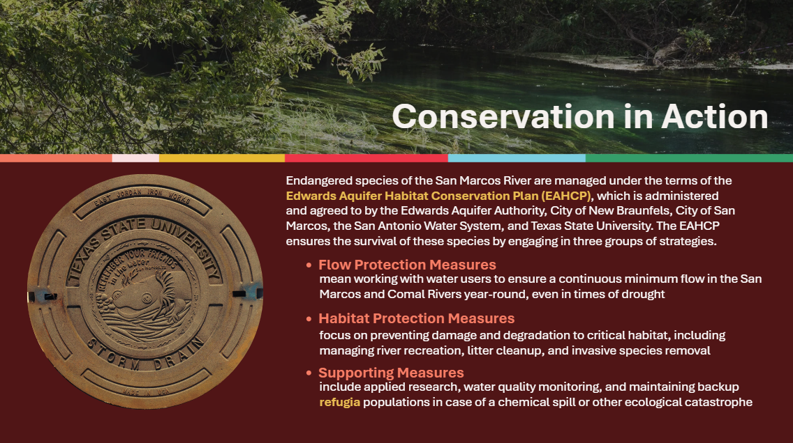 | Conservation in Action  This slide transitions to an explanation of how endangered species in San Marcos are being conserved by the Edwards Aquifer Habitat Conservation Plan. While it is not necessary for students to remember the details of the EAHCP, this slide serves to show how various entities including Texas State University are enrolled in preserving the endangered species populations in the San Marcos, a fact which forms a bridge to student investment in conservation in the following slide.
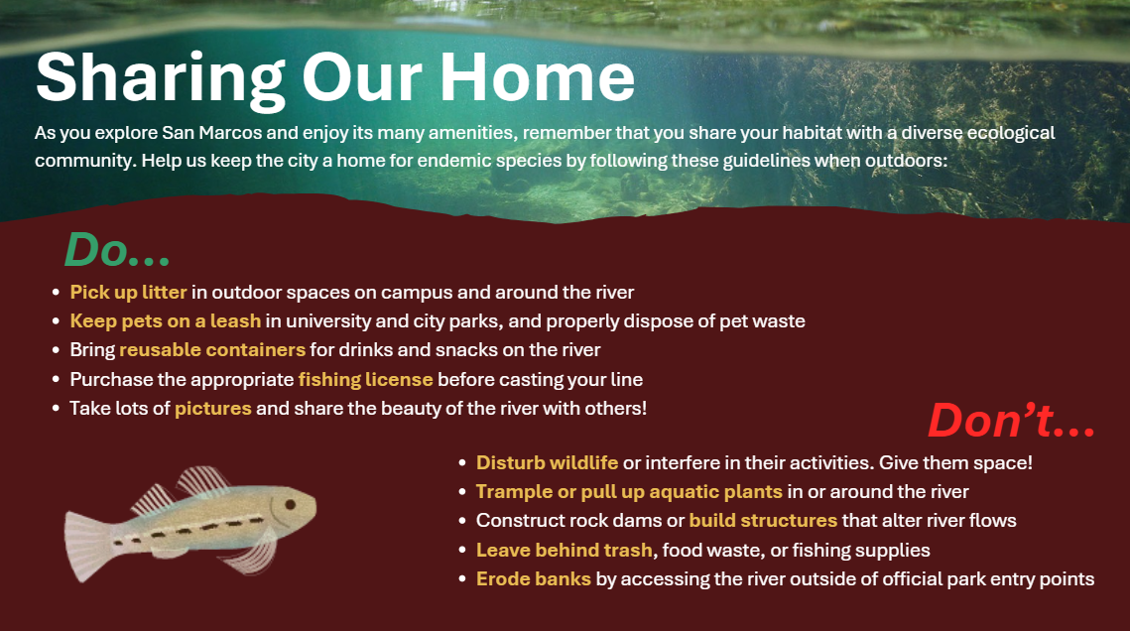 | Sharing Our Home  The last three slides highlight student responsibilities and actions in relation to endangered species conservation. Go through each “do” and “don’t” with the class, explaining that although it may seem that riverside parks are catered towards human recreation, they are also the habitats of a variety of native wildlife (endangered or otherwise). Emphasize that what may seem like a small infraction in the moment (like one piece of litter) can build up to cause significant problems when hundreds of parkgoers partake in it, which is why it is important to follow park etiquette.
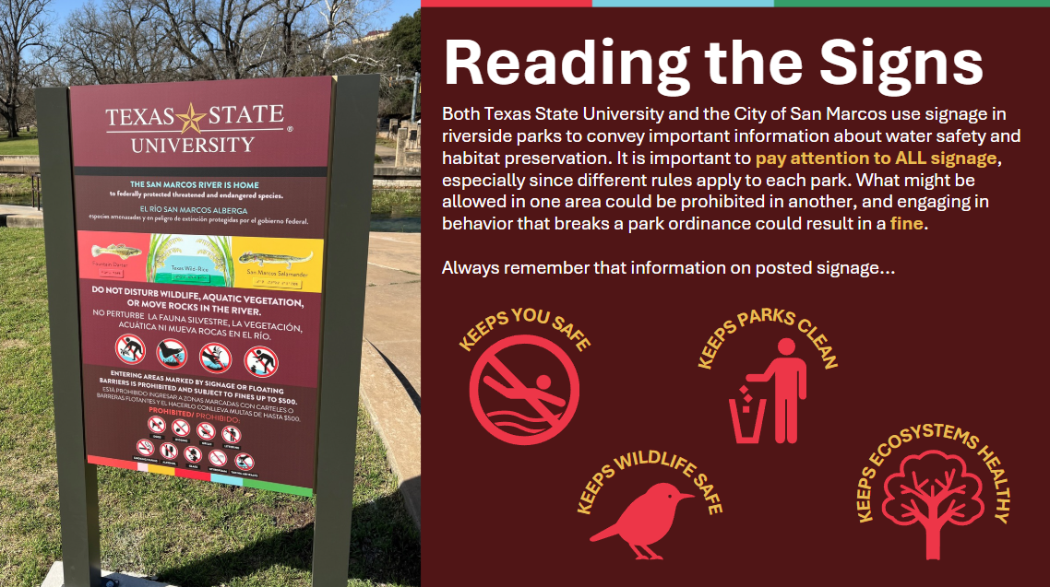 | Reading the Signs  While the previous slide offers general recommendations for all parks, this slide highlights the importance of paying attention to the more specific regulations of each riverside park, which are posted on signage across TXST and CoSM properties. Stress to students that it is important to read all park signage because of varying regulations, and because rules may be different even within the same park depending on where a person is in relation to the river.
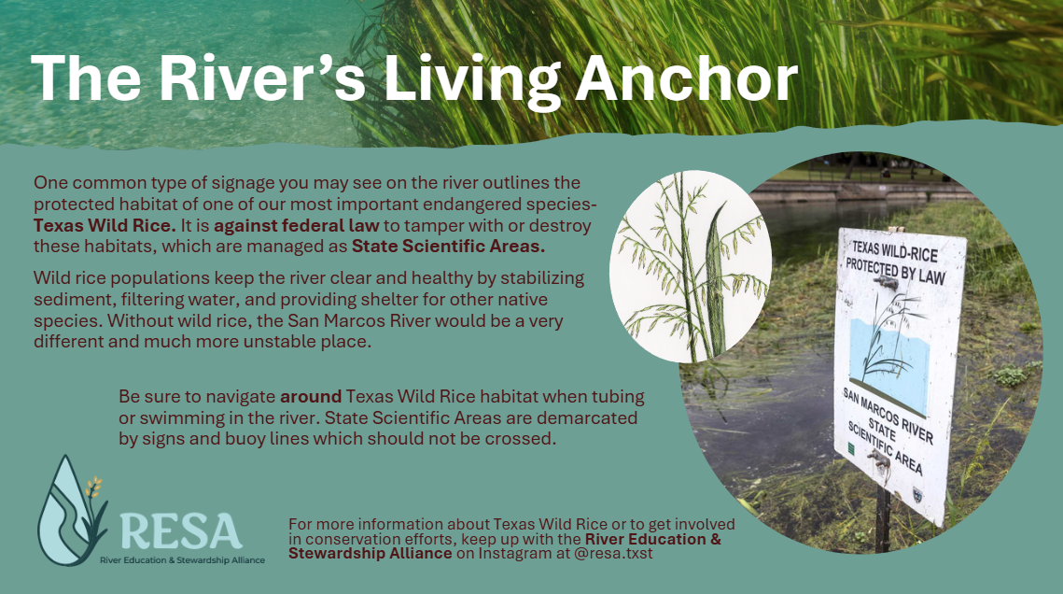 | The River’s Living Anchor  This slide centers a specific type of signage that is most relevant for rivergoers and students who may be tubing or swimming. State Scientific Areas set aside for Wild Rice Habitat are places that are among the most sensitive and exposed to river recreation. Stress to students the importance of respecting these areas and all places where wild rice grows, even if they may be tempted to trample or rip up the grass which is sometimes mistaken for weeds. Frame the wild rice as an essential part of what keeps the San Marcos River a destination for tourism and enjoyable for students.
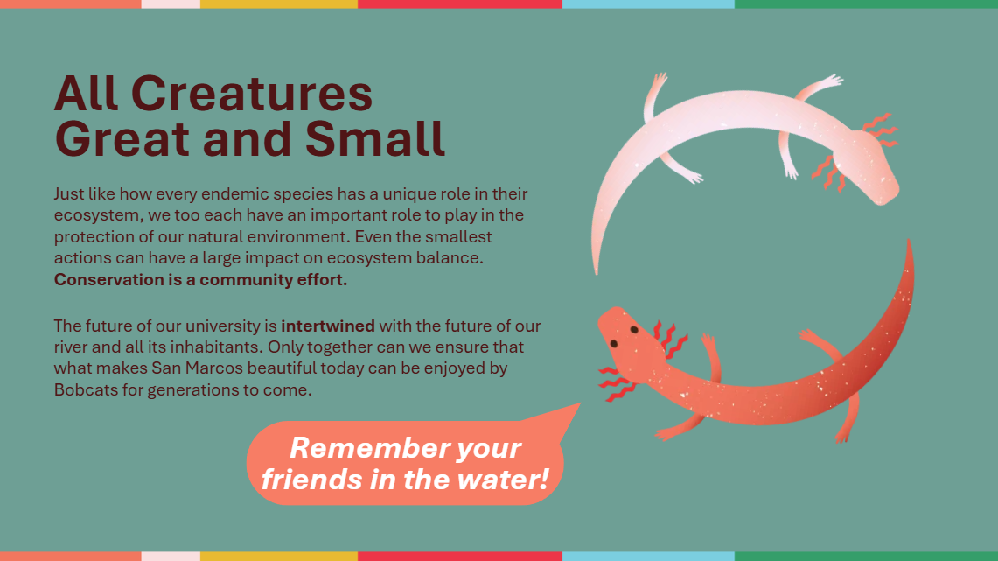 | All Creatures Great and Small  The final slide of the presentation leaves students with a call to action, asking them to remember in their daily activities that they are not just part of a university, but a greater ecological community made up of human and nonhuman members whose actions all impact each other. Emphasize to students that a central part of TXST and San Marcos’s community character is its rich environmental resources, making conservation also a central part of residents’ responsibility.

Activity: Creature Feature
Return to the presentation slide which showcases the 5 endemic species of the San Marcos River. Leaving the slide up as a reference point, organize the class into a five groups, one for each endemic species. Assign (or have students choose) which species each group is going to focus on.
Give students 5-10 minutes to research their species, drawing information from the US Fish and Wildlife database, Edwards Aquifer Authority, or Texas Parks and Wildlife websites. Figure 1 illustrates examples of acceptable sources for students to pull information from.
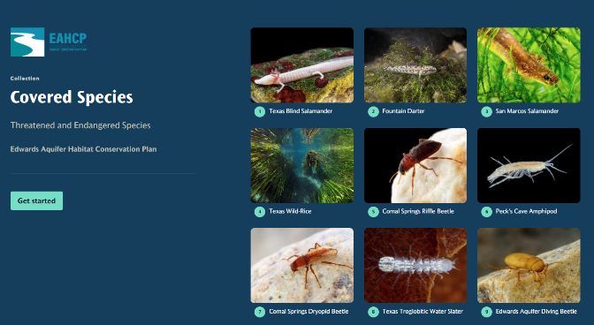
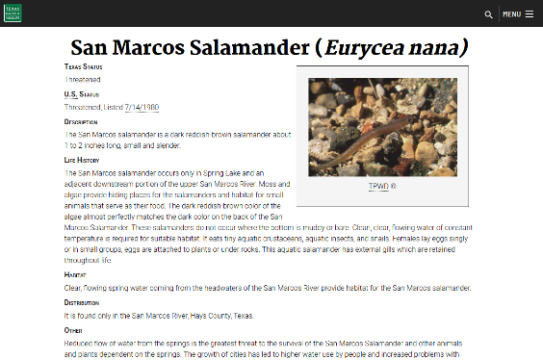
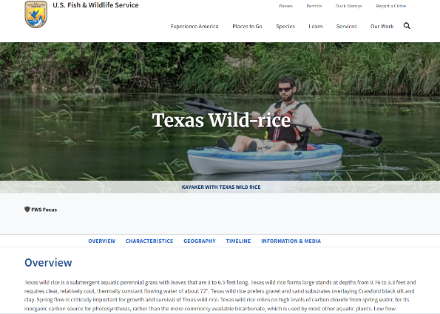
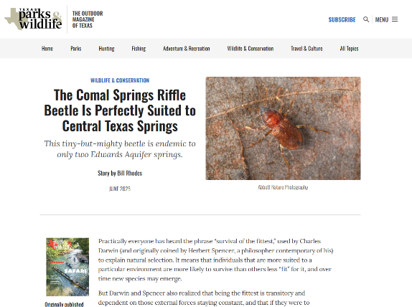
Figure 1
On a spare sheet of paper, ask that students find and write down the answers to the following questions based on their research:
- What specific habitat is this species found in? (Emphasize that this should be as specific as possible, not just “the river,” but something like “in river channel,” “around springs,” or “underground.”)
- What are three qualities or adaptations the species has evolved with that make it uniquely fit to live in this habitat?
(Examples for these qualities might include “lack of a swim bladder” for the fountain darter, which lives near spring openings at the bottom of the river, or “reddish-brown color” for the San Marcos salamander, which is designed to hide amongst algae.)
After time has elapsed, ask a representative from each group to write on the board (or simply read out loud) their group’s answers to each question.
For the final portion of the activity, pick a few species to focus on and facilitate a class discussion around the question:
How does human behavior impact this species’ ability to live in its habitat?
This might look like thinking about how litter can introduce chemicals or microplastics into a fountain darter habitat, or how over-pumping from the aquifer might lower streamflow levels to a point that wild rice may not be able to grow in the river channel.
Conclude by asking students to consider how they fit into the San Marcos ecosystem themselves. Will their behaviors leave their habitat worse or better off than they found it? Frame participation in conservation as its own kind of adaptation, wherein students, like the endemic species, can partake in certain small behaviors or habit changes to live more harmoniously with their new surroundings. Reiterate that conservation is not just a job for scientists, but a responsibility of all San Martians who want to preserve the unique environment for future generations.

